Evaluation of generative models for obtaining synthetic fundus images with retinal diseases using a visual Turing test
Augusto Javier Reyes Delgado^{[0009-0000-6863-3507]}, Isaac Machorro Cano^{[0000-0002-3822-4478]}, José Luis Sánchez Cervantes^{[0000-0001-5194-1263]}, Giner Alor Hernández^{[0000-0003-3296-0981]}, Lisbeth Rodríguez Mazahua^{[0000-0002-9861-3993]}
Abstract Retinal diseases progressively deteriorate vision, and, despite the availability of treatments, they cause irreversible damage; therefore, prevention remains a priority. This study evaluates the use of generative artificial intelligence to synthesize fundus images depicting one of the main retinal pathologies, age-related macular degeneration (AMD). The goal is to obtain realistic outputs that may support medical counseling. Three models were trained under limited computational resources: StyleGAN2, FastGAN, and Stable Diffusion v2, using a curated dataset of 526 images. Each model generated 30 independent samples for quantitative analysis and comparison. The evaluation combined a clinical Turing-like test and the Fréchet Inception Distance (FID) metric. StyleGAN2 achieved the best objective and perceptual fidelity (FID = 60.73) and exhibited the highest clinical plausibility. Non-specialists most frequently classified its images as real, and the retinal specialist reported a high deception rate (0.9667). FastGAN demonstrated feasibility in low-resource environments, preserving key retinal structures, although peripheral distortions were observed (FID = 78.36). Stable Diffusion v2 captured pathological features with clarity; however, it showed the greatest divergence from the training distribution (FID = 97.80) and was most often identified as synthetic. The discrepancy between FID and Turing test outcomes highlights the indispensability of human validation. In conclusion, StyleGAN2 emerges as the most suitable initial option for medical counseling systems and data augmentation in AMD research.
Keywords: Denoising, Diffusion Probabilistic Models (DDPM), Generative Artificial Intelligence, Generative Adversarial Networks (GANs), Retinal Diseases, Turing test.
  - Introduction
Retinal diseases are a group of conditions that progressively affect visual health, which, despite the availability of treatments that may slow their progression, cause irreversible damage [1]. In this context, one of the main strategies emphasized by healthcare professionals is prevention, along with raising public awareness about the potential consequences that certain habits and lifestyles may have on health.
Recent advances in generative artificial intelligence for the creation of synthetic images have made it a widely used technique in tasks such as data augmentation for the training of classification models, due to its ability to produce new data with high quality, variety, and fidelity to the original data [2].
From this arises a hypothesis: the use of synthetic medical images to simulate the progression of a disease may contribute to informing patients about the potential future consequences for their health. To test this hypothesis, the present study evaluates several generative models for the generation of retinal fundus images depicting a disease that represents one of the leading causes of blindness worldwide, age-related macular degeneration (AMD) [3]. This disease is frequently associated with chronic non-communicable conditions, which may alter its course of progression; hence, its clinical indicators could provide the basis for a conditional mechanism to enrich the generation of synthetic images.
Accordingly, three models were selected for this study. Based on the review of related literature, two were chosen—StyleGAN2 and Stable Diffusion. In addition, a model not yet employed in the directly related literature was included: FastGAN, whose reported technical characteristics suggest feasibility in resource-constrained environments [4], potentially enabling future systems that could bring such models closer to wider populations. Complementarily, a Denoising Diffusion Probabilistic Model (DDPM) was trained from scratch, with the aim of analyzing the behavior of a fusion-based model on retinal fundus images.
Given the objective of this project, a qualitative evaluation of the results generated was necessary. Healthcare specialists conducted a Turing-like visual test comparing a random sample of real and synthetic images to determine whether the latter offered a convincing representation.
Furthermore, the study revealed an additional finding: there is no public database dedicated to retinal fundus images with pathologies from the Mexican population. The literature reviewed indicates that generative models constitute a powerful tool for data augmentation. Therefore, as a secondary outcome, this study identifies the most suitable model for such a task, according to its capacity to preserve the key characteristics required for the diagnosis of retinal diseases.
The structure of this work is as follows. Sect. 1.2 presents the theoretical background necessary to understand the study, both from a medical and technological perspective. Sect. 1.3 describes the related literature and its main findings. Sect. 1.4 explains the methodology for data acquisition, model training, and evaluation. Sect. 1.5 presents the synthetic images generated by the trained models. Sect. 1.6 evaluates these images through computational and human-based assessments. Sect. 1.7 discusses the results, and finally, Sect. 1.8 presents the conclusions and outlines future work.
  - Theoretical Context
In the following sections, two main aspects will be addressed: the clinical condition under study and the fundamental concepts of artificial intelligence that help explain the role of generative technologies in the field of visual health from a preventive perspective.
    - Age-related Macular Degeneration (AMD)
It is a degenerative disease that affects a retinal structure known as the macula lutea and represents the leading cause of irreversible blindness in individuals over 60 years of age in developed countries. It is classified into two clinical forms: the non-neovascular or dry form, which accounts for approximately 85% of cases, and the neovascular or wet form, responsible for the most severe vision loss. Both can be further subdivided into stages of progression: early, characterized by small drusen deposits; intermediate, with multiple medium or large drusen; and advanced, which includes geographic atrophy (dry) or choroidal neovascularization with exudation and hemorrhage (wet) [3].
The progressive and, in many cases, asymptomatic nature of AMD in its initial stages makes it a challenge for timely detection. Its effects on central vision impair basic functions such as reading, driving, or recognizing faces, thereby affecting patients’ quality of life and independence.
The increasing prevalence due to population aging, combined with the limited availability of effective treatments for the atrophic form, makes AMD a major public health concern.
    - Artificial Intelligence

Artificial intelligence (AI), as a branch of computer science, is a term to which several definitions can be attributed. According to the research [5], these definitions may be classified based on: (A) how the concept of intelligence is understood, and (B) the capabilities, behaviors, principles, and structures (particularly those imitating the human brain) that are endowed to a computer. Beyond these distinctions, there is a common consensus among researchers that artificial intelligence refers to the ability of computer systems to replicate behaviors and capacities inherent to human cognition, namely processes such as learning, decision-making, and drawing conclusions from such learning.
These capabilities provided to computer systems have been well documented. In the specific case of the medical domain, [6] identifies several applications, including: (A) the management of medical data, (B) disease diagnosis, (C) digital consultation, and (D) the analysis of health plans, among others. These applications are enabled through the use of different methods or algorithms of machine learning and deep learning.
The extensive documentation of these capabilities provides the foundation for the present study, which leverages them to determine their effectiveness in generating visual resources that depict the projected progression of retinal diseases.
      - Generative Artificial Intelligence
Generative artificial intelligence (AI) is a branch of AI that, based on its training data, is capable of creating original content such as text, images, videos, audio, or software code in response to a user’s request or prompt. As presented in [7], it can be understood as a machine learning architecture that, through an inverse application of the learning obtained by detecting patterns and relationships in the training data, can generate new data instances. Specifically, while a machine learning or deep learning classification model seeks to distribute a given input X into different categories of Y, a generative model instead aims to infer a function P(Y) that allows the generation of a value for X. A generative model must be capable of producing a new synthetic data sample, given an input that is indistinguishable from the probabilistic distribution derived from the training data.
This mechanism has multiple areas of application, where the creation of synthetic content through generative AI increases efficiency in performing numerous tasks. According to [8], the potential applications of this technique can be summarized into 13 areas, depending both on the type of data generated and the domains in which it is applied. These include text generation, image generation, video synthesis, 3D modeling, code and software generation, voice generation, AI comprehension, business applications, video games, music, biotechnology, brain-wave analysis, as well as multimodal and computational efficiency.
With respect to healthcare applications, generative AI can be employed either individually or in combination through different workflows. The work [9] presents a review exploring the application of these techniques in several medical domains, including medical imaging, namely, a set of non-invasive techniques that enable the visualization of anatomical structures for disease diagnosis and monitoring. These techniques face challenges such as limited data and variability across modalities, where AI emerges as a tool for improvement.
Medical imaging benefits from several subdomains of generative AI applications, including:

- Data augmentation. The creation of synthetic images similar to real ones increases both the diversity and quantity of training data, particularly in rare medical conditions or cases with limited samples, thereby reinforcing the accuracy of diagnostic models.
- Image enhancement and reconstruction. Transformations that reduce noise, increase resolution, and correct distortions in scans enable more precise diagnoses, reliable longitudinal monitoring, and detailed quantitative analysis of anatomical structures.
- Cross-modality image translation. The conversion of medical images between different modalities, such as transforming computed tomography (CT) scans into magnetic resonance imaging (MRI), while preserving clinically relevant information.

These approaches allow the combination of advantages from each technique and help overcome individual limitations, improving both diagnosis and treatment planning. Furthermore, interpretability and explainability are also included, enabling a better understanding and explanation of the decision-making process of AI models, while providing end-users with a comprehensible justification for specific outputs.

        - Variational Autoencoders

The Variational Autoencoder (VAE) is an architecture for probabilistic models whose taxonomy consists of two interconnected neural networks. The first encodes large amounts of unstructured and unlabeled data into parameters, transforming them into a latent feature space—namely, a reduced vector containing the essential characteristics of the input data. The second network decodes this latent space to reconstruct the original data, incorporating stochastic variations in the reconstruction process, which differentiates it from traditional autoencoders [10]. VAEs are capable of generating multiple variations of content, making them particularly useful for tasks such as natural language generation or anomaly detection [11].

        - Generative Adversarial Networks

As introduced in [12] , Generative Adversarial Networks (GANs) consist of two neural networks that operate in opposition. One is the generator, responsible for creating new content; the other is the discriminator, whose role is to evaluate the quality of the generated content. The objective of this process is to reach a point at which the generator produces results so convincing that the discriminator can no longer reliably distinguish between original and synthetic content.
This adversarial interaction enables GANs to generate high-quality content, making them particularly useful in image and video generation, as well as in tasks such as style transfer and the creation of synthetic datasets [13].

        - Denoising Diffusion Probabilistic Models

Another taxonomy of great relevance for synthetic data generation, whose results have proven remarkable in recent years, is the class of diffusion probabilistic models. These were originally introduced in [14] , inspired by nonequilibrium statistical physics, namely, by iteratively driving data into an entropic state and subsequently defining an inverse process that allows highly flexible data generation.
In a process similar to the encoding and decoding steps of VAEs [15], the fundamental flow of these models consists of the gradual addition of random noise to training data through a Markov chain of multiple iterations. In this way, an original input is decomposed into latent variables in the form of Gaussian noise. An inverse process is then applied, with a number of iterations equivalent to those of the diffusion step, to gradually remove the noise and reveal the desired content, as illustrated in Figure 1.1.

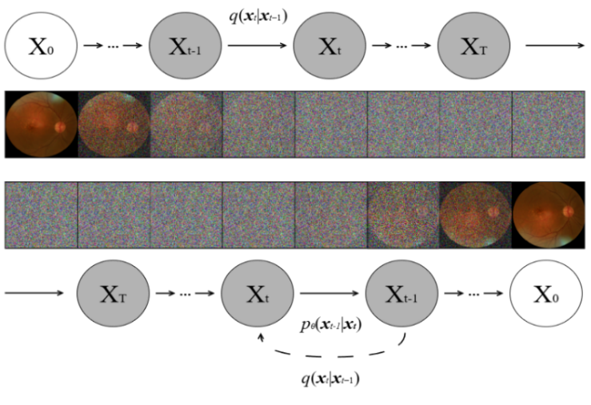
Fig. 1.1 Representation of the deconstruction–reconstruction process by a Markov chain. Based on [16].

[16] Although diffusion models take longer to train, they provide more precise control over the output, making them well-suited for high-quality image generation, as in tools such as Stable Diffusion and DALL-E [17], [18].
      - Transfer Learning and Fine-tuning
Transfer learning is a strategy within machine learning that enables a system to reuse knowledge and skills acquired in previous tasks and apply them effectively to new tasks. This approach is particularly useful when the target task has limited training data or when it would be costly to initiate the learning process from scratch.
According to [19], transfer learning is defined as the process by which knowledge is extracted from one or more source tasks and transferred to solve a target task. Unlike multitask learning—where all tasks (source and target) are addressed simultaneously and on equal footing—transfer learning places emphasis on the target task, using the source tasks as a means to improve its performance. This implies an asymmetrical relationship among tasks: the source tasks contribute previously learned representations and patterns, which are then adapted to the new domain of interest.
This makes transfer learning an efficient method for optimizing models by reducing data requirements, improving generalization, and accelerating training, thereby enabling the reuse of accumulated knowledge across different tasks or domains.
A widely used technique within transfer learning is the fine-tuning of pretrained models. This procedure adapts a model previously trained on a source task to a new target task, preserving the learned knowledge and specializing it according to the characteristics of the new domain. The process can be described in four fundamental stages [20]:

- Pretrain a source model on a large, well-curated dataset, allowing it to learn general representations useful for diverse tasks.
- Instantiate the target model by replicating the architecture and parameters of the source model, except for the output layer. The output layer is omitted because it is tightly coupled to the source dataset’s specific labels and is therefore not useful for the new task.
- Add a new output layer to the target model that matches the number of categories in the target dataset. This layer is initialized with random parameters, as it will be trained from scratch.
- Train (fine-tune) the target model using the data specific to the new task. During this process, the new output layer is trained fully, while the remaining layers are gradually adjusted from the values inherited from the source model.

Such technique is especially valuable in cases such as the one presented in this study, where the target dataset is considerably smaller than the source dataset, as it improves the model’s capacity for generalization by leveraging prior representations rather than starting from scratch.
  - State of the Art
This section describes the body of related work addressing the problem studied here, with the aim of identifying the reported contributions—namely, the methods, techniques, and technologies employed to obtain their respective solutions. The goal of this review is to compare, select, assimilate, and adapt what has already been discovered.
Among the generative models considered within the scope of this study, autoencoders are the least demanding in terms of computational resources. This was one of the selection criteria used by Chen et al. [21] to develop a method for augmenting and improving image datasets—specifically, retinal fundus images—to mitigate deep learning models’ dependence on large data volumes. An autoencoder was trained on six open-access datasets with glaucoma, comprising patients aged 40–80 from Singapore, China, India, and Spain. Preprocessing was applied to extract only the primary region of interest for glaucoma detection, the optic nerve head. The effectiveness of the approach was validated by training Vision Transformer classifiers with and without synthetic images generated by the autoencoder. Across all datasets, the classification models trained with synthetic images achieved superior performance, with an improvement of at least 0.05 in area under the curve (AUC). The authors further noted that, compared with GANs, autoencoders require fewer training data, and that DDPMs may produce images with hallucinations.
The absence of datasets is a commonly cited issue among studies applying artificial intelligence techniques in the medical domain, as noted by Guibas et al. [22], who highlight privacy and patient-data protection as major obstacles to data access. To mitigate this problem, they proposed generating synthetic images using a two-stage GAN-based workflow, with retinal fundus images from two datasets as a case study: DRIVE [23], which contains only photorealistic fundus images. The methodology is as follows: the workflow comprises two stages. The first employs a Deep Convolutional GAN (DCGAN) to produce synthetic segmentation masks from the MESSIDOR set, under the premise that the generated images no longer correspond to any real patient. The second stage uses a conditional GAN (cGAN), trained on the paired data in DRIVE, to learn an image-to-image translation model. This second model takes the masks generated in the first stage and synthesizes photorealistic images from these synthetic segmentation masks. The authors report that decomposing the production of synthetic images into two stages reduces task complexity by breaking it into smaller subproblems and improves the quality of the results.
Having established that the absence of data and restricted access are obstacles in themselves, additional issues arise when working with available data, such as lack of labeling and class imbalance. Zheng et al. [24] address these challenges from a generative-AI perspective. In their study, a convolutional ensemble model based on U-Net (MU-Net) was trained to detect exudates in retinal fundus images with diabetic retinopathy. Four datasets with imbalanced positive and negative cases were used; one served as the training set and the remaining as test sets. To mitigate the imbalance problem, the authors adopted synthetic oversampling of minority classes (SMOTE) via a conditional GAN based on the Pix2Pix architecture. The generative model was trained in two phases. Sixty synthetic images were obtained in each phase; however, a portion was discarded due to artifacts. In total, 86 images were selected for training the MU-Net model. The training results showed increased robustness and generalization when synthetic images were incorporated.
Another study on improving datasets for training deep learning models is presented by Burlina et al. [25], specifically targeting high-resolution synthetic data generation in retinal fundus images with age-related macular degeneration (AMD). They reported training two image-synthesis models using progressively growing generative adversarial networks (ProGAN). Both models were trained on the AREDS dataset [26], which was split into two parts: one subset containing images with AMD and a second subset without the disease, with the aim of obtaining two models specialized in generating specific image types. The generated data were evaluated using two methods: human validation and the training of a convolutional neural network for classification (DCNN). For human validation, both specialists produced similar results when assessing real versus synthetic images: the first achieved accuracies of 0.8454 and 0.8412 for real and synthetic data, respectively, and the second achieved 0.8947 and 0.8919 on the same test. Regarding the DCNN models, the classifier trained on real data obtained an AUC of 0.9706, while the one trained on synthetic data achieved 0.9235.
On the other hand, analyzing retinal fundus images can be challenging, as the quality of the acquired images often limits the effectiveness of computer-aided diagnostic systems. Luo et al. [27] developed a two-stage, generative-AI–based framework for restoring images degraded by crystalline lens opacities without requiring aligned pre-/post-surgery image pairs. In the first stage, they proposed an unpaired generative model, CataractSimGAN, tasked with synthesizing cataract-like images from a set of 400 cataract-free images together with 400 cataract images. This network employs a multiscale discriminator to preserve both fine details and global structures, as well as two specialized loss functions: a multiscale loss based on feature maps extracted by U-Net, and a structural loss focused on preserving blood vessels and the optic disc. In the second stage, a supervised Pix2Pix-type network, CataractDehazeNet, was trained using the synthetic images generated in the first stage as inputs and the original clear images as references; this network was subsequently used to restore real cataract images. To validate the effectiveness of the proposed system, images from 50 patients captured before and after surgery were used, focusing on the optic disc region. SSIM (Structural Similarity Index Measure) and PSNR (Peak Signal-to-Noise Ratio) were employed to quantify the similarity between the restored images and the clear reference images. Finally, the authors highlighted that the system enables the revelation of small lesions such as exudates and hemorrhages.
Another related work that employs generative artificial intelligence for data augmentation additionally addresses the explicit manipulation of lesions and severity stages. Zhou et al. [28] proposed a conditional generative model, DR-GAN, designed to synthesize photorealistic retinal images with controllable lesions and adjustable severity levels via structural masks and latent severity vectors. The model comprises two components: an encoder–decoder–style generator with multiscale spatial- and channel-attention (SCA) modules, and a set of multi-scale discriminators, optimized with multiple loss functions (adversarial, perceptual, classification, and feature-matching). To control severity levels, the authors introduced Adaptive Grading Manipulation (AGM), which uses latent vectors learned from a pretrained ResNet-50 to encode distributions corresponding to the five stages of diabetic retinopathy. Training employed masks generated from datasets that included microaneurysms, exudates, hemorrhages, laser marks (scars), and proliferative membranes, obtained via supervised and weakly supervised segmentation. Evaluation combined quantitative metrics such as FID (Fréchet Inception Distance) with expert assessment by ophthalmologists, who rated the synthetic images with an average fidelity score of 7.97/10 and achieved an accuracy of 0.8530 in assigning the correct severity stage. Moreover, the generated images improved automated DR classification in models such as VGG-16, ResNet-50, and Inception-v3, with performance gains particularly pronounced at the most severe stages.
These observations indicate that collaboration with medical experts is crucial for evaluating synthetic images. Another example is the study by Coyner et al. [29], who assessed the diagnostic fidelity of images generated by a conditional generative adversarial network (pix2pix) trained to reconstruct retinal fundus photographs from vascular maps extracted with a U-Net model, with the goal of detecting plus disease in retinopathy of prematurity. The authors trained two model variants: one using raw vascular maps and another using filtered maps without choroidal patterns. Validation involved blind grading by three ophthalmologists, who assigned labels of normal, pre-plus, or plus, showing high levels of agreement with diagnoses on real images. Although the experts were able to distinguish real from synthetic images in most cases, they noted that the generated images preserved sufficient clinical information to enable consistent diagnoses. On Cohen’s kappa metric, the results were 0.8800 and 0.9020 for synthetic and real images, respectively. The images also allowed reliable discrimination among the three grades of disease progression. Finally, the authors emphasized that, while the synthetic images could lack certain minor clinical features in the vascular maps (e.g., hemorrhages), they nonetheless maintained diagnostic utility.
Another notable work on synthetic retinal fundus image generation was proposed by Kim et al. [30], who implemented a StyleGAN-derived model to synthesize realistic retinal images at a resolution of 1024×1024 pixels. The model was trained on more than 270,000 real retinal images without pathology, yielding a generator robust in reproducing normal anatomical structures. A subsequent transfer-learning stage was applied to generate images exhibiting epiretinal membrane (ERM). Validation included a clinical Turing test in which a group of ophthalmologists attempted to distinguish real from synthetic images. The results indicated an accuracy of 0.5400, underscoring the difficulty of discrimination, with a sensitivity of 0.7110 and a specificity of 0.3670. Quantitative analysis showed differences of less than 1.5% in morphological metrics such as vessel count and signal-to-noise ratio. To assess clinical fidelity, the fine-tuned model was used to generate images with characteristic signs of the condition—perifoveal tortuosity and the presence of epiretinal membranes—which were confirmed by specialists. Finally, the collected evidence showed that synthetic images improved the performance of classification models on imbalanced datasets; specifically, AUC increased from 0.7350 to 0.9090 when synthetic images were used to balance class proportions.
The limited availability of clinical images for training robust artificial intelligence models has motivated approaches that expand datasets via synthetic generation. In this context, Wang et al. [31] developed a generative model based on a StyleGAN2 architecture to synthesize retinal fundus images containing characteristics typical of age-related macular degeneration (AMD). Because images depicting advanced AMD were scarce in their original training set (which included more than 125,000 clinical images, mostly without AMD), they applied an innovative Human-in-the-Loop strategy in which human experts iteratively validated the quality and clinical relevance of the generated images. This method substantially increased the proportion of synthetic images with advanced AMD.
The quality of these images was evaluated objectively using metrics such as SSIM and FID, yielding results that confirmed their visual realism and originality relative to the original dataset. In a clinical Turing-like evaluation, four ophthalmology residents achieved an overall accuracy of 0.6600 in distinguishing real from synthetic images, which improved to 0.7200 with the use of this objective scale. Synthetic images corresponding to mild AMD were particularly difficult to differentiate from real ones, with accuracy near chance of 0.5500, whereas advanced synthetic images were more readily detected 0.8900. The authors emphasized that this type of approach could be useful not only for improving the performance of automated detection models through data augmentation, but also for medical education and for the secure sharing of clinical data, preserving privacy via controlled (sandbox) environments.
Complementing the discussion on various architectures and approaches for generating synthetic medical images, the work of Skandarani et al. [32], stands out for conducting an empirical comparative analysis across different generative adversarial models. The study evaluated DCGAN, LSGAN, WGAN, HingeGAN, SPADEGAN, and StyleGAN on three types of medical images: cardiac magnetic resonance imaging, hepatic computed tomography, and RGB retinal fundus photographs (using the IDRiD dataset [33], which contains images with diabetic retinopathy). The authors performed an extensive hyperparameter search to optimize each model, dedicating approximately 500 GPU-days to training. Focusing specifically on retinal fundus images—which present unique anatomical and textural characteristics—the evaluation revealed that StyleGAN and SPADEGAN achieved superior performance both qualitatively and quantitatively. However, SPADEGAN obtained the best results, generating high-quality synthetic fundus images with a notably low FID of 1.09, indicating high perceptual realism. Additionally, when training a U-Net–type neural network to segment anatomical structures from these synthetic images, SPADEGAN proved most effective in preserving the clinical richness of the original dataset. Nonetheless, the study also reported that, despite the high visual realism achieved, no GAN surpassed the accuracy of models trained exclusively on real images.
Another noteworthy contribution to the use of generative artificial intelligence for retinal fundus imagery is presented by Kang et al. [34], who proposed a method based on the conditional generative model Pix2Pix to predict static perimetry (visual field) outcomes from color fundus images (CFIs). Their technique, termed CFI2GM, translates CFIs into grayscale visual field maps (GMs), enabling clinically meaningful results within seconds—compared to the 15–20 minutes typically required for conventional static perimetry. The model was trained on a robust clinical dataset from 3,306 patients at the Samsung Medical Center (South Korea), yielding 5,869 CFI–GM pairs. Quantitative evaluation demonstrated strong performance, achieving a mean squared error (MSE) of 57.99 and a peak signal-to-noise ratio (PSNR) of 30.61 dB, indicating high structural and visual similarity between generated and real images. Clinical validation by ophthalmology specialists further supported the diagnostic utility and accuracy of the generated maps, underscoring their potential to substantially improve the reliability and efficiency of clinical testing by reducing patient visual fatigue. The authors also emphasized rigorous ethical handling of sensitive data, employing robust anonymization procedures to comply with current ethical and legal standards.
In the pursuit of improving the generalization and robustness of deep learning models for medical imaging, Oliveira et al. [35] conducted an extensive comparative study across generative adversarial architectures (GANs), with an emphasis on retinal fundus images for detecting age-related macular degeneration (AMD). Ten GAN architectures were analyzed—DCGAN, LSGAN, WGAN, WGAN-GP, DRAGAN, EBGAN, BEGAN, CGAN, ACGAN, and StyleGAN2-ADA—with the latter achieving the best performance according to the Fréchet Inception Distance (FID), obtaining a score of 166.17. In addition, two clinical specialists validated the synthetic images generated by StyleGAN2-ADA and were unable to consistently distinguish the synthetic data from the real. To assess the impact of synthetic imagery, the authors performed mixed training with varying proportions of real and synthetic images using convolutional neural networks (SqueezeNet, AlexNet, and ResNet18). With ResNet18, they achieved an optimal accuracy of 0.8300 when the training set included 60% synthetic images, a strategy that consistently outperformed training on exclusively real images. Finally, the model was externally validated on an independent dataset, yielding an overall accuracy of 0.8130, thereby demonstrating its capacity to generalize across different clinical contexts.
Another line of work aimed at improving synthetic retinal fundus images was proposed by Jia et al. [36], who developed a GAN-based super-resolution model guided by vascular structural information. Their approach sought to overcome the structural distortions observed in prior methods such as Real-ESRGAN, particularly for retinal imagery where preserving vascular morphology is critical for clinical diagnosis. The model integrates vascular segmentation maps previously generated with a U-Net, using them as contextual guidance for the generator during super-resolution. This structural guidance is fused via Spatial Feature Transform (SFT) layers inserted into dense residual blocks, which improves the anatomical consistency of the produced images. Additionally, the discriminator incorporates spatial and channel attention modules, enhancing its ability to distinguish clinically relevant characteristics. A specialized loss function was also introduced to penalize discrepancies in vascular reconstruction between real and generated images, promoting greater structural fidelity. The model was evaluated against multiple prior GAN-based super-resolution techniques, demonstrating superior performance on metrics such as PSNR and SSIM, as well as in clinical visual appraisal. As a limitation, the authors noted the model’s high computational cost; future work will focus on optimizing efficiency for deployment in real clinical contexts with limited resources.
More recently, diffusion-based generative models have gained traction in work on synthetic medical image generation. An example is the study by Müller et al. [37], who conducted a systematic comparison between generative adversarial network (GAN)–based models and latent denoising diffusion probabilistic models (DDPMs) for synthesizing medical images across three domains: retinal fundus photography, chest radiography, and stained histological tissue. For fundus images, the AIROGS dataset [38] was used to compare the performance of the diffusion model Medfusion—inspired by Stable Diffusion—against GAN architectures such as StyleGAN-3, ProGAN, and cGAN. In this task, Medfusion consistently achieved superior results in both visual fidelity and diversity, outperforming StyleGAN-3 on metrics including FID, precision, and recall. A notable finding was that GAN-generated images exhibited severe structural artifacts, such as duplicated optic discs, whereas Medfusion more faithfully preserved ocular anatomy.
To assess the clinical utility of synthetic images, the authors trained ResNet classifiers on both real and synthetic data. In all cases, models trained with images produced by Medfusion achieved higher AUROC, notably 0.8800 for fundus imagery, surpassing the 0.8500 obtained with StyleGAN-3, while also maintaining better performance for histological and chest X-ray images. Furthermore, the latent autoencoder employed by Medfusion enabled the generation of high-resolution images without significant loss of clinically relevant content. This study positions diffusion models as a more robust alternative to traditional GANs, particularly for synthetic retinal image generation aimed at training, evaluation, or data augmentation in automated diagnostic models.
From this review of the state of the art, a synthesis of the findings from the related works has been compiled. Table 1.1 presents a comparison of the studies, considering the following fields:

- Work: The citation to the publication.
- Model type: Indicates whether the model is a variant of a Denoising Diffusion Probabilistic Model (DDPM), a Generative Adversarial Network (GAN), or a Variational Autoencoder (VAE).
- Model: Specifies the base model(s) trained in each study.
- Task: Indicates whether the model’s objective is:
- Image synthesis: Create new image samples.
- Restoration: Reconstruct or complete image structure.
- Super-resolution: Increase image resolution.
- Condition: The disease or set of diseases present in the images used in each study.

Table 1.1 Comparative table of related works
Work | Model Type | Model | Task | Condition
Chen et al. [21] | VAE | Autoencoder | Image synthesis. | Glaucoma
Guibas et al. [22] | GAN | Stage-I: DCGAN  Stage-II: cGAN | Image synthesis. | General (non-specific)
Zheng et al. [24] | GAN | Pix2Pix | Image synthesis. | Diabetic retinopathy
Burlina et al. [25] | GAN | ProGAN | Image synthesis. | Age-Related Macular Degeneration
Luo et al. [27] | GAN | CataractSimGAN | Image restoration | Cataracts
Zhou et al. [28] | GAN | DR-GAN | Image synthesis. | Diabetic retinopathy
Coyner et al. [29] | GAN | StyleGAN | Image synthesis. | Diabetic retinopathy
Kim et al. [30] | GAN | StyleGAN | Image synthesis. | Diabetic retinopathy
Wang et al. [31] | GAN | StyleGAN2 | Image synthesis. | Degeneración macular.
Skandarani et al. [32] | GAN | SpadeGAN | Image synthesis. | Diabetic retinopathy
Kang et al. [34] | GAN | Pix2Pix | Image synthesis. | Glaucoma.
Oliveira et al. [35] | GAN | StyleGAN2 | Image synthesis. | Age-Related Macular Degeneration
Jia et al. [36] | GAN | Real-ESRGAN | Super-resolution | General (non-specific)
Müller-Franzes et al.[37] | DDPM | Medfusion (Stable Diffusion) | Image synthesis. | Glaucoma.

As shown in Table 1.1, generative adversarial networks remain the state of the art for the synthesis of retinal fundus images, with 12 of the 14 related studies employing variants of this technique.
A technique was identified for addressing small, disease-specific datasets: leveraging large unlabeled datasets so that the model learns typical structural characteristics and then, through transfer learning, training a new model that incorporates disease-specific features from a smaller labeled dataset [30], [31].
It was also found that human clinical validation provides valuable evidence for assessing results, bringing evaluations closer to real-world settings. Moreover, the use of synthetic medical images for educational purposes is an emerging idea, extending their application beyond purely diagnostic use [29].
Finally, none of the surveyed works references a fundus-image dataset composed of images drawn from the Mexican population.
  - Methods and Materials
The workflow adopted for this study was carefully designed to ensure the robustness and validity of the results obtained. The methodology integrates several fundamental stages that systematically address the generation and evaluation of synthetic retinal fundus images using generative models. Each phase of the process was structured with consideration for both the technical needs and the clinical requirements of the medical domain. The methodology stages are illustrated in Figure 1.2.

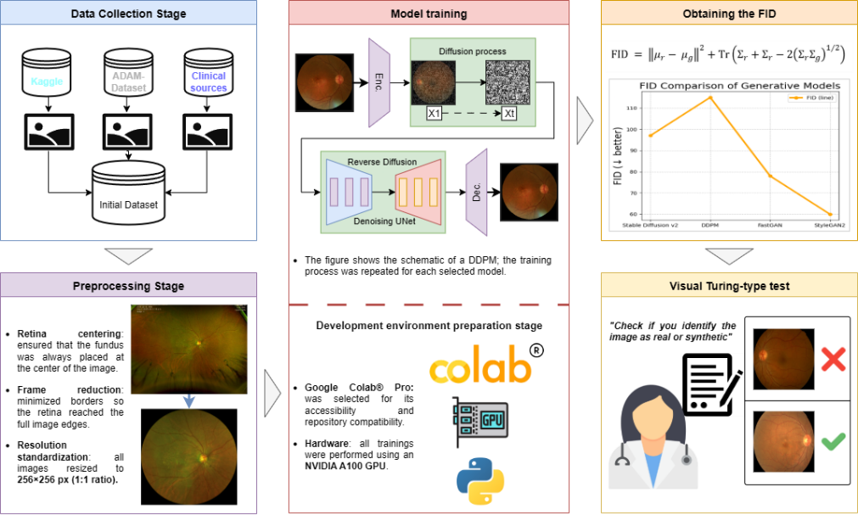
Fig. 1.2 Methodology Stages.

- Data collection stage. Retinal fundus images were retrieved from multiple data sources.
- Preprocessing stage. A series of transformations were applied to the dataset to achieve a consistent format.
- Development environment preparation stage. Code repositories were retrieved and parameters adjusted for execution in Google Colab®.
- Model training stage. Four image-generation models were trained. Three of them were selected for and a sample of 30 images per model was obtained.
- Results evaluation stage. The models’ outputs were evaluated using:
- Fréchet Inception Distance (FID). A widely used quantitative metric to assess the quality of images generated by generative AI models. Its purpose is to estimate how similar the statistical distributions are for features extracted from real and synthetic images [39]. Let $μ_{r}, Σ_{r}$ be the mean and covariance of features from real images, and $μ_{g}, Σ_{g}$ those from generated images. FID is defined as in Equation (1):
$$FID ={\left\|μ_{r}- μ_{g}\right\|}_{2}^{2}+Tr\left(Σ_{r}+Σ_{g}-2{\left(Σ_{r}Σ_{g}\right)}^{1/2}\right)$$ | (1)

This formula combines the Euclidean distance between the means ${\left\|μ_{r}-μ_{g}\right\|}^{2}$ with a measure of dissimilarity between the covariance matrices based on the matrix square root of their product ${\left(Σ_{r}Σ_{g}\right)}^{1/2}$. A lower FID value indicates greater similarity between real and generated images, ergo, a superior performance of the generative model in terms of visual fidelity.
- Turing-like visual test. Complementing the quantitative analysis, a Turing-like visual assessment was conducted to evaluate how realistic AI-generated synthetic images appear, based on human evaluators’ ability to distinguish them from authentic images [40]. We collaborated with four general practitioners and one retina specialist to assess the anatomical plausibility and clinical coherence of the generated images. Evaluators received a randomized, anonymized set comprising 90 real and 90 synthetic fundus images produced by three different generative models. Each image was presented in a form where physicians indicated whether they believed it was (a) real or (b) synthetic, thereby identifying which models yielded images most convincing from an expert standpoint. This human-centered evaluation complements the FID-based assessment by capturing perceptual and clinical cues that distributional metrics may not fully reflect.
      - Data Collection and Preprocessing
The dataset used in this study was compiled from four sources. The first was obtained from Kaggle, comprising diverse images aggregated from datasets published in public repositories [41], [42]. The second source was ADAM [43]. The authors of [45] provided a third dataset consisting of 1,098 images. Due to development-environment (VRAM) constraints, a random 20% subsample was selected for use. Finally, 13 images were contributed by the Instituto de Oftalmológico Conde de Valenciana.
After processing and removing images with noise (reflections and acquisition artifacts), the final dataset comprised 526 images. Access to the dataset assembled for this study can be granted upon reasonable request for academic or research purposes.
The retrieved data exhibited notable differences in resolution and format. To address this, the raw set underwent the following preprocessing steps:

- Centering the fundus field. Ensure the retinal fundus is centered in every image, as some samples were off-center.
- Minimizing external frames/margins. Reduce or remove added borders so the retinal field fits tightly within the image boundaries.
- Resolution normalization to 256×256 px. Resize all images to 256×256 pixels—chosen to fit available VRAM during training and to align with commonly used resolutions—ensuring a 1:1 aspect ratio across the dataset.
      - Development Environment

The working environment for this research was Google Colab® Pro (paid plan). It was selected for its accessibility and compatibility with code repositories used for training the models, which were cloned into the environment for execution. The runtime was Python 3.12.11 (main, Jun 4, 2025, 08:56:18) [GCC 11.4.0].
All training runs used an NVIDIA A100 GPU. A snapshot of the environment is shown in Figure 1.3.
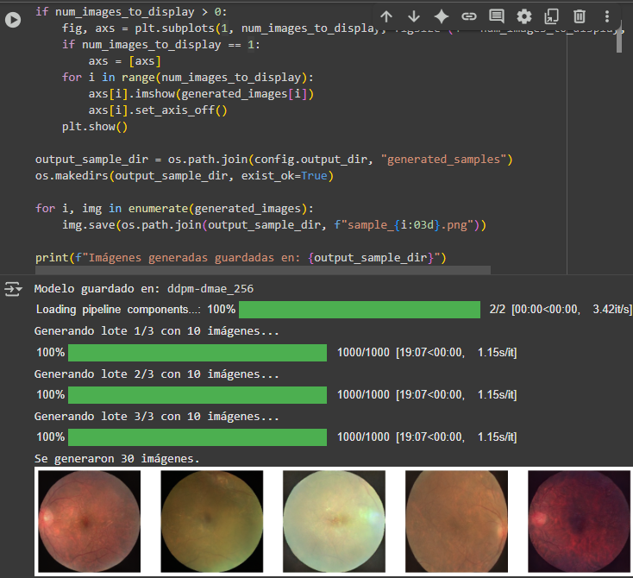
Fig. 1.3 Code executed in the development environment.
      - Generative Models
The review of related literature indicates that, at least for the present case study, GANs remain the preferred method for obtaining synthetic images. The work of Müller-Franzes et al. [37], which employed diffusion mechanisms, did not focus exclusively on fundus imagery but on several anatomical domains, yet it proved effective across the reported metrics.
Expanding the scope of the survey reveals studies such as the review by Ibrahim et al. [2] on synthetic data generation across medical modalities, which reports the growing adoption and effectiveness of diffusion probabilistic models (DDPMs) and provides a detailed catalog of models and application areas.
Accordingly, the set of models selected for this study includes two GAN variants: StyleGAN2, one of the most frequently reported alternatives in the literature, and FastGAN, a less-studied architecture that offers training-time and resource advantages in constrained settings like ours [4].
With respect to diffusion models, although the literature remains smaller than for GANs, Stable Diffusion variants stand out for the high image quality they can achieve; therefore, Stable Diffusion v2 was also selected for this study. These models were fine-tuned due to limited computational resources and the modest dataset size.
As an initial proof of concept, we additionally experimented with training a baseline DDPM from scratch, in order to explore the behavior of a diffusion model trained from scratch.
It is important to note that the selected models either natively support, or can be extended to support, conditional generation; this criterion was considered with a view toward future advances in the research.
  - Results
This section presents the outcomes obtained after training the selected generative models—StyleGAN2, FastGAN, Stable Diffusion v2, and DDPM—each trained on a dataset of 526 images.
For each model, a set of 30 synthetic images was generated and subsequently analyzed from two complementary perspectives: (A) a quantitative evaluation using the Fréchet Inception Distance (FID) metric, and (B) a Turing-like clinical assessment in which general practitioners and a retina specialist participated.

      - Denoising Diffusion Probabilistic Model
This model was trained to observe the behavior of a diffusion mechanism in recreating a retinal fundus image. It constitutes the foundation of modern diffusion models; however, in its pure form—and under limited data and computational resources—its results are the least similar to the original dataset. Although the model captures the overall appearance of the target structure, it does not sharply reproduce the subtle retinal anatomical details in fundus images. A sample of the generated results is shown in Figure 1.4.

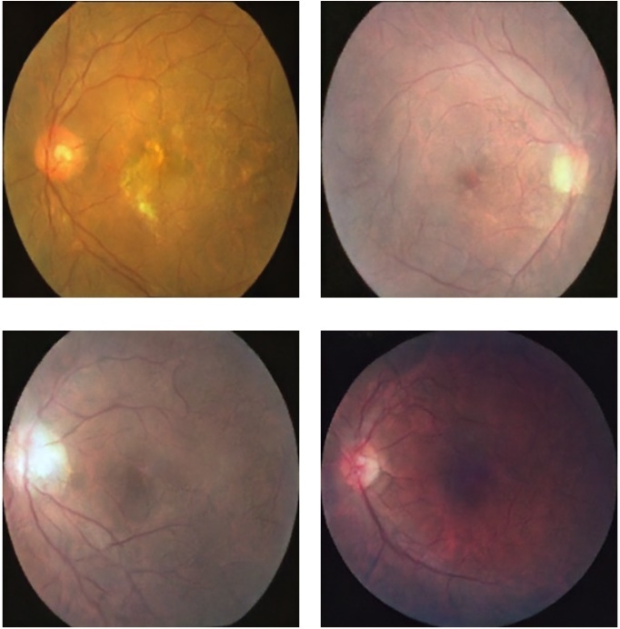
Fig. 1.4 Sample of images generated by the DDPM model.
      - FastGAN
This model is distinguished by its reduced computational requirements. Unlike the other two models, it was trained from scratch, as no checkpoint matching the target resolution of 256×256 pixels was available. Nevertheless, it required a relatively short training time of 60 minutes and 27 seconds, using 5.2 GB of VRAM.
The resulting images coherently represent the principal structures of retinal fundus photography, preserving color and structures such as the macula, the vascular tree, and the optic disc, consistently connected, while also exhibiting typical features of macular degeneration.
Despite these results, the generated images present several artifacts, including deformations and irregularities along the boundaries. A sample of these can be seen in Figure 1.5.

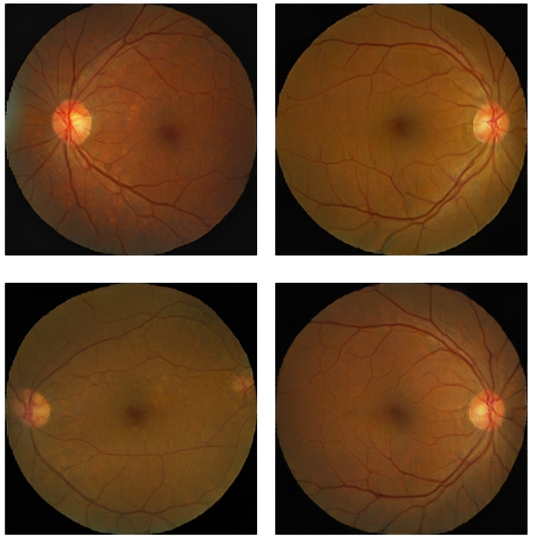
Fig. 1.5 Sample of images generated by the FastGAN model.
      - StyleGAN2
This model is among the most frequently reported in the literature. Although it was trained via fine-tuning, the procedure required 343 minutes of training. This duration stems from the choice of a small batch size (4 images) to stay within the available VRAM limits.
The model delivers results with colors and structures faithful to the originals, along with stable contours and harmonious proportions. These observations are consistent with the state-of-the-art reports for StyleGAN2 and differ from the behavior reported for StyleGAN3 in [37]. However, there are regions in some images where the vascular tree does not form complete connections. A sample of the images obtained with this model is shown in Figure 1.6.

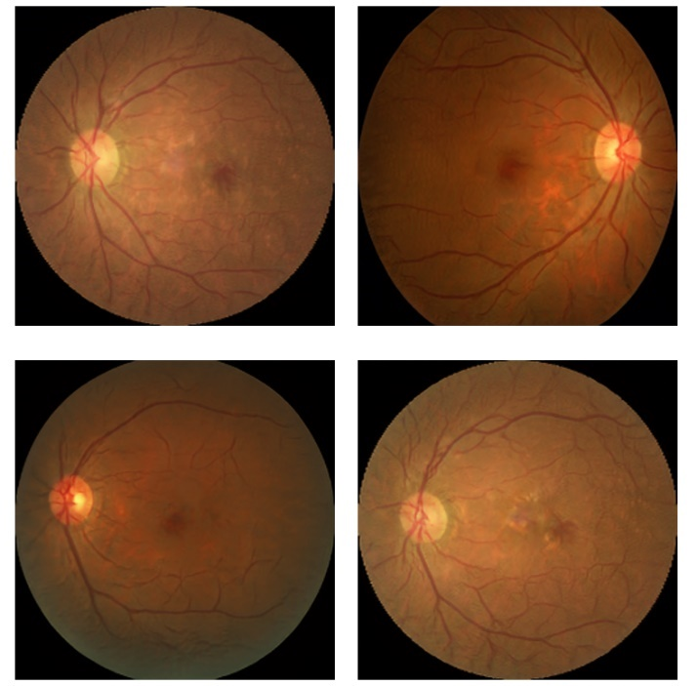
Fig. 1.6 Sample of images generated by the StyleGAN2 model.
      - Stable Diffusion v2
As a variant derived from DDPMs and the second iteration of Stable Diffusion, this model reports substantial improvements over its predecessor. Nevertheless, in its most recent updates it is quite computationally demanding; therefore, version 2 was selected to explore the capabilities of this family. Training via fine-tuning required 53 minutes and 5.2 GB of VRAM.
Overall, the results preserve the principal fundus structures; however, they do not maintain the typical proportions observed in the training images—for example, the optic disc tends to be too small, while the vascular tree appears over-vascularized.
Even so, it is worth noting that this model most prominently exhibits characteristic features of macular degeneration. As with the previous models, a set of 30 images was generated. A sample is shown in Figure 1.7.

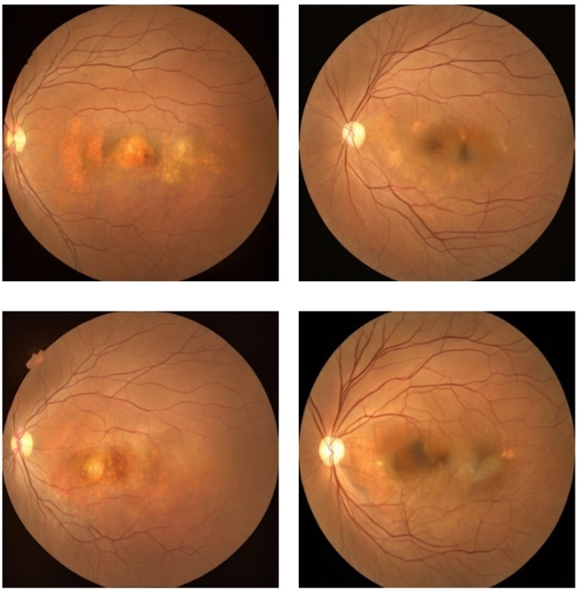
Fig. 1.7 Sample of images generated by the Stable Diffusion v2 model.

As shown in Figures 1.5–1.7, FastGAN, StyleGAN2, and Stable Diffusion v2 are capable of reproducing the basic retinal structures. By contrast, DDPM—whose results are illustrated in Figure 1.4—yields representations that deviate substantially from the original data.
  - Evaluation
Once the samples produced by the models were obtained, the workflow proceeded to the evaluation phase. Because the image samples exhibit substantial variability, each set was first subjected to an objective computational assessment before advancing to the clinical evaluation. The results of these assessments are presented below.
      - Fréchet Inception Distance
The Fréchet Inception Distance (FID) is a widely used metric for evaluating images generated by generative models in the related literature. As an objective computational metric, it complements the human clinical assessment, estimating distributional similarity between features extracted from real and synthetic images (as defined in Equation (1)). The results of the evaluation for the samples produced by each model are shown in Figure 1.8.

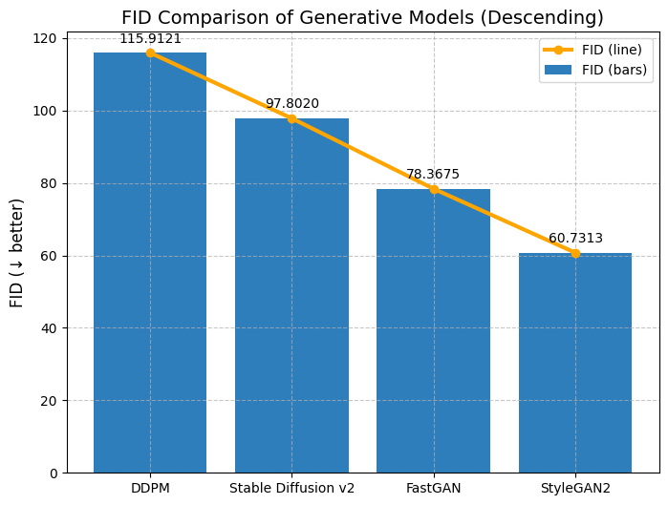
Fig. 1.8 Fréchet Inception Distance obtained for each model.

This metric quantifies how far the outputs of a generative model are from the original dataset; lower values indicate better performance.

- DDPM: Achieved a high FID of 115.9121, the highest reported in this study, indicating that its results are far from the original distribution.
- Stable Diffusion v2: Generated data show substantial differences from the originals, reflected in an FID of 97.8020.
- FastGAN: The sample yielded an FID of 78.3675, which is typically considered high. This aligns with the observations reported in Section 5.1.2.
- StyleGAN2: Obtained the lowest FID among the three, 60.7313, and is considerably ahead of the other models.

Summary. StyleGAN2 shows the best score among the evaluated models (FID = 60.73). However, given the limited sample size due to computational constraints, the estimates for all models could improve with larger samples. Even so, the results reveal a clear trend: the baseline DDPM diverges markedly from the original data—as captured by FID—and was therefore excluded from the next evaluation phase, the Turing-like test.
      - Clinical Evaluation via Turing-like Test
For the second evaluation phase, a Turing-like clinical test was conducted in collaboration with four general practitioners and one retina specialist to assess the anatomical plausibility and clinical coherence of the generated images. The evaluators were presented with a randomized, anonymized sample.
The set comprised a total of 90 real images and 90 synthetic images generated by the three generative models. Upon viewing each image, the doctors indicated in a form whether they believed it was (a) real or (b) synthetic. This procedure was used to determine which of the generative models produced images that were most convincing under expert scrutiny.
The responses from the general practitioners showed similar patterns, and these results are summarized in Table 1.2.

Table 1.2 Average results from general practitioners.
Set | Accuracy | Recall | Precision | F1-score | Fooling  rate
Real | 0.4958 | 0.4655 | 0.4779 | 0.4716 | -
Synthetics | 0.4958 | 0.5242 | 0.5118 | 0.5179 | 0.4758
FastGAN | - | 0.6136 | - |  | 0.3864
StyleGAN2 | - | 0.3696 | - |  | 0.6304
Stable Diffusion 2 | - | 0.6176 | - |  | 0.3824

The results in Table 1.2 reveal several noteworthy patterns. In general, non-specialist physicians found it difficult to discriminate between real and synthetic images; however, the real image set achieved a higher rate of being labeled “real” than the sets produced by FastGAN and Stable Diffusion v2. The outcomes for StyleGAN2 stand out, as its images were most frequently judged as real.
By contrast, the retina specialist’s assessment diverged from that of the general practitioners; this evaluation is summarized in Table 1.3.

Table 1.3 Results from the retina specialist.
Set | Accuracy | Recall | Precision | F1-score | Fooling  rate
Real | 0.6666 | 0.9778 | 0.6027 | 0.7458 | -
Synthetics | 0.6666 | 0.3556 | 0.3556 | 0.5161 | 0.6444
FastGAN | - | 0.1000 | - | - | 0.9000
StyleGAN2 | - | 0.0333 | - | - | 0.9667
Stable Diffusion 2 | - | 0.9333 | - | - | 0.0667

As shown in the preceding table, the retina specialist’s evaluation differed markedly. Of the 90 real images presented, only 2 were incorrectly labeled as synthetic. By contrast, the FastGAN and StyleGAN2 sets achieved fooling rates equal to or greater than 0.9000, with StyleGAN2 maintaining an advantage of 0.0667 over FastGAN. For Stable Diffusion v2, more than 93% of the images generated were correctly identified as synthetic.
  - Discussion
Synthetic retinal fundus images exhibiting macular degeneration were evaluated using FastGAN, StyleGAN2, and Stable Diffusion v2, all trained under limited data and computing resources. The evaluation focused primarily on medical validation through a Turing-like test with general practitioners and a retina specialist.
The results of this test, together with per-model FID measurements, indicate that—at least within the context of this study—StyleGAN2 offers the best performance in terms of clinical perception: its images were most often identified as real by general practitioners and achieved a fooling rate of 0.9667 for the specialist. StyleGAN2 also attained the strongest objective visual fidelity (lowest FID), although there remains room for improvement on this metric.
FastGAN showed competitive performance in resource-constrained settings. Although it exhibits peripheral artifacts, it preserves key characteristics needed to depict a retinal fundus image with its physiological structures—criteria that matter most to a domain specialist. However, for non-specialists, its outputs were less convincing, as reflected in a comparatively low fooling rate among general practitioners.
The choice of Stable Diffusion v2 as the diffusion model (see Sect. 4.1.3) was motivated by the computational demands of more recent variants. Despite the fact that its generated images were most frequently labeled as synthetic by both general practitioners and the specialist, Stable Diffusion v2 most clearly captured pathological features of macular degeneration. Consequently, it merits further experimentation—particularly with fully conditional variants—to determine whether conditioning improves alignment with the study’s objectives.
The original and primary aim of this work was to select a model that can not only produce realistic images but also be conditioned on covariates of chronic non-communicable diseases. During the documentation phase, two additional findings emerged: (A) no retinal fundus dataset specific to the Mexican population was identified in the literature, and (B) generative models are an efficient tool for data augmentation. Taken together, these points underscore the need to create such a dataset and to leverage generative models to enrich it.
Returning to the study’s original purpose, the findings provide evidence that synthetic images—especially those generated by StyleGAN2—have potential as resources for counseling and patient awareness tools, even in settings with limited computational resources, owing to their ability to preserve the complex structures of the retinal fundus.
  - Conclusions and Future Work
The results demonstrate that it is feasible to generate convincing retinal fundus images exhibiting macular degeneration in resource-constrained environments and at moderate image resolutions.
StyleGAN2 stands out, reaffirming its status as one of the most robust models for biomedical image synthesis: it achieved the lowest FID (60.7313), the highest perceived realism among non-specialists, and was surpassed in perceived realism only by real images under the specialist’s review. This positions StyleGAN2 as the primary candidate for developing a conditional model focused on medical counseling and patient awareness.
Regarding FastGAN and Stable Diffusion v2, the following considerations apply. Among non-specialists, both models obtained similar fooling rates of 0.3864 and 0.3834, respectively. Because the final system is intended for use by both clinicians and patients, these and other usability aspects must be weighed. Stable Diffusion v2 most clearly captured pathognomonic features of macular degeneration, which makes its family of models promising for continued experimentation—particularly in fully conditional settings. FastGAN, in turn, offers a fast, low-cost deployment pathway, potentially covering specific implementation needs temporarily or partially while the system’s scope expands.
A key conclusion is that human evaluation is irreplaceable. The observed FID–Turing discrepancy confirms that clinical plausibility cannot be substituted with purely statistical similarity metrics. Blinded validation with specialists should therefore be part of the evaluation standard.
Also, it was identified the absence of national public datasets: there is no public fundus-image repository representative of the Mexican population. This underscores the value of curated repositories enriched with labeled, clinically validated synthetic images.
Finally, for the goals of awareness and counseling, combining StyleGAN2 (as the main model) with clinical validation protocols and anatomy-specific metrics offers a practical path to building effective, efficient visual tools.
As a natural next step, we will leverage generative models’ capacity for conditioning on the presence and progression of chronic non-communicable diseases (e.g., diabetes, hypertension, heart disease, chronic obstructive pulmonary disease). This line of work aims to visually project expected systemic deterioration based on single or combined diagnoses, providing an educational tool for patient awareness.
We also plan to extend the approach to additional anatomical structures where chronic-disease effects can be depicted, including:

- Cardiovascular disease. Using coronary CT angiography (CCTA) to visualize the progression of atherosclerotic plaques or alterations in blood flow in patients at cardiovascular risk.
- Chronic lung disease. Using chest CT to simulate the progression of COPD or pulmonary fibrosis, incorporating parenchymal and pulmonary vascular structures.

In parallel, we will explore the creation of a public fundus-image dataset with pathologies representative of the national population—curated, anonymized, and standardized—and establish a benchmarking suite for generative models aimed at data augmentation, enabling selection of the most suitable model based on its ability to preserve diagnostic features, combining quantitative metrics with blinded clinical validation.

References
1. World Health Organization, “World report on vision,” 2019. Accessed: Mar. 01, 2023. [Online]. Available: https://apps.who.int/iris/handle/10665/328717
2. M. Ibrahim et al., “Generative AI for Synthetic Data Across Multiple Medical Modalities: A Systematic Review of Recent Developments and Challenges,” Jun. 2024, doi: 10.1016/j.compbiomed.2025.109834.
3. C. J. Thomas, R. G. Mirza, and M. K. Gill, “Age-Related Macular Degeneration,” Medical Clinics of North America, vol. 105, no. 3, pp. 473–491, May 2021, doi: 10.1016/j.mcna.2021.01.003.
4. B. Liu, Y. Zhu, K. Song, and A. Elgammal, “Towards Faster and Stabilized GAN Training for High-fidelity Few-shot Image Synthesis,” Jan. 2021, [Online]. Available: http://arxiv.org/abs/2101.04775
5. P. Wang, “What Do You Mean by ‘AI’?,” 2008. [Online]. Available: https://www.researchgate.net/publication/262357941
6. Amisha, P. Malik, M. Pathania, and V. Rathaur, “Overview of artificial intelligence in medicine,” J Family Med Prim Care, vol. 8, no. 7, p. 2328, 2019, doi: 10.4103/jfmpc.jfmpc_440_19.
7. S. Feuerriegel, J. Hartmann, C. Janiesch, and P. Zschech, “Generative AI,” Business and Information Systems Engineering, vol. 66, no. 1, pp. 111–126, Feb. 2024, doi: 10.1007/s12599-023-00834-7.
8. R. Gozalo-Brizuela and E. E. G. Merchan, “A Survey of Generative AI Applications,” 2024, Science Publications. doi: 10.3844/jcssp.2024.801.818.
9. S. Sai, A. Gaur, R. Sai, V. Chamola, M. Guizani, and J. J. P. C. Rodrigues, “Generative AI for Transformative Healthcare: A Comprehensive Study of Emerging Models, Applications, Case Studies, and Limitations,” IEEE Access, vol. 12, pp. 31078–31106, 2024, doi: 10.1109/ACCESS.2024.3367715.
10. D. P. Kingma and M. Welling, “Auto-Encoding Variational Bayes,” Dec. 2022, [Online]. Available: http://arxiv.org/abs/1312.6114
11. J. de la Torre, “AUTOCODIFICADORES VARIACIONALES (VAE) FUNDAMENTOS TEÓRICOS Y APLICACIONES SURVEY,” 2023.
12. I. J. Goodfellow et al., “Generative Adversarial Nets.” [Online]. Available: http://www.github.com/goodfeli/adversarial
13. J. de la Torre, “REDES GENERATIVAS ADVERSARIAS (GAN) FUNDAMENTOS TEÓRICOS Y APLICACIONES SURVEY,” 2023.
14. J. Sohl-Dickstein, E. A. Weiss, N. Maheswaranathan, and S. Ganguli, “Deep Unsupervised Learning using Nonequilibrium Thermodynamics,” Nov. 2015, [Online]. Available: http://arxiv.org/abs/1503.03585
15. B. E. MECANISMOS DE DIFUSIÓN SURVEY Jordi de la Torre, “MODELOS GENERATIVOS,” 2023.
16. J. Ho, A. Jain, and P. Abbeel, “Denoising Diffusion Probabilistic Models,” in Proceedings of the 34th International Conference on Neural Information Processing Systems, doi: 10.5555/3495724.3496298.
17. L. Yang et al., “Diffusion Models: A Comprehensive Survey of Methods and Applications,” ACM Comput Surv, vol. 56, no. 4, Apr. 2023, doi: 10.1145/3626235.
18. M. Chen, S. Mei, J. Fan, and M. Wang, “Opportunities and challenges of diffusion models for generative AI,” Dec. 01, 2024, Oxford University Press. doi: 10.1093/nsr/nwae348.
19. S. J. Pan and Q. Yang, “A survey on transfer learning,” 2010. doi: 10.1109/TKDE.2009.191.
20. A. Zhang, Z. C. Lipton, M. Li, and A. J. Smola, Dive into Deep Learning. Cambridge University Press, 2023.
21. D. Chen, Y. Han, J. Duncan, L. Jia, and J. Shan, “Generative Artificial Intelligence Enhancements for Reducing Image-based Training Data Requirements,” Ophthalmology Science, vol. 4, no. 5, Sep. 2024, doi: 10.1016/j.xops.2024.100531.
22. J. T. Guibas, T. S. Virdi, and P. S. Li, “Synthetic Medical Images from Dual Generative Adversarial Networks,” Sep. 2017, [Online]. Available: http://arxiv.org/abs/1709.01872
23. J. Staal, M. D. Abramoff, M. Niemeijer, M. A. Viergever, and B. van Ginneken, “Ridge-based vessel segmentation in color images of the retina,” IEEE Trans Med Imaging, vol. 23, no. 4, pp. 501–509, 2004, doi: 10.1109/TMI.2004.825627.
24. E. Decencière et al., “FEEDBACK ON a PUBLICLY DISTRIBUTED IMAGE DATABASE: THE MESSIDOR DATABASE,” Image Analysis & Stereology, vol. 33, no. 3, p. 231, Jun. 2014, doi: 10.5566/ias.1155.
25. R. Zheng et al., “Detection of exudates in fundus photographs with imbalanced learning using conditional generative adversarial network,” Biomed Opt Express, vol. 9, no. 10, p. 4863, Oct. 2018, doi: 10.1364/boe.9.004863.
26. P. M. Burlina, N. Joshi, K. D. Pacheco, T. Y. A. Liu, and N. M. Bressler, “Assessment of Deep Generative Models for High-Resolution Synthetic Retinal Image Generation of Age-Related Macular Degeneration,” JAMA Ophthalmol, vol. 137, no. 3, pp. 258–264, Mar. 2019, doi: 10.1001/jamaophthalmol.2018.6156.
27. Age-Related Eye Disease Study Research Group, “The age-related eye disease study system for classifying age-related macular degeneration from stereoscopic color fundus photographs: the age-related eye disease study report number 6,” Am J Ophthalmol, vol. 132, no. 5, pp. 668–681, Jun. 2001, doi: 10.1016/s0002-9394(01)01218-1.
28. Y. Luo et al., “Dehaze of Cataractous Retinal Images Using an Unpaired Generative Adversarial Network,” IEEE J Biomed Health Inform, vol. 24, no. 12, pp. 3374–3383, Dec. 2020, doi: 10.1109/JBHI.2020.2999077.
29 Y. Zhou, B. Wang, X. He, S. Cui, L. Shao, and S. Member, “DR-GAN: Conditional Generative AdversarialNetwork for Fine-Grained Lesion Synthesis on Diabetic Retinopathy Images,” Nov. 2020.
30. A. Coyner et al., “Diagnosability of Synthetic Retinal Fundus Images for Plus Disease Detection in Retinopathy of Prematurity,” AMIA Annu Symp Proc, vol. 2020, pp. 329–337, Jun. 2021.
31. M. Kim et al., “Synthesizing realistic high-resolution retina image by style-based generative adversarial network and its utilization,” Sci Rep, vol. 12, no. 1, Dec. 2022, doi: 10.1038/s41598-022-20698-3.
32. Z. Wang et al., “Synthetic artificial intelligence using generative adversarial network for retinal imaging in detection of age-related macular degeneration,” Front Med (Lausanne), vol. 10, 2023, doi: 10.3389/fmed.2023.1184892.
33. Y. Skandarani, P. M. Jodoin, and A. Lalande, “GANs for Medical Image Synthesis: An Empirical Study,” J Imaging, vol. 9, no. 3, Mar. 2023, doi: 10.3390/jimaging9030069.
34. P. Porwal et al., “Indian Diabetic Retinopathy Image Dataset (IDRiD): A Database for Diabetic Retinopathy Screening Research,” Data (Basel), vol. 3, no. 3, p. 25, Jul. 2018, doi: 10.3390/data3030025.
35. H. Kang et al., “Visual Field Prediction for Fundus Image with Generative AI,” in Proceedings of the 2024 18th International Conference on Ubiquitous Information Management and Communication, IMCOM 2024, Institute of Electrical and Electronics Engineers Inc., 2024. doi: 10.1109/IMCOM60618.2024.10418344.
36. G. C. Oliveira et al., “Robust deep learning for eye fundus images: Bridging real and synthetic data for enhancing generalization,” Biomed Signal Process Control, vol. 94, Aug. 2024, doi: 10.1016/j.bspc.2024.106263.
37. Y. Jia, G. Chen, and H. Chi, “Retinal fundus image super-resolution based on generative adversarial network guided with vascular structure prior,” Sci Rep, vol. 14, no. 1, p. 22786, Dec. 2024, doi: 10.1038/s41598-024-74186-x.
38. G. Müller-Franzes et al., “A multimodal comparison of latent denoising diffusion probabilistic models and generative adversarial networks for medical image synthesis,” Sci Rep, vol. 13, no. 1, Dec. 2023, doi: 10.1038/s41598-023-39278-0.
39. C. de Vente, K. A. Vermeer, N. Jaccard, B. van Ginneken, H. G. Lemij, and C. I. Sá‎nchez, “Rotterdam EyePACS AIROGS train set,” Dec. 2021, Zenodo. doi: 10.5281/zenodo.5793241.
40. S. Jayasumana, S. Ramalingam, A. Veit, D. Glasner, A. Chakrabarti, and S. Kumar, “Rethinking FID: Towards a Better Evaluation Metric for Image Generation,” Nov. 2023, [Online]. Available: http://arxiv.org/abs/2401.09603
41. M. J. M. Chuquicusma, S. Hussein, J. Burt, and U. Bagci, “How to fool radiologists with generative adversarial networks? A visual turing test for lung cancer diagnosis,” in 2018 IEEE 15th International Symposium on Biomedical Imaging (ISBI 2018), IEEE, Apr. 2018, pp. 240–244. doi: 10.1109/ISBI.2018.8363564.
42. “Baidu Research Open-Access Dataset - download.” [Online]. Available: https://ai.baidu.com/broad/download.
43. R. Mujib, “ARMD curated dataset 2023,” Kaggle. Accessed: Aug, vol. 31, [Online]. Available: https://www.kaggle.com/datasets/rakhshandamujib/armd-curated-dataset-2023
44. H. Fu et al., “ADAM: Automatic Detection challenge on Age-related Macular degeneration,” 2020, IEEE Dataport. doi: 10.21227/dt4f-rt59.
45. W. Wang et al., “Learning Two-Stream CNN for Multi-Modal Age-Related Macular Degeneration Categorization,” IEEE J Biomed Health Inform, vol. 26, no. 8, pp. 4111–4122, 2022, doi: 10.1109/JBHI.2022.3171523.

https://www.institutodeoftalmologia.org

