lab04.R
augustou
2026-01-16
x <- seq(1, 50, by = 0.01)
plot(x)
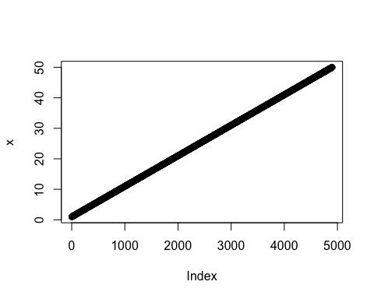
plot(x, sin(x), typ = "l", col = "purple", lwd = 3, xlab = "WHAT")
