Part 1 - design specification

**Agree on the content for the web site**

Final Answer:

1. Homepage

* Formula 1 City, with welcome words and sentence when visitor visits website
* Teasers of all attractions and events > Linking to attraction page
* Overview of all information and services > Linking to Information and Services Page
* Social Media Links (Facebook, Instagram) and Contact Details (Address, email etc)

1. Attractions and Events

* Attraction 1 images and description: F1 Racing Simulator
* Attraction 2 images and description: Go Kart racing track
* Attraction 3 images and description: The Michael Schumacher experience
* Showing schedules and images of: Events

1. Information and Services

* Tickets for 1. Adults 2. Children 3. Family
* Facilities include things like restaurants and toilets and baby changing facilities etc.
* Local transport arrangements and Opening time information

**Agree on the structure of the web site**

HOMEPAGE:

* Pop-up: Important Information + Header: Theme Park name and logo
* Body:
* Theme park slideshow and map
* Attractions and Events
* Information and Services
* Footer: Social media and contacts

ATTRACTIONS:

* Pop-up: Important Information + Header: Theme Park name and logo
* Body:
* Attraction #1 / Attraction #2 / Attraction #3
* Events
* Footer: Social media and contacts

INFORMATION AND SERVICES:

* Pop-up: Important Information + Header: Theme Park name and logo
* Body:
* Booking and ticketing information
* Services / Facilities
* Footer: Social media and contacts

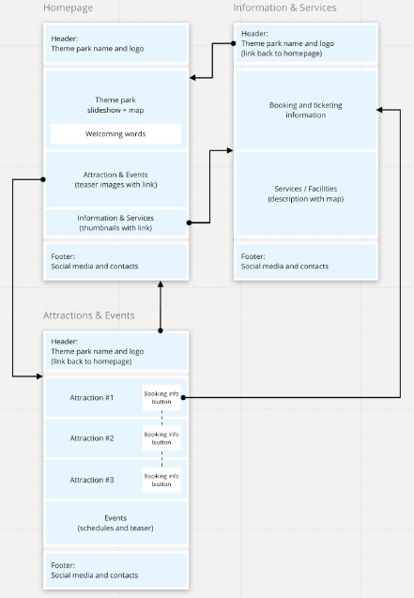

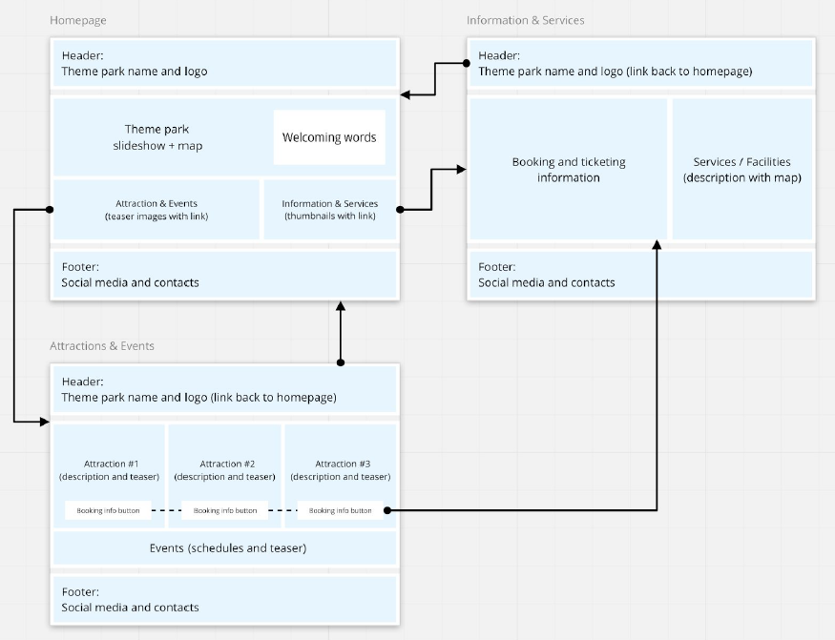

Part 2 – Markup and Code HTML

**Markup wireframes with HTML**

Review the three wireframes that you produced for the large screen version of your web site from part 1 of the team project and make any changes that you think would improve them. Work through the wireframes and decide on the correct HTML to build those pages. Think carefully about the use of layout tags such as tables, and only use them where content is really a table. Make sure that all the parts of the pages have a semantic identity, either by using existing semantic tags or by defining "div" tags for the content. Attempt to use a range of the various formatting tags available to add richness and extra meaning to your content. Consider how different media can add to the way that your pages communicate information.

Mark up your wireframes with the HTML tags that you intend to use. Upload these marked-up wireframes in a .zip file into the **Workspace: static web pages** that is located in**the end of** **week 10** and generate a shareable URL. Consider how your HTML supports the use of your pages by users with disabilities.

**Code HTML pages**

Code the three pages in HTML and enter in some essential text content that you write yourself. Name the main/first page of your web site: index.html. Ensure that you use comments to help all the coders to understand the code.

Find some pictures and any other media that you consider appropriate and embed them into the pages using the correct HTML tags. Ensure that your code includes comments to help you work with the code and quickly relate it to the wireframes. It could be helpful to include comments to indicate who contributed chunks of the code so that you can ensure you can work together as a team.

Marks will be awarded for the following:

* Appropriate semantic tags used, both the predefined tags and the appropriate use of div block tags.
* The range of different layout, formatting and media HTML tags used and their appropriate use (eg tables used as tables not for layout)
* Rich comments
* Accessibility, particularly in the use of the media tags. Tidy directory structure

Part 3 – Markup and Code Appearance CSS

**Markup wireframes with Appearance CSS**

Review the three wireframes that you produced for the large screen version of your web site from part 1 of the team project and add to them to ensure that they have the appearance that you wish your site to have. Ensure that you have agreed the colours that will be applied to the elements. Agree the font family or specific font that you will use for different parts of your site, and the colours that should be used.

Work through the wireframes and decide on the correct CSS to build those pages, and add classes and identities to the pages. Mark up your wireframes accordingly. Upload a .zip file of these new marked-up versions of the wireframes into the Workspace: static web pages in week 10.

**Set up and link stylesheet**

Code the CSS stylesheet with these appearance styling instructions and link them to the correct HTML elements using the class and id mechanism.

Marks will be awarded for the following:

* Applying Appearance Styling: Stylesheets
* Applying Appearance Styling - Styling Text
* Applying Appearance Styling - Font Families
* Applying Appearance Styling - HTML Object Colouring
* Applying Appearance Styling - Colour Definition

Part 4 – Markup and Code Layout CSS

**Markup wireframes with Layout CSS**

Review the three wireframes that you produced for the large screen version of your web site from the part 3 of the team project and add to them to ensure that they have the layout that you wish your site to have. In particular identify the HTML elements' absolute and relative positions taking the element enclosing hierarchy in your web site. Use the various ways of measuring elements on web pages as appropriate. Additionally, identify the boxes that enclose the HTML elements in your web site and consider the box properties (padding borders etc) that you want to define.

Work through the wireframes and decide on the correct CSS to build those pages, and check the class and identity properties of the elements in the pages. Mark up your wireframes accordingly. Upload these new marked-up versions of the wireframes a .zip file into the Workspace: static web pages in week 10.

**Set up and link stylesheet**

Code the CSS stylesheet with the layout styling instructions and link them to the correct HTML elements using the class and id mechanism.

Marks will be awarded for the following:

* Box Modelling Styling
* X, Y, Z of Styling
* Grids & Columns
* Media Styling
* Animation