The First International Forum on Makers and Education and

The Inauguration of Tsinghua Makers’ Day

第一届国际创客与教育论坛暨“清华创客日”启动活动

*“Innovative Educational Practices Shaping the Future of University”*

“创新教育实践塑造大学未来”

Tsinghua University, Beijing. Nov. 29, 2014

北京 清华大学 2014年11月29日

**Context: Tsinghua Makers’ Day**

Tsinghua University is embracing many technology-driven educational practices. We believe that Open Source Movement, Creative Commons-like content licensing protocols, and Internet of Things are already shaping the future of education in an accelerated fashion. Working with global educational innovators, we have implemented Massive Online Open Courses (MOOC), Flipped Classroom operations, Hackers in Residence Program, and student-run Hackathons. We consider these educational innovators as hackers and makers of future education. These people are capable of utilizing not only technologies, but also capable of addressing social needs and formulating pragmatic educational practices. As these Hackers/Makers continue to push the envelop of educational practices, we decided to mark the last Saturday of every November as Tsinghua Makers’ Day (创客日).

**论坛背景：清华创客日**

清华大学在教学实践中越来越多地采用前沿科技驱动的教学方法。我们相信，诸如开源运动、物联网、知识共享（Creative Commons）及其他各类内容版权协议等这些技术或方法，正以越来越快的速度改变着教育的未来。我们在同全球教育创新人士的合作下，已经将大规模开放在线课程、翻转课堂、驻校创客、学生自发组织的创客马拉松等学习活动或方法带到了校园。我们认为，这些教育创新者，如同未来教育的“创客”。这些人士不仅善用科技，还熟知如何应对社会需求，形成有效的、实用的教育实践方法。随着这些创客不断推进教育的发展，我们决定将每年十一月最后一个周六，定为“清华创客日”。

**International Forum: Kicking Off Tsinghua Makers’ Day**

To kickoff Makers’ Day, we have invited a number of international makers to participate in an open forum. This forum will enable participants to communicate and share information digitally and in a physical venue. The digital forum will be held at this URL: “http://toyhouse.cc”.

The physical forum will be held on campus at ROHM Building, Electronic Engineering Department of Tsinghua University.

**Topic: Innovative Educational Practices Shaping the Future of University**

We welcome all participants to share their ideas on the digital platform, and we will have many leading personalities in the maker community to respond to various voices.

The key sub-topics include, but not limited to:

* **What kind of technological and societal resources, and government policies can be recombined to produce positive impacts on education?**
* **Whether and how digital technologies and open source movements are going to affect the way we manage Learning Outcomes?**
* **How and what aspects of hacker/maker culture may have a stronger role in shaping the culture of universities and educational practices?**
* **Will hackathon and other similar activities change the way we conduct existing teaching practice?**
* **How to utilize fragmented human resource and make online interactions to help organize collaborative learning experience?**

**主题：创新教育实践塑造大学未来**

在本届论坛上，我们首先希望探讨创客运动是否会改变教育的未来。如果创客会对教育产生影响，为何这些影响需要持续下去，以及如何使其形成持续性发展。进一步我们希望讨论何时、多快，以及在怎样的特定条件下，这些改变会在未来教育实践中占据主导地位。我们欢迎所有论坛参与者首先通过数字论坛分享各自观点。我们会邀请创客界领先人士参与讨论，与各方观点进行交锋。

论坛主要议题包括，但不限于：

* 哪些技术资源、社会资源、政府政策等，可以通过重组，对教育产生积极影响？
* 数字化技术、开源运动是否会影响我们管理学习成效及效果的方式？将怎样影响？
* 创客文化将以何形式、在何方面，对未来大学文化的塑造及教育实践的开展产生更为重要的作用？
* 创客马拉松及其他相似的活动，是否会改变目前常见的教育实践方式？
* 如何利用碎片化的人力资源、通过互联网进行互动、开展协同学习？

**Time and Venue**

13:00 – 17:00, November 29, 2014

Multi-function Room 11-203, ROHM Building, Dept. Electronics Eng.

**时间及地点**

2014年11月29日，13:00-17:00

北京市清华大学罗姆楼（电子工程系）11层203多功能厅

**Host**

Office of Academic Affairs, Tsinghua University

**主办方**

清华大学教务处

**Co-Host**

Fundamental Industry Training Center

Department of Industrial Engineering

Academy of Art and Design

**承办方**

基础工业训练中心

清华大学工业工程系

清华大学美术学院

**Invited Keynote Speakers (Tentative)**

**Mitch Altman**, Founder of the Hackerspace Movement: ‘**Real Education Today, for the Future of All**’

**Luis Felipe**, Harvard Berkman Center, An anthropolist’s view of Hacker/Maker Community: ‘**Hacking as Transformative Experience**’

**Fan Xiang**, Professor of Arts: ‘**Peep at Art School through the Visualization**’

**Zhiyong Fu**, Maker Activities and Service Design: ‘**Creativity through maker experiences and design thinking**’

**Lin Zhang**, Professor of Electronics Engineering: ‘**What are we talking about when we are talking about innovation education?**’

**Luping Xu**, Founder of Open Fiesta

**Hao Wang**, Maker/Entrepreneur: ‘**Self Confidence is the Foundation of Innovation**’

**Benjamin Bacon**, NYU Shanghai Professor running Hackerspaces in Shanghai

**特邀演讲嘉宾（拟定）**

* **米奇·奥特曼**（Mitch Altman），创客空间运动发起人。演讲主题：Real Education Today, for the Future of All（当下真正的教育，为所有人的未来）
* **路易斯·费利佩**（Luis Felipe R. Murillo），哈佛大学伯克曼英特网与社会中心，人类学角度看创客文化。演讲主题：Hacking as Transformative Experience（创客作为一种变革的体验）
* **向帆**，清华大学美术学院教授。演讲主题：Peep at Art School through the Visualization
* **付志勇**，清华大学美术学院教授，创客活动与服务设计。演讲主题：Creativity through maker experiences and design thinking
* **张林**，清华大学电子工程系教授。演讲主题：What are we talking about when we are talking about innovation education?
* **徐芦平**，猫头鹰实验室创始人
* **王昊**，创新社AOI创始人之一，幻腾智能创始人之一，创客兼创业者。演讲主题：Self Confidence is the Foundation of Innovation

**Meeting in Person: Flipped Conference**

To ensure communication effectiveness on the first Makers’ Day, we cooked up a conference format called ‘Flipped Conference’, with 3 stages

* **Pre-meeting: Video-based online speech review**
* **Within-meeting: Topic-oriented question and answer**
* **Post-meeting: continued interaction with interest**

**创客面对面：翻转会议**

为了增强首届创客日上交流的有效性，我们设计了一种新的会议组织形式，“翻转会议”，包含三个阶段：

* **会前：基于视频的演讲内容在线讨论**
* **会中：围绕主题的问答环节**
* **会后：兴趣浓厚的持续互动**

**Input/output of Speakers/Challengers**

* Speakers: Name, photo, bio, title of presentation, one-line slogan, presentation slides, video abstract
* Challengers: Name, photo, bio, question

**演讲者/挑战者的输入/输出**

* 演讲者提供：姓名、照片、个人简介、演讲题目、演讲口号、幻灯片、视频摘要
* 挑战者提供：姓名、照片、个人简介、问题或观点

**Pre-forum Discussion: Open, with insight, digitally tracked**

|  |  |  |  |
| --- | --- | --- | --- |
| Time | Topic | Content | Venue |
| Nov. 21-26 | Breakout Discussion | Top Makers and Tsinghua Students meet-ups | Toyhouse Studio (Shunde Bld. 410) |
| Nov. 23-26 | Keynote Speeches | 5-min Keynote speech video abstracts are released and being commented. | http://toyhouse.cc (online) |
| Nov. 24-27 | Questions Review | 1-min Keynote questions will be reviewed | Toyhouse and online |
| Nov. 28 | Question release | 7 challengers are selected and final questions are released to the public | Online |
| Nov. 29 | Forum | Discussion will be compiled and demonstrated on Forum with more interaction | ROHM Bld. 11-203 |

**会前讨论：开放、深入探讨、数字记录**

|  |  |  |  |
| --- | --- | --- | --- |
| 时间 | 环节 | 内容 | 平台 |
| 11月21日-26日 | 分论坛 | 顶尖创客与清华学生主题研讨 | Toyhouse工作室  （清华舜德楼北410） |
| 11月23日-26日 | 主题演讲 | 主题演讲内容在线发布，讨论 | <http://toyhouse.cc>（在线平台） |
| 11月24日-27日 | 问题研讨 | 1分钟提问筛选 | Toyhouse及<http://toyhouse.cc> |
| 11月28日 | 问题发布 | 7位提问者及问题公布 | <http://toyhouse.cc> |
| 11月29日 | 现场论坛 | 会前讨论汇总并发布，现场延续讨论 | 罗姆楼11-203多功能厅 |

**Forum Agenda: Short, with insight, digitally tracked**

|  |  |  |  |  |
| --- | --- | --- | --- | --- |
| Time | Topic | Content | Venue 罗姆楼 | Note |
| 1300-1330 | Registration |  |  |  |
| 1330-1400 | Warm up | Theme video, report of 7-day discussion | 11-203 |  |
| 1400-1415 | Opening | Introduction, Tsinghua Makers’ Day Inauguration | 11-203 | Master of Conference: Ben Koo |
| 1415-1515 | Section 1 | (5 min talk + 3 min prepared Q&A + 2 * 3 min impromptu Q) * 3 | 11-203 | Each talk includes a keynote speech and a prepared question |
| 1515-1530 | Tea break | Free discussion | Lobby + 11-203 |  |
| 1530-1630 | Section 2 | (5 min talk + 3 min prepared Q&A + 2 * 3 min impromptu Q) * 4 | 11-203 | Each talk includes a keynote speech and a prepared question |
| 1630-1645 | Interactive Section | 5 * 3 min impromptu Qs | 11-203 | WeChat Wall interaction |
| 1645-1700 | Closing | Conference executive report,  Closing talk | 11-203 | Mr. Song Shu-Qiang,  Ben Koo |

**会中讨论：简短、深入探讨、数字记录**

|  |  |  |  |  |
| --- | --- | --- | --- | --- |
| 时间 | 环节 | 内容 | 会场-罗姆楼 | 备注 |
| 1300-1330 | 注册 |  |  |  |
| 1330-1400 | 暖场 | 主题视频，7天会前研讨汇总报告 | 11-203 |  |
| 1400-1415 | 开场 | 论坛简介，清华创客日发布仪式 | 11-203 | 论坛主持：顾学雍老师 |
| 1415-1515 | 上半场 | 5分钟演讲+9分钟问答互动 | 11-203 | 每个演讲后挑战者提问 |
| 1515-1530 | 茶歇 | 自由讨论 | 11层大厅及11-203 |  |
| 1530-1630 | 下半场 | 5分钟演讲+9分钟问答互动 | 11-203 | 每个演讲后挑战者提问 |
| 1630-1645 | 互动 | 5个3分钟现场提问 | 11-203 | 结合微信墙互动 |
| 1645-1700 | 闭幕 | 论坛总结报告，闭幕总结 | 11-203 | 宋述强老师、顾学雍老师 |

**Stage logistics: Dynamic Roundtable**

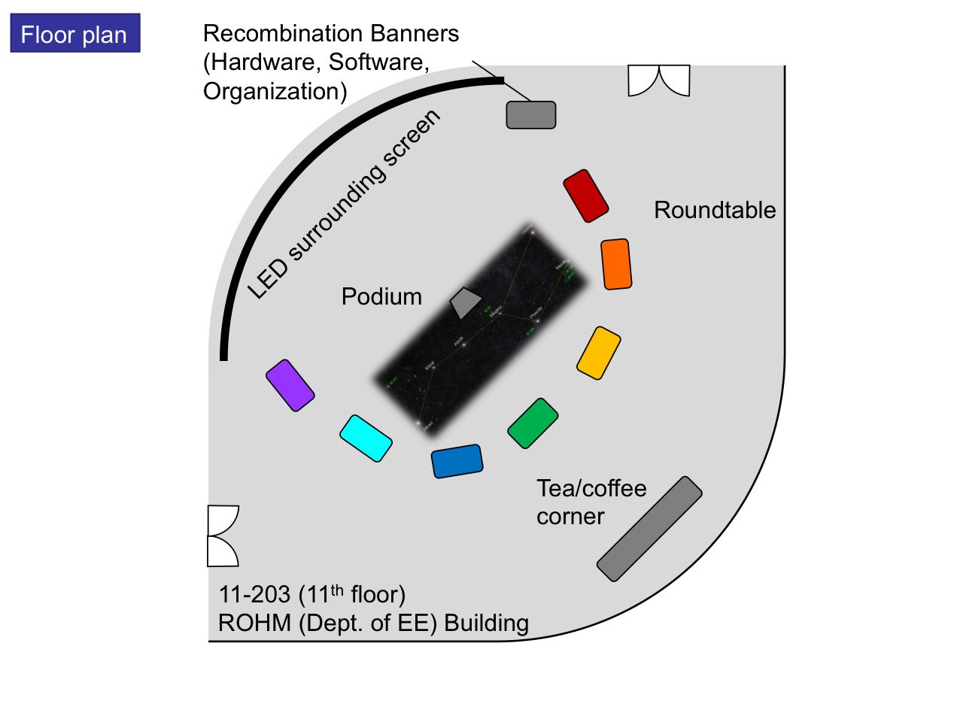

Venue floor plan

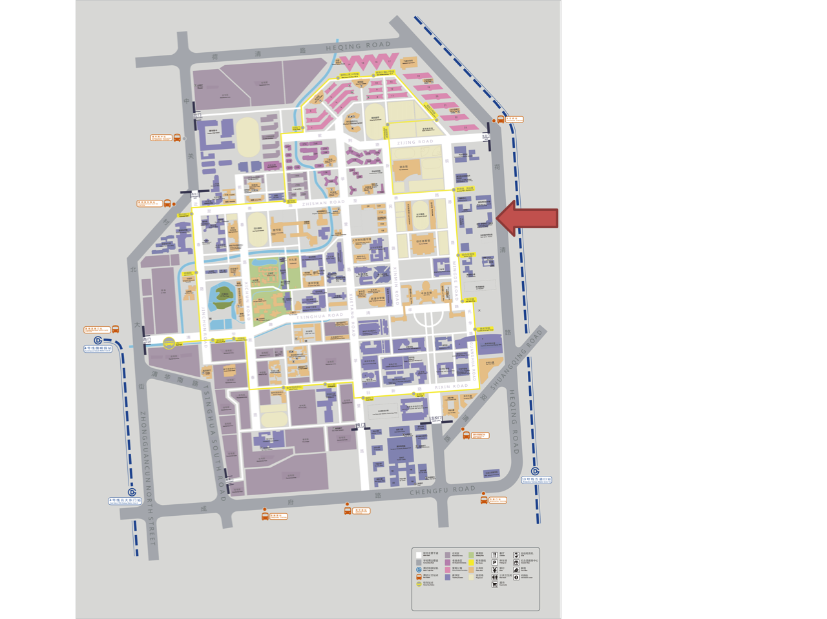

Campus map and venue location (电子工程系罗姆楼)