**­­­­Extreme Learning Process (XLP):**

**An Engineering Approach to “Education For All”**

*“After seeing [that] the students with low test scores can sometimes be the most productive contributors in XLP-enabled learning process, I realized XLP presents many opportunities for students to demonstrate their natural talents.”*

-Teacher from Tianjin Vocational College of Mechanics and Electricity

**Background**

In 1948, the United Nations unveiled it’s Universal Declaration of Human Rights, and committed UNESCO towards improving educational access for the world, among other important goals. In the last 60+ years, much progress has been made, most particularly in the last two decades. With technological progress and a more open culture of sharing resources, education is in a far superior place compared to 1948. However, continuing the incredible work of previous generations will require a radical shift in practice.

**Improving Education is an Engineering Challenge**

The 21st Century has brought numerous urgent problems to be solved. The twin issues of poverty and violence are sometimes exacerbated by social networking technology and new computing power. New issues, like climate change, stateless aggressors and government transparency, have entered our consciousness. Entire industries are being reshaped, so much so that previously exemplary engineering programs are becoming obsolete. This has led to intense experimentation on new models of education, learning and adaptation, which has left some graduates equipped to create great value and solve problems in the 21st century, while ***others have fallen behind***. It has always been the goal of international educational cooperation to advance all students’ learning, and to provide a minimum standard in education that we all benefit from. As the 21st century has brought new upheavals and new problems, our educational systems will need to lay a new level of operational capability that empowers students to be flexible, adaptive and creative in the face of a rapidly changing world.

To address the status quo of geographical and gender unbalance of education, we can use *Johari Window[1]* to describe it. The four quadrants of the window represent the information known to oneself or to other people within a group. If we see a country or a region as a group, we know that the lack of education and communication will incur that people not only know less about the world around them, but know less about themselves. The example of an African kid named William Kamkwamba just showed us how much the untapped potentials in these forgotten area can help change the world not where he lives in, but we share. It’s urgent for us to find a way that can bring together global wisdom for the global needs.

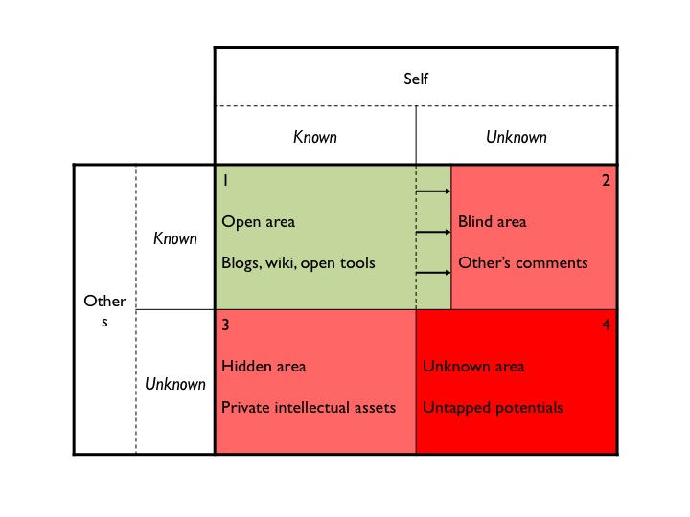

Diag. 1 What the society needs to gain from education

**Arising Opportunities for Open and Shared Crowd-Learning**

At the meantime, a lot of new tools have emerged that present opportunities for historically disadvantaged learners. Many of these new tools are open, free and accessible, in contrast to the closed, expensive and exclusive educational device of the past. Access to these resources mean educators can have big goals and ambitions even on a limited budget. However, these tools are still out of reach for some due to limited computing power, limited access to the Internet and obsolete learning models that aren’t delivering content in a way that’s relevant to learners.

If there is a solution to the problem of inadequate and inflexible education, globally, what does the solution look like? While there is glory in politics, military and economic professions, it has always been people with great technical literacy that equipped societies with engineered and pragmatic solutions. What skills and technical mind set will the 21st century citizens need to architect a sustainable society, and how does an institution provide those skills in a readily accessible way?

**XLP in a Nutshell**

XLP, Extreme Learning Process, is a methodology to design crowd-learning activities, where participants of different ages, backgrounds, and professions can recombine into teams and collaborate to achieve certain goals.

XLP defines a core functional digital publishing workflow, which grants each participant a digital identity, interconnects distributed wisdoms over large geographical scale, keeps track of individual and group learning, and converges the crowd learning outcomes.

Participants will work as digital natives and practice their collaborative learning skills, so as to obtain an increase of literacy in next-generation technologies, and to discover untapped potentials.

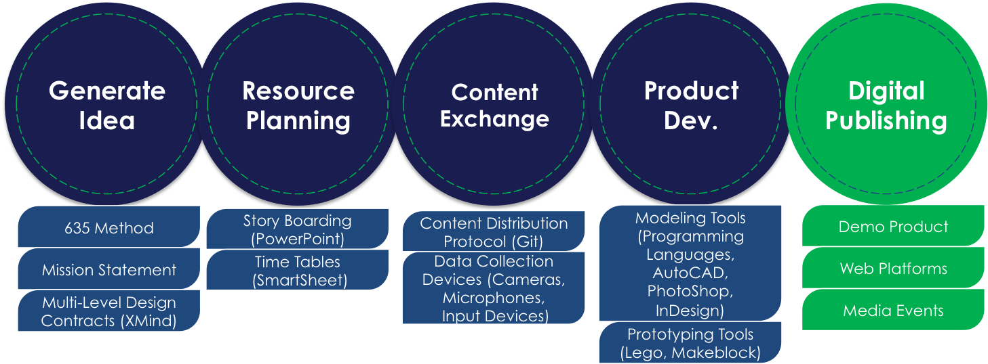

Diag. 2 Logic model of XLP, the five stages of digital publishing workflow

XLP adopts a peer-to-peer education model, where one groups of participants, the challenge designers, compose a set of comprehensive learning tasks with professional supports that they can find locally and globally with the help of internet. And then another groups of participants, the mission executors, will be challenged with the task set.

The digital publishing workflow in XLP corresponds to the idea of BlockChain University[2], which has completely transformed the concept of schooling. With a proper network connection, anyone can access global crowd learning activities and resources simply by entering the digital publishing workflow with his or her digital identity.

XLP creates a miniature society that provides context for new technologies to be used, by participants of all backgrounds, in a professional manner that simulates the real world. They perform within the context of four forces of society including an architecture of technologies, laws and rules, marketplace for trading, and cultural norms.

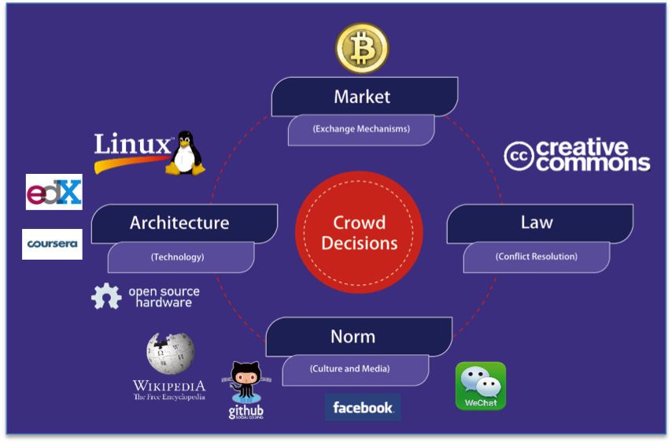

Diag. 3 Four forces in the miniature society of XLP

**Who Has Been Left Behind, And Why**

UNESCO has an especially ambitious goal in education, the foremost of which is Education for All, aiming to erase barriers to education that exist, in part, due to language, geography, family finances and gender. The education of women and girls remains a primary and complex mission. Not only do we know that including women in group-collaborations yields superior results, but the achievements of women scientist, engineers and inventors have empowered us all. The concept of frequency hopping is used in all Wi-Fi communications; this was co-patented by Austrian-American inventor Hedy Lamarr. Had she not invented this, it may have delayed the development of the Internet by decades. The empowerment of women must grow beyond the borders of the West, to the intersectional needs of this new century. What new inventions and fresh perspectives will the women of the world bring to the table of ideas? That is one of many questions that will drive the remainder of this century.

In addition to an unbalanced gender ratio, other factors limit educational access, such as family finances, language and geography. Technology and clever startup organizations have found quite a few fantastic solutions to these issues. As tablet computers get cheaper, they become more accessible, even in poor and rural areas. Companies like Facebook are pushing for larger populations of people to have access to the Internet, while some use tools like YouTube to deliver readily accessible how-to content. Internet institutions like TED and Wikipedia have translated their content into dozens of languages for greater international access. MIT began it’s Open Courseware Initiative over a decade ago, and many universities, including Tsinghua have become a full participating member of the “MOOC” movement. Through the edX alliance, Tsinghua University has started making video and audio lectures available online for free, producing an astounding array of free educational content. This includes a series of MOOC content explaining the XLP method and its practices.

**Free Online Knowledge Sharing: The Next Generation**

While older organizations refine and relaunch their content, new startups are producing nimble and effective tools for international learners. Some provide revolutionary language learning tools, such as Duolingo, so many more people can learn another language quickly, and accurately. This can be done at low cost-often no cost. One popular tool is Khan Academy, a free video series explaining mathematical concepts in a way that’s been extremely popular with learners. These two areas, language learning and mathematical proficiency, are proving critical for a truly global education. This type of dynamic, low-cost, and sometimes no-cost, user to user education model is transforming the lives of many historically underprivileged populations, and has exciting potential over the next decade.

XLP provides a flexible framework for each of these tools, and more, to be used in dynamic, project-based learning. There is a strong focus on content through digital publication, both in consuming new content needed to solve a problem, and producing content through a variety of platforms. Digital publication has become incredibly powerful, with resources like Instructables and BioCoder being made available for free. XLP has found exciting uses for Git, using GitHub and GitBooks to share user-created content to team members and more broadly online. This preserves innovative ideas in a way that makes it accessible to users engaged in problem-solving projects worldwide.

GitHub is moving in especially exciting directions, allowing users all around the world to share code. Curated projects exist for scientific research, open journalism, data visualization and more. An entire section exists for code that is “Made in Africa”, and has helped a community to form. This community of coders from African nations will be crucial in pushing greater educational access in Sub-Saharan Africa, a major and ambitious goal of UNESCO.

**Education for All Will Need Internet for All**

These resources are emerging at a historic moment in human history, with a massive percentage of the population between the ages of 16-24. The window on their formative education is rapidly closing. As these educational resources become open and accessible to more and more people, those learners and students see their futures as successful workers and responsible global citizens brighten dramatically. XLP gives them the foundation to apply these resources in a way that’s relevant to their education and their future.

Even five years ago, the concept of people who were economically disadvantaged affording a computer was absurd. Perhaps living on $10 USD a day, it was economically impossible to afford a $300 USD netbook, among the cheapest of options. However, manufacturing has caught up to demand, and today, some tablet computers are sold around the world for about $40 USD. A full feature computer, Raspberry Pi v2, in the form factor of a credit card, is available for $35 USD. In terms of software tools, Raspberry Pi has the options of running Linux or Windows operating system. Users can run full-featured office suite software and even complex engineering software like Mathematica, all free of charge. This dramatic drop in price means quality educational tools in the hands of those who were the least likely to get a quality education. While these computers might remain too highly priced for someone living in extreme poverty, global wages are rising and the prices of computers are falling at a very rapid pace.

These low-priced tablets run on the popular Android operating system; hundreds of the same applications enjoyed by those in wealthy countries are now available to an entirely new audience. An entire industry has developed around the niche market of apps aimed at enhancing primary education. As UNESCO gravely notes, access to primary education has been flat since 2008. With proper access, these apps that aid Western children in learning could jumpstart a new chapter in primary education in the developing world. By revolving around common content and interactivity, it encourages learners towards finding creative solutions by having a shared experience as global citizens from a young age.

One new format that can impact primary education is Blockchain University, which makes educational resources available regardless of age.

Of course, these computers won’t be very powerful tools without an Internet connection, and this is an area of intense development. A new organization, Internet.org, notes that the number of people in the world with Internet access is still a minority of people on Earth, and they want to change that. Composed of companies like Facebook, Qualcomm, Samsung, Nokia and Ericsson, they released a collaborative white paper in 2013. This paper identified two needed innovations: lower cost of Internet access in the developing world, and more efficient use of data for popular applications.

In 2014, Internet.org released their State of Connectivity report. Three reasons were identified for why people were not online. First and foremost, there was a lack of physical infrastructure in many developing countries, such as Ethiopia or Myanmar. Second was affordability, with the cost of access far too high. 68% of Sub-Saharan Africans live on about $2 USD per day. Thirdly, they noted that the content lacked relevance to potential users. Often, content is not available in the user’s native language, or the potential user does not know enough about Internet content to see relevance to their lives. All of these factors will need to be addressed for billions of new users to come online. If these issues can be resolved, there are incredible options for populations that experience consistently high dropout rates among students, with distance learning being especially exciting.

**Towards a Brighter, Cleaner, Inclusive Future**

The subjects of pollution, air and water quality, and climate change are never far from the subject of economic development. Excitingly, these resources and initiatives being pursued open the door to greener economic development over the next decade. While previous models focused on creating paper, physical, labor-intensive books, physical structures and massive energy uses, these new tools require dramatically less energy and resources.

If educational content can be delivered in an energy-efficient way, it creates the possibility for higher incomes and lower unemployment, while lowering pollution rates and reducing the consumption of limited resources. XLP encourages the efficient use of resources that creates a culture of sustainability, which meshes well with the goals of UNESCO, Internet.org and other organizations.

**What We Now Know About Learning**

Just as economics has shifted away from a study of money to a study of human behavior, so too must engineers strongly consider the flow of ideas through a society, not just the flow of particles, materials and goods. We know that small group collaboration benefits from each member bringing a unique skillset and world view. Celebrating this individual diversity has grown far beyond political correctness, as it gives tangible benefits to creating new solutions to perplexing challenges. We also know that social intelligence is mandatory for a group to successfully innovate, and that a balanced group gender ratio produces tangible benefits. Making engineering education accessible to women and girls is not just the right thing to do, but can help groups make better design decisions in solving complex problems.

This study of idea flow and gender diversity has been validated in the research done by Dr. Alex Pentland of MIT. In his book, “Social Physics”, he lays out the conclusions from many hundreds of gigabytes of social data: We must have a diversity of ideas and a balanced gender ratio in a group to achieve that group’s maximum potential for finding intelligent solutions. The 21st century thus demands a more inclusive and intersectional empowerment of women and girls.

Dr. Pentland builds on the foundation of social science laid out by David Logan in his theory of tribal group decision-making and leadership, by John Hunter in his remarkable research using his “World Peace Game”, and by psychologists Harry Harlow and Edward Deci in their separate research on human motivation. Each of these researchers contributed greatly to the effort of spreading peace around the world, by proving how possible it can be to work together and collaborate with others in a meaningful and sustainable way.

With one obstacle for accessible education being an unacceptably high school dropout rate, we can no longer ignore these sociological research findings. At it’s best, XLP takes this data into account, and is able to raise the level of discourse among students in accordance with Mr. Logan’s research. His area of interest, tribal leadership, is readily present in XLP, introducing students to new ideas that shift their worldview for the better.

John Hunter is an educator who has been experimenting with a system he calls the “World Peace Game”, based on the World Game system proposed by Buckminster Fuller in 1961. This model involves setting up learners in a sandbox of role play and stand-ins for societal infrastructure like governments, law and markets. XLP simulates students building a new society of their very own, giving them incredible skills that Mr. Hunter masterfully demonstrates as necessary for a great 21st century. This type of collaboration encourages not only excellent design, but demonstrates the many benefits of peaceful cooperation.

In letting students direct their own projects, XLP defers to the wisdom of what we know of human motivation beyond profit, in accordance with Mr. Harlow and Mr. Deci. Their research stresses that access to autonomy in education and work are crucial for long-term engagement. XLP students quickly learn what they love doing and how they can benefit those around them, even in a complex, rapidly-changing environment.

Thus far, over 1000 students have benefitted from being taken out of traditional academic studies, going through the gauntlet of XLP orientation, conducting their self-directed experimentation, research, collaboration and invention, and reintegrating into academia and the society at large with a fresh perspective. This process has yielded some truly innovative design, with completed projects going far beyond reproducing the work of other engineers, but providing original, inventive solutions to real world problems that hadn’t yet been produced. This is a crucial set of skills in a global labor market that is constantly evolving.

As the world changes, new challenges face us in amorphous forms that are agnostic to specific disciplines. Often, we are called to solve these problems with a truly small and dwindling amount of financial, human and physical resources. Meanwhile, there are an extraordinary amount of resources made available by the Internet; as well, a dizzying array of startups and initiatives. Most of these startups and initiatives are kicked-off by inter-disciplinary teams, and these teams are usually not organized by traditional academic departments organized by one specific set of technical disciplines.

Some traditional universities have tried to integrate these disciplinary programs and Internet-based technologies, with varying levels of success. As UNESCO has noted, this is not always done in a way that’s relevant to what students want to do after graduation. Education has still more to learn from social sciences, in terms of how students learn efficiently, what constitutes as relevant content, what motivates us and how students can stay adaptable to a changing world well after graduation.

**What Makes XLP So Extreme**

XLP was first developed by Prof. Ben Koo of Tsinghua University as a way to rapidly prepare Chinese students for the demands of the massive change the nation has experienced over the past 30 years. While Chinese students benefitting from a truly rigorous, and intensive educational regimen, Prof. Koo noticed a tendency for Chinese students to lack the creative problem-solving mindset that more commonly arises from American and European students. For the Chinese economy to complete its pivot to a more capitalist economy, an eye for design and innovation was necessary for engineers.

Every year the Internet operates, it enables creative designers to create new tools that are slowly becoming more and more accessible to non-technical global citizens. It becomes clear to all educators that these tools need to be integrated into student’s educational diet. However, simply grafting them onto a learning model that is hundreds of years old often doesn’t result in relevant content for the student. An entire new system needs to be developed from the ground up, an environment that a broad variety of bleeding edge technologies can be introduced into. Without this system in place, educators will struggle to integrate new tools into a student’s learning. XLP aims to be that system, and has had exciting results with thousands of students.

To be truly effective, this system needed to be designed from the start to involve all types of learners from every discipline. Technology literacy is vital for everyone, from artists to engineers to educators to journalists.

XLP begins with an orientation that forces students to develop skills to explore, collaborate and self-direct their learning. The beginning of this orientation is an early success. Students are given a mild challenge, designed to promote basic team building and build student confidence.

The second stage of the orientation provides a sharp contrast, challenging the students’ confidence in their skills. Much innovation involves productive failure, and the intent of this stage of XLP is to cause students to experience that failure early, in a safe environment. They are given a very complex task so that students must reach for collaboration, efficient communication and effective inter-personal skills.

In the third stage, students mature from what they’ve learned. They have confidence in their skills, but have a deeper respect for the need to collaborate. Separated into teams, they form a miniature society, complete with a legal and financial system. They must build the society that meets the needs of everyone, and to interact with it in a meaningful way. This goes beyond person-to-person negotiation, and teaches the reality of team-to-team, business-to-business and country-to-country communication and negotiation, which can be far more complex, aggravating and ultimately, more fruitful. Without this ability, 21st century engineers will not be able to address the interlocking problems that this century presents to them.

The final stage of XLP orientation is for student teams to demonstrate their work. Collaborating on building technology, they must present their collective accomplishments. This is the moment that all of their efforts and decisions are validated and it becomes evident what collaboration was truly effective and what was inappropriate.

This orientation is recursive, meaning that this process is repeated multiple times over the course of the semester and year, and hopefully, throughout the lifetime of these engineers. After orientation, students must choose their own project, and direct their own work with their new skills.

**Creating a New, Miniature World**

XLP creates a sandbox game environment for all of these bleeding edge tools to be dropped into and used successfully, just as they would in the real world. This environment is co-created with students, and creates a structure for how they adapt to the challenges presented.

This structure draws heavily from the philosophy advanced by Lawrence Lessig that law is only one of four fundamental forces in society, which also include architecture, market and cultural norms. XLP simulates these forces in our sandbox in the following ways.

*Law:* In the XLP sandbox, participants write their own constitutions and establish rules on copyright, lawsuits, personal liberties, and what happens when these rules are broken. Judges are appointed to mediate disputes. This infrastructure is necessary to regulate crowd behavior in a relevant way.

*Architecture:* XLP exists in real-world spaces, in rooms with walls and floors and chairs and desks, electronics, robotics, computers and wireless routers. XLP also extensively uses any available digital architecture, sharing code and documents via Github, and readily using online tools for research, language learning, data visualization, 3D modeling and more.

*Market:* XLP uses the crypto-currency Bitcoin to familiarize students with the new technology as well as establish market forces within the sandbox. All supplies are accessible through a capitalist model of distribution, and this model shapes how the challenges are faced and overcome.

*Cultural Norms:* XLP promotes group problem-solving and collaboration to unleash the maximum potential of each participant, promoting productive idea flow and the effective use of tools in a way that’s relevant to each participant’s learning process.

Using this system, learners are able to use collaborative tools and self directed educational resources in a complex environment that is much more similar to the real world than taking notes in a lecture or taking a multiple choice quiz. This prepares us all for industries that are becoming more connected, more automated and more disruptive.

This system has proved highly flexible and modular. Its been integrated into curriculum at primary education and secondary education levels, in high schools, universities and vocational schools. It has also been integrated into other new learning paradigms. One system, iPodia, enables students from universities across multiple continents to collaborate on projects and take courses concurrently. This includes students from Tsinghua University, The Indian Institute of Technology Bombay, Peking University, University of Southern California, Qatar University, Korea Advanced Institute of Science and Technology, National Taiwan University, Technion and Universidade de São Paulo in Brazil. It has proven highly effective and popular to have these students participate in iPodia/XLP hybrid systems.

**The Recombination of Social and Engineering Sciences**

Over the last few years, Tsinghua University has worked with many social enterprises to engineer a social network of learning organizations. On Saturday, November 26, 2014, Tsinghua University invites constitutional scholars, international organizers of hackerspaces, and heads of engineering training centers of 18 top Chinese universities to kick-off the announcement of Tsinghua’s Maker Day. Tsinghua’s Vice President and Provost, Yang Bin, pronounced that every last Saturday of November will be the official Maker/Hacker Day of Tsinghua University. On the same day, the same set of leaders started the inauguration of International Maker Education Alliance (IMEA). The first task for these community leaders is to write a constitution for the alliance, using the same techniques and tools that we organize XLP-based learning events. To be globally inclusive, IMEA invited UNESCO Chaired Professor on Cooperation between High Education and Industry, Prof. John Cha, to chair the meeting, and he also introduced the International Alliance of Vocational Education, as a participating organization with additional 81 vocation colleges, located in Germany, South Kora, Australia and China.

**Projects: Island Construction and Low Cost Atomic Force Microscope**

Here is where XLP is at it’s most exciting and innovative. This sandbox learning model can be used to meet a variety of challenges. Many challenges revolve around engineering solutions. One challenge was the hypothetical discovery of a new island, and inviting students to create a plan for how this resource should be utilized. Participants crafted a massive model of the island to showcase the portfolio of resources it represented and how these can best be developed in a way that benefits everyone.

In another XLP session, the challenge was to create an atomic-force microscope. For reference, this technology was unavailable to most of the physics and chemical revolutions of the 20th century, as it was only developed as recently as 1986. This XLP course was an 80 hour orientation, and engineering students had to quickly establish their Constitution and resulting sandbox society.

80 hours later, the students had built a completely functional atomic-force microscope, with resolution 1000 times beyond the optical diffraction limit. Educators were shocked to discover that this was developed on a budget far below that of commercially available systems. The model that the students developed in 80 hours of XLP proved simpler, cheaper and more accessible than decades of research by top engineers, scientists and billion dollar companies. Of course, it is only fair to note that these XLP students were not teenage college students barely starting their first year at university. They were teenagers still in high school.

XLP has been used dozens of times on projects well beyond that of engineering disciplines. Virtually any subject imaginable can be dropped into the sandbox students co-create, bleeding edge tools can be utilized, and educators can simply get out of the way while students create a dynamic learning environment and provocative results. This model is an opportunity to hook a creative engine to the powerful minds of all types of learners around the globe to provide relevant content to their education and produce unprecedented content of their own.

Case: XLP Family, making model solar system by 10-year-old kids

**Conclusion**

XLP will undoubtedly undergo iterative changes, as it becomes a more flexible framework. XLP can be applied to a broad range of educational areas, because it is designed to be content agnostic. XLP as a crowd-learning method, stimulates the crowd by instituting a generic, yet operational motivation mechanism using compatible digital networking technologies. XLP is new, because technologies and price points of supporting infrastructures and devices are just becoming available at a reasonable scale and maturity. As the Internet of Things continue to penetrate new territories and market places, XLP, and its digital publishing workflow, may not only serve the needs of international university students, but for every learner, in every country, of any age. By combining access to computing power, Internet access and physical tools like robotics components, all kinds of radical educational opportunities open up for learners that need them most.

We face immense challenges, not only at the university level, but across the other kinds of educational institutions. To succeed in making a true impact through education, a reliable, yet technically minded educational research/service institution must deliver results on an incredibly small and closing window of time to meet generational needs, and at times will operate on the slimmest of budgets. Since XLP will guide participants to draw on resources available to them in a distributed manner, the current conditions of the world make XLP the ideal framework to forge ahead and tackle our most ambitious goals.

At last, China’s National Academy of Engineers, and Tsinghua University, as the original investigator of this ground breaking educational methodology will be willing to host and financially sponsor this research and service institution on a permanent base with UNESCO’s blessing and adopt her global brand. We dearly hope that UNESCO would accept our application, and work with China’s National Academy of Engineering and Tsinghua University to make a significant wave of contributions to the global society.

**References**

UNESCO

http://unesdoc.unesco.org/images/0023/002312/231288e.pdf

Internet.org 2013 White Paper

<https://fbcdn-dragon-a.akamaihd.net/hphotos-ak-prn1/851575_520797877991079_393255490_n.pdf>

Internet.org: State of Connectivity 2014

<https://fbnewsroomus.files.wordpress.com/2015/02/state-of-connectivity1.pdf>

Github “Made in Africa” Projects

<https://github.com/showcases/made-in-africa>

The Four Forces, Lawrence Lessig

<http://cyber.law.harvard.edu/works/lessig/laws_cyberspace.pdf>

John Hunter and Sandbox Environments

<http://www.ted.com/talks/john_hunter_on_the_world_peace_game>

Buckminster Fuller and the World Game

<http://bfi.org/about-fuller/big-ideas/world-game>

David Logan and Higher Level Group Dynamics

<http://www.ted.com/talks/david_logan_on_tribal_leadership>

1. Johari window is a tool developed by two American psychologists to describe and understand self-awareness and peer awareness among groups of people.
2. BlockChain University uses BlockChain technology to record and verify all learning activities and performances in a distributed manner. The BlockChain records are also the foundation for learning assessment and evaluation.