|  |
| --- |
| Building Materials |
| Term Report |
| TiO2-based Building Materials |
| Student: Pan Shengjie  (2013011712 class S42)  2015/12/10 |
|  |
|  |

|  |
| --- |
|  |

**DEPARTMENT OF CIVIL ENGINEERING**

**TSINGHUA UNIVERSITY**

**TiO2-based Building Materials**

Panshengjie

(2013011712 class S42)

【**Abstract**】**:** **In 1972, photocatalytic property of TiO2 was observed. Then its application of cleaning and sterilization was used in building materials. Before that, TiO2 was just used as pigments and opacifier. Nowadays, TiO2 -based building materials were widely used for air cleaning, sterilization, self-cleaning, etc. Especially, in our country——China which has serious air pollution, there is a very bright prospect to combine TiO2 and massive building materials to degrade air pollutants. But some aspects of TiO2 based building materials such as improving the stability and enhancing photoactive performance of the materials need more future research.**

**【key words】:pollutants,** **TiO2-based Building Materials, photocatalysis.**

Nowadays, a serious problem that has been affecting some of the big cities in China is air pollution. More exactly, it is smog. According to an essay from South China Morning Post on November 5th 2014, smog caused by coal consumption has led to the death of 670,000 people in 2012. Smog in Beijing includes organics(40%), sulfate(17%), nitrate(14%), etc.[1]

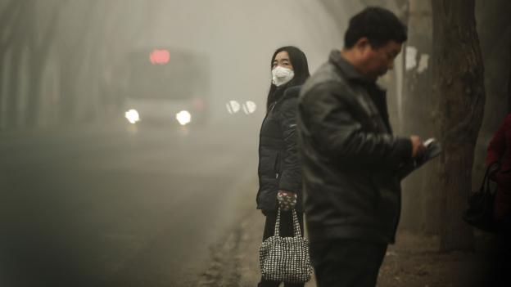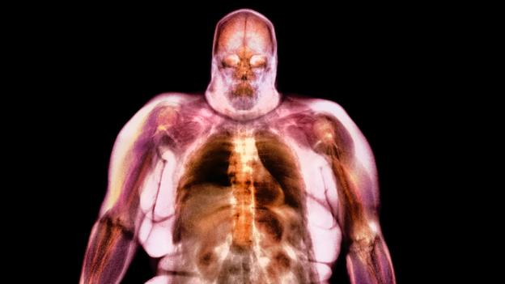

**From BBC: Tiny particles irritating the lungs may set off a cascade of reactions throughout the body, disrupting the hormones that control appetite (Credit: Science Photo Library)**

As a student in Tsinghua University, especially a student that has learned building materials, it is my duty to explore new building materials that benefit environment.

After all, there is a great deal of building materials to be consumed. If every part of building materials can improve a little quality of air, then the massive building materials will change the situation greatly. Luckily, when I read some paper about functional concrete, I found out that TiO2-based building materials are very effective when degrade air pollutants. Since the reason mentioned above, I will do a brief journals review about TiO2-based building materials (TBM). Then I will offer my opinions about deeper study.

**1 combination of TiO2 and building materials**

TiO2 is a kind of nontoxic, stable and inexpensive building materials. Because of its high refractive index (n = 2.7), Traditional TiO2-based building materials were used as opacifier in the 1910s. It was also used as pigment sometimes.[2]

But in 1972 Fujishima[3] found water can be split into H2 and O2 by TiO2,and then many photoactive propertiesof TiO2 (such as photocatalysis, photoinduced superhydrophilicity, and ultraviolet radiation absorption) were further observed. After that, many researchers tried to combine TiO2 with building materials by mixing or coating methods to get new TBMs with photoactive functions such as air cleaning, sterilization, self-cleaning, etc. These kinds of TBMs can be used in exterior construction, road construction. But we should be clear that TiO2 used for

TBMs is in the forms of nanoparticles or nanometer thin films which can obtain good photoactivity.

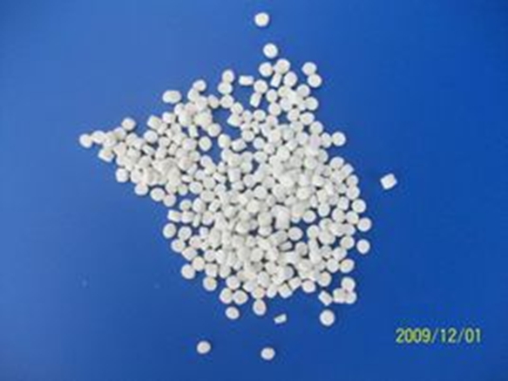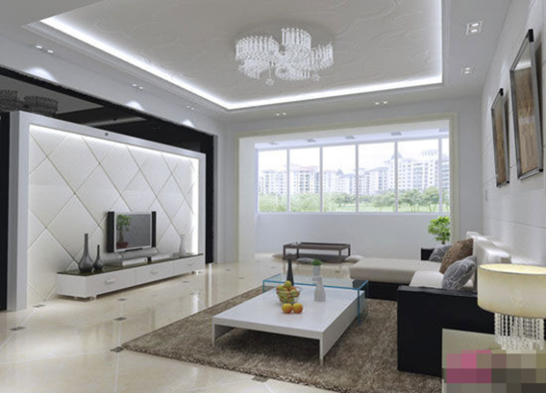

**2 Air-cleaning TBMs**

TiO2 photocatalytic process is an efficient way to photodegrade air pollutants, since it can decompose many kinds of air pollutants at relative low concentrations, like hydrocarbons(aldehyde), halogenated compounds, nitrogen-containing compounds, sulfur-containing compounds, and inorganic compounds, etc. There are more than 2000 companies in the worldwide that manage photocatalysis cleaning.

Some experiments can prove the effect of TBM. Maggos used TiO2-containing photocatalytic paint in a closed artificial parking area to degrade the concentration of NO and NO2, and achieved the degradation of 19 and 20%, respectively[4]. Salthammer used TiO2-indoor wall paints in a 1 m3 chamber to degrade formaldehyde from 1.2 mg/m3 influent to 0.4 mg/m3 effluent[5].

As I have mentioned above, the three main ingredients of smog are organic, sulfate and nitrate. They are also the air pollutants that can be decomposed by TiO2 photocatalytic process. Thus I suggest that TiO2 can be used to clear smog. Recently I plan to go to the lab to test its practicability.

In fact, a more practical way to use TiO2 is adsorption and decomposition of indoor air pollutants. Indoor air pollution is considered as a significant risk source for human health. Unluckily, people spend most of their life time in the indoor environment (WHO, 2010).

How do TBM deal with indoor and outdoor air pollutants? Take example for nitrogen oxides which is one of the criteria pollutants regulated by many countries. The photocatalytic oxidation reaction of NO using TiO2 in the ambient condition was usually suggested and the mechanism was proposed as: NO → HONO → NO2 → NO- 3.

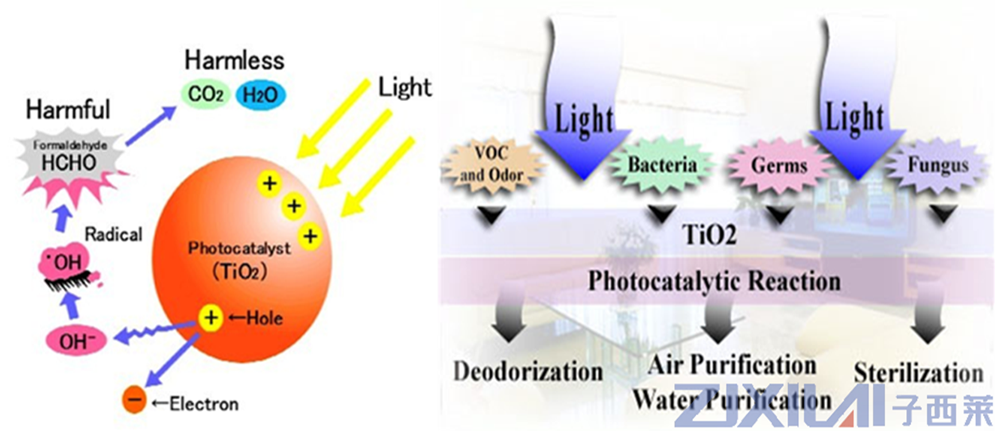

I think it is beneficial to adopt massive TBM because it is an unpowered air-cleaning system so that the system performs an enduring and automatic degradation of air pollutants.

**3 Sterilization TBMs**

Nowadays TiO2 photocatalysis is a suitable method for disinfection. It has excellent ability in sterilization. Even cancer cells can be completely deactivated by TiO2 photocatalysis.[6]

In 1985, Matsuyama found sterilization capability of TiO2. Several years later, the antibacterial ceramic tiles of floors and walls in several hospital operating rooms, which need strict sterile conditions, were coated with photoactive TiO2. And this kind of tiles started full-scale manufacturing. Is there any sterilization effect when TiO2 is mixed with building materials like tiles? Fujishima found that the bacterial counts on the walls decreased to negligible levels and the bacterial counts in the surrounding air also decreased significantly in 1h after installing antibacterial tiles.

What need to notice is that only under the condition of ultraviolet light can TBM show good sterilization ability. Thus we can foresee that a typical indoor condition in which the ultraviolet light intensity is low requires longer reaction time to disinfect. As a result, enhancing the sterilization ability of TBM is a project that is worth to study.

Like air cleaning, it is more convenient to use sterilization TBMs outdoor. On the one hand, TiO2-based photocatalytic sterilization needs support from ultraviolet light; on the other hand TBM can maintain a persistent sterilization since the remains of microorganism decomposition will be washed by rainfall after sterilization.

**4 other TBMs**

Self-cleaning TBMs are the most common TBMs which are based on the photoinduced superhydrophilicity of TiO2.

Its main mechanism is formation of highly hydrophilic surface, on which a uniform water film covering the surface formed. The film soaks into the dirt and stain on the hydrophilic surface, so the stain can be washed off by water easily.[7] Furthermore, organic deposits can be degraded by the material. It is important that water film is thin enough so that material can form a dry surface quickly.

Nowadays self-cleaning TBMs include glass, tiles, fiber, metal and PVC, and are widely used in exterior walls, siding, boards, curtain walls, screen doors,etc.

There are other interesting and valuable TBMs like anti-fogging TBMs, Decoration TBMs, etc.

**5 Problems of TBMs application**

(i) Effective regeneration methods for inactive TBMs. TiO2 deactivation may

be caused by deposition of surface species, intermediates by-products or pollutants which are difficult to decompose. Actually, washing by rainfall is the only adoptable regeneration way for practical use of TBMs. A proper regeneration method is needed for the large-scale practical application of TBMs.

(ii) The properties of TBM would be changed by the addition of TiO2. As we know, organic compounds can be decomposed by TiO2 under ultraviolet radiation, but organic compounds are necessary for many building materials (such as organic paints). Thus, the durability, strength, sensitivity and ageing process of TBMs might be affected by photocatalytic TiO2.

**6 Future perspectives**

Now many researchers exert to improve the photoactive performances of TBMs and enhance the stability of TBMs. Many challenges exist in enhancing photoinduced activity of TiO2, or increasing spectral sensitivity of TiO2 to visible light. How to enhance the stability of the materials is one of the most important issues in the practical application of TBMs.[8]

Since its advantages, we can predict that TBMs have bright prospects. And there will be more study associating TBMs with smog in China. I believe our building materials will contribute to the improvement of environment.

1. 熊言林、刘顺江. 雾霾天气与化学. 化学教育 2013年第12期
2. Carp O, Huisman C L, Reller A. Photoinduced reactivity of titanium dioxide. Prog Solid State Ch, 2004, 32(1-2): 33―177
3. Fujishima A, Honda K. Electrochemical photolysis of water at a semiconductor electrode. Nature, 1972, 238: 37―38
4. Maggos T, Bartzis J G, Liakou M, et al. Photocatalytic degradation of NOx gases using TiO2-containing paint: A real scale study. J Hazard Mater, 2007, 146: 668―673
5. Salthammer T, Fuhrmann F. Photocatalytic surface reactions on indoor wall paint. Environ Sci Technol, 2007, 41(18): 6573―6578
6. Seo J W, Chung H, Kim M Y, et al. Development of water-soluble single-crystalline TiO2 nanoparticles for photocatalytic cancer-cell treatment. Small, 2007, 3(5): 850―853
7. GUO Sen, WU ZhongBiao , ZHAO WeiRong. TiO2-based building materials: Above and beyond traditional applications. Chinese Science Bulletin April 2009 vol. 54 no. 7 1137-1142.
8. GUO Sen, WU ZhongBiao , ZHAO WeiRong. TiO2-based building materials: Above and beyond traditional applications. Chinese Science Bulletin April 2009 vol. 54 no. 7 1137-1142.