清华大学i.Center驻校创客导师项目（Hackers in Residence at Tsinghua）

The purpose of the Hacker in Residence at Tsinghua University is to create unique technology projects and help students achieve creative success, by helping them develop their ideas and introduce them to great people in Beijing, and around the world, who can help them create their vision. This position is extremely new, having only recently been adopted by other universities such as Harvard and NYU, and now LinkedIn, SparkFun and other companies. By being a very early adopter of this program, Tsinghua can deliver the best possible opportunity to students, regardless of the unique project they want to create.

清华驻校创客导师计划，是由清华大学i.Center与全球创客空间运动发起人Mitch Altman共同发起的一个长效性高校创客合作机制。该机制旨在建立一个有效的方式，支持学生从事具有创造性的科技项目，并取得具有创新性的成果。通过该机制，清华在校学生在创立项目方面获得针对性的指导与帮助，并同来自全球的各个领域人才深度合作，拓展视野，碰撞思想。通过人才长期进驻来对学生提供指导的机制在全球范围都是十分新颖的。类似机制近期才在包括哈佛大学、纽约大学等在内的高校进行尝试，最近又在以领英（LinkedIn）、开源硬件巨头SparkFun为代表的企业开展。这一机制将进一步加强清华学生与国际前沿创客界的交流，支撑学校创意创新创业教育，为学生提供独特的机会，激发学生的潜能。

ZIMMER BARNES, CURRENT HACKER-IN-RESIDENCE FOR TSINGHUA UNIVERSITY

齐默巴恩斯（Zimmer Barnes），在任清华驻校创客导师简介

My name is Zimmer Barnes and I will be the hacker-in-residence for Tsinghua University full time for the Fall 2015/2016 semester. I've previously served as the Technology Officer for the New York Initiative, and as such appeared in the Emmy-nominated documentary, "Superheroes". I've created several technology prototypes, including completing a successful technology Kickstarter project. I've learned by making and doing, and I hope that my mistakes can be a good lesson to future engineers, inventors and entrepreneurs in creating their own projects! My current prototypes include a system for plants that help them to clean the air, a chewing gum that increases mental focus and memory and an app that can help with setting and achieving goals. I want to be available as a resource to any student who has a cool idea they want to become reality. Please get in touch with my by WeChat at fangx1a0l0ng or through email at [zimmerbarnes@QQ.com](mailto:zimmerbarnes@QQ.com).

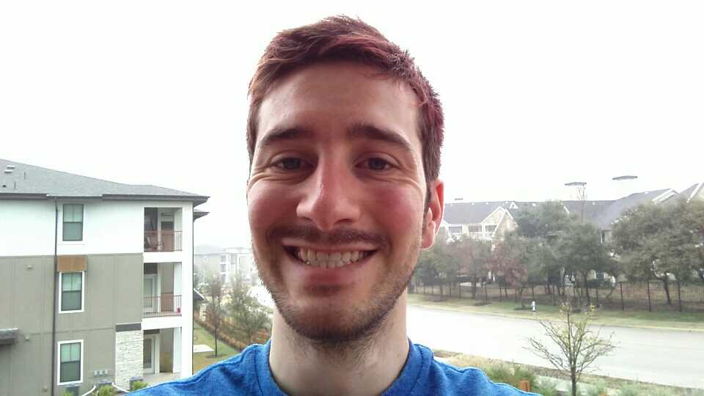

齐默巴恩斯，在任清华驻校创客导师，全职任期为2015-2016秋季学期（2015.9-2016.3）。齐默是前“纽约倡议”技术官员，并受邀拍摄艾美奖提名纪录片《超级英雄》。齐默从事多项技术创新作品和原型产品的开发，并成功在Kickstarter上完成了一项技术产品项目的众筹。齐默通过产品开发和制作积累了大量经验，并希望将过程中的经验分享给未来的工程师、产品设计师、开发者、发明家，以及创业家们，用以更加顺利地推进他们所从事的项目。齐默目前正在从事的项目包括一款植物水培空气清洗系统，一款促进注意力集中和提升记忆力的口香糖，以及一款帮助制定目标管理进度的移动应用。作为创客导师，齐默愿意与任何拥有奇特想法并寻求实现的同学，分享他的经验，并尽其所能提供相关资源，并作为国际创客社群的桥梁，吸引更多不同专长的人士成为清华驻校创客导师。

联系方式

电子邮箱：zimmerbarnes@qq.com

微信号：fangx1a0l0ng

HACKER TRIP TO CHINA

噪音桥创客空间创客中国行2015

On October 14th, Mitch Altman, an engineer, inventor and TED presenter, will arrive in Beijing, accompanied by many international makers from many different backgrounds. This entourage of makers are interested in meeting with Chinese engineers, makers, inventors, entrepreneurs, students, artists and more to learn, share and collaborate on exciting future projects. Please contact Tsinghua's Hacker-in-Residence, Zimmer Barnes, for details on meeting with the group!

国际创客空间运动发起人、美国噪音桥创客空间创始人、TED演讲人、知名工程师、发明家Mitch Altman将于2015年10月14日，率领来自六个国家或地区，具有不同技术背景的国际创客来到北京。同往年一样，创客一行将利用此次机会了解国内创客群体及相关资源，并同国内工程师、创客、发明家、创业者、学生、艺术家等各类人士进行交流，学习并分享各自经验，介绍作品和项目，寻求未来合作机会。届时清华大学将举办专场交流会，为清华学生提供难得的交流机会。敬请关注。