Contents

Concept 2

Structure 2

Functionality 3

Step 1 4

Step 2 4

Step 3 4

Step 4 4

Step 5 4

Step 6 4

Design Notes 4

Texts 5

Text 0 5

Text 1 5

Text 2 5

Text 3 5

Text 4 6

Text 5 6

Text 6 6

Text 6a 6

# Concept

Kronologispillet is a game designed for 3rd grade high school students and its purpose is to train their ability to understand historical chronology. The game has 6 steps each providing a different task to complete. Tasks include dragging graphic elements (representing periods of history) from a toolbox and into the game board. Here they can be placed in chronological order and resized to fit the historical duration of that period. The game also includes the historical timeline (found on the main webpage) allowing the user to browse through the historical events, pick them up and place them on the game board.

# Structure

For a structural overview of the game please refer to the Sitemap below. The game begins with an introduction page followed by the six steps (Trin 1-6).

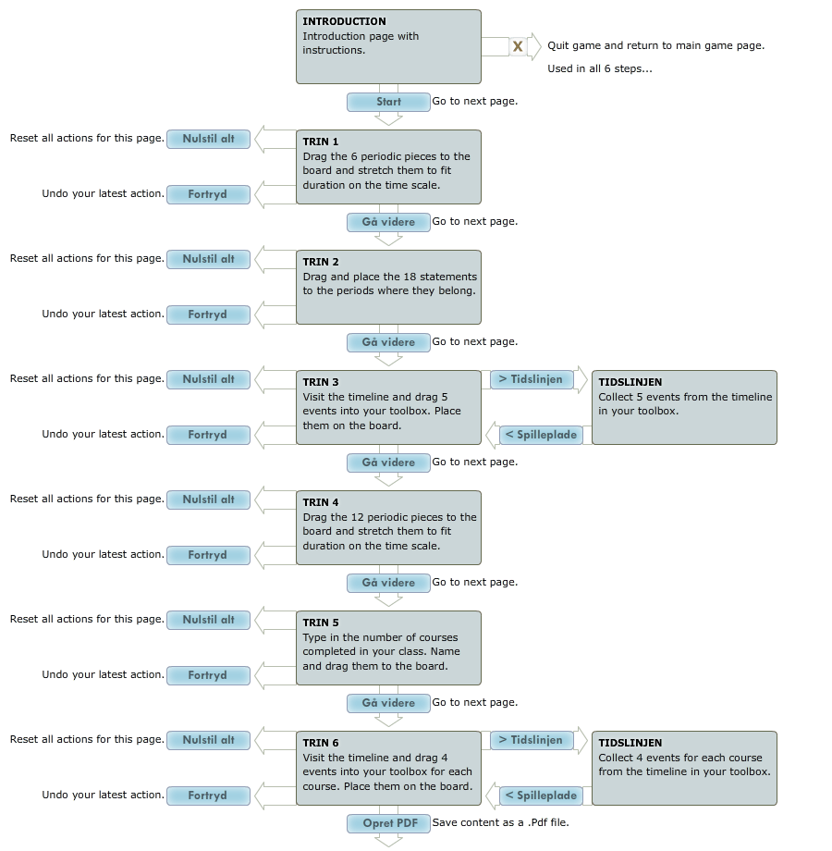

# Functionality

In this section I will try to describe which kind of functionality we would like with each of the steps in the game.

## Step 1

When Step 1 begins 6 graphic objects appear in random order in the toolbox. I have added these in the graphics folder for you (P_1_01-06A). I don't expect you to use them directly in the game since dynamic html objects would suit our needs better. Instead use them as examples and guidelines. In my design notes I will specify color, size etc. The idea is that the user can move and resize the objects. Once an object is moved inside an area where it can be placed (dropfieldKRO_1) a shadow effect will indicate which position it will snap to when you release it. Once an object has snapped in position the length will be fixed to 326 pixels to fit the drop area. Height can be resized by the user and the object can still be moved up or down within the area. If an object is released outside the permitted area it will return to the toolbox. Like the _A pieces the _B pieces are meant as examples and guidelines. Note that the user is free to place the objects in any order he wants and that he can proceed with both a correct or failed result. The idea is that once the game has been completed the student will save his result and have his teacher review it.

## Step 2

When Step 2 begins 18 new objects appear in the toolbox and in random order. These are statements and the task in Step 2 is to place them on top of the 6 historical periods used in Step 1. The statements are to be used as they are (P1_01-06_text_1-3) and cannot be resized - only moved. Unlike the historical periods the statements don't snap into position when placed.

## Step 3

No objects appear in step 3 except the ones already placed on the game board. Instead the user must click the (btn_KROtidslinje) button to visit the general timeline. This will be a modified version of the timeline where any listed event can be dragged into the toolbox. When the user clicks the (btn_KROspilleplade) button he returns to the game board and the events placed in his toolbox are transferred to the game. The events can now be moved and placed on the game board in one of the 5 specified drop fields.

## Step 4

Step 4 is very similar to step 1, except there are two sets of objects to be placed. When Step 4 begins the total of 13 objects appear in the toolbox in random order - mixed. Drag and drop the objects to the specified drop fields. Note that any object from set 2 (P_2_01-08) placed outside (dropfieldKRO_2) will return to the toolbox as will objects from set 3 placed outside (dropfieldKRO_3).

## Step 5

Step 5 is a little different from the other steps. In a text field (textformKRO) the user must type in a number between 1 and 10 representing the number of historical courses he has participated in during a semester. Based on the user input the game will generate a number of graphic elements in the toolbox - similar to the historical periods of Step 1. Design examples are (P4_01_A) and (P4_01_B). When generated the objects will appear with the text ">Angiv titel<" allowing the user to rename them. Once renamed the generated objects can be placed on the game board and resized according to their duration in time. Similar to Step 1.

## Step 6

Step 6 is similar to Step 3 except that the user can bring back 4 events for each object generated in Step 5. Like with Step 3 the events are transferred from the timeline to the game board and can be placed on top of the generated objects in (dropfieldKRO_4). When the user returns to the game board the (btn_KROpdf) button will become active allowing him to save a copy of his results as a .Pdf file.

# Design Notes

In this section I will provide the details for the dynamic graphic objects in the game.

## Step 1: Historical Period Objects

Base color: #BBCECC

Effects: Inner glow 5 px #3D362E

Border: 0.1 px #666666

Text: Verdana, Bold, Size 10, #000000, glow #FFFFFF

Note: Please add (reziseMARK_01) in the lower right corner.

## Step 4: Stylistic Period Objects

Base color: #C9CC9F

Effects: Inner glow 5 px #3D362E

Border: 0.1 px #666666

Text: Verdana, Bold, Size 10, #000000, glow #FFFFFF

Note: Please add (reziseMARK_02) in the lower right corner.

## Step 4: Government Period Objects

Base color: #DBC886

Effects: Inner glow 5 px #3D362E

Border: 0.1 px #666666

Text: Verdana, Bold, Size 10, #000000, glow #FFFFFF

Note: Please add (reziseMARK_03) in the lower right corner.

## Step 5: User Generated Objects

Base color: #B3AF8C

Effects: Inner glow 5 px #3D362E

Border: 0.1 px #666666

Text: Verdana, Bold, Size 10, #000000, glow #FFFFFF

Note: Please add (reziseMARK_04) in the lower right corner.

# Texts

Each page of the game has a text window (textKRO_0 to 6 and 6a) with the following texts. The text 6a is displayed once the user has completed the final task.

## Text 0

Heading 0 (Verdana, Bold, Size 10, #000000)

KRONOLOGISPILLET, SÅDAN GØR DU!

Body 0 (Verdana, Bold, Size 11, #000000)

Kronologispillet består af seks trin, hvor du skal arbejde med periodisering. I starten af hvert trin får du en række elementer til rådighed. Elementerne finder du i værktøjskassen herunder.Øvelserne går ud på at du skal flytte elementer ud på spillepladen, placere dem korrekt og i visse tilfælde ændre deres størrelse.Du skal placere elementerne i de angivne områder. Når et element nærmer sig en tilladt placering, vises en skygge, som fortæller, hvor elementer vil placere sig.Når du er igennem alle seks trin, kan du gemme dit resultat som .pdf og gennemgå den med din underviser.Du kan afslutte spillet undervejs ved at klikke "Afslut" i toppen af siden. Når du logger ind igen, kan du genoptage dit spil.

## Text 1

Heading 1 (Verdana, Bold, Size 10, #000000)

TRADITIONEL PERIODISERING

Body 1 (Verdana, Bold, Size 11, #000000)

Placer de 6 brikker i kronologisk rækkefølge til højre for tidslinjen og stræk brikkerne så de matcher periodens udstrækning i tid.

## Text 2

Heading 2 (Verdana, Bold, Size 10, #000000)

PERIODE BESKRIVELSE

Body 2 (Verdana, Bold, Size 11, #000000)

Fordel følgende tekster i de 6 perioder ved at trække dem over i den periode du mener de hører til.

## Text 3

Heading 3 (Verdana, Bold, Size 10, #000000)

HISTORISK UDVIKLING

Body 3 (Verdana, Bold, Size 11, #000000)

Besøg den historiske tidslinje ved at trykke "> Tidslinjen" og udvælg 5 begivenheder, som markerer overgange mellem de 6 perioder. Begivenheder vælges ved at trække dem over i værktøjskassen. Placer dem herefter på spillepladen.

## Text 4

Heading 4 (Verdana, Bold, Size 10, #000000)

STYREFORM OG STILART

Body 4 (Verdana, Bold, Size 11, #000000)

Herunder ses to alternative periodiseringer; stilistisk og styreform. Placer brikkerne i kolonnerne på venstre side af tidsskalaen og stræk brikkerne så de matcher periodernes udstrækning i tid.

## Text 5

Heading 5 (Verdana, Bold, Size 10, #000000)

STUDIEPLAN

Body 5 (Verdana, Bold, Size 11, #000000)

Angiv, hvor mange undervisnings-forløb I har været igennem på klassen. Oplysninger om under- visningsforløb findes i din studieplan. Navngiv brikkerne efter undervisningsforløb og placer dem på spillepladen i kronologisk rækkefølge.

## Text 6

Heading 6 (Verdana, Bold, Size 10, #000000)

BESKRIVELSE AF FORLØB

Body 6 (Verdana, Bold, Size 11, #000000)

Besøg den historiske tidslinje og udvælg 4 vigtige begivenheder for hvert undervisningsforløb ved attrække dem over i værktøjskassen.

Placer dem i det tilhørende undervisningsforløb på spillepladen.

## Text 6a

Heading 6a (Verdana, Bold, Size 10, #000000)

BESKRIVELSE AF FORLØB

Body 6a (Verdana, Bold, Size 11, #000000)

Når du har udvalgt og placeret begivenheder i klassens undervisningsforløb, kan du gemme dine resultater som en .pdf fil og udskrive dem.