TAXI APP

INTRODUCTION
An example of a technical tool being used to digitize transportation is a taxi booking app. The primary goal of cab booking applications was to make the processes simpler, and they have largely succeeded in doing so. The taxi booking apps' overall process structure is automated and demonstrates a basic management of resources across a range of operations. It is easier to run a taxi booking app than any other specialty for anyone with ideas for enterprise mobility because there are various responsible resources at each end and the tasks are process-oriented rather than dependent on global peers.
The only way to generate income when operating a taxi booking application is through rides. Your revenues rise in direct proportion to how frequently your drivers use the app to transport customers. Without a doubt, the taxi drivers who use the app are what drive the commuters and the company's revenue. They utilize the application's technological response and support to generate income. The drivers directly benefit from the application because they can rely on it to increase their income. Customers can get regular rides at low cost and even cash back.
Several platforms, including Android and iOS, can be used to develop mobile applications. IOS uses swift while Android uses Java or Kotlin. However, simultaneously developing an app for iOS and Android is challenging. Cross- platform languages are utilized to deal with this scenario; "React Native" is the most recent and effective one.
In the market for online mobility services, e-hailing is rapidly expanding. offers all functions for its users' convenience. Additionally, it offers options for gender filtering and real-time tracking.

In this project, react native will be used to create an android application for taxi services. Since "React native" is cross-platform software, the main goal of using it is to make the application available for both Android and iOS devices.

IMPLEMENTATION
For the purpose of creating login and registration pages, detailed coding is provided here. Laravel, React Native, and other platforms are very important.

DESIGN IMPLEMENTATION AND RESULTS
The actual live operation of the designed program is referred to as design implementation. The program modules are presented in this section along with descriptions of their functions and deployment options.

FEATURES:
- Map Optimization
- Recent version of react native
- New UI designs
- Fleet Management
- Background Services
- Car Pooling/ Ride Sharing option (We done powerful shared ride algorithm for you)
- Multiple stops (Customer can multiple destinations in single ride,

swap the destinations)
- Scheduled Booking - (Pick Later)
- Bird View / Live Tracking (Admin will see all the cab live locations from admin panel)
- SOS (Complete sos module integrated and we share customer live locations to sos contacts in emergency situations)
- Commercial module (Our app support both taxi and commercial module)
- Multiple trip types (Daily, Rental, Outstation - one way and rounded, Shared, Delivery)
- Multi Language and RTL
- Responsibility privilege module (You can create multiple roles from admin panel)
- Live Tracking (Live tracking polyline available and you enable and disable using admin panel)
- Driver Tip (Customer can pay tip for drivers at the end of the trip)
- Favorite Locations (Customer can mark favourite locations in map)
- Recent Locations (We suggest to customers past 5 locations)
- Vehicle Categories (You can add all the passenger and commercial vehicles from admin side)
- Promo codes (Fully customized promo code module like redemption, min and max value, assign to particular customer etc.)
- Booking cancellation (We integrated cancel option for both customer and driver app)
- Booking auto assign to driver
- Payment modes (Flutter wave, razor pay, pay stack, stripe)
- ETA (Estimated time arrival)
- Location search (Google location search for both pickup and drop locations)
- Chat (Customer to driver chat available)
- Admin chat (Customer to admin chat available)

- Rating (Rating module we integrated both customer and driver app)
- Real-time time drop locations (We maintained actual pickup, drop locations and final pickup, drop location)
- Push Notifications (Customers and drivers get booking status notifications)
- Driver recharges option from the driver app
- Driver KYC verification
- Driver tutorial and training module
- Dynamic fare management (you can change fare from admin panel anytime)
- Customer in-app wallet option
- Complaint module (Customer can register complaints using application)
- Invoice (Customer will get invoice through mail)
- Tax (You can add multiple taxes from admin panel)
- Auto payment mode selection (At the end of trip system will select payment mode automatically)
- Owner in-app vehicle live tracking option
- Zones - (You can draw zones from admin panel)
- Dispatch Module (Admin will create trip, view drivers live locations, view reports, cancel trips etc.
CUSTOMER APPLICATION

SPLASH SCREEN
For two to three seconds, the splash screen for the customer's Taxi2door application will be visible here. Here, your app name and logo will be displayed.

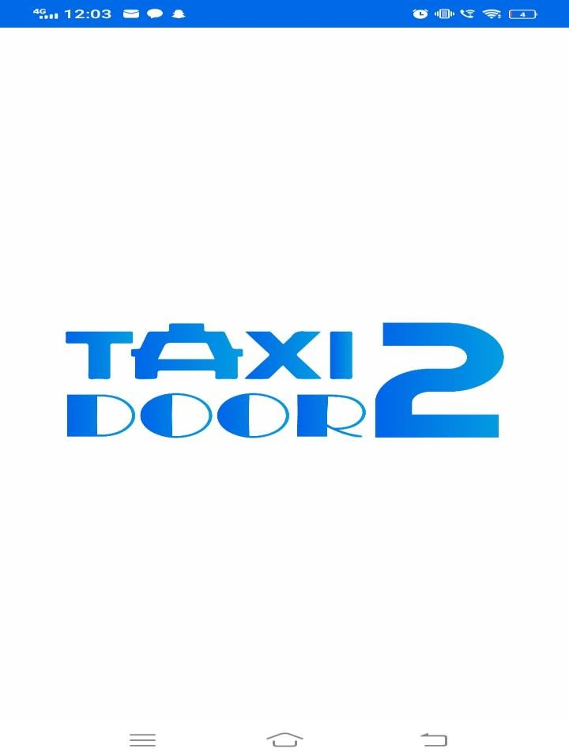

INTRODUCTORY SCREENS

Customer can see these introductory screens which gives introduction to the application, before getting in to the home screen.






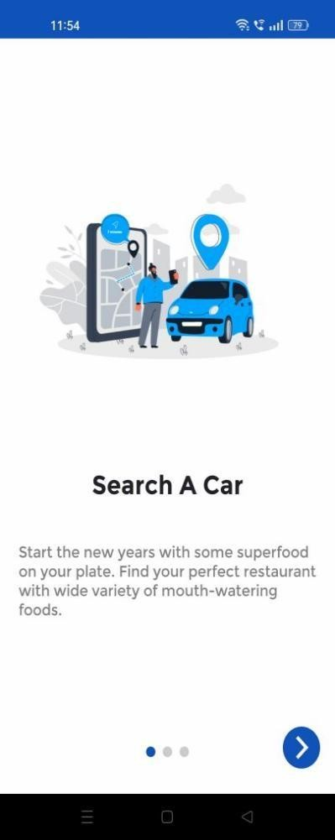
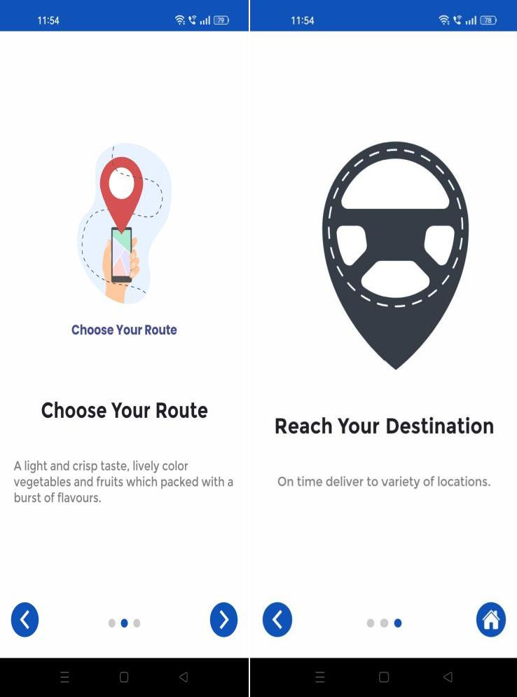

LOGIN

Existing users can access the app from this page by entering their login information, which includes their phone number and password. Additionally, this page has a feature that enables users to maintain their login status even after closing the application.

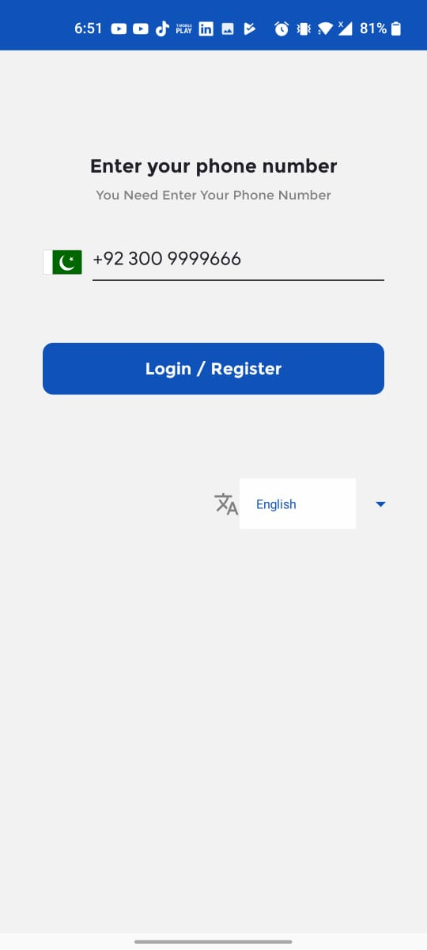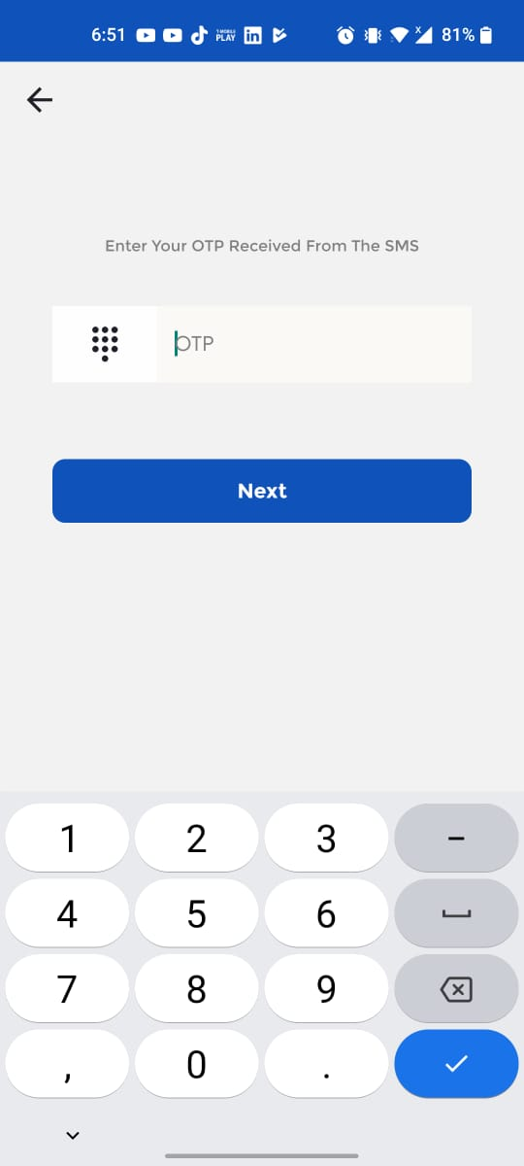

NEW USER REGISTER

You can enter your information in the user name, email, and password fields on the new user registration page.

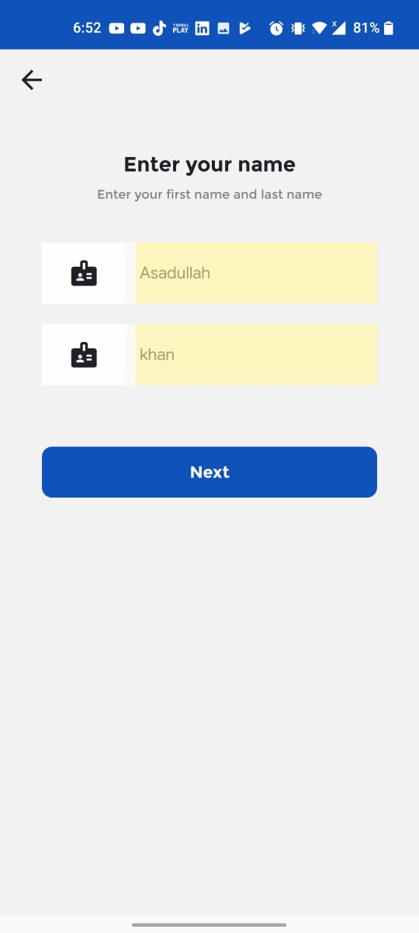

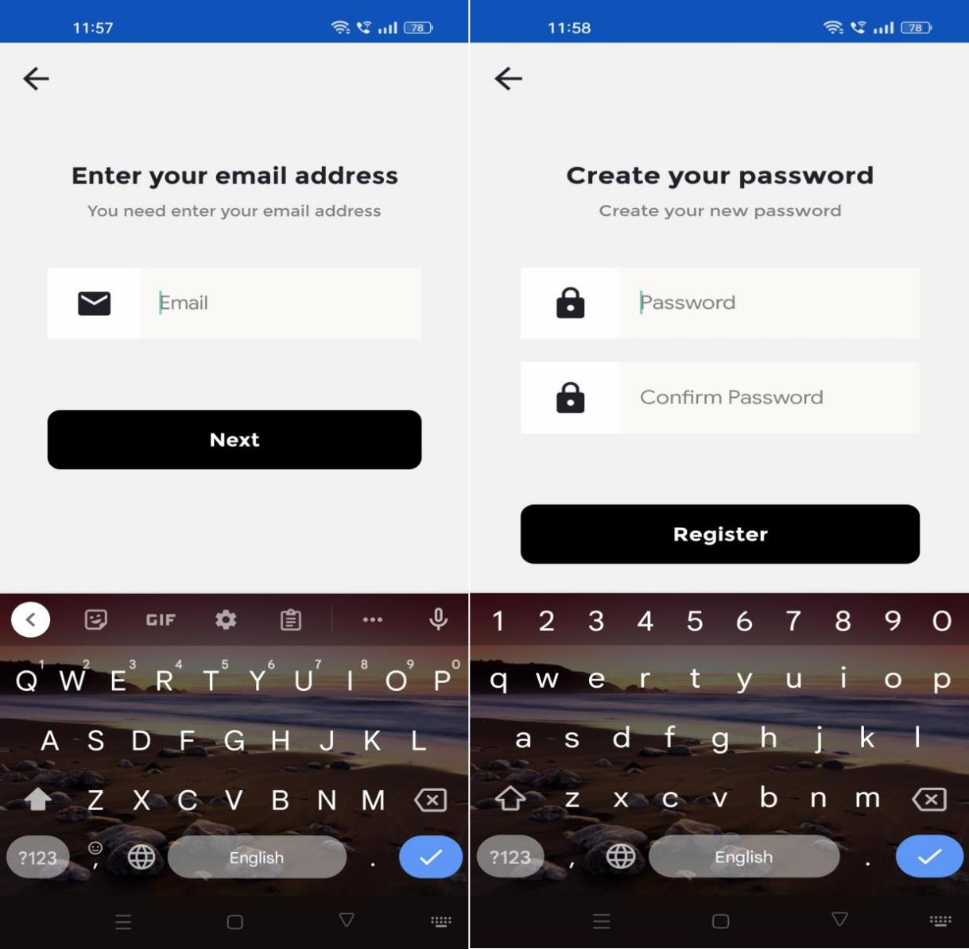

OTP
You can verify your OTP number on the app's OTP page. If you need to change your password at the same time, you must confirm the OTP that was sent to your registered phone number.






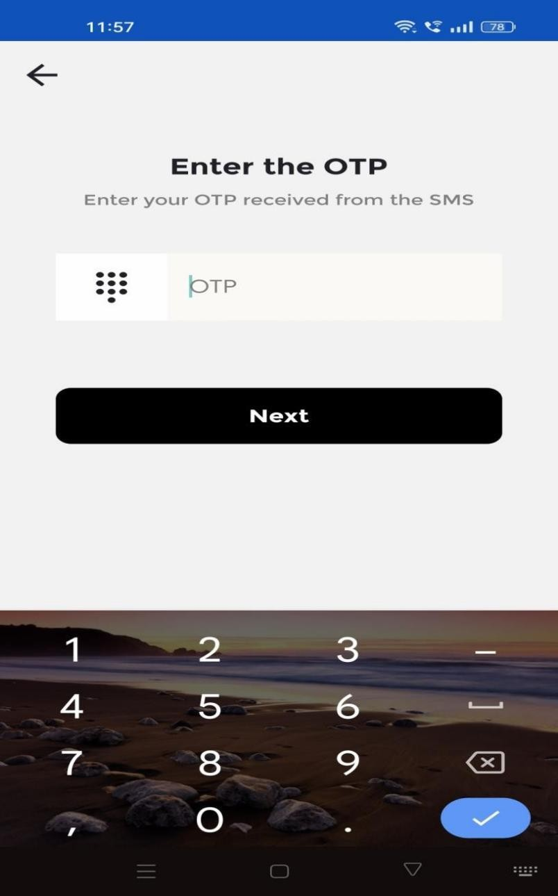

HOME:
The list of services offered by this app is displayed on this page. In this app can offer daily, rental, outstation, shared and delivery services. We offer the choice to modify the services via the admin panel.

The user can manually or dynamically add their pick-up and drop-off locations here. Additionally, we provided instant distance calculation in this application.






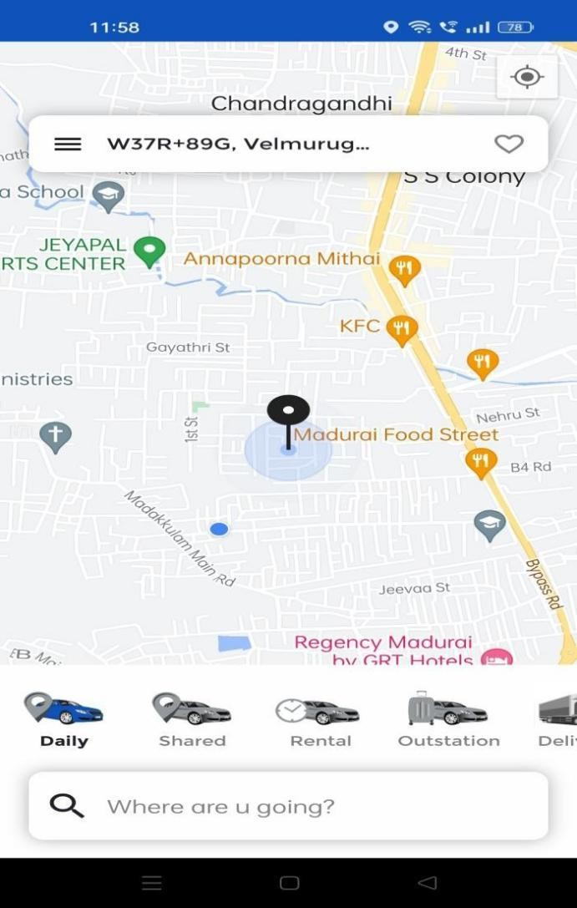

PICKUP AND DROP LOCATION BY SCROLLING OPTION
Here, the scrolling map is used to choose the pickup and drop-off locations based on customer simplification.






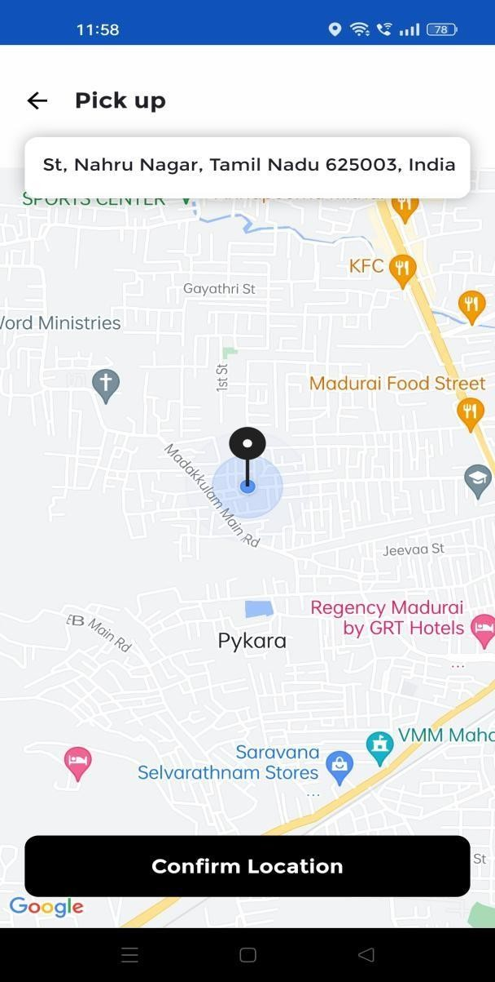
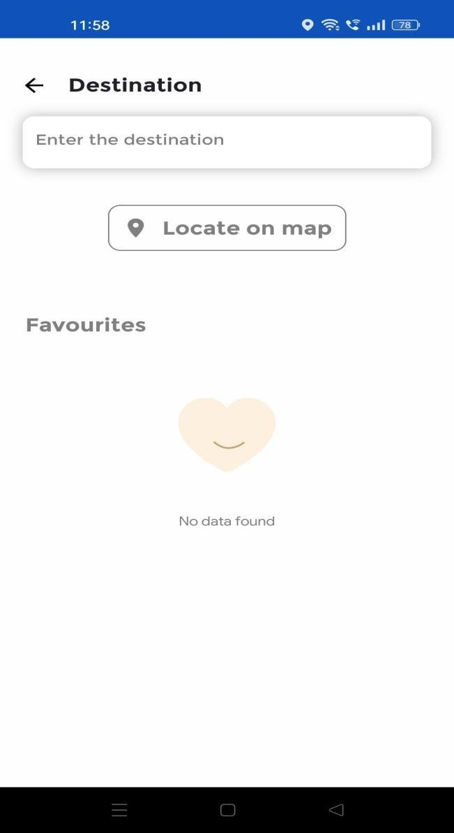

PICKUP AND DROP LOCATION SELECTING BY MANUAL OPTION
Here, the customer's c a n a b l e t o search is used to manually type the pickup anddrop-off location options.






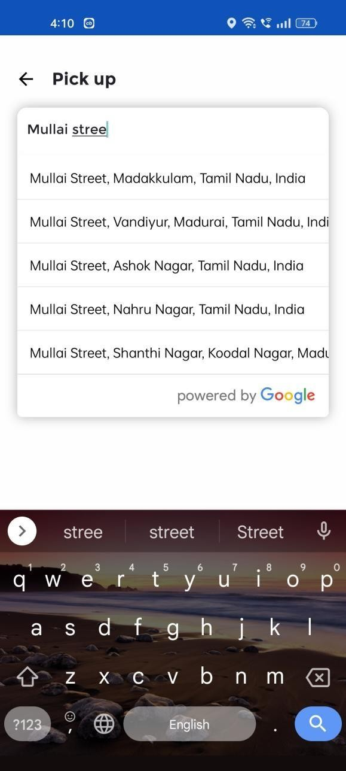
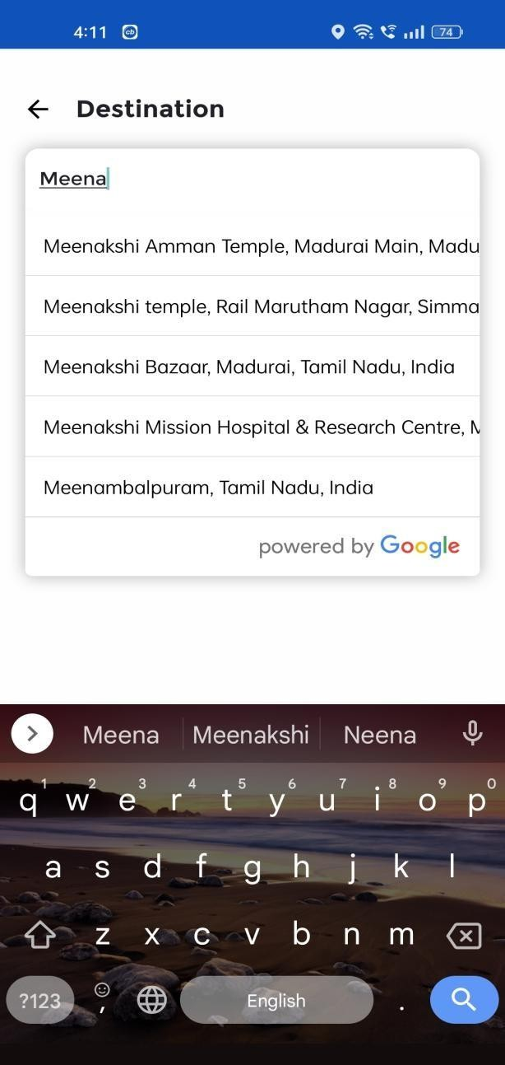

BOOKING RIDE
Below screens are shows customer booking request and process flow






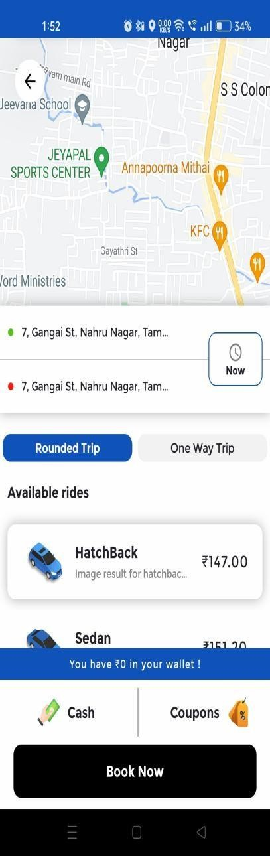
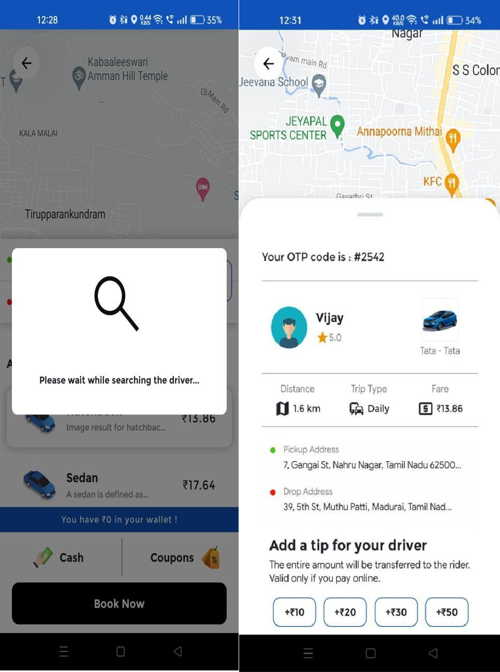

EMERGENCY INFORMATION
Riders can press the SOS button in the event of an emergency or other unfortunate circumstance. So, their emergency contact received an SOS alert with a live location.

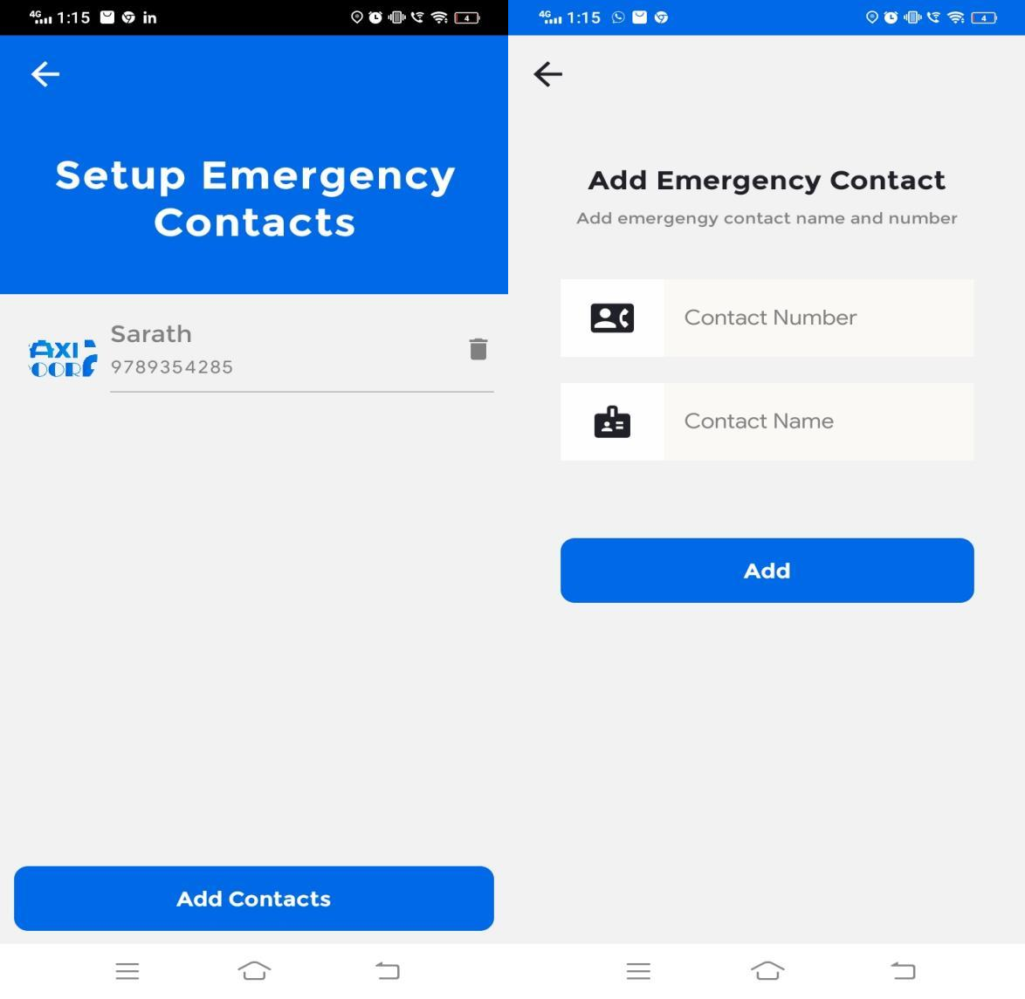

MY RIDES
Riders are given a detailed view of their previous journey. Riders can view the pick-up and drop-off locations, the date, and other information on the My Rides page.






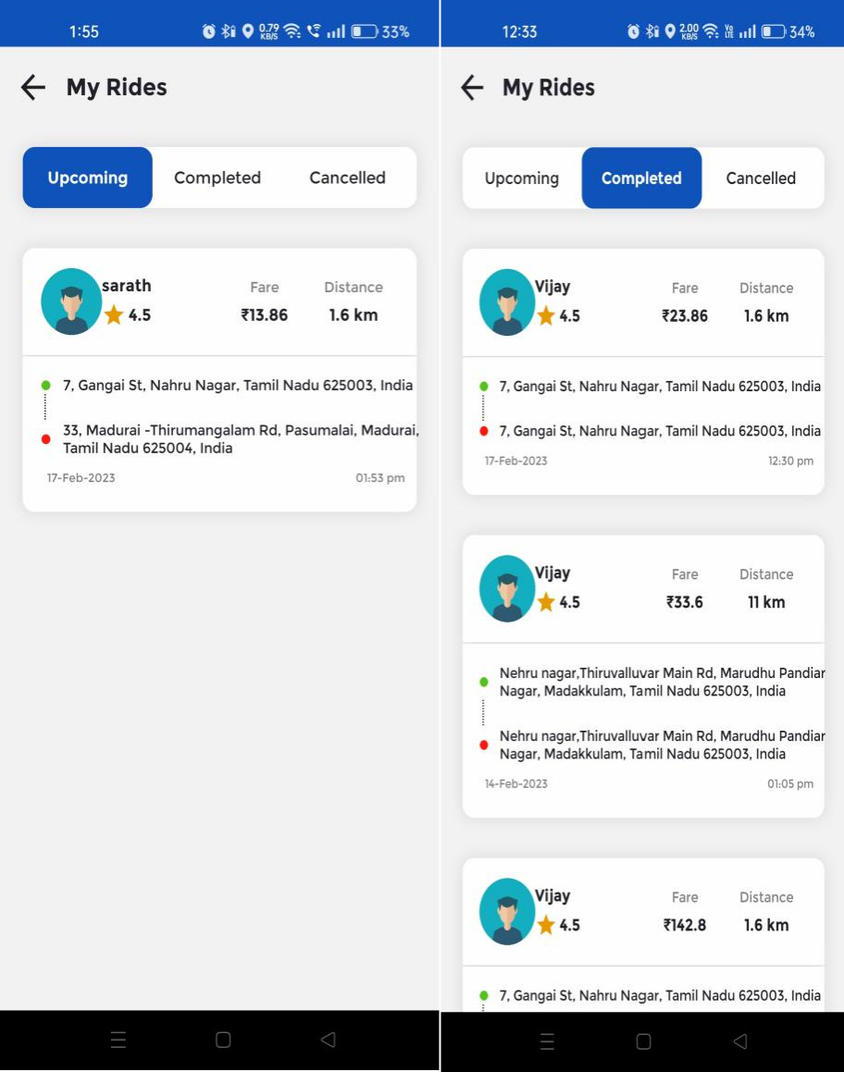
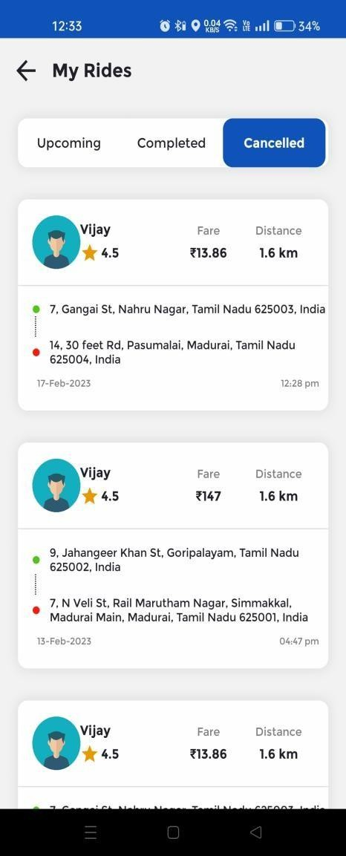

PROFILE
Riders can manage their profile details like Photo, Name, Email address, Mobile number and Gender from their My Profile Page. They can also update password in here.






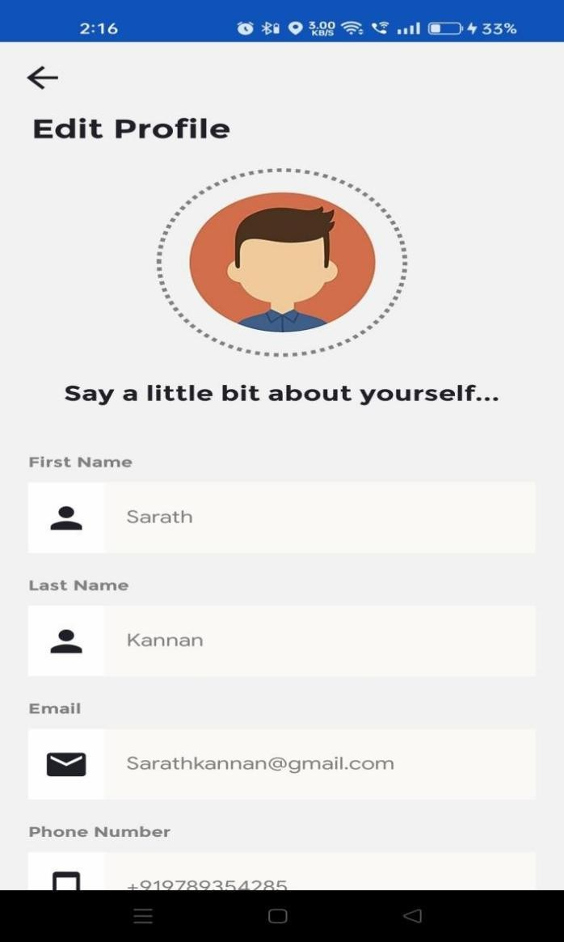

WALLET
All wallet transactions and their details are displayed in the wallet section.





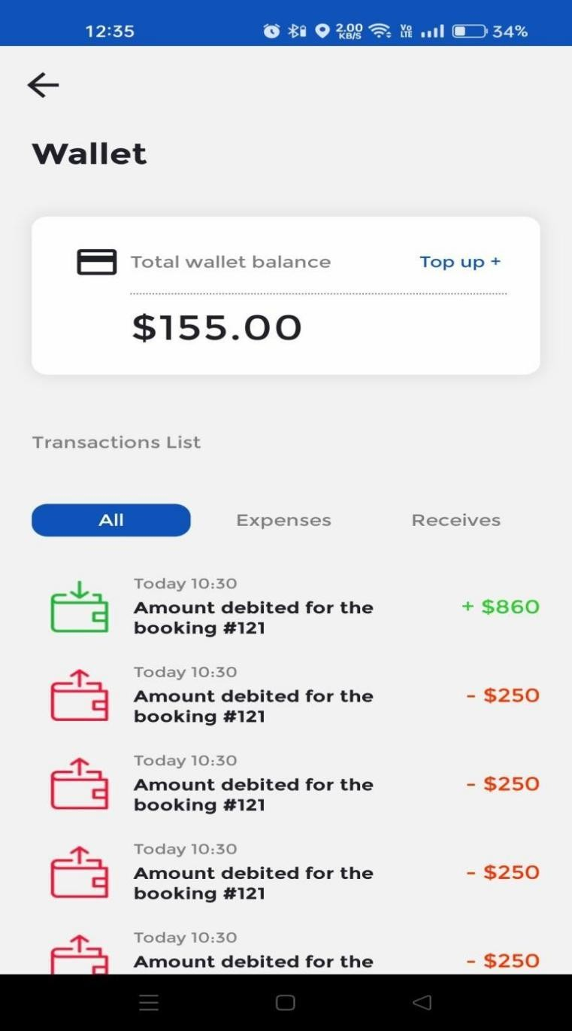

NOTIFICATIONS
Admin can add notifications what need to announce to customers can add from admin panel also have an edit and delete options.






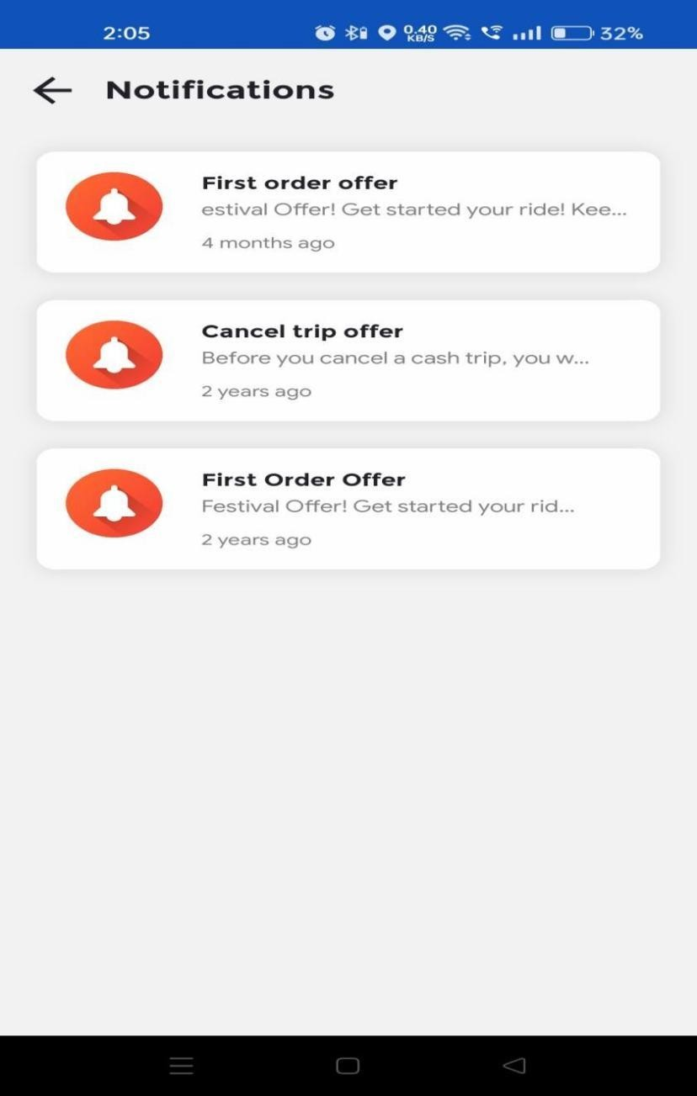

FAQ
The Apps will include FAQ pages. A d d, e dit a nd d el et e opt io n will be available tothe administrator.






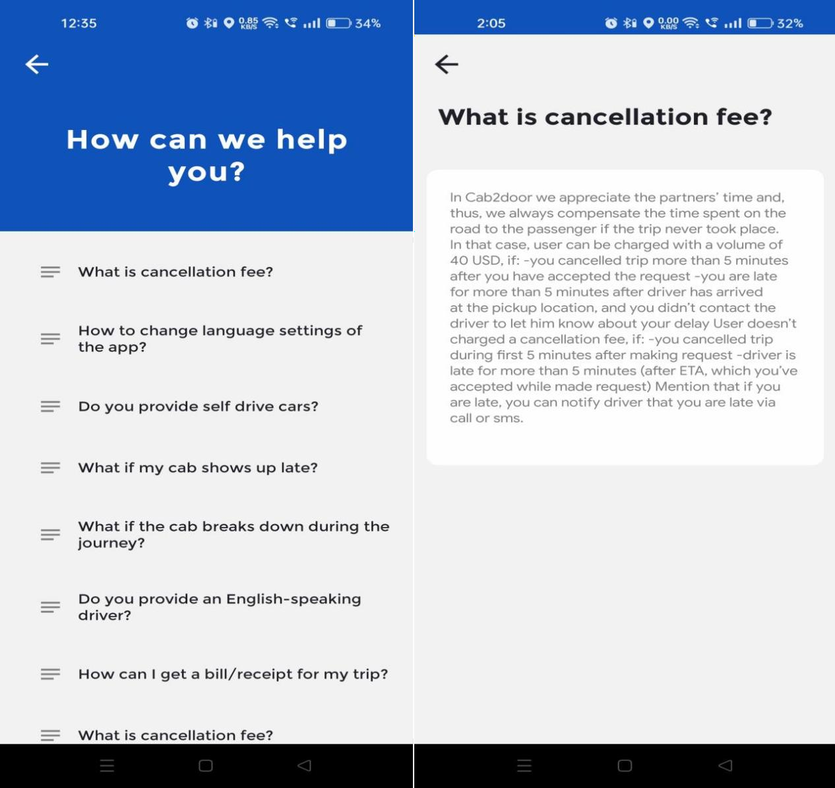

PRIVACY POLICIES
The Apps will include P r i v ac y Po l i c i es pages. Ad d, e dit an d de l et e o pt io n will be available tothe administrator.





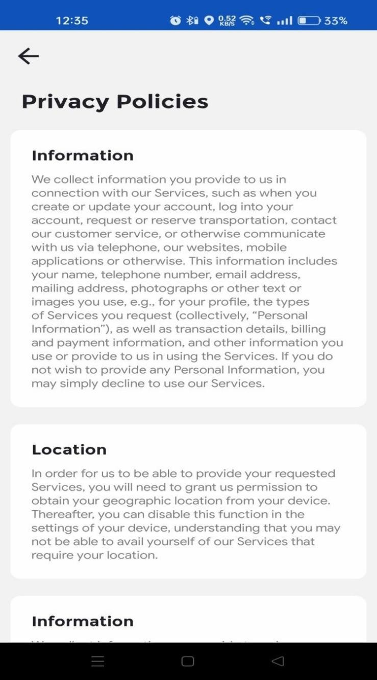

ABOUT US
The Apps will include I nf or m at i o n pages. A dd , ed i t a nd d el et e opt i o n will be available tothe administrator.

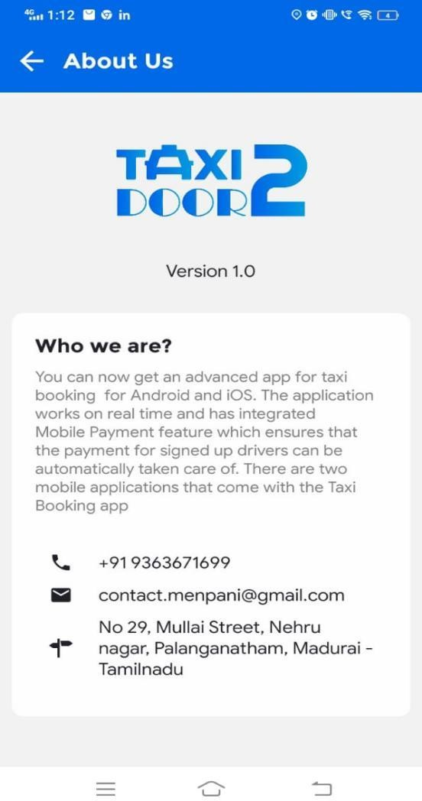



LOGIN
Driver can access their account by entering registered phone number and password. If you can't remember your password, click the 'Forgot my password' to generate a new one.



HOME

In the home screen driver can handle online and offline changes and in this screen also shows drivers today earnings, total earnings and incentives.

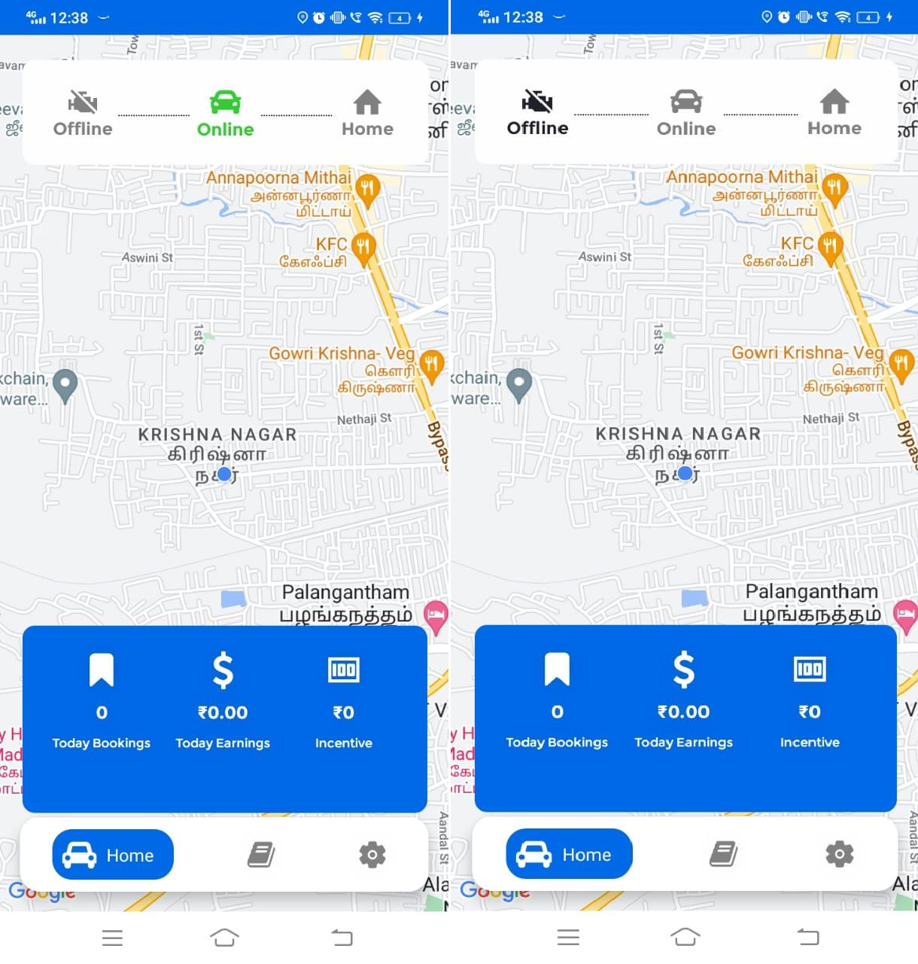

BOOKINGS
This screen displays trip information such as pickup location and drop location, and assigned cab fare.






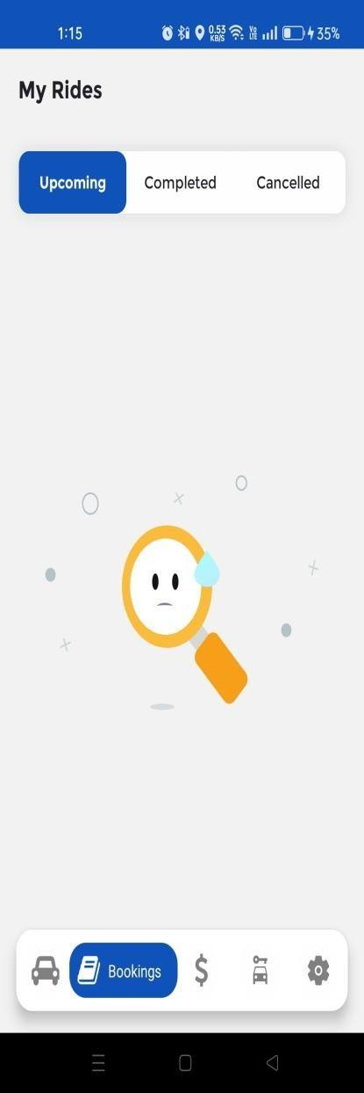
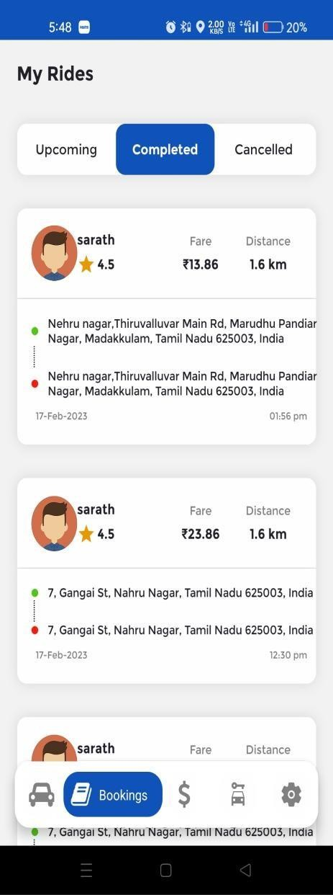
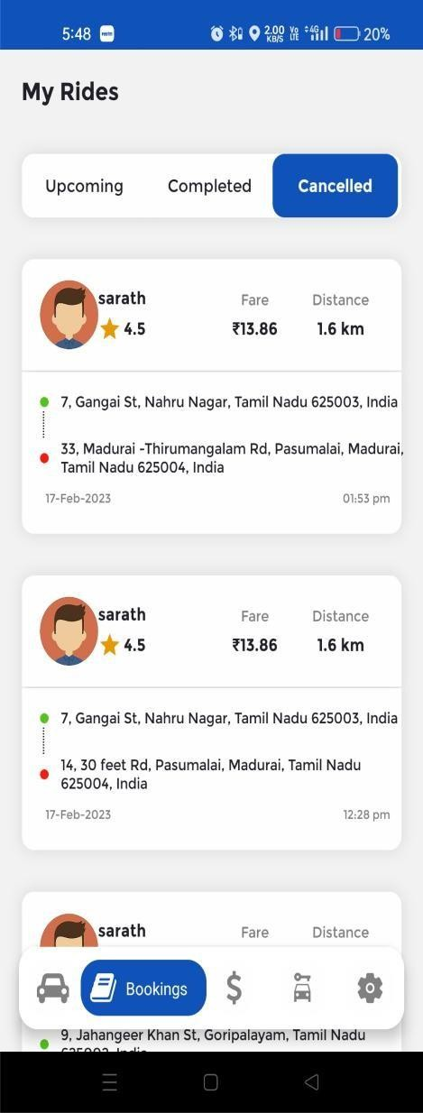

NOTIFICATIONS
Admin can add notifications what need to announce to customers can add from admin panel also have an edit and delete options.

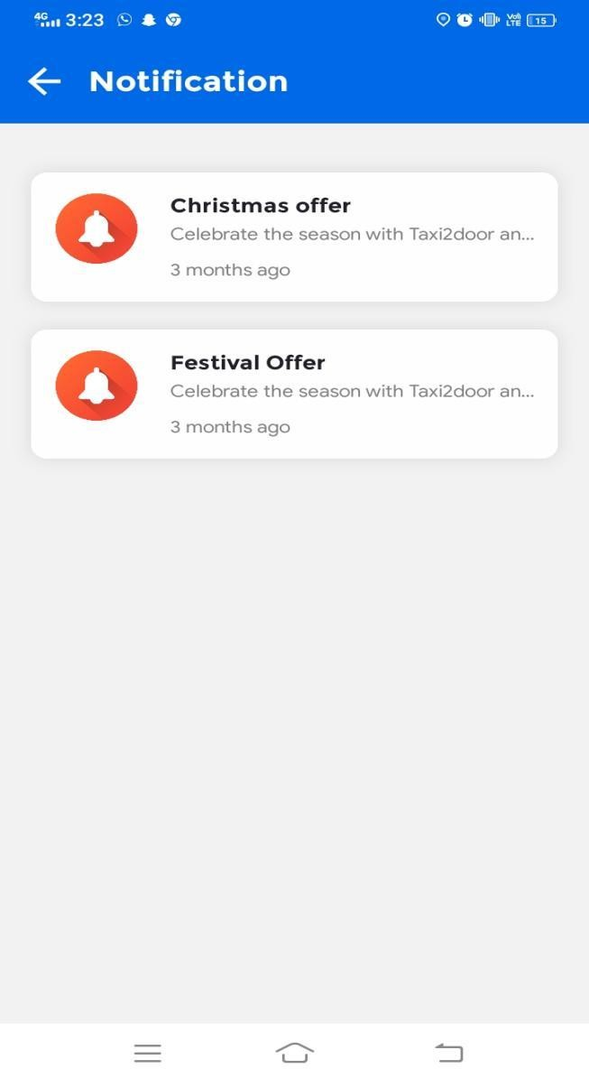

DRIVER MENU
A driver has access to the app's menu, which includes the profile page, KYC verification, training page, partner care, earnings, withdrawal, wallet transactions, SOS settings, and Logout page.
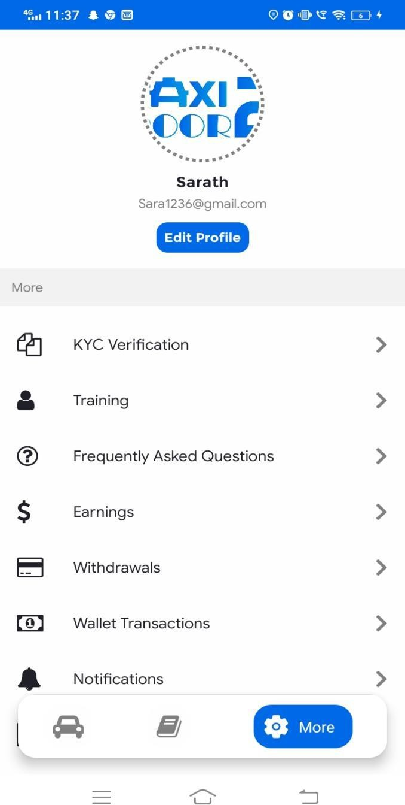

PROFILE
From the My Profile Page, drivers can edit their profile information such as their photo, first name, last name, email address, and phone number. They can also change their password here.






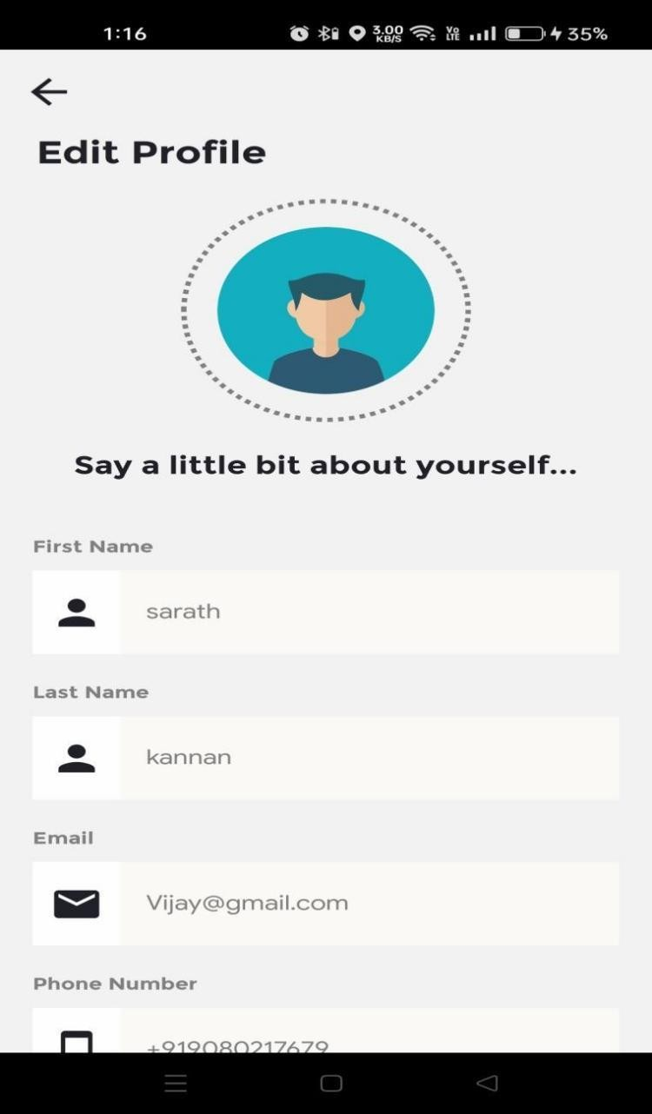

KYC VERIFICATION
Taxi2door has simplified KYC verification. Drivers can enter their bank information here.





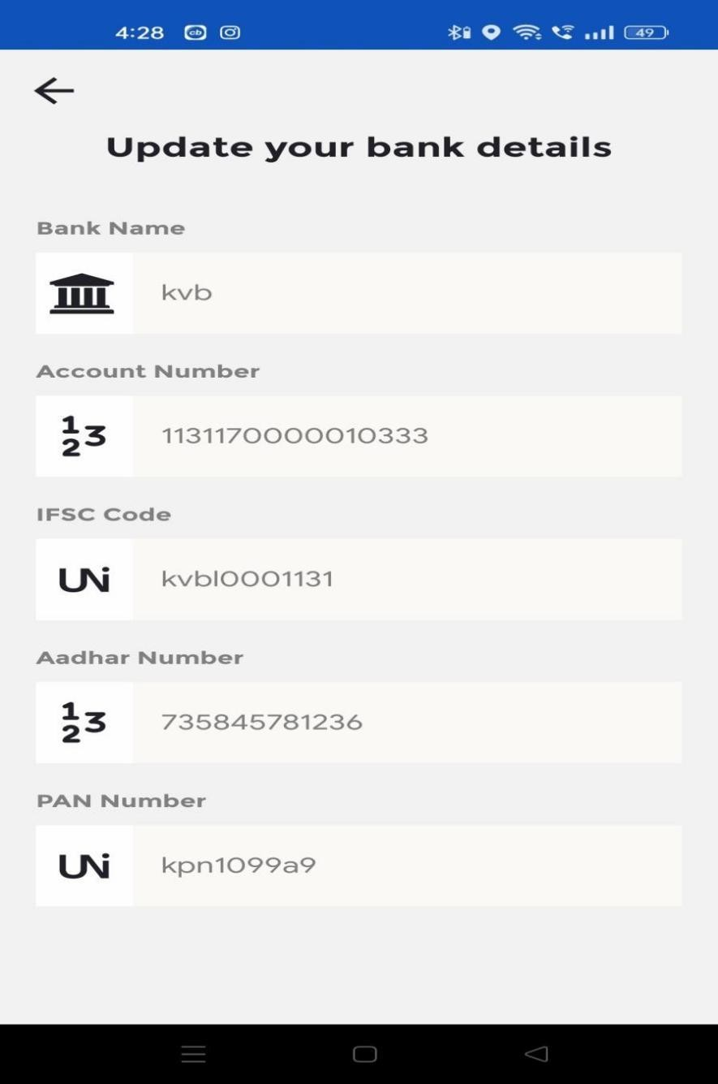

TRAINING

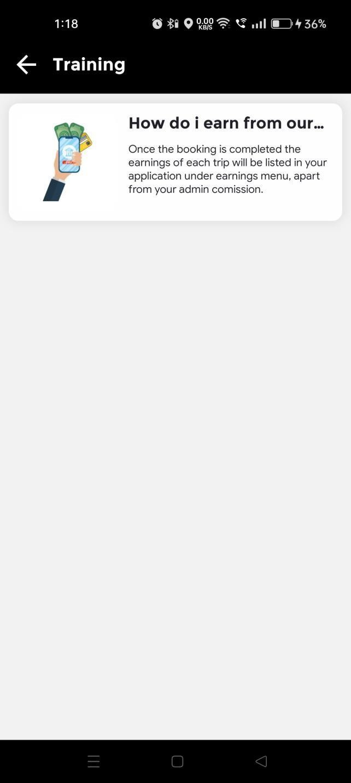
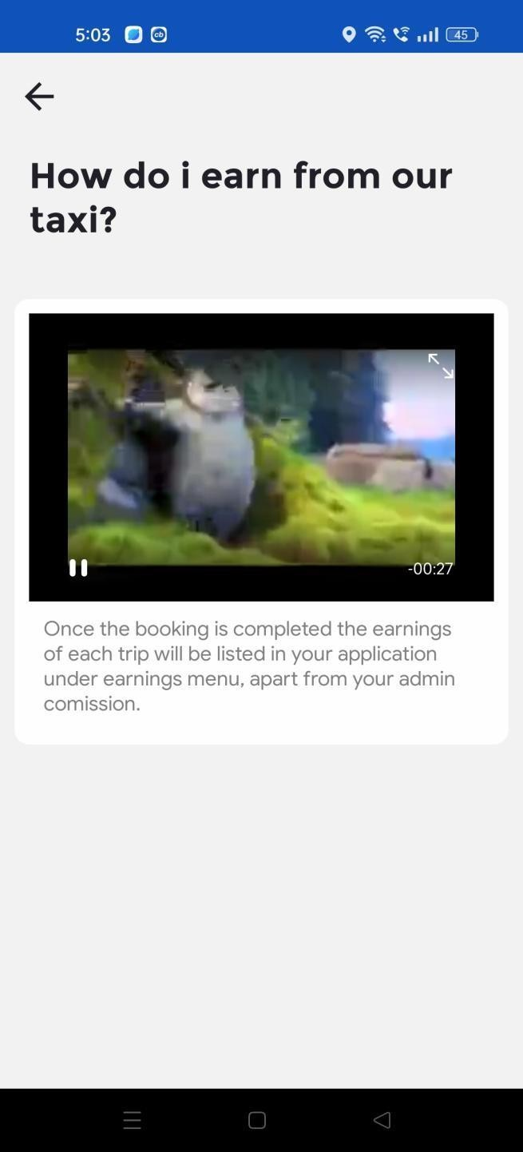
If want training video to the driver admin can add from admin panel here driver can check that.







32

PARTNER CARE
The Apps will include FAQ pages. A d d, e dit a nd d el et e opt io n will be available tothe administrator.






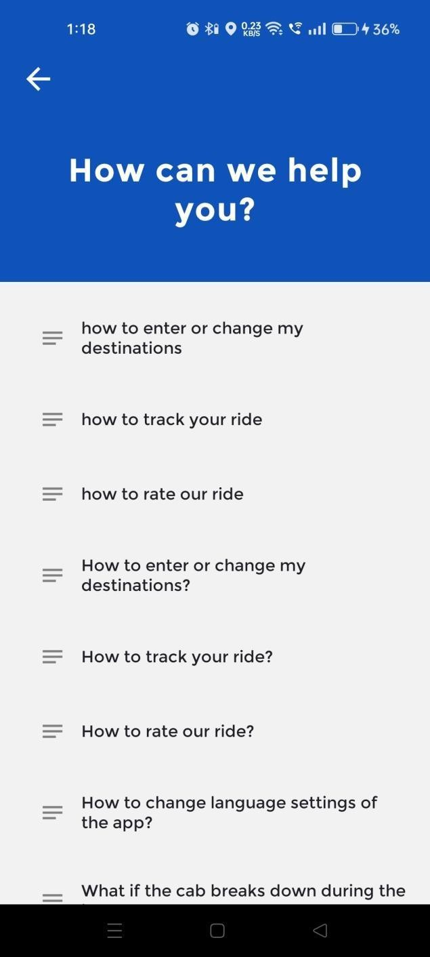
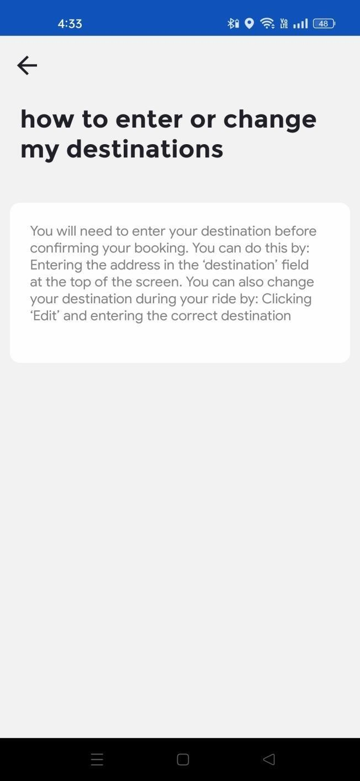

EARNINGS
The Earnings details can be viewed by the driver.





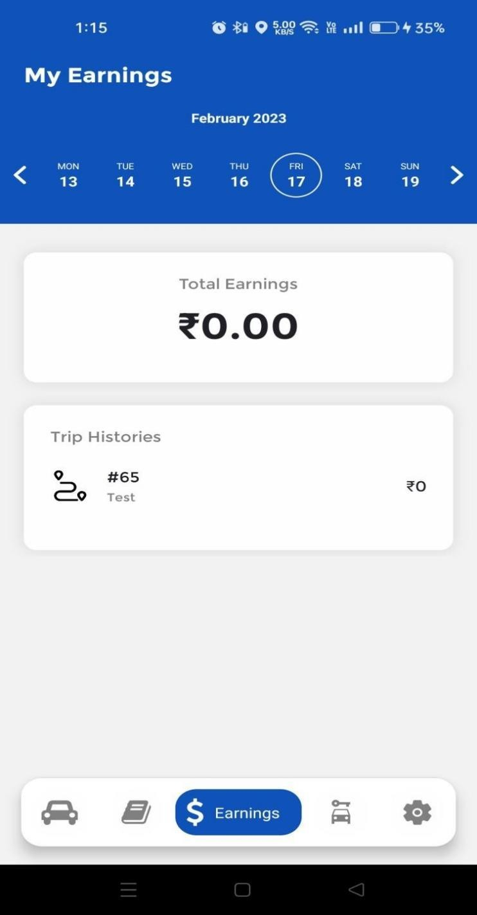

WITHDRAWAL
Here driver can make withdraw request from their wallet.






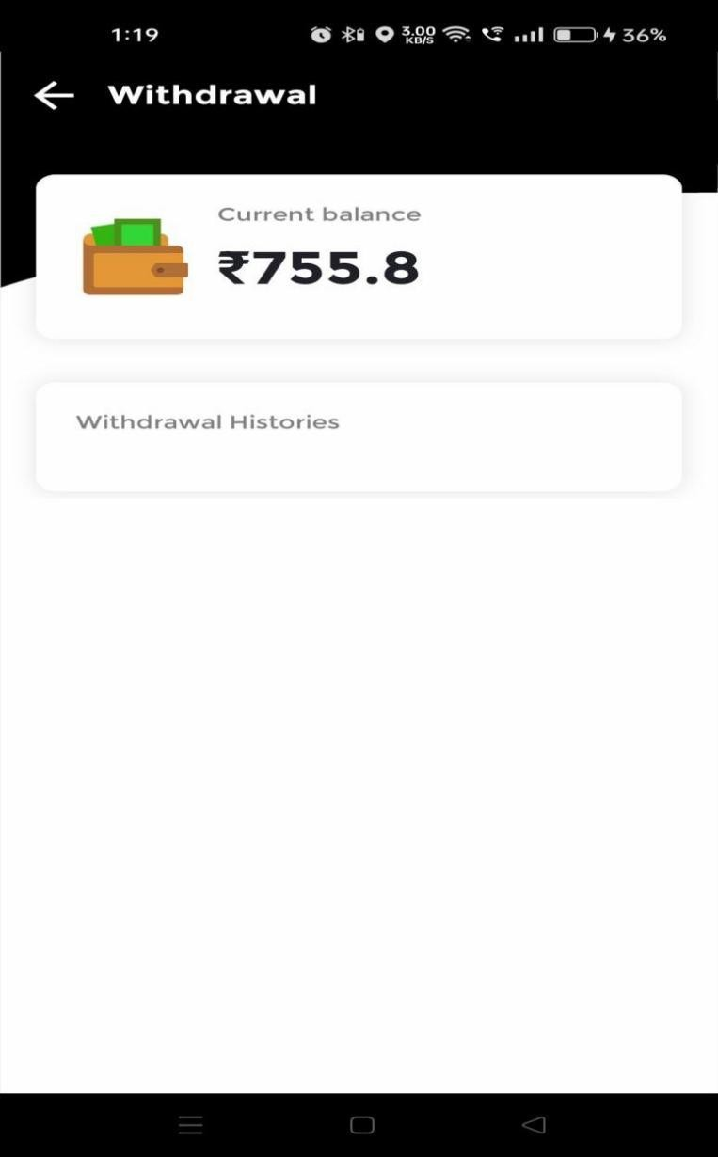

WALLET TRANSACTIONS

The wallet transaction details can be viewed by the driver.






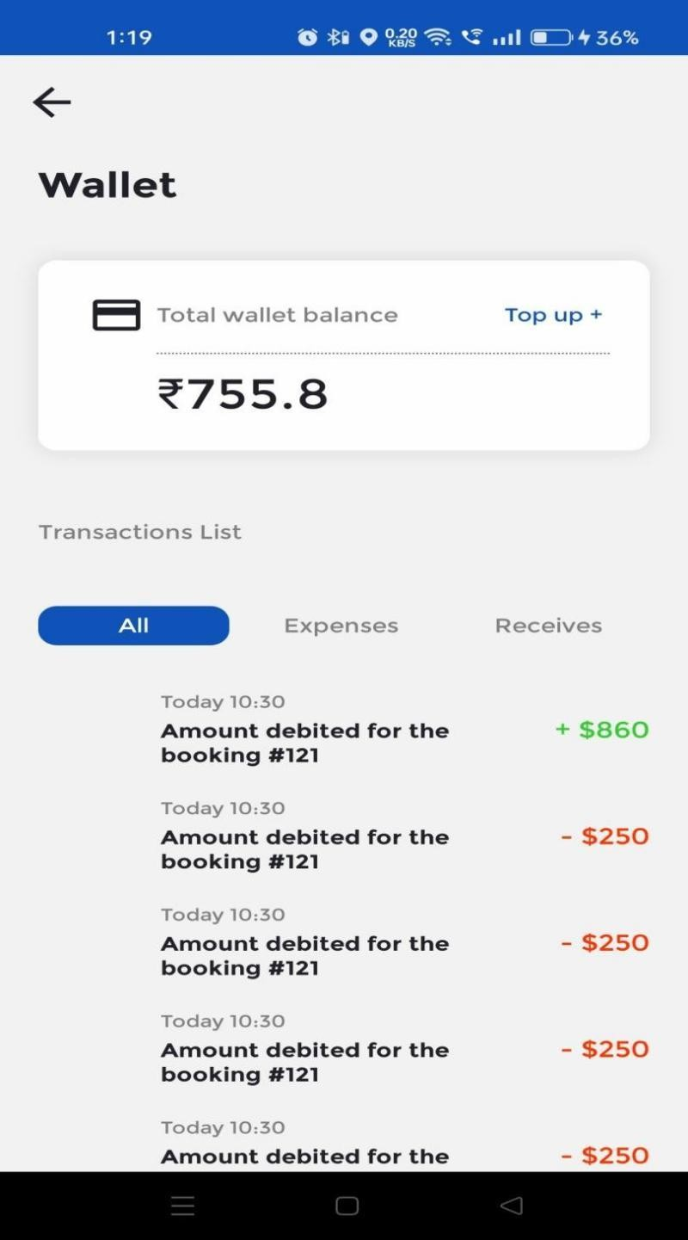

OWENER APPLICATION

SPLASH SCREEN

For two to three seconds, the splash screen for the owner's Taxi2door application will be visible here. Here, your app name and logo will be displayed.



HOME
Here, Owner can check number off active vehicles and inactive vehicles , current balance , total earnings ,today earnings and also can see withdrawal requests

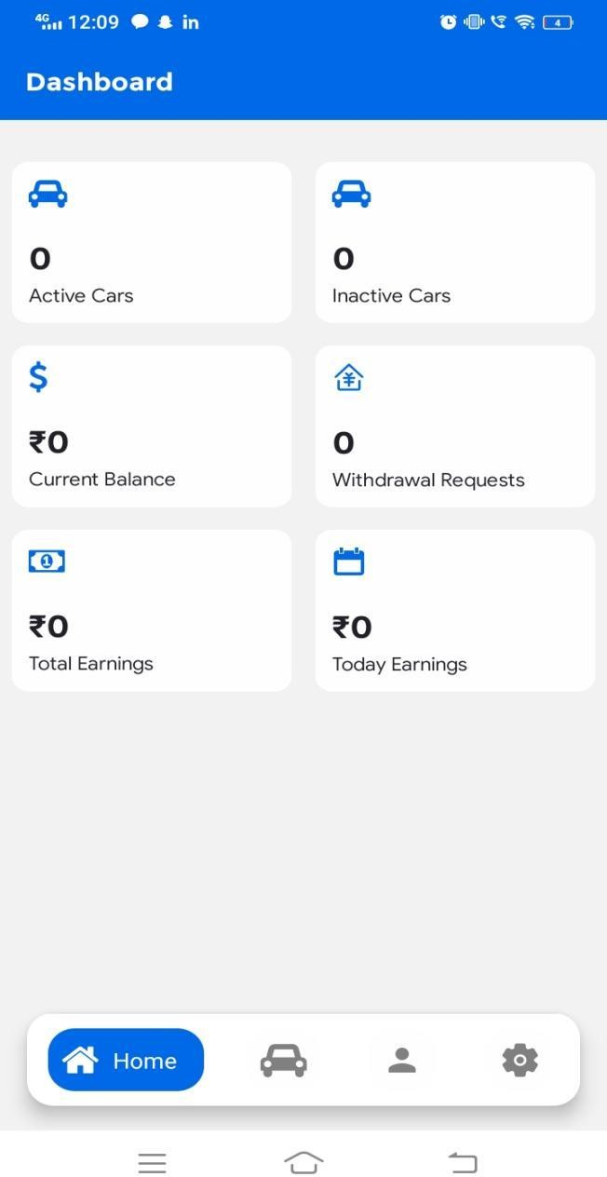

LOGIN

Existing users can access the app from this page by entering their login information, which includes their phone number and password.
Additionally,
this page has a feature that enables users to maintain their login status even
after closing the application.



NEW USER REGISTER

You can enter your information in the user name and password fields on the user registration page.



PROFILE
Owner can manage their profile details like Photo, Name, Email address, Mobile number and Gender from their My Profile Page. They can also update
password in here.

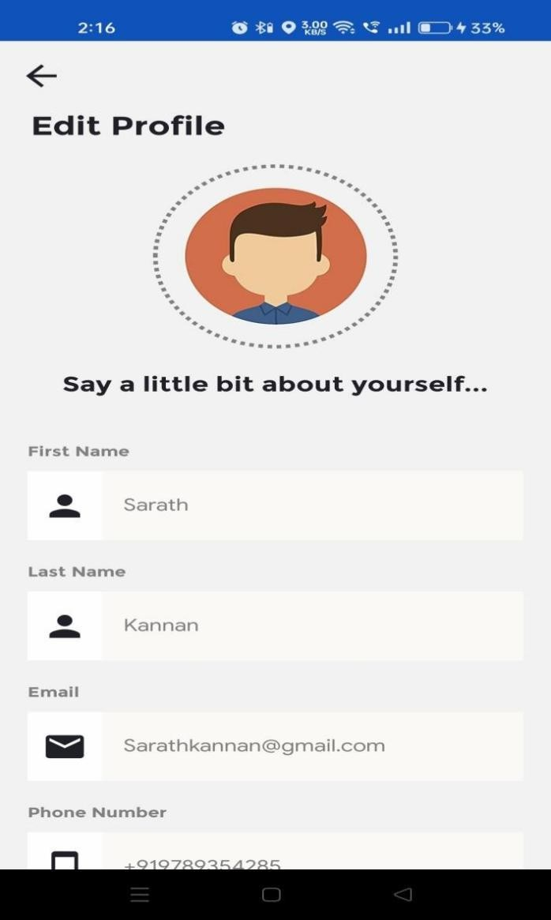

TAXI APP ADMINISTRATIVE PANEL
The admin panel is your one-stop shop for handling and managing your entire app. It allows you to add functionality to the apps and even get a good look at the map to see how your fleet is spread at any given time. It also shows you the number of rides booked through your app and the type of commission you earn on them. Everything from surcharges to vehicle type and rates can be customized. You can also view all reports to help you better plan your business.
This admin panel was created with everyone in mind. You don't have to be an expert in technology to work on it. Its responsive design and user- friendly interface will ensure that you don't need any assistance in determining what your taxi booking app is up to.
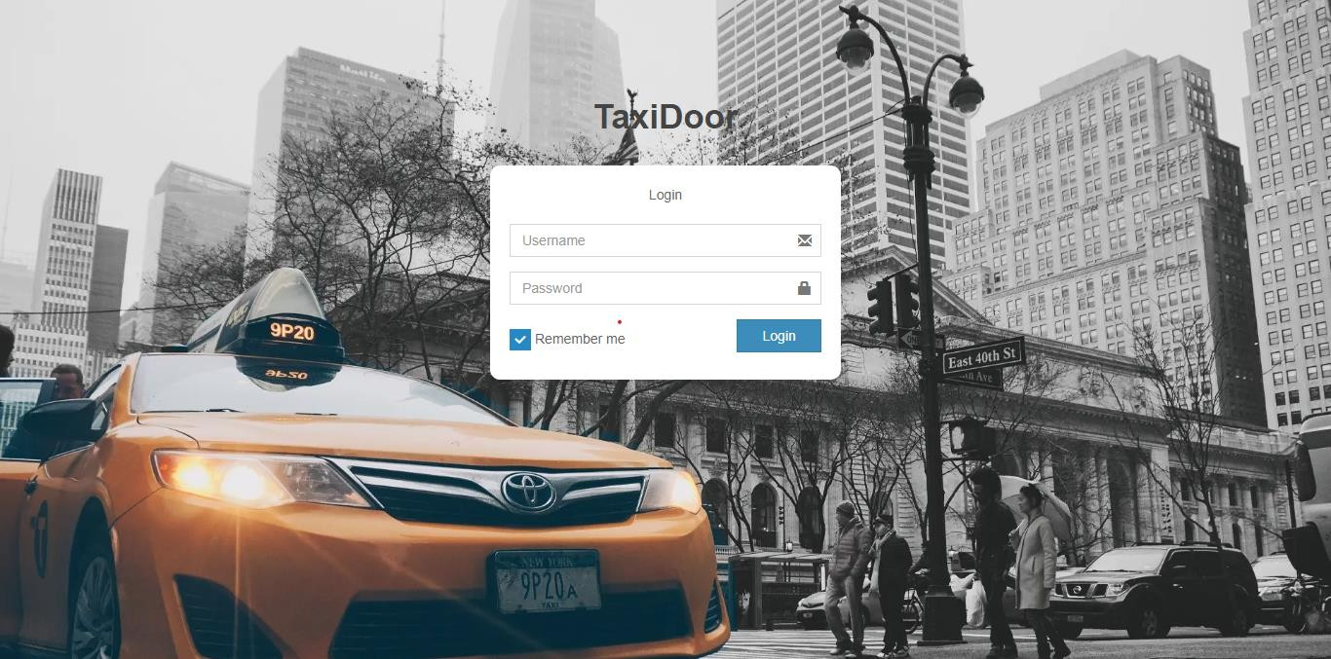

CUSTOMERS MANAGEMENT
The administrator can manage the riders who have registered f r o m t h e m o b i l e a p p .

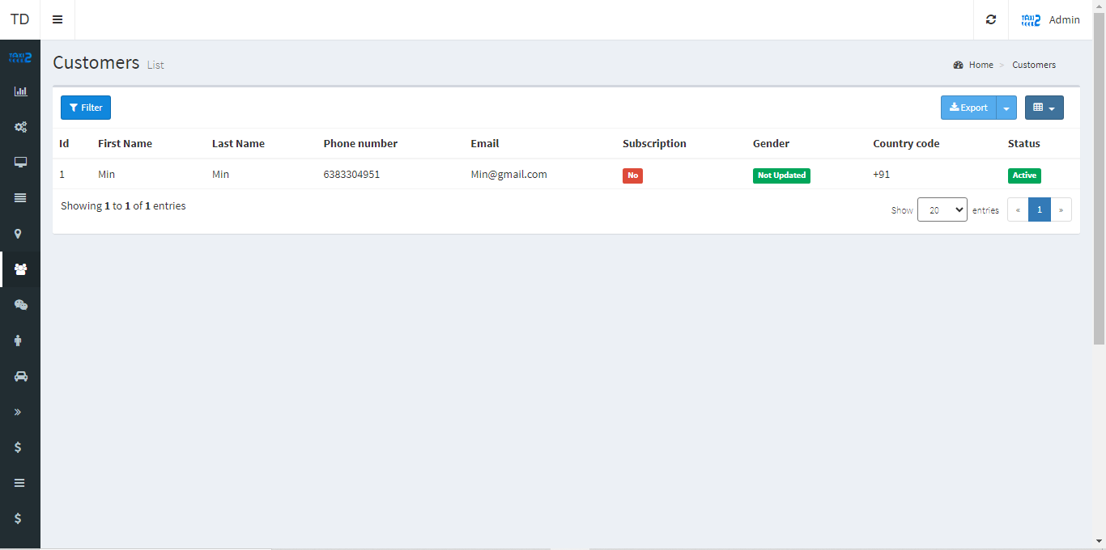

DRIVERS MANAGEMENT
The administrator can manage the drivers who are registered on the system. Admin can review the documents and vehicles that they have added. Any driver's account can be approved or rejected by the admin. A driver can only go online if their account has been approved by the admin. Any driver can be added, modified, or deleted by the administrator.

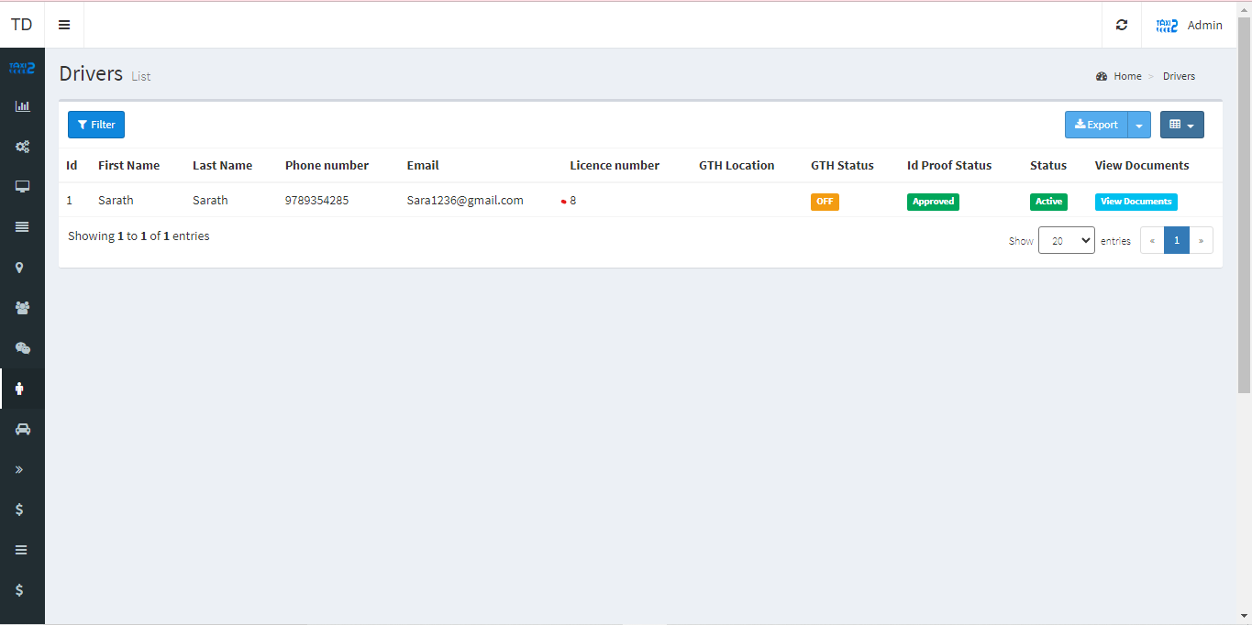

OWNER MANAGEMENT
The administrator can manage the o w n e r s who have registered on the system. Any owner can be added, modified, or deleted by the administrator.

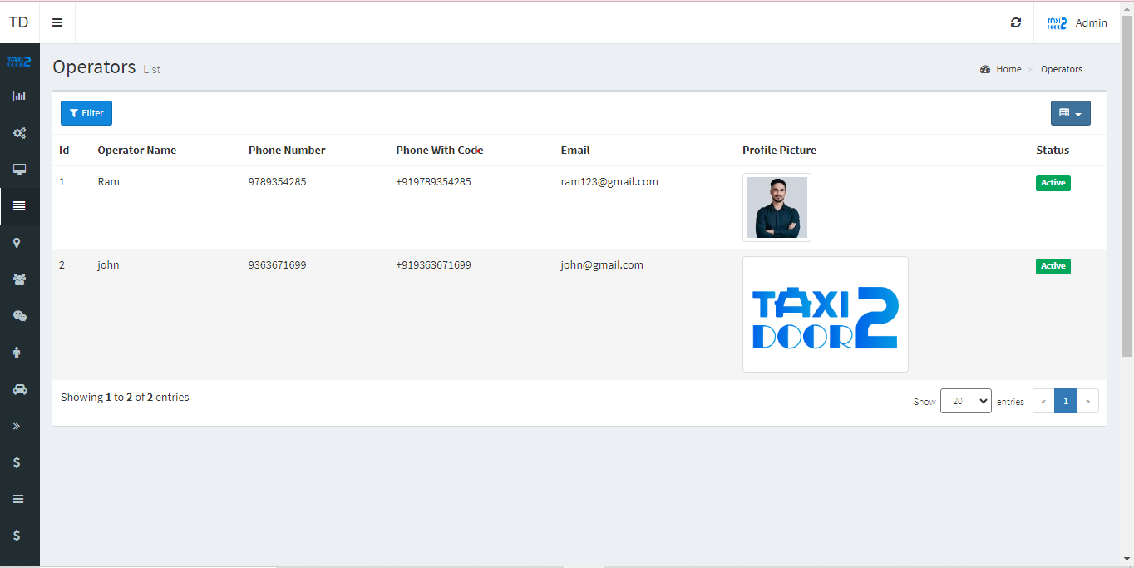

VEHICLE CATEGORIES MANAGEMENT
The administrator can add vehicle categories from admin panel .

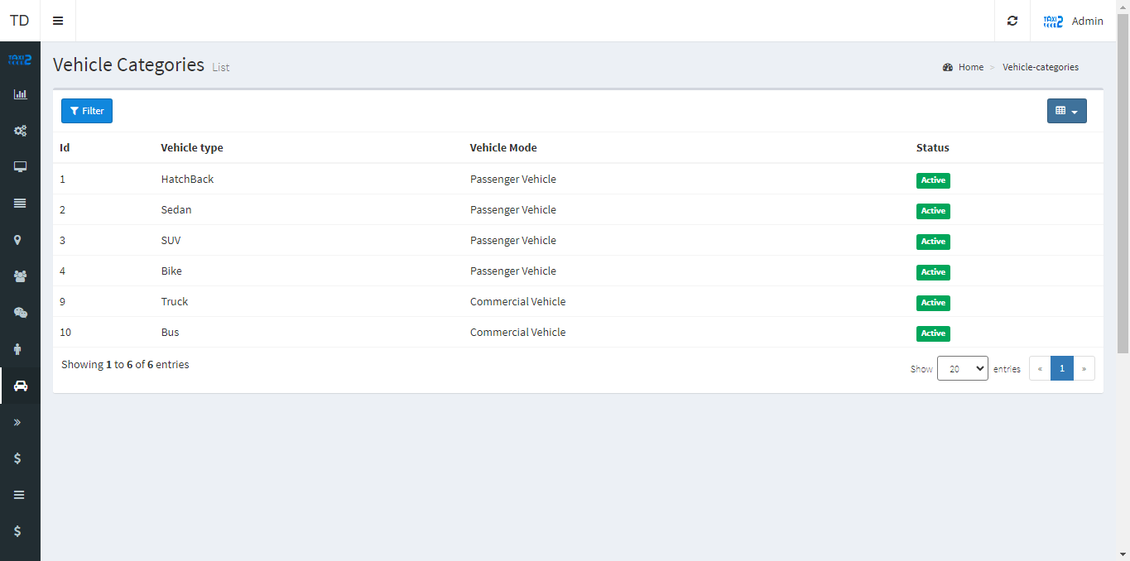

TRIP MANAGEMENT
On the system, admin can see all of the trips that have been completed thus far. Admin can view the status of any trip and filter it by customer name, driver name, vehicle number, payment method, promo code, sub-total, discount, and total fare.

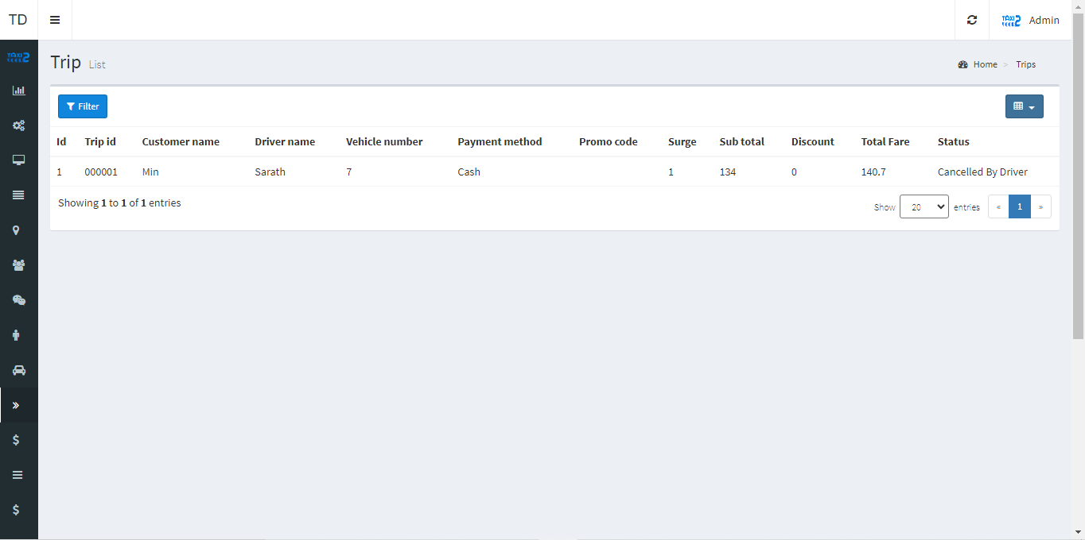

PROMO CODES
Admin can add promo codes what need to announce to customers can add from admin panel also have an edit and delete options.

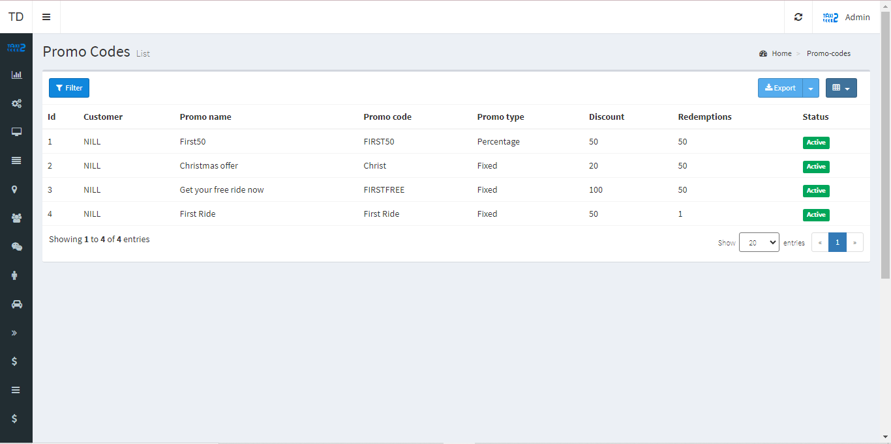

TAX LISTS
The tax can be added by the administrator. They can able to add, edit, and delete tax list pages.

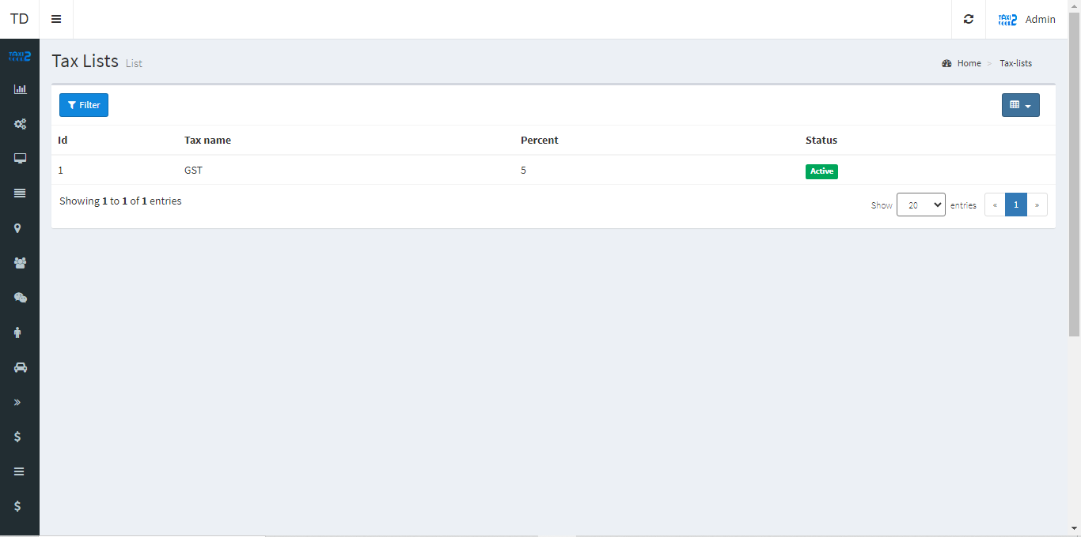

NOTIFICATION MESSAGES
Admin can add notifications messages what need to announce to customers can add from admin panel also have an edit and delete options.

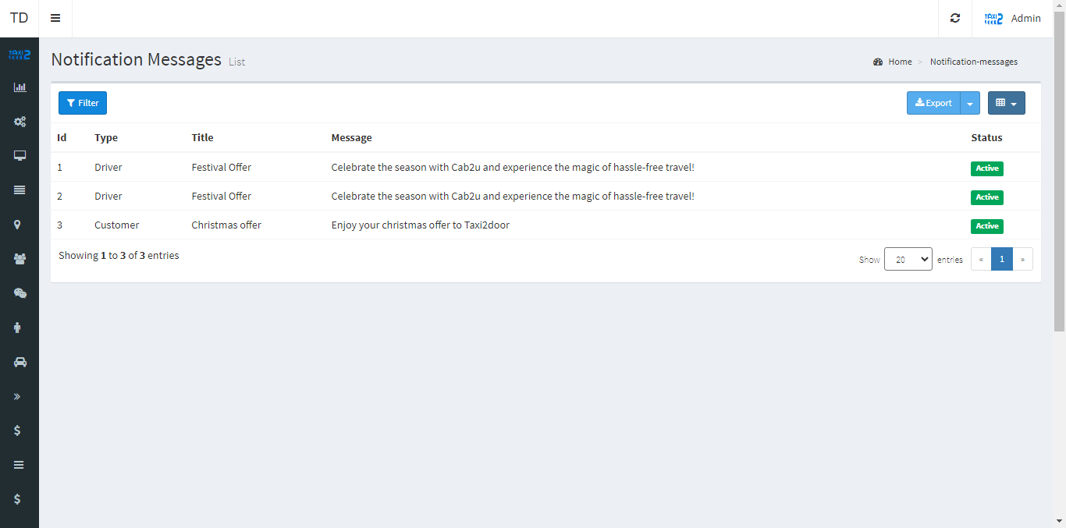

CANCELLATION REASONS
The Apps will include C a nc el l at io n r e aso n s pages. A d d, ed i t a nd d el et e o pt io n will be available tothe administrator.

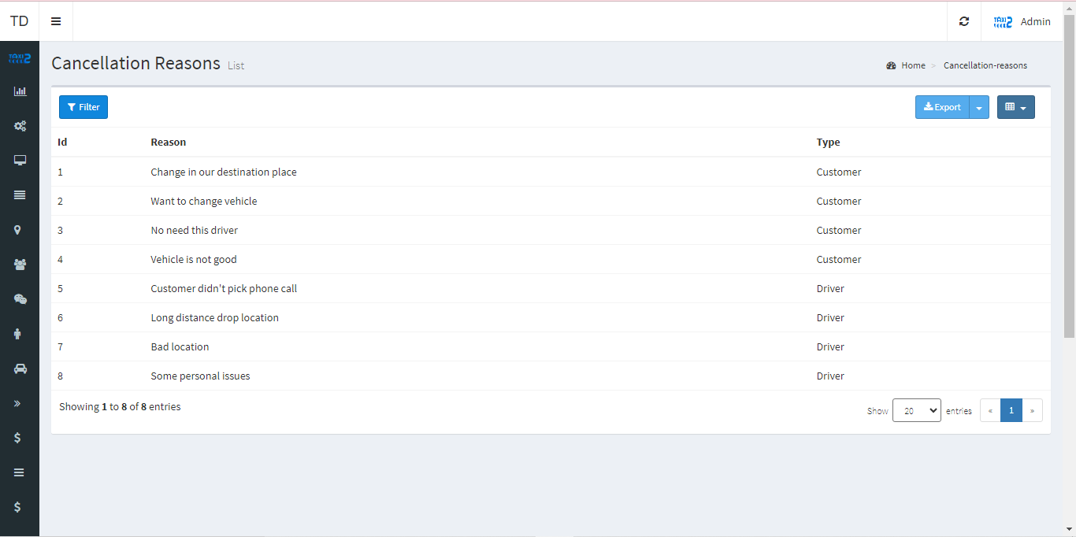

FARE MANAGEMENT
The administrator can view the fare management and define the vehicle type, fare type, base fare, and price per kilometer. This fare is dynamically displayed in the customer app.

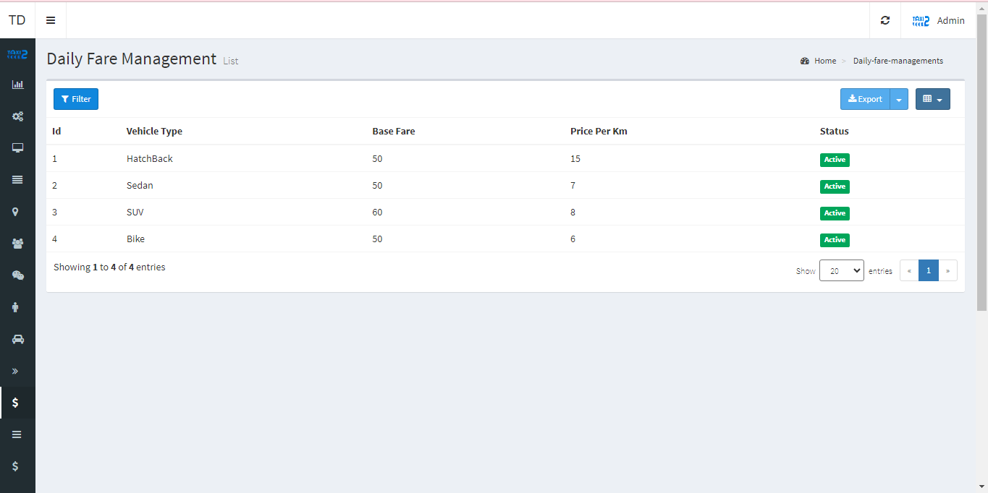

FAQ
The Apps will include FAQ pages. A d d, e dit a nd d el et e opt io n will be available tothe administrator.

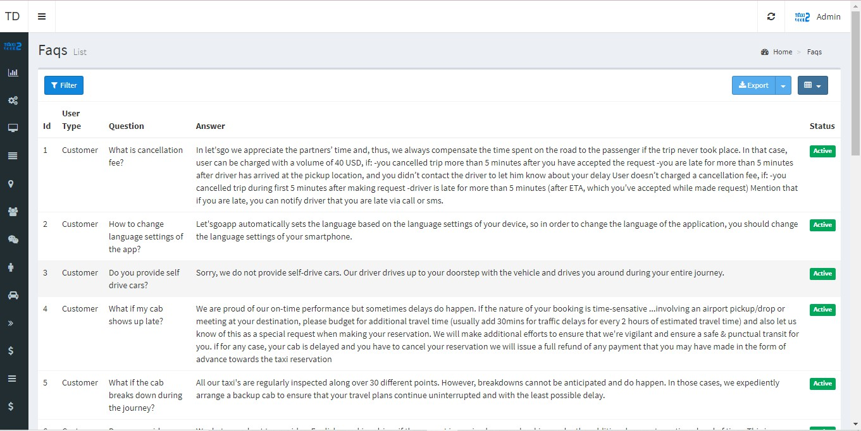

PRIVACY POLICIES
The Apps will include P r i v ac y Po l i c i es pages. Ad d, e dit an d de l et e o pt io n will be available tothe administrator.

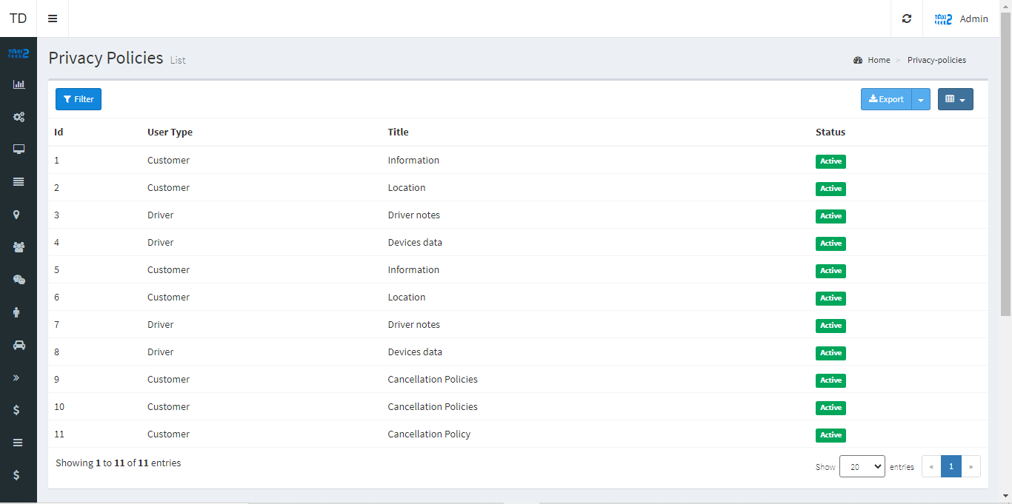

THANK YOU

