QueueAnalyzer (QWA)

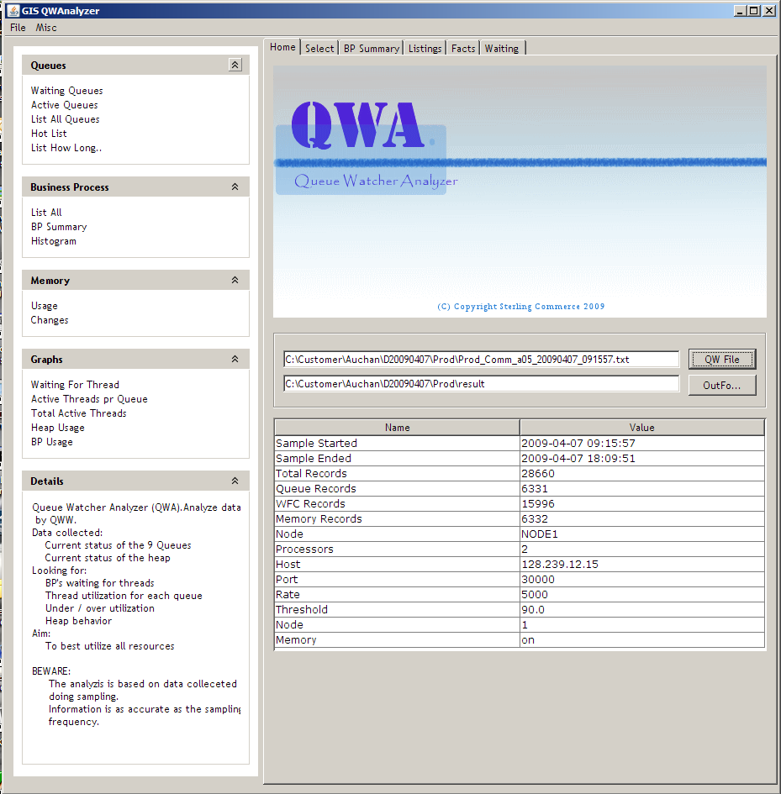

QWA: Program to analyze data collected by QWW from GIS

Require:
JVM 1.6
Windows
QWW and QWE (QueueWatcherExtended) installed to GIS to retrive memory info.

To invoke:
Edit the file startQWW.cmd to point at the jdk1.6
>startQWA.cmd

Menues
Heading | Description
QWFile | Collection of data records from QWW which will be analyzed by QWA
Outfolder | Foldername for output data generated by QWA. Default: QWA will make a result subfolder in QWFile folder.
QUEUES  – Most commands will navigate to a tab menu | - Summary – navigate to summary tab  - Waiting Queues – navigate to select tab  - Active Queues – navigate to Select tab  - List All Queues –navigate to Select tab  - Hot List – navigate to Select tab  - List How Long – navigate to Select tab
Select Tab (Waiting Queues)  Time: time of collection  Queue : actual queue  Threads: active threads (BP’s)  Calc: Allowed threads for queue  Depth: Bp’s waiting for thread  Wfc_id: Workflow_id  Step: current steps*  Active: active in ms  BP Name: BP name  *Step counter is only updated when BP is requeued. | - List when ANY waiting – Will list time, queue , # threads running, # threads allowed running and #bp’s waiting to run. It will list if any bp is waiting for a thread. If a cell has a red background the queue is underscheduled meaning the queue is allowed to run more threads then it currently does.  - List when 1 ore more waiting – will list all occurences when 1 or more BP’s are waiting for a thread  - List when 5 ore more waiting – will list all occurences when 5 or more BP’s are waiting for a thread  - List when 10 or more waiting – will list all occurences when 10 or more BP’s are waiting for a thread  - List How Long ALL (Q1-Q9) lasted - Will produce a list of (Listing Tab) how long a queue of waiting BP’s were present for a ALL or Qn queues. This information is usefull to understand how fast individual queues are serviced.
Select Tab (Active Queues)  Time: time of collection  Queue : actual queue  Threads: active threads (BP’s)  Calc: Allowed threads for queue  Depth: Bp’s waiting for thread  Wfc_id: Workflow_id  Step: current steps*  Active: active in ms  BP Name: BP name  *Step counter is only updated when BP is requeued.  Hot List will correlate active BP’s with the current heap level. Usefull to detect GC potential OOM situations. | - List when 1 or more active – list all occurences when 1 or more BP’s (threads) active.  - List when 5 or more active – list all occurences when 5 or more BP’s (threads) active.  - List when 10 or more active – list all occurences when 10 or more BP’s (threads) active.  - Hot List 1 or more [1,5,10,15,20,30] active – Will correlate active threads (1,5..) with memory level. This will indicate how heap memory behaves whith the intensity of threads.
Select Tab (List Queues) | - List Individual Q1..Q9 queues – List activities on individual queues. This list will include all sampling with 1 or more active BP’s.
Select Tab (List Memory)  Detect if and when free memory gets lower than a certain free heap %. Should be used to decide if memory needs adjusment. | - Less Than [100%..10%] Heap – List of time, heap size (GB) and free heap (%) of memory.
BUSINESS PROCESS | - List All – list all BP’s collected during the session.  - BP Summary – Will list the name of all BP’s encountered during the session and the number of times each was encountered.  - Histogram – Display of counters.
MEMORY | - Usage – current commited heap size and free heap percentage.  - Changes – this will list heap size comitted changes. (The IBM jvm seems to change more often than SUN).
Graphs | - Waiting for thread – shows the number of waiting BP’s for each queue.  - Active threads pr. Queue – a graph of active threads pr. Execution queue.  - Total Active threads – A graph showing all queue threads active during sampling period.  - Heap Usage – Graph showing the commited and free heap. Will be able to display memory leak.  - BP Usage – Graph to show the occurences of BP’s during the sampling period.

Summary

Summary of Queue usages. This information is collected during the initial startup of QWA.

List When ANY waiting

Display an entry whenever any BP is found waiting for a thread. The ALLOWED column will have a red background if more threads are allowed for this queue (ALLOWED > THREADS while DEPTH > 0).

Purpose : Fast view of queue buildup.

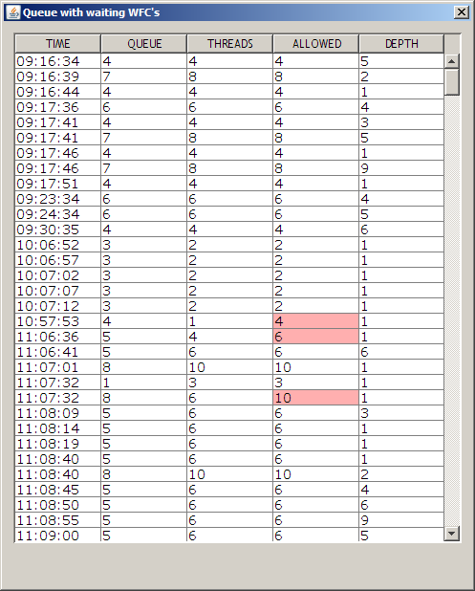

List Queues when [n or more] waiting for thread

A detailed view of activities when more then “n” BP’s waited for a thread on a queue. A list of all active queues at this TIME will be displayed if one or more queues have a waiting list.

Purpose: Show all active threads and calculated (Calc) fairness. The display should be helpful do determine the MaxPoolSize for a Queue and the resource value.

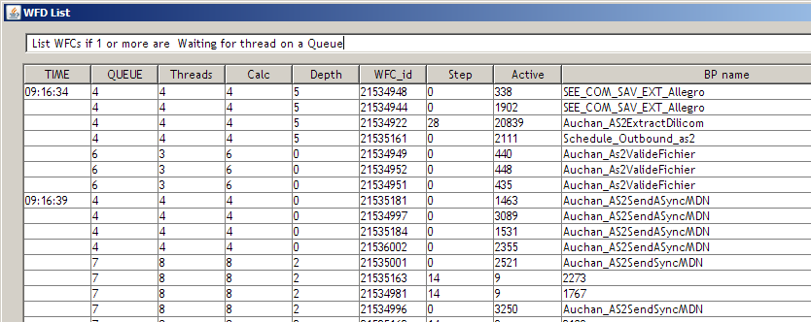

List how long Queues [All, n or more] lasted

A list of when a waiting list for queues was detected and when it was gone.

Purpose: To give an overview of the “service time” for a dispatching queue.

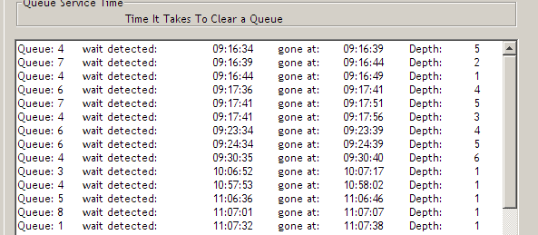

Active Queues

List Queues when [n or more] active

Examines all queues in a TIME record to determine if the total count of active BP is “n” or higher.

Purpose: View the usage of the thread allocation for a queue such as MinPoolSize/ MaxPoolSize and Resource value.

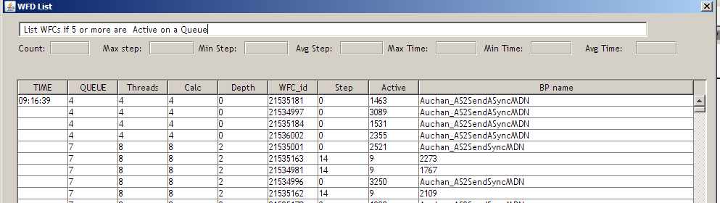

List Queue and Memory when [n or more ] Active

Correlates active threads (BP’s) and heap memory.

Purpose: to spot any potential OOM condition. For OOM condition the thread count should be reduced for one or more queues,

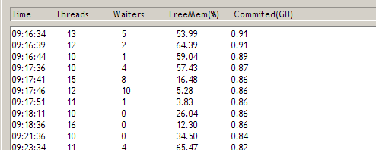

List individual [Qn] Queues

Activities by queues.

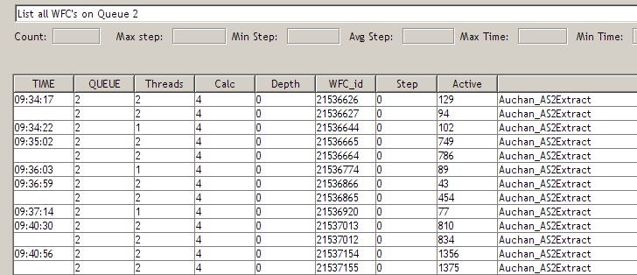

Less then [n %] heap

Purpose: List when available heap was less then “n” percent (%). Will give an indication of how the heap behave during the day. Should be helpful to adjust heap settings.

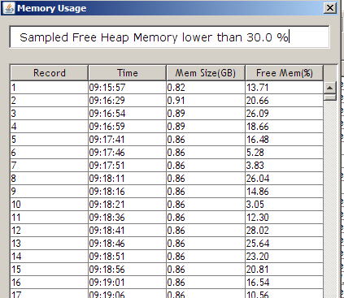

BP summary

Purpose: Display the name of all the BP’s and the number of encounters during the collection session. The same BP (wfcid) can have been encountered more that once. By clicking on a BP name record a list of the occurrences of this BP will be displayed.

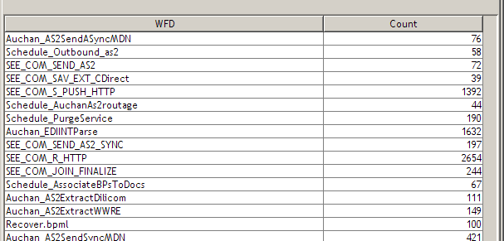

Clicking on a WFD record: the following display will list each BP .

It will list the max / min / avg step and the min / max / avg time (in ms) for this BP.

NB! This will only be as accurate as the sampling interval and NOT real numbers. The values are just for indication purpose.

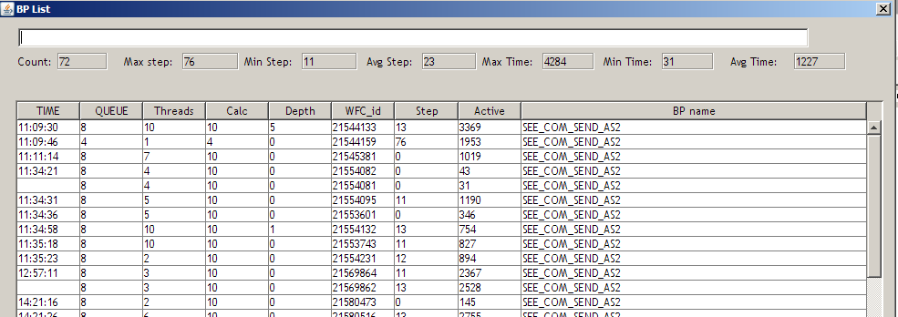

Histogram

The top table: A list of how often queue depths was found within each interval and the total number of times a queue was found.

Underscheduling detected: Number of times underscheduling was detected on a queue.

Min / Max Pool : The configured MinPoolsize / MaxPoolSize for each queue.

Peak of waiting BP’s: The time each queue had the highest count of waiting BP’s.

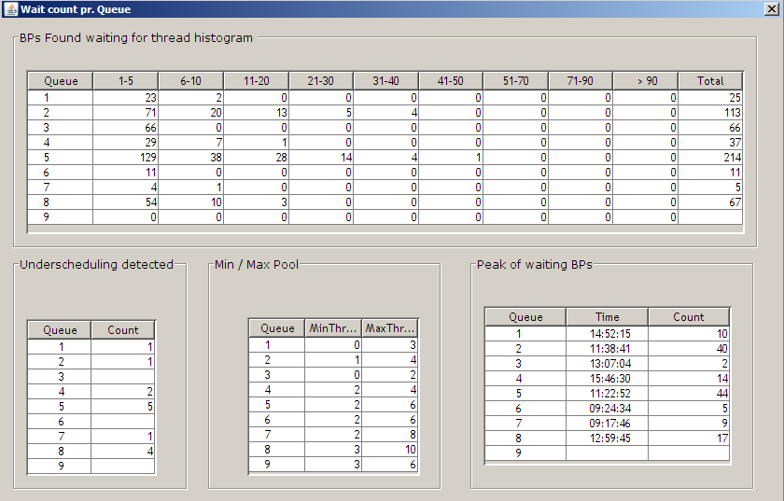

Memory

Usage: Committed and free heap % . See the Select tab for more choices.

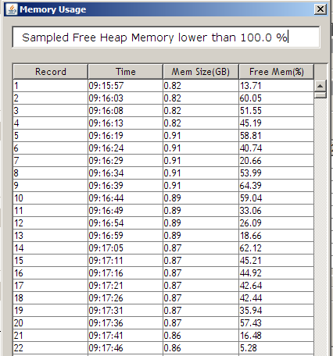

Changes: list changes (expansion / contraction) of committed heap memory.

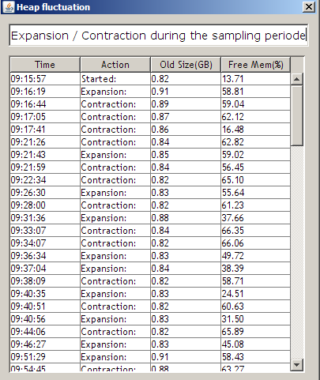

Summary tab

Summary page.

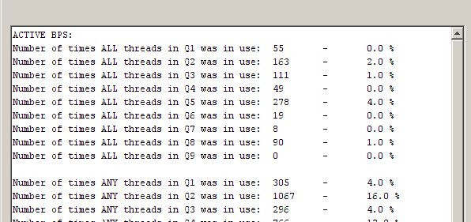

Graphs
A graph showing the queue depth of waiting BP’s for all 9 queues.

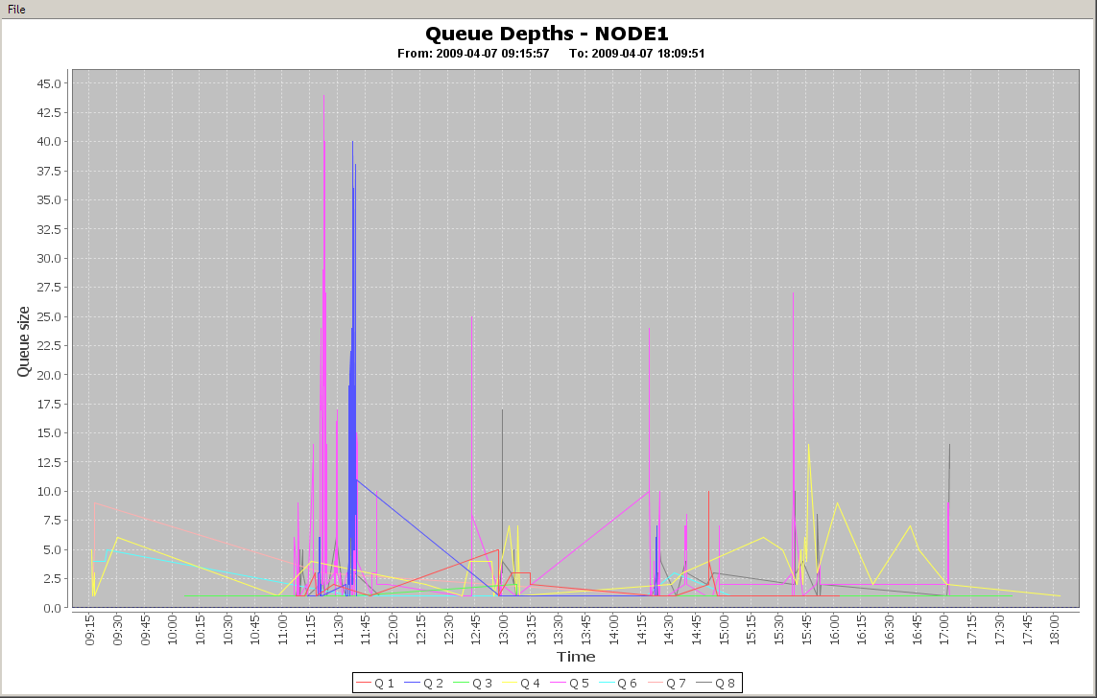

Showing all active threads for each queue.

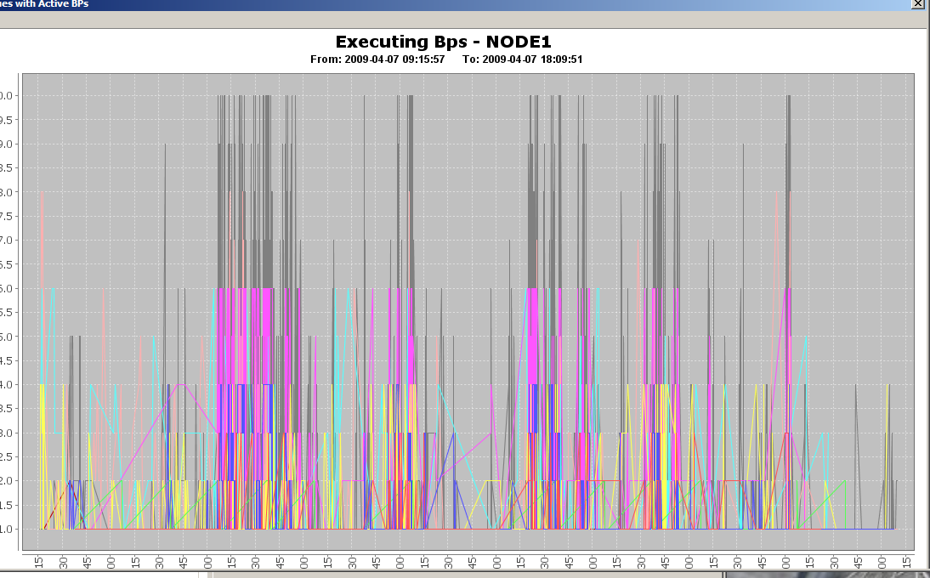

The flowing chart shows the current TOTAL threads in use.

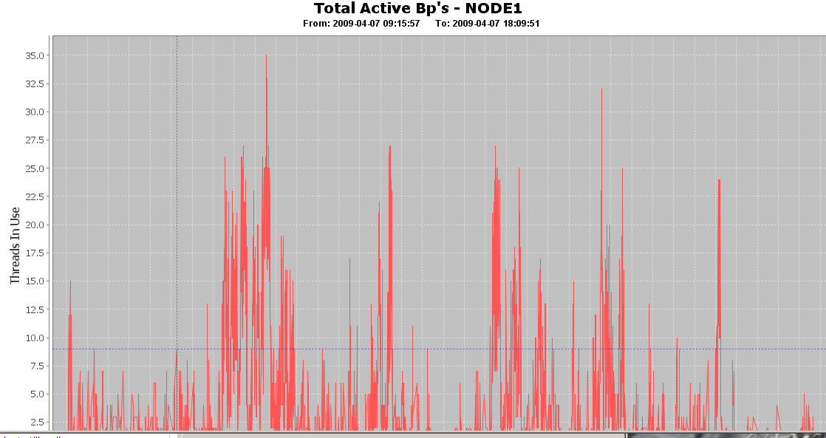

The flowing chart shows the current state of HEAP memory. It shows the total committed and free % .

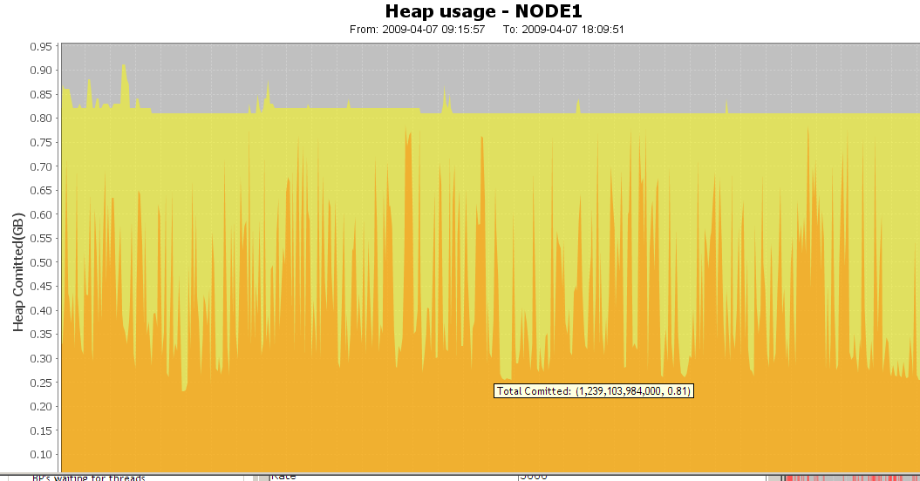

The following chart shows the occurrence of BP’s. The same wfc_id can appear multiple times for a BP.

