Nama | : | Aulia Tauhid Akbar
NIM | : | 250401020136
Jurusan | : | Informatika
Mata Kuliah | : | Struktur Data dan Algoritma

- SIMULASI MANUAL
Penyelesaian Hashing (N = 11, H(k) = k mod 11)
Langkah 0: Hitung nilai hash tiap key
Key | Perhitungan | H(k)
43 | 43 mod 11 | 10
22 | 22 mod 11 | 0
1 | 1 mod 11 | 1
12 | 12 mod 11 | 1
34 | 34 mod 11 | 1
56 | 56 mod 11 | 1
77 | 77 mod 11 | 0
88 | 88 mod 11 | 0

Terlihat bahwa banyak key akan bertabrakan di indeks 0 (22, 77, 88) dan indeks 1 (1, 12, 34, 56).
  - Linear Probing
Rumus: H(k, i) = (H(k) + i) mod 11, i = 0, 1, 2, ...
Langkah insert satu per satu:
- 43 → H=10 → slot 10 kosong → taruh di 10
- 22 → H=0 → slot 0 kosong → taruh di 0
- 1 → H=1 → slot 1 kosong → taruh di 1
- 12 → H=1 → slot 1 terisi (1) → i=1: (1+1)=2 → slot 2 kosong → taruh di 2
- 34 → H=1 → slot 1 terisi, i=1: slot 2 terisi, i=2: (1+2)=3 → slot 3 kosong → taruh di 3
- 56 → H=1 → slot 1,2,3 terisi, i=3: (1+3)=4 → slot 4 kosong → taruh di 4
- 77 → H=0 → slot 0 terisi (22), i=1: slot1 terisi, i=2: slot2 terisi, i=3: slot3 terisi, i=4: slot4 terisi, i=5: (0+5)=5 → slot 5 kosong → taruh di 5
- 88 → H=0 → slot 0,1,2,3,4,5 semua terisi (cek berurutan i=1..5), i=6: (0+6)=6 → slot 6 kosong → taruh di 6

Hasil Akhir Linear Probing
Indeks | 0 | 1 | 2 | 3 | 4 | 5 | 6 | 7 | 8 | 9 | 10
Isi | 22 | 1 | 12 | 34 | 56 | 77 | 88 | - | - | - | 43

  - Separate Chaining
Setiap indeks punya linked list. Key baru ditambahkan di akhir list pada indeks hasil H(k), tanpa perlu mencari slot lain.
Langkah insert:
- 43 → H=10 → list[10]: 43
- 22 → H=0 → list[0]: 22
- 1 → H=1 → list[1]: 1
- 12 → H=1 → tabrakan, tambah di akhir → list[1]: 1 → 12
- 34 → H=1 → tambah di akhir → list[1]: 1 → 12 → 34
- 56 → H=1 → tambah di akhir → list[1]: 1 → 12 → 34 → 56
- 77 → H=0 → tabrakan, tambah di akhir → list[0]: 22 → 77
- 88 → H=0 → tambah di akhir → list[0]: 22 → 77 → 88
Hasil Akhir Separate Chaining
Indeks | Isi (Linked List)
0 | 22 → 77 → 88
1 | 1 → 12 → 34 → 56
2 | NULL
3 | NULL
4 | NULL
5 | NULL
6 | NULL
7 | NULL
8 | NULL
9 | NULL
10 | 43

Ringkasan Perbedaan
- Linear Probing: semua key tersebar ke slot kosong terdekat (indeks 0–6 dan 10 terisi), sehingga load factor tabel tampak penuh tapi setiap slot hanya menyimpan 1 elemen.
- Separate Chaining: elemen yang bertabrakan tetap berada di indeks hash aslinya (0 dan 1), tetapi disimpan sebagai list berantai, sehingga sebagian besar slot lain (2–9) tetap kosong.
- IMPLEMENTASI PEMROGRAMAN

HashTable.java
import java.util.Scanner;

public class HashTable {

// ---------- Node untuk Linked List (chaining) ----------
private static class Node {
int key;
String value;
Node next;

Node(int key, String value) {
this.key = key;
this.value = value;
this.next = null;
}
}

// ---------- Atribut Hash Table ----------
private Node[] table; // array of linked list (chain)
private int capacity; // ukuran array
private int size; // jumlah elemen yang tersimpan

// ---------- Konstruktor ----------
public HashTable() {
this.capacity = 10; // ukuran awal array = 10
this.table = new Node[capacity];
this.size = 0;
}

// ---------- Fungsi Hash (metode pembagian / modulo) ----------
private int hashFunction(int key) {
// Math.abs untuk berjaga-jaga jika key negatif
return Math.abs(key) % capacity;
}

// ---------- a. insert(key, value) ----------
public void insert(int key, String value) {
int index = hashFunction(key);
Node head = table[index];

// Jika key sudah ada, update value-nya (tidak membuat duplikat)
Node current = head;
while (current != null) {
if (current.key == key) {
current.value = value;
System.out.println("Key " + key + " sudah ada, value diperbarui menjadi \"" + value + "\" pada indeks " + index);
return;
}
current = current.next;
}

// Buat node baru dan sisipkan di AKHIR linked list (chaining)
Node newNode = new Node(key, value);

if (head == null) {
table[index] = newNode;
} else {
Node temp = head;
while (temp.next != null) {
temp = temp.next;
}
temp.next = newNode;
}

size++;
System.out.println("Insert -> key: " + key + ", value: \"" + value + "\" ke indeks " + index);
}

// ---------- b. search(key) ----------
public String search(int key) {
int index = hashFunction(key);
Node current = table[index];

while (current != null) {
if (current.key == key) {
return current.value;
}
current = current.next;
}
return "Tidak ditemukan";
}

// ---------- c. remove(key) ----------
public boolean remove(int key) {
int index = hashFunction(key);
Node current = table[index];
Node previous = null;

while (current != null) {
if (current.key == key) {
if (previous == null) {
// Node yang dihapus adalah head dari list
table[index] = current.next;
} else {
previous.next = current.next;
}
size--;
System.out.println("Key " + key + " berhasil dihapus dari indeks " + index);
return true;
}
previous = current;
current = current.next;
}

System.out.println("Key " + key + " tidak ditemukan, tidak ada yang dihapus");
return false;
}

// ---------- d. display() ----------
public void display() {
System.out.println("\n===== Isi Hash Table (kapasitas = " + capacity + ", jumlah elemen = " + size + ") =====");
for (int i = 0; i < capacity; i++) {
System.out.print("Indeks " + i + ": ");
Node current = table[i];

if (current == null) {
System.out.println("kosong");
} else {
StringBuilder sb = new StringBuilder();
while (current != null) {
sb.append("[").append(current.key).append(" -> ").append(current.value).append("]");
if (current.next != null) {
sb.append(" -> ");
}
current = current.next;
}
System.out.println(sb.toString());
}
}
System.out.println("=================================================\n");
}

// ---------- Getter tambahan (opsional, berguna untuk verifikasi test) ----------
public int getSize() {
return size;
}

public int getCapacity() {
return capacity;
}

// ---------- Program Utama: MENU INTERAKTIF ----------
public static void main(String[] args) {
HashTable ht = new HashTable();
Scanner sc = new Scanner(System.in);
boolean running = true;

System.out.println("=====================================================");
System.out.println(" PROGRAM HASH TABLE (Separate Chaining) - MODE MANUAL ");
System.out.println("=====================================================");

while (running) {
System.out.println("\nPilih operasi yang ingin diuji:");
System.out.println("1. Insert (key, value)");
System.out.println("2. Search (key)");
System.out.println("3. Remove (key)");
System.out.println("4. Display seluruh Hash Table");
System.out.println("5. Tampilkan jumlah elemen & kapasitas");
System.out.println("0. Keluar");
System.out.print("Masukkan pilihan: ");

String pilihanStr = sc.nextLine().trim();
int pilihan;
try {
pilihan = Integer.parseInt(pilihanStr);
} catch (NumberFormatException e) {
System.out.println("Input tidak valid, masukkan angka menu (0-5).");
continue;
}

switch (pilihan) {
case 1: {
System.out.print("Masukkan key (angka bulat): ");
int key = bacaInt(sc);
System.out.print("Masukkan value (teks): ");
String value = sc.nextLine();
ht.insert(key, value);
break;
}
case 2: {
System.out.print("Masukkan key yang dicari: ");
int key = bacaInt(sc);
String hasil = ht.search(key);
System.out.println("Hasil pencarian key " + key + " -> " + hasil);
break;
}
case 3: {
System.out.print("Masukkan key yang ingin dihapus: ");
int key = bacaInt(sc);
ht.remove(key);
break;
}
case 4:
ht.display();
break;
case 5:
System.out.println("Jumlah elemen tersimpan : " + ht.getSize());
System.out.println("Kapasitas array : " + ht.getCapacity());
break;
case 0:
running = false;
System.out.println("Program selesai. Terima kasih!");
break;
default:
System.out.println("Pilihan tidak dikenal, silakan pilih 0-5.");
}
}

sc.close();
}

// Helper untuk membaca input integer dengan validasi sederhana
private static int bacaInt(Scanner sc) {
while (true) {
String input = sc.nextLine().trim();
try {
return Integer.parseInt(input);
} catch (NumberFormatException e) {
System.out.print("Input harus berupa angka bulat, coba lagi: ");
}
}
}
}

Test Case
  - Operasi Pengujian
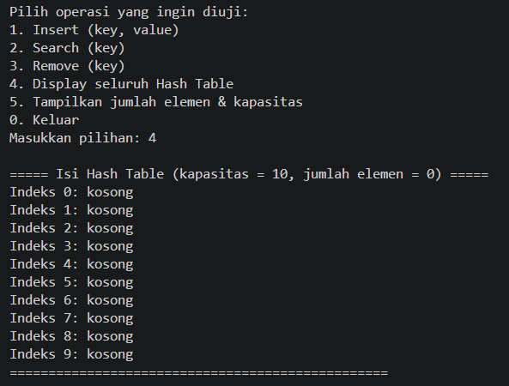
  - Insert Key
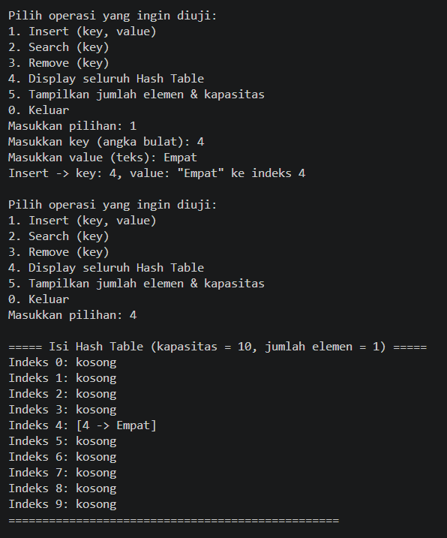
- Search Key
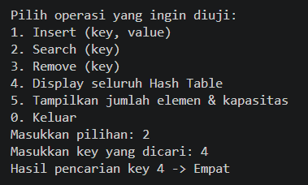
- Delete Key
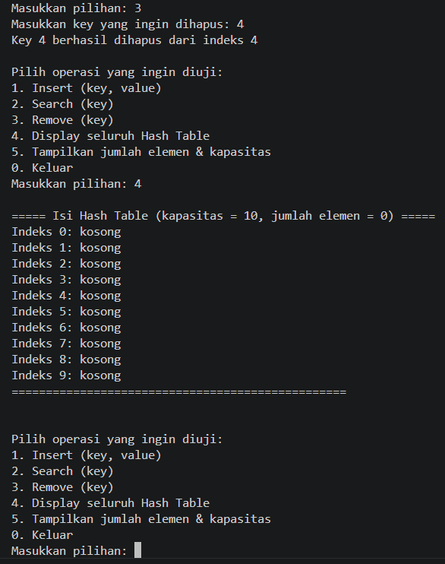
- Show Key
