1) Perform Ansible operations: Create/delete directories on managed nodes and copy local files using Ad-hoc commands.
Before starting:
sudo apt update
sudo apt install ansible -y

Task | Command
Inventory creation | echo "localhost ansible_connection=local" > host
Ping managed node | ansible all -i host -m ping
Create directory | ansible all -i host -m file -a "path=/tmp/mydir state=directory"
Create local file | echo "Hello Ansible" > test.txt
Copy local file | ansible all -i host -m copy -a "src=test.txt dest=/tmp/test.txt"
Verify copied file | cat /tmp/test.txt
Delete directory | ansible all -i host -m file -a "path=/tmp/mydir state=absent"

labex:project/ $ echo "localhost ansible_connection=local" > host
labex:project/ $ cat host
localhost ansible_connection=local
labex:project/ $ ansible all -i host -m ping
localhost | SUCCESS => { "changed": false, "ping": "pong" }
labex:project/ $ ansible all -i host -m file -a "path=/tmp/mydir state=directory"
localhost | SUCCESS => { "state": "directory" }
labex:project/ $ echo "Hello Ansible" > test.txt
labex:project/ $ cat test.txt
Hello Ansible
labex:project/ $ ansible all -i host -m copy -a "src=test.txt dest=/tmp/test.txt"
localhost | CHANGED => { "state": "file" }
labex:project/ $ cat /tmp/test.txt
Hello Ansible
labex:project/ $ ansible all -i host -m file -a "path=/tmp/mydir state=absent"
localhost | CHANGED => { "state": "absent" }

2) Configure a Jenkins job tracking external repository data with a programmatic automated trigger run setting (such as scheduled every minute or tracking code commits).

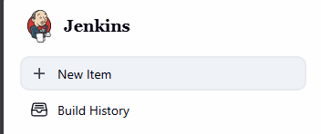

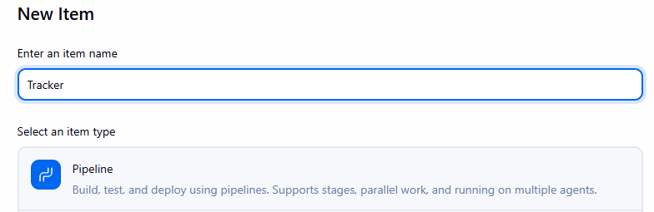



Go to git hub



Re-open repository if add file not showing
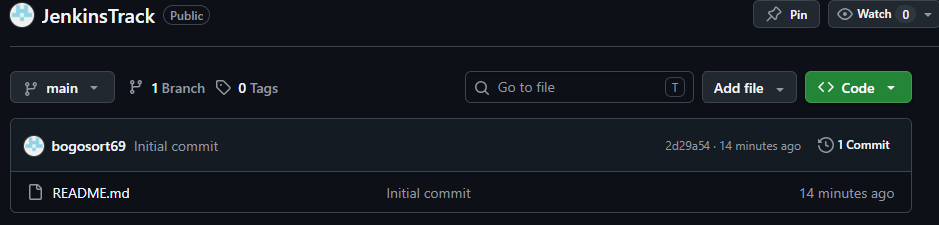


Name file Jenkinsfile (without any extension, not even .txt)


Add this code:
pipeline {
agent any

stages {
stage('Track') {
steps {
echo 'Pipeline triggered successfully'
}
}
}
}
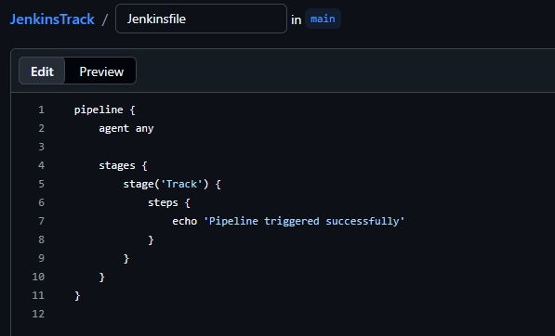

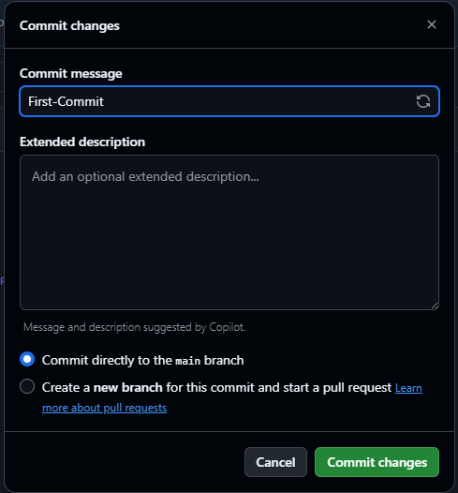


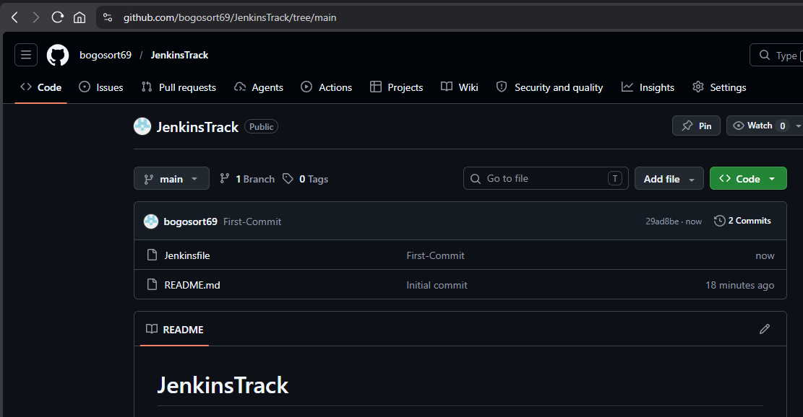
Copy url
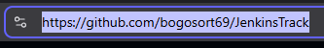
Now back to Jenkins
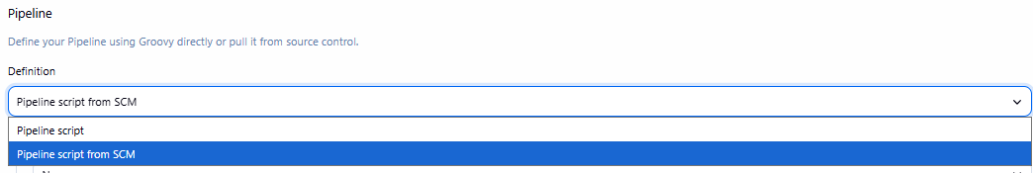
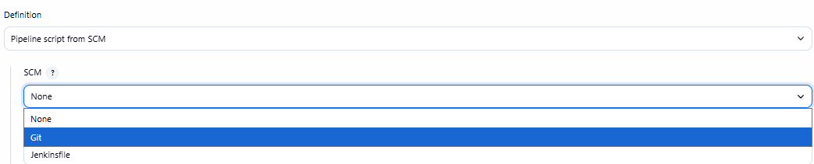

Paste url:
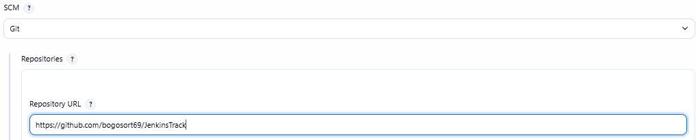
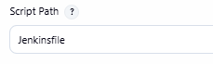
***IMPORTANT: change name to main if the main branch name is main instead of master:
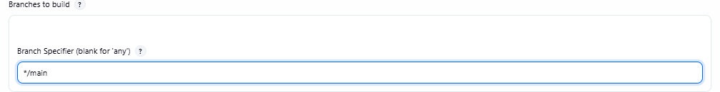

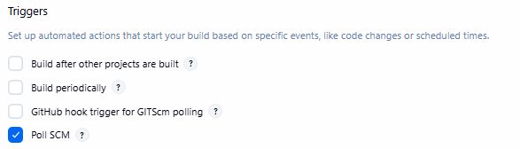
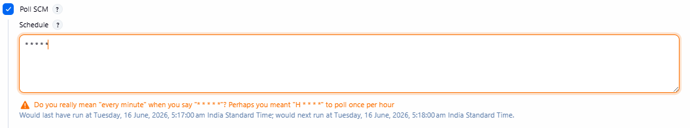


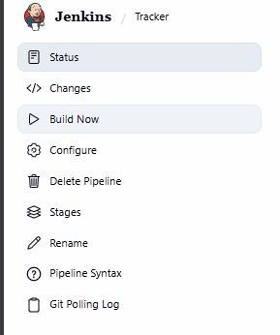

If done correctly:
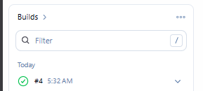
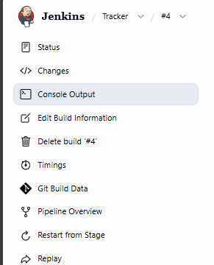
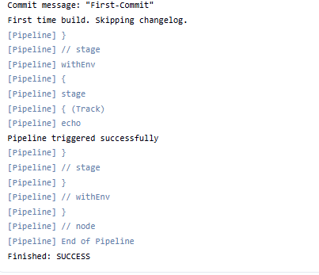

Now go to git hub

Create new file:
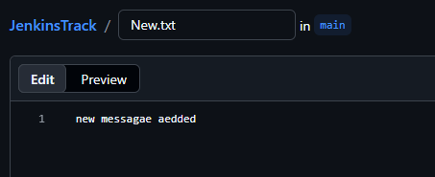


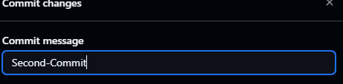


Now when you go back to Jenkins:
Output:
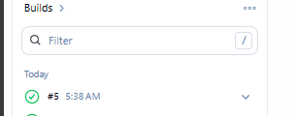
#5 will be automatically added(Tracked)

3)

