Aim: Simulate linear convolution and circular convolution on discrete time signals.

#Linear Convolution:

Program:
import numpy as np
import matplotlib.pyplot as plt

x = np.array([1, 2, 3, 4, 5])
h = np.array([2, 4, 6, 8, 10]) y = np.convolve(x, h)
plt.stem(y)
plt.title('Linear convolution')

plt.xlabel('n')
plt.ylabel('y[n]') plt.grid(True) plt.show()
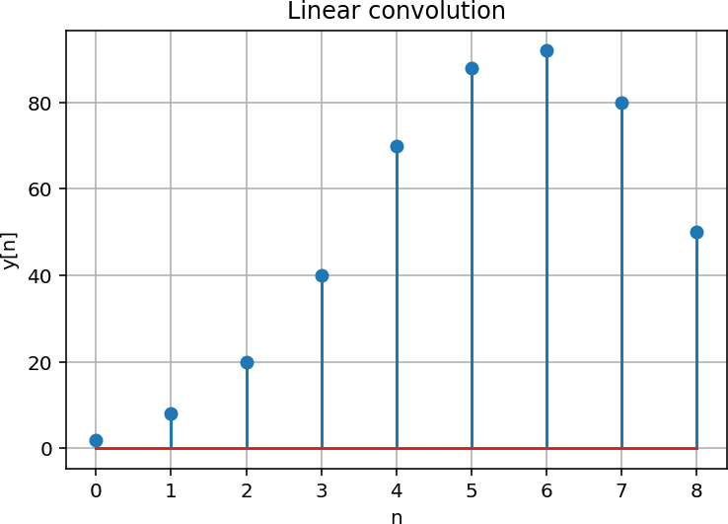

Convolution:
This experiment showed me how linear convolution combines two signals to make a new signal. Every value of the first signal is multiplied with the values of the second signal and then added at different shifted positions. The output signal becomes longer than the input signals and gives the complete result. This helped me understand how convolution is used to combine signals and is commonly used in filtering.

Circular Convolution:

Program:
import numpy as np
import matplotlib.pyplot as plt

x = np.array([1, 2, 3, 4, 5])
h = np.array([2, 4, 6, 8, 10])

N = len(x) + len(h) - 1 X = np.fft.fft(x, N)
H = np.fft.fft(h, N)
y = np.fft.ifft(X * H)
plt.stem(y.real) plt.title('Circular convolution')
plt.xlabel('n')
plt.ylabel('y[n]') plt.grid(True) plt.show()
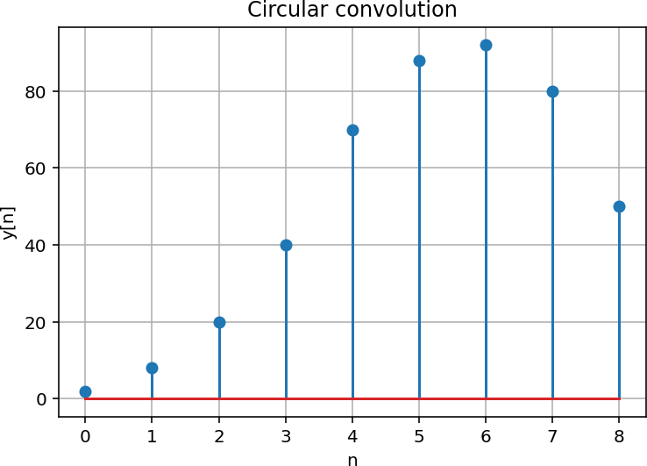

Analysis:
This experiment showed me how circular convolution combines two signals using a fixed length. When the length is small, the extra values wrap around and get added to the starting values, which changes the output. When the length is large enough, no wrap around happens and the result becomes the same as linear convolution. This helped me understand the difference between linear and circular convolution.

Both Together:
Program:
import numpy as np
import matplotlib.pyplot as plt

def linear_convolution(signal1, signal2):
linear = np.convolve(signal1, signal2, mode='full') return linear

def circular_convolution(signal1, signal2): fft_length = len(signal1) + len(signal2) - 1 fft_signal1 = np.fft.fft(signal1, fft_length) fft_signal2 = np.fft.fft(signal2, fft_length) circular = np.fft.ifft(fft_signal1 * fft_signal2) return circular

signal1 = np.array([1, 2, 3, 4, 5])
signal2 = np.array([2, 4, 6, 8, 10])

linear_con = linear_convolution(signal1, signal2) circular_con = circular_convolution(signal1, signal2)

plt.figure(figsize=(10, 6))

plt.subplot(2, 1, 1) plt.stem(linear_con) plt.title('Linear conv.') plt.xlabel('sample') plt.ylabel('amplitude')

plt.subplot(2, 1, 2) plt.stem(circular_con.real) plt.title('Circular conv.') plt.xlabel('sample') plt.ylabel('amplitude')

plt.tight_layout() plt.show()

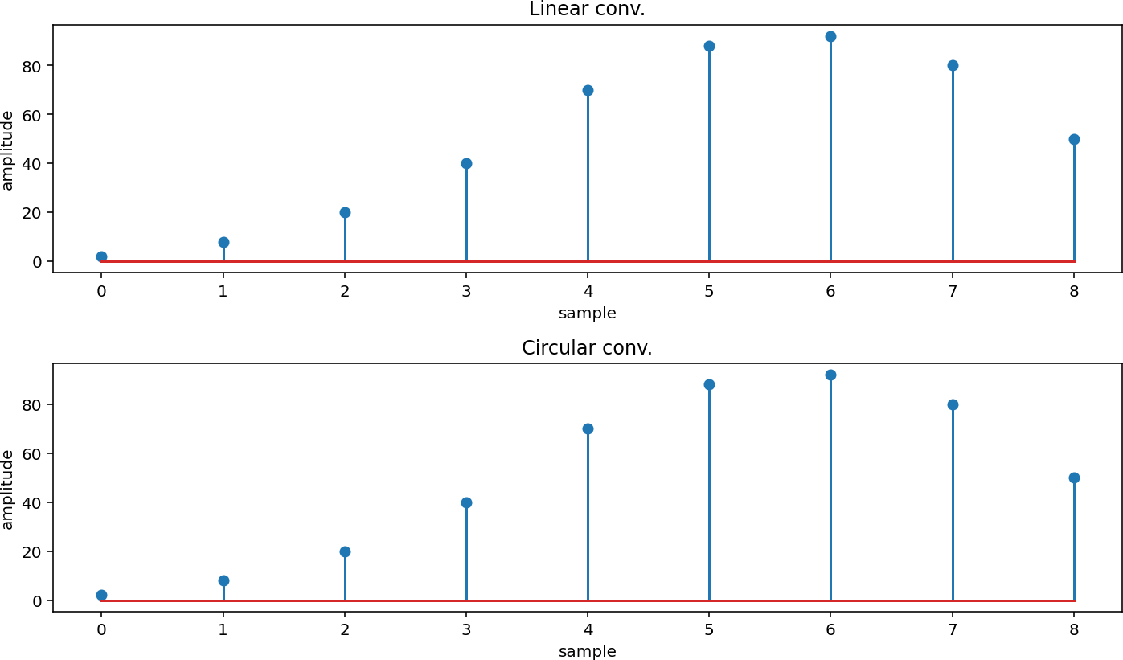
Result:

Conclusion:
This experiment showed me how linear and circular convolution both combine two signals to make a new signal, but they work differently. Linear convolution gives the full result without any wrap around, while circular convolution works with a fixed length and can wrap extra values around if the length is small. In this experiment, the length was chosen properly, so both methods gave the same output. This helped me understand how circular convolution can give the same result as linear convolution when used correctly.

GitHub’s Link:

