
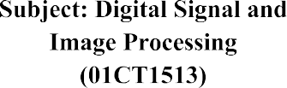 | AIM:Simulate smoothening and sharpening operation on image using spatial filter
Experiment No:9 | 26  21-09-2026 | 92400133058

AIM:Simulate smoothening and sharpening operation on image using spatial filter Introduction
Image smoothing and sharpening are important image-processing operations performed using spatial filters. Spatial filtering processes an image by operating directly on its pixels using a small matrix called a filter or kernel.
- Smoothing reduces noise and unwanted small details from an image.
- Sharpening enhances edges and fine details, making the image appear clearer.

- Spatial Filtering
In spatial filtering, a kernel is moved over the image pixel by pixel. For each position, the neighboring pixels are combined according to the values in the kernel.
For example, a 3 × 3 kernel:
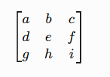

is applied to a corresponding 3 × 3 region of the image. The result produces a new pixel value.

Smoothing
Smoothing is used to reduce noise and small variations in an image. The experiment uses three smoothing techniques:
  - Gaussian Filter
A Gaussian filter performs weighted averaging. Pixels closer to the center receive greater weight. Your experiment uses:
kernel_size = (5, 5)
sigma = 1.5
and creates the Gaussian kernel using:
cv2.getGaussianKernel()
The 1D Gaussian kernel is converted into a 2D kernel using np.outer(), and then applied using cv2.filter2D(). Purpose: Reduce noise and smooth the image.

Averaging Filter
An averaging filter gives equal weight to all pixels inside the kernel. For a 5 × 5 filter:
⎡1 1 1 1 1⎤
1 1 1 1 1 1

The PDF creates this using:
𝐾 = 25 1 1 1 1 1
⎢1 1 1 1 1⎥
[1 1 1 1 1]

kernel = np.ones(kernel_size, dtype=np.float32) / 25 and applies it using cv2.filter2D().
Purpose: Simple image smoothing and noise reduction.

Median Filter
A median filter replaces the current pixel with the median value of its neighboring pixels. The experiment uses a kernel size of:

kernel_size = 5 and applies:
cv2.medianBlur(image, kernel_size)
The kernel size should be an odd number such as 3, 5, or 7.
Main advantage: Median filtering is particularly useful for removing impulse-type noise while preserving edges better than simple averaging.

Sharpening
Sharpening is used to enhance edges and fine details in an image.
Your experiment includes spatial high-pass sharpening using a Laplacian-based kernel:
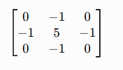

The PDF first applies Gaussian smoothing optionally to reduce noise and then applies this sharpening kernel using cv2.filter2D().
The negative neighboring values emphasize changes between neighboring pixels, while the center value strengthens the original pixel.

Quick Difference
Filter Main purpose Basic idea
Gaussian Smoothing Weighted averaging
Averaging Smoothing Equal averaging
Median Smoothing Replace with median High-pass/Laplacian Sharpening Enhance edges/details

code :
import cv2
import numpy as np
import matplotlib.pyplot as plt
# Load the image
image = cv2.imread(‘/content/aum.jpeg)
image_rgb = cv2.cvtColor(image, cv2.COLOR_BGR2RGB) #
# 1. Gaussian Smoothing #

kernel_size = (5, 5)
sigma = 1.5

# Create 1D Gaussian kernel
gaussian_kernel_1d = cv2.getGaussianKernel(5, sigma)
# Convert 1D kernel into 2D kernel gaussian_kernel = np.outer(
gaussian_kernel_1d, gaussian_kernel_1d
)
print("Gaussian Kernel:") print(gaussian_kernel)

# Apply Gaussian smoothing smoothed_image = cv2.filter2D(

image,
-1,
gaussian_kernel
)
# Convert BGR to RGB smoothed_rgb = cv2.cvtColor(
smoothed_image, cv2.COLOR_BGR2RGB
)

#
# 2. Sharpening #

sharpening_kernel = np.array([ [-1, -1, -1],
[-1, 9, -1],
[-1, -1, -1]
])
# Apply sharpening sharpened_image = cv2.filter2D(
image,
-1,
sharpening_kernel
)

# Convert BGR to RGB sharpened_rgb = cv2.cvtColor(
sharpened_image, cv2.COLOR_BGR2RGB
)

#
# 3. Display using Matplotlib #
plt.figure(figsize=(15, 5)) # Original
plt.subplot(1, 3, 1) plt.imshow(image_rgb) plt.title("Original Image") plt.axis("off")
# Smoothed plt.subplot(1, 3, 2)
plt.imshow(smoothed_rgb) plt.title("Gaussian Smoothed") plt.axis("off")

# Sharpened plt.subplot(1, 3, 3)
plt.imshow(sharpened_rgb) plt.title("Sharpened Image") plt.axis("off")

plt.tight_layout() plt.show()

output:
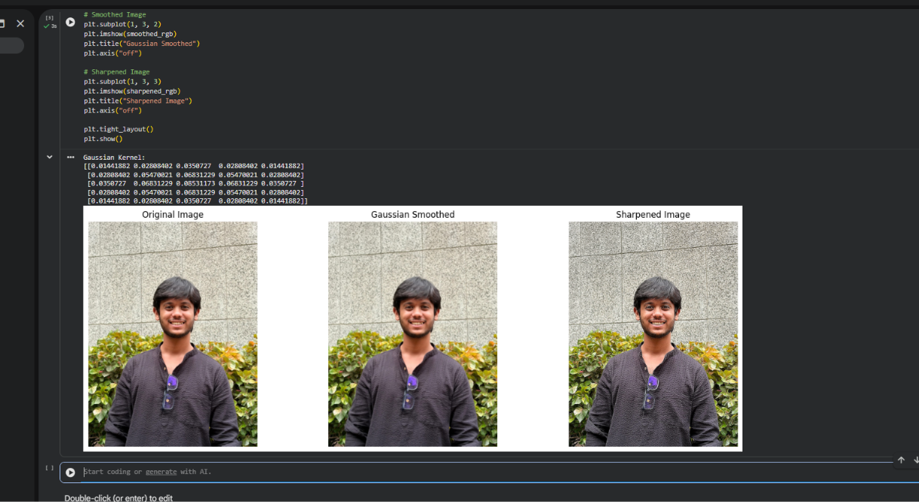

Observation:
- The Gaussian filter smooths the image by reducing noise and fine details using a weighted average of neighboring pixels.
- The averaging filter produces a smoother image by assigning equal weights to all pixels within the filter window.
- The median filter smooths the image by replacing pixel values using the median of the neighborhood. It is applied with an odd-sized kernel.
- The spatial high-pass/Laplacian filter enhances edges and fine details, producing a sharper image.

Conclusion:
Spatial smoothing filters reduce noise and unwanted details, while spatial sharpening filters enhance edges and fine details directly by operating on neighboring pixels using a kernel.

GitHub Link: http://github.com/aumdave1979/DSIP/tree/main/Exp9

