
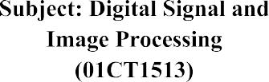 | AIM: Apply non-linear filters on images and investigate its application in noise-removal
Experiment No:10 | 26 | 92400133058
AIM: Apply non-linear filters on images and investigate its application in noise-removal
Theory:
Non-linear filters are image processing techniques used for noise removal by considering the local neighborhood of each pixel. Unlike linear filters, non-linear filters modify pixel values based on their relationship with neighboring pixels, allowing them to effectively suppress different types of noise.
Flowchart:
The flowchart for the program will consist of the following steps: Load the input image. Apply the desired non-linear filter to remove noise. Display the original image and the filtered image side by side. Save the filtered image (optional).
Program:
import cv2
import numpy as np
Import google.colab.patches import cv2_imshow

def apply_median_filter(image, kernel_size):
# Apply median filter to remove noise
filtered_image = cv2.medianBlur(image, kernel_size)
return filtered_image

def apply_bilateral_filter(image, d, sigma_color, sigma_space):
# Apply bilateral filter to remove noise while preserving edges
filtered_image = cv2.bilateralFilter(
image, d, sigma_color, sigma_space
)
return filtered_image

# --------------------------------------------------
# Load the input image
# --------------------------------------------------

image_path = "/content/aum.jpeg"
input_image = cv2.imread(image_path)

# Check if image is loaded successfully
if input_image is None:
print("Error: Could not load the image.")
print("Check whether 'imagebright.png' exists in the current folder.")
exit()

# --------------------------------------------------
# Apply Median Filter
# --------------------------------------------------

median_filtered_image = apply_median_filter(
input_image,
kernel_size=5
)

# --------------------------------------------------
# Apply Bilateral Filter
# --------------------------------------------------

bilateral_filtered_image = apply_bilateral_filter(
input_image,
d=9,
sigma_color=75,
sigma_space=75
)

# --------------------------------------------------
# Resize images for proper display
# --------------------------------------------------

width = 400
height = 300

original_resized = cv2.resize(
input_image,
(width, height)
)

median_resized = cv2.resize(
median_filtered_image,
(width, height)
)

bilateral_resized = cv2.resize(
bilateral_filtered_image,
(width, height)
)

# --------------------------------------------------
# Combine images horizontally
# --------------------------------------------------

combined_image = np.hstack(
(
original_resized,
median_resized,
bilateral_resized
)
)

# --------------------------------------------------
# Display result
# --------------------------------------------------

cv2.imshow(
"Original | Median Filtered | Bilateral Filtered",
combined_image
)

cv2.waitKey(0)
cv2.destroyAllWindows()

# --------------------------------------------------
# Save filtered images
# --------------------------------------------------

median_filtered_path = "median_filtered_image.jpg"
bilateral_filtered_path = "bilateral_filtered_image.jpg"

cv2.imwrite(
median_filtered_path,
median_filtered_image
)

cv2.imwrite(
bilateral_filtered_path,
bilateral_filtered_image
)

print("Median filtered image saved at:",
median_filtered_path)

print("Bilateral filtered image saved at:",
bilateral_filtered_path)
output:
observations:
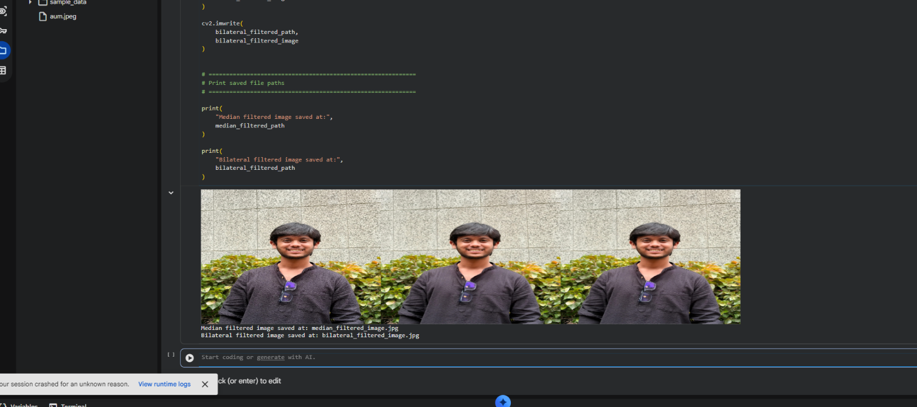
conclusion:
Github Link:
https://github.com/aumdave1979/DSIP/tree/main/Exp10

