Aim:
Simulate cross correlation and autocorrelation on discrete time signals.

Cross Correlation:
Definition:
Cross correlation is a way to check how much two different signals are same. We slide one signal over the other signal. At each shift we get one value. That value tells us how much they match at that shift.

Simple Explanation:

The formula for cross correlation of two discrete signals x[n] and y[n] is this:
r(k) = Σ x[n] * y[n - k]
Here k is the shifting value.

This experiment showed me how cross-correlation can be used to find the shift between two similar signals. One signal is shifted step by step over the other signal, and at each shift the matching values are multiplied and added together. When the value is large, it means the two signals match well at that particular shift. This helped me understand how cross- correlation is useful for finding the time delay between signals.

Applications of Cross-Correlation
- Finding time delay: Used to find the time difference between two similar signals.
- Signal synchronization: Helps synchronize signals in communication systems.
- Radar and sonar: Used to detect the position and distance of objects.
- Audio processing: Helps find similarities between audio signals and identify delays.
- Image processing: Used to find a particular pattern or object inside an image.
- Speech recognition: Helps compare and match speech signals.
- Communication systems: Used to detect and recover transmitted signals from noisy signals.

Example:
Take two signals.
sig1 = [1, 2, 3, 4, 5]
sig2 = [3, 6, 9, 12, 15]
Here sig2 is sig1 multiplied by 3, so both signals have the same shape. Only their scale is different. Because their shape is the same, the highest cross-correlation value comes at shift zero. This is because both signals line up perfectly at shift zero. When we move away from shift zero, fewer samples overlap, so the correlation value becomes smaller.

Auto Correlation:

Definition:
Auto correlation is a special type of cross correlation. Here we do not compare two different signals. We compare one signal with its own shifted copy.

Explanation:
The formula is this. r(k) = Σ x[n] * x[n - k]

In autocorrelation we take only one signal and compare it with itself at different shifts. When there is no shift, the signal matches completely with itself, so the highest value comes at shift zero. This highest value represents the energy of the signal. As we increase the shift on either side, fewer values overlap, so the correlation value becomes smaller. Because of this, the autocorrelation graph is symmetric on both sides of shift zero.

Application:

Auto correlation is used in many places. It is used to find repeating pattern inside a signal. It is used to detect noise in a signal. It is used to measure the energy of a signal.

Example:
Take a signal sig1 = [1, 2, 3, 4, 5]. In autocorrelation, we compare this signal with a shifted version of the same signal. At shift zero, all the values match with their original positions, so the correlation is maximum. As we move the signal to the left or right, the number of overlapping values decreases, so the correlation also decreases. This gives a symmetric autocorrelation graph with the highest point at shift zero.

Code:
import numpy as np
import matplotlib.pyplot as plt

# two signals
sig1 = np.array([1, 2, 3, 4, 5])
sig2 = np.array([2, 4, 6, 8, 10])

cross = np.correlate(sig1, sig2, mode='full') auto = np.correlate(sig1, sig1, mode='full')

shift = np.arange(-(len(sig1) - 1), len(sig1)) print("sig1 :", sig1)

print("sig2 :", sig2)
print("cross correlation :", cross) print("auto correlation :", auto)

# cross correlation: plt.subplot(2, 1, 1) plt.stem(shift, cross)
plt.title('Cross correlation of sig1 and sig2') plt.xlabel('shift')
plt.ylabel('amplitude') plt.grid(True)

# auto correlation: plt.subplot(2, 1, 2) plt.stem(shift, auto)
plt.title('Auto correlation of signal1') plt.xlabel('shift') plt.ylabel('amplitude')
plt.grid(True)

plt.tight_layout() plt.show()

Result:
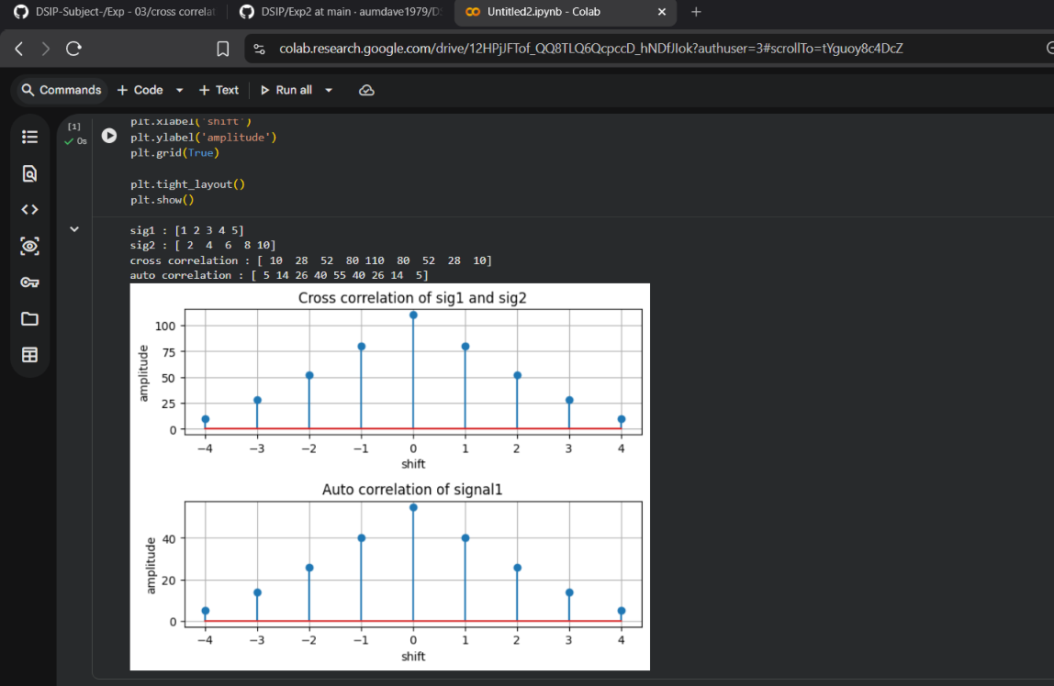

Conclusion:

Cross correlation and auto correlation are useful tools in digital signal processing. Cross correlation is used to compare two different signals at different shifts, while auto correlation compares a signal with its own shifted copy. In both cases, the highest value shows where the signals match the most. In auto correlation, the highest value comes at shift zero and this value is equal to the energy of the signal.
Both operations follow almost the same method. At each shift, we multiply the matching values of the signals and then add them together. The main difference is that cross correlation uses two different signals, while auto correlation uses the same signal with itself.
This experiment helped me understand how correlation can be used to compare signals, find the best matching position, and identify patterns. These concepts are useful in applications like radar, sonar, and speech processing.

GitHub’s Link:

