Aim: Design Butterworth and Chebyshev filter using bilinear transformation method.

Theory:

Bilinear Transformation Method
The Bilinear Transformation Method is used to convert an analog filter into a digital filter. Analog filters work with continuous-time signals, while digital filters work with discrete-time signals. This method helps us convert an analog filter design into a digital filter that can be implemented using a computer or digital signal processor.

Advantages:

  - It converts analog filters into digital filters.
  - It avoids frequency aliasing during the transformation.
  - It provides a stable digital filter when the original analog filter is stable.

Butterworth Filter
A Butterworth filter is a type of filter that provides a maximally flat frequency response in the passband. This means that the output does not contain ripples in the passband, and the response changes smoothly.

It is commonly used when a smooth and uniform frequency response is required. Butterworth filters are available as low-pass, high-pass, band-pass, and band-stop filters.

Advantages:

  - It has a smooth frequency response.
  - It does not have ripples in the passband.
  - It is suitable for applications where signal quality and smoothness are important.

Applications:

  - Audio signal processing.
  - Noise reduction.
  - Communication systems.
  - Biomedical signal processing.

Chebyshev Filter
A Chebyshev filter is a type of filter that provides a sharper transition between the passband and stopband compared to a Butterworth filter of the same order. It achieves this sharper transition by allowing ripples in either the passband or the stopband, depending on the type of Chebyshev filter.

There are two main types of Chebyshev filters:

  - Type I: Allows ripples in the passband while maintaining a smooth response in the stopband.
  - Type II: Maintains a smooth response in the passband but allows ripples in the stopband.

Advantages:

  - It provides a sharper frequency transition than a Butterworth filter of the same order.
  - It can achieve the required filtering with a lower filter order in some designs.
  - It is useful when strong separation between wanted and unwanted frequencies is required.

Applications:

  - Communication systems.
  - Audio processing.
  - Signal filtering.
  - Electronic measurement systems.

Program:

import numpy as np
import matplotlib.pyplot as plt
from scipy.signal import butter, bilinear, freqz, cheby1, lfilter

def design_butterworth_filter(filter_order, cutoff_frequency, sampling_frequency): analog_b, analog_a = butter(
filter_order, cutoff_frequency, analog=True, btype='low'
)

digital_b, digital_a = bilinear( analog_b,
analog_a, fs=sampling_frequency

)

return digital_b, digital_a

def design_chebyshev_filter(filter_order, cutoff_frequency, sampling_frequency, ripple): analog_b, analog_a = cheby1(
filter_order, ripple, cutoff_frequency, analog=True, btype='low'
)
digital_b, digital_a = bilinear( analog_b,
analog_a, fs=sampling_frequency
)

return digital_b, digital_a

def plot_filter_response(digital_b, digital_a, sampling_frequency): frequency, magnitude_response = freqz(
digital_b, digital_a,
fs=sampling_frequency
)

plt.figure(figsize=(10, 6))
plt.plot(frequency, np.abs(magnitude_response)) plt.title('filter magnitude response') plt.xlabel('frequency (Hz)') plt.ylabel('magnitude')
plt.grid(True) plt.show()
impulse = np.zeros(100) impulse[0] = 1

impulse_response = lfilter(digital_b, digital_a, impulse)

plt.figure(figsize=(10, 6)) plt.stem(range(len(impulse_response)), impulse_response) plt.title('filter impulse response')
plt.xlabel('sample') plt.ylabel('amplitude') plt.grid(True) plt.show()

filter_order = 4
cutoff_frequency = 1000
sampling_frequency = 8000
ripple = 0.5
digital_b, digital_a = design_butterworth_filter( filter_order,
cutoff_frequency, sampling_frequency
)
print("Butterworth filter coefficients:") print("numerator:", digital_b) print("denominator:", digital_a)
plot_filter_response(digital_b, digital_a, sampling_frequency) digital_b, digital_a = design_chebyshev_filter(
filter_order, cutoff_frequency, sampling_frequency, ripple
)
print("Chebyshev filter coefficients:") print("numerator:", digital_b) print("denominator:", digital_a)

plot_filter_response(digital_b, digital_a, sampling_frequency) filter_path = 'filter_coefficients.txt'
np.savetxt(filter_path, np.vstack((digital_b, digital_a)), delimiter=',') print(f"Filter coefficients saved at: {filter_path}")

Output:
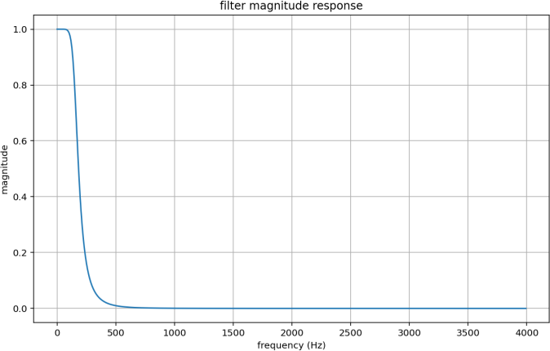
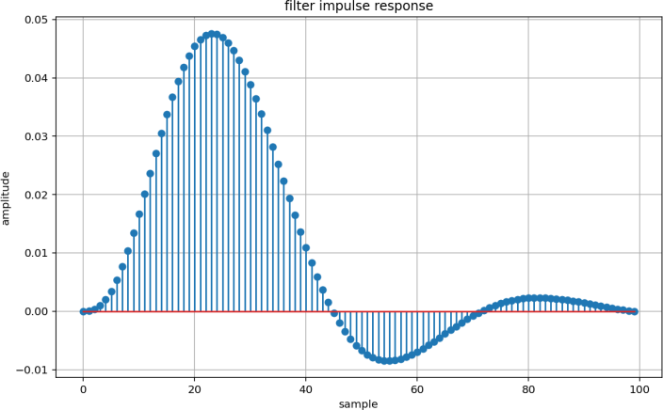
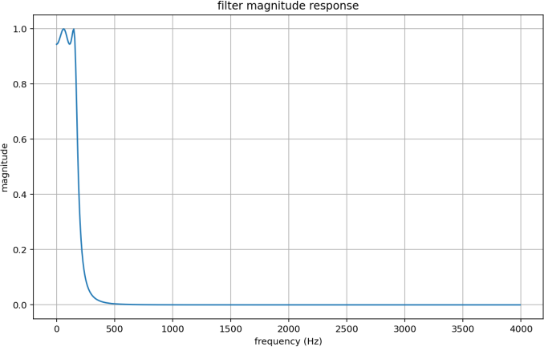
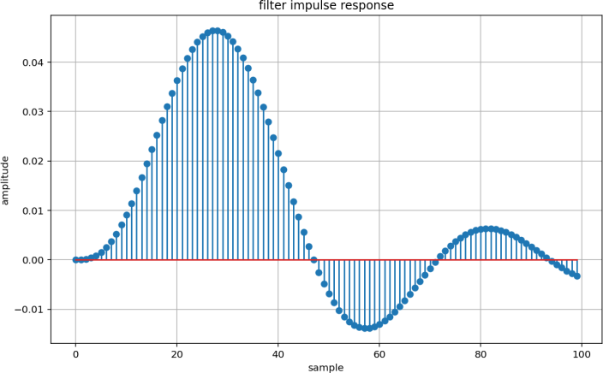
Both filters output plot:

Observation:

- Passband: Butterworth is smooth at 1.0. while Chebyshev has small ripples within the 0.5 dB limit.
- Transition band: Chebyshev drops faster than Butterworth near the cutoff frequency.
- Stopband: Both filters reduce the signal close to 0 up to 4000 Hz.
- Impulse response: Butterworth reaches a peak of about 0.047 at sample 24. while Chbeyshev peaks around sample 28.
- Difference: Chebyshev has a larger second peak (0.006) than Butterworth (0.002) and takes longer to settle.

Conclusion:

→In this experiment, 4th-order Butterworth and Chebyshev Type I low-pass filters were designed at a sampling frequency of 8000 Hz.

→The Butterworth filter has a smooth passband and settles faster. The Chebyshev filter has small ripples of 0.5 dB and a sharper cutoff. but it shows more oscillations. Both filters reduce high-frequency signals.

→The cutoff frequency in the report should match the frequency used in the plots. The plots appear to show a cutoff of about 150 Hz not 1000 Hz.

Extra Task
Task 1: Generate and plot 1, 2, 3, 4 kHz sine waves.

Code:

import numpy as np
import matplotlib.pyplot as plt
fs = 16000
duration = 0.01
frequencies = [1000, 2000, 3000, 4000] t = np.arange(0, duration, 1 / fs)
fig, axes = plt.subplots(4, 1, figsize=(11, 10)) for ax, f in zip(axes, frequencies):
x = np.sin(2 * np.pi * f * t) ax.stem(t * 1000, x, basefmt="k-")
ax.set_title(f"Discrete Sine Wave - {f // 1000} kHz") ax.set_xlabel("Time (ms)") ax.set_ylabel("Amplitude")
ax.grid(True)
plt.tight_layout() plt.show()

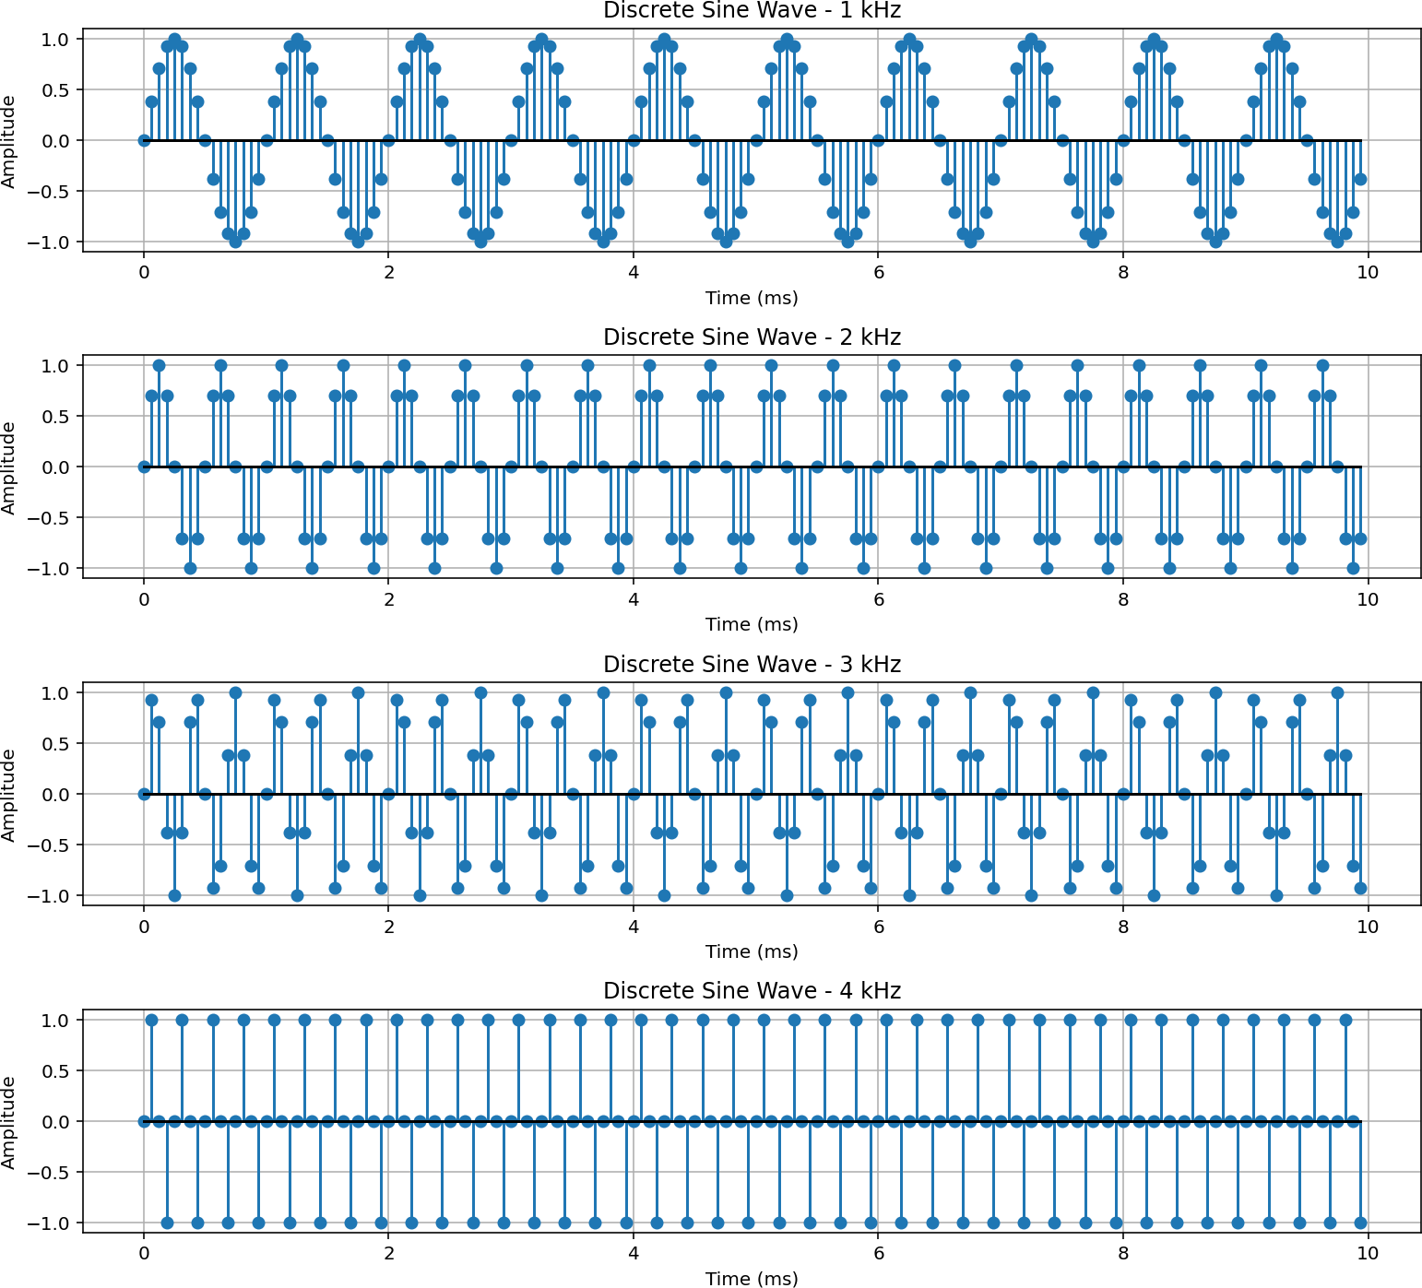
Output:
Observation:
- Four sine waves of 1, 2, 3 and 4 kHz were generated at fs = 16 kHz with amplitudes between -1 and +1.
- As frequency increases the number of cycles in 10 ms increases from 10 to 40.
- Samples per cycle decrease from 16 to 4. so the higher frequency waves look less smooth.
- All frequencies are below the Nyquist frequency of 8 kHz. so no aliasing occurs.

Task 2: Add all four signals, plot in time and frequency domain.
Code: (Extra part from the task1) # Add all 4 sine waves...
combined_signal = sum(np.sin(2 * np.pi * f * t) for f in frequencies)

spectrum = np.fft.rfft(combined_signal)
freq_axis = np.fft.rfftfreq(len(combined_signal), d=1 / fs) magnitude = np.abs(spectrum) / len(combined_signal) magnitude[1:-1] *= 2

fig, axes = plt.subplots(2, 1, figsize=(11, 8)) axes[0].plot(t * 1000, combined_signal) axes[0].set_title("Combined Signal - Time Domain") axes[0].set_xlabel("Time (ms)") axes[0].set_ylabel("Amplitude")
axes[0].grid(True)

axes[1].plot(freq_axis / 1000, magnitude) axes[1].set_title("Combined Signal - Frequency Domain") axes[1].set_xlabel("Frequency (kHz)") axes[1].set_ylabel("Magnitude")
axes[1].grid(True) axes[1].set_xlim(0, fs / 2000)

plt.tight_layout() plt.show()

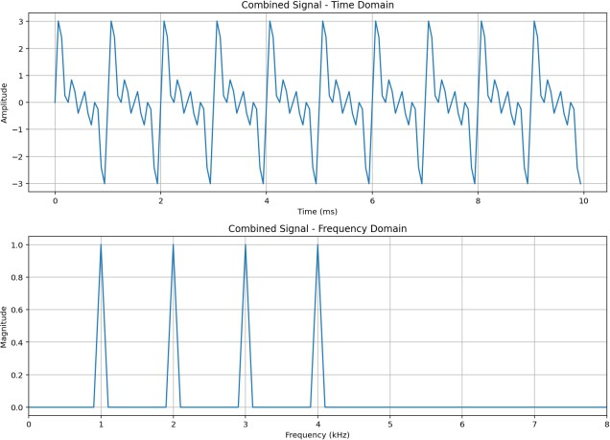
Output:
Observation (Task 2: Combined Signal)

- The combined signal is the sum of four sine waves. so its amplitude is about -3 to +3.
- The signal repeats every 1 ms and has a complex shape.
- The frequency plot shows four peaks at 1, 2, 3 and 4 kHz. each with magnitude 1.
- No other frequency components are present in the signal.
- The time plot shows the overall signal. while the frequency plot clearly shows the four frequencies.

Task 3: Butterworth low-pass filter (2 kHz cutoff).

Code:
#apply Butterworth filter
b, a = butter(filter_order, cutoff, btype="low", fs=fs) output = lfilter(b, a, combined_signal)

print("Numerator coefficients:", b) print("Denominator coefficients:", a)
spectrum = np.fft.rfft(output)
freq_axis = np.fft.rfftfreq(len(output), d=1 / fs) magnitude = np.abs(spectrum) / len(output) magnitude[1: -1] *= 2
fig, axes = plt.subplots(2, 1, figsize=(11, 8)) axes[0].plot(t * 1000, output)
axes[0].set_title("butterworth o/p - time domain (2 kHz cutoff)")
axes[0].set_xlabel("Time (ms)") axes[0].set_ylabel("amplitude") axes[0].grid(True)

axes[1].plot(freq_axis / 1000, magnitude) axes[1].set_title("butterworth o/p - freq. domain") axes[1].set_xlabel("frequency (kHz)") axes[1].set_ylabel("magnitude") axes[1].grid(True)
axes[1].set_xlim(0, fs / 2000)

plt.tight_layout() plt.show()

Observation:
The output amplitude (-1.4 to +1.6) is smaller than the input (-3 to +3). B’coz the high-freq content is reduced.

- The 1 kHz component passes almost unchanged (about 0.96).
- The 2 kHz component at the cutoff drops to about 0.66 (aound 70%). which matches the -3 dB point.
- The 3 kHz component is reduced a lot and the 4 kHz component is almost removed (about 0.03). so frequencies above the cutoff are attenuated gradually not cut sharply.

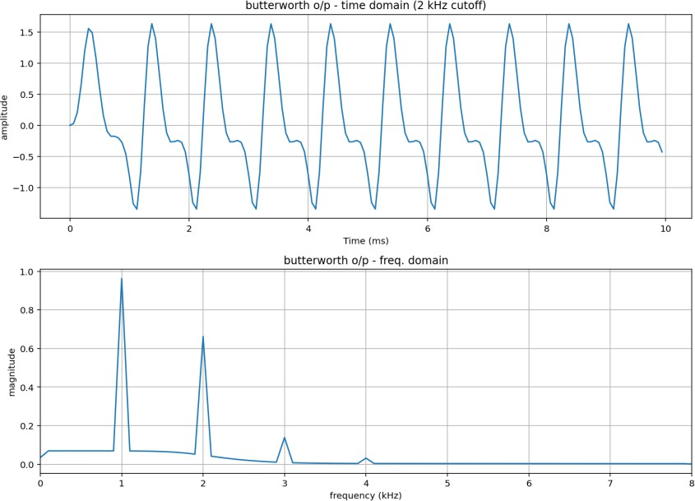
Output:

Task 4: Chebyshev Type-I low-pass filter (3 kHz cutoff).

Code:
#apply Chebyshev Type1 filter...
b, a = cheby1(filter_order, ripple, cutoff, btype="low", fs=fs) output = lfilter(b, a, combined_signal)

print("Numerator coefficients:", b) print("Denominator coefficients:", a)

# single-sided amplitude spectrum spectrum = np.fft.rfft(output)
freq_axis = np.fft.rfftfreq(len(output), d=1 / fs) magnitude = np.abs(spectrum) / len(output) magnitude[1:-1] *= 2
fig, axes = plt.subplots(2, 1, figsize=(11, 8)) axes[0].plot(t * 1000, output)
axes[0].set_title("Chebyshev O/p - time domain (3 kHz cutoff)") axes[0].set_xlabel("Time")
axes[0].set_ylabel("amplitude")

axes[0].grid(True)

axes[1].plot(freq_axis / 1000, magnitude) axes[1].set_title("Chebyshev O/p - freq domain") axes[1].set_xlabel("Freq (kHz)") axes[1].set_ylabel("magnitude") axes[1].grid(True)
axes[1].set_xlim(0, fs / 2000)

plt.tight_layout() plt.show()

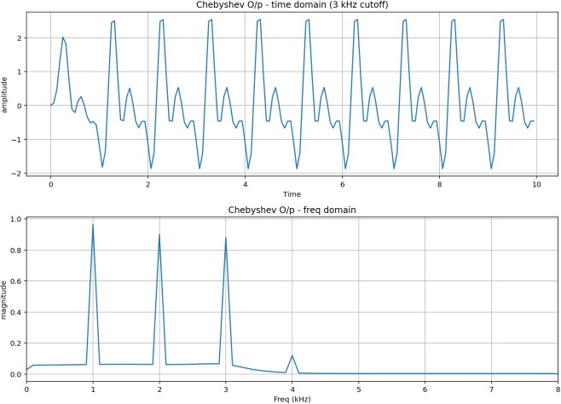
Output:
Observation:
- The output amplitude is about -1.9 to +2.5. which is larger than the Butterworth output.
- The 1, 2 and 3 kHz components remain close to their
original values (0.96, 0.90 and 0.88).
- The 4 kHz component is reduced to about 0.12. so it is strongly attenuated.
- Compared to Butterworth, Chebyshev keeps the 3 kHz component better (0.88 vs 0.14) and has a sharper transition.

Overall Conclusion:
In this experiment four sine waves of 1, 2, 3 and 4 kHz were generated and combined. The frequency plot showed four clear peaks at these frequencies. The Butterworth filter reduced frequencies above 2 kHz smoothly while the Chebyshev filter kept freq. up to 3 kHz and reduced 4 kHz more sharply. Butterworth has a smooth passband while Chebyshev has small ripples. This shows how both filters reduce unwanted high freq. components differently.

GitHub’s Work Link:
https://github.com/Dharmik2005-Godalka/DSIP-Subject-/tree/main/Exp%20-%2004

