Aim: Perform FFT and IFFT on discrete time signal.

Theory:

Some Basic Information About the Terms

FFT (Fast Fourier Transform)
→ FFT is a fast technique used to break a signal into its different frequency components. It helps us identify which frequencies are present in the signal.

IFFT (Inverse Fast Fourier Transform)
→ IFFT performs the reverse operation of FFT by combining the frequency components back together. It helps us obtain the original signal in the time domain.

Magnitude Spectrum
→ The magnitude spectrum represents the strength or size of each frequency component in a signal. A higher peak in the graph indicates that the corresponding frequency is stronger.

Phase Spectrum
→ The phase spectrum represents the starting position or shift of each frequency component. It shows where each wave starts in relation to the other waves.

Program:
import numpy as np
import matplotlib.pyplot as plt signal = np.array([1,2,3,4,5,6,7,8])
fft_result = np.fft.fft(signal) print(fft_result)

magnitude_spectrum = np.abs(fft_result)

print(magnitude_spectrum)

phase_spectrum = np.angle(fft_result) print(phase_spectrum)
reconstructed_signal = np.fft.ifft(fft_result) print(reconstructed_signal)

sample_index = np.arange(len(signal)) plt.figure(figsize=(12,10))
#plot-1 plt.subplot(2,2,1)
plt.stem(sample_index,signal) plt.title('Original Signal') plt.xlabel('Frequency Index') plt.ylabel('Amplitude') plt.grid(True)

#plot-2 plt.subplot(2,2,2)
plt.stem(sample_index,magnitude_spectrum) plt.title('MAGNITUDE SIGNAL')
plt.xlabel('Frequency Index') plt.ylabel('Magnitude Spectrum') plt.grid(True)
#plot-3 plt.subplot(2,2,3)
plt.stem(sample_index,phase_spectrum) plt.title('PHASE SIGNAL') plt.xlabel('Frequency Index') plt.ylabel('Phase Spectrum') plt.grid(True)

#plot 4 plt.subplot(2,2,4)
plt.stem(sample_index,reconstructed_signal) plt.title('RECONSTRUCTED SIGNAL')
plt.xlabel('Frequency Index') plt.ylabel('Reconstructed Signal') plt.grid(True)

Output:

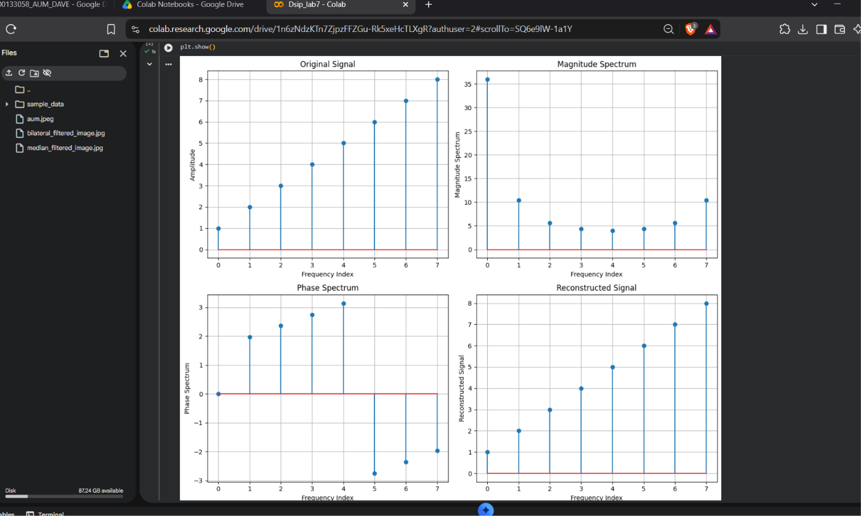
→Original Signal: This graph shows the input signal, which goes up step by step from 1 to 8.
→Magnitude Spectrum: This graph shows how strong each frequency is. The first value (0) is the biggest at 36. so most of the signal's strength is in the average (DC) part.
→Phase Spectrum: This graph shows the shift of each frequency wave, with values between about -3 and +3 radians.
→Reconstructed Signal: This graph is the output of the IFFT, and it looks exactly the same as the original signal (1 to 8).

Conclusion:
we used FFT to change a discrete time signal into its frequency form and found its magnitude and phase spectrum. Then we used IFFT to change it back to the time signal. The reconstructed signal was the same as the original signal, which shows that no information is lost in FFT and IFFT.

GitHub’s Link:
https://github.com/aumdave1979/DSIP/tree/main/Exp5

