
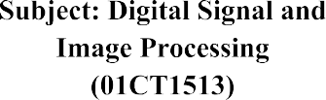 | AIM: Generate Histogram of Images,apply Histogram Equalization and Histogram matching on it
Experiment No:8 | 26  22-09-2026 | 92400133058

Introduction:

Image Histogram
An image histogram is a graph that shows how the pixel intensity values are distributed in an image. It helps us understand whether the image is mostly dark, bright, or somewhere in between.
- The X-axis shows the pixel intensity values.
- The Y-axis shows how many pixels have each intensity value.
For a grayscale image, the intensity usually ranges from 0 (black) to 255 (white). In a color image, we can create separate histograms for the Red, Green, and Blue (RGB) channels.

Uses of Histogram
Histograms are useful for:
- Adjusting the brightness and contrast of an image.
- Improving the overall appearance of an image.
- Understanding the distribution of pixel values.
- Performing techniques such as histogram equalization and histogram matching.

Histogram Equalization:
Histogram equalization is a technique used to improve the contrast of an image. It works by redistributing the pixel intensity values so that the details in the image become easier to see.
It is especially useful when an image has low contrast and looks faded or unclear. The main goal is to spread the intensity values across the available range, which can make the image look clearer and improve its overall appearance.

Calculation Steps: Steps

Steps of Histogram Equalization

1. Calculate the Histogram
First, we find the histogram of the input image. It shows how the pixel intensity values are distributed. For a grayscale image, the values usually range from 0 (black) to 255 (white).

2. Calculate the Cumulative Distribution Function (CDF)
Next, we calculate the CDF from the histogram. It is the running total of the pixel frequencies and tells us how many pixels have an intensity value less than or equal to a particular value.

3. Normalize the CDF
The CDF is then normalized so that its values fit within the complete intensity range. For an 8-bit grayscale image, this range is 0 to 255.

4. Map the Intensity Values
Finally, the original pixel values are replaced using the corresponding values from the normalized CDF. This produces the equalized image.
As a result, the intensity values are spread across a wider range, which usually improves the contrast and visible details of the image.

Advantages and Limitations
Histogram equalization is useful for improving the contrast of images, especially when the original image looks dull or unclear. It can be useful in areas such as medical images, satellite images, and old photographs.
However, it does not work perfectly for every image. If an image already has good contrast, histogram equalization may create unwanted effects or unnatural-looking results.

Histogram matching, also called histogram specification, is a technique used to change the histogram of one image so that it becomes similar to the histogram of another image.
Here, the first image is called the source image, and the second image is called the reference image.
The main purpose is to transfer the brightness, contrast, and overall tonal appearance of the reference image to the source image. It is useful when we want one image to have a similar visual look to another image.

Steps in Histogram Matching Compute histograms for each image Take the reference image histogram
Update the pixel intensity values in the input image using the reference histogram, such that they match
The result is a new image (the matched image) with a histogram that closely resembles the histogram of the reference image. This process can be used to align the tonal characteristics and contrast of the source image with those of the reference image. The matched image will have a similar overall tonal distribution, which can be particularly useful for tasks such as style transfer or color correction.

Histogram matching is a powerful tool in image processing, and it can be employed in various applications, including medical image analysis, color grading in photography and film, and improving the consistency of images in computer vision tasks.

source_hist /= source_hist.sum() is an example of in-place normalization of a histogram. Histogram normalization is a technique used to ensure that the values in the histogram represent a probability distribution, meaning that the sum of all values in the histogram equals 1.

This operation divides each element of the source_hist array by the total count of pixels. This operation scales the histogram values so that they represent a probability distribution.

Code:
import cv2
import numpy as np
import matplotlib.pyplot as plt import os

image = cv2.imread(‘/content/aum.jpeg’, cv2.IMREAD_GRAYSCALE) if image is None:
raise FileNotFoundError(
f"Source image not found:\n{source_path}"
)

# ============================================================ # 3. CALCULATE ORIGINAL HISTOGRAM
# ============================================================

histogram = cv2.calcHist( [image],
[0],
None, [256],
[0, 256]
)

# ============================================================ # 4. DISPLAY ORIGINAL HISTOGRAM
# ============================================================
plt.figure(figsize=(8, 6)) plt.title("Original Image Histogram") plt.xlabel("Pixel Value") plt.ylabel("Frequency") plt.plot(histogram)
plt.xlim([0, 256]) plt.grid(True) plt.show()

# ============================================================ # 5. HISTOGRAM EQUALIZATION
# ============================================================

equalized_image = cv2.equalizeHist(image)
# ============================================================

# 6. DISPLAY ORIGINAL AND EQUALIZED IMAGES
# ============================================================

plt.figure(figsize=(10, 5))
plt.subplot(1, 2, 1) plt.title("Original Image") plt.imshow(image, cmap="gray") plt.axis("off")

plt.subplot(1, 2, 2) plt.title("Equalized Image")
plt.imshow(equalized_image, cmap="gray") plt.axis("off")

plt.tight_layout() plt.show()
# ============================================================ # 7. CALCULATE EQUALIZED HISTOGRAM
# ============================================================

equalized_histogram = cv2.calcHist( [equalized_image],
[0],
None, [256],
[0, 256]
)
# ============================================================ # 8. DISPLAY EQUALIZED HISTOGRAM
# ============================================================
plt.figure(figsize=(8, 6)) plt.title("Equalized Image Histogram") plt.xlabel("Pixel Value") plt.ylabel("Frequency") plt.plot(equalized_histogram) plt.xlim([0, 256])
plt.grid(True) plt.show()
# ============================================================ # 9. LOAD REFERENCE IMAGE
# ============================================================
reference_path = os.path.join(folder, "imagebright.png") reference_image = cv2.imread(
reference_path, cv2.IMREAD_GRAYSCALE
)

if reference_image is None:
raise FileNotFoundError(
f"Reference image not found:\n{reference_path}"

)
# ============================================================ # 10. CALCULATE SOURCE AND REFERENCE HISTOGRAMS
# ============================================================
source_hist = cv2.calcHist( [image],
[0],
None, [256],
[0, 256]
)

reference_hist = cv2.calcHist( [reference_image],
[0],
None, [256],
[0, 256]
)

# ============================================================ # 11. NORMALIZE HISTOGRAMS
# ============================================================

source_hist = source_hist / source_hist.sum() reference_hist = reference_hist / reference_hist.sum()
# ============================================================ # 12. CALCULATE CUMULATIVE DISTRIBUTION FUNCTIONS (CDF)
# ============================================================

source_cdf = source_hist.cumsum() reference_cdf = reference_hist.cumsum()
# ============================================================ # 13. PERFORM HISTOGRAM MATCHING
# ============================================================

mapping = np.interp( source_cdf, reference_cdf, np.arange(256)
)
matched_image = mapping[image].astype(np.uint8)

# ============================================================ # 14. DISPLAY SOURCE, REFERENCE AND MATCHED IMAGES
# ============================================================

plt.figure(figsize=(15, 5))

plt.subplot(1, 3, 1) plt.title("Source Image") plt.imshow(image, cmap="gray")

plt.axis("off")
plt.subplot(1, 3, 2) plt.title("Reference Image")
plt.imshow(reference_image, cmap="gray") plt.axis("off")
plt.subplot(1, 3, 3) plt.title("Matched Image")
plt.imshow(matched_image, cmap="gray") plt.axis("off")
plt.tight_layout() plt.show()

# ============================================================ # 15. CALCULATE MATCHED IMAGE HISTOGRAM
# ============================================================

matched_hist = cv2.calcHist( [matched_image],
[0],
None, [256],
[0, 256]
)
matched_hist = matched_hist / matched_hist.sum()

# ============================================================ # 16. COMPARE HISTOGRAMS
# ============================================================
plt.figure(figsize=(12, 6)) plt.plot(
source_hist, label="Source Histogram"
)

plt.plot( reference_hist,
label="Reference Histogram"
)
plt.plot( matched_hist,
label="Matched Histogram"
)
plt.title("Histogram Matching") plt.xlabel("Pixel Value") plt.ylabel("Normalized Frequency") plt.xlim([0, 256])
plt.grid(True) plt.legend()

plt.show() output:

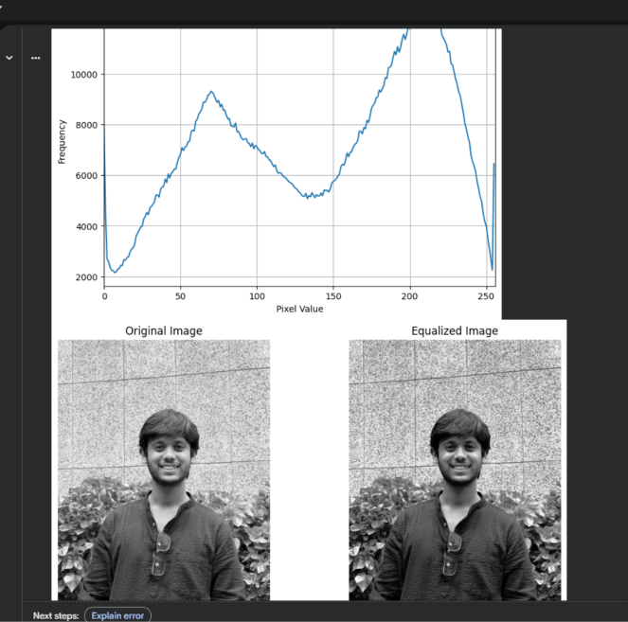

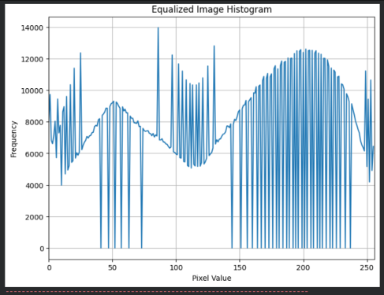

Github Link:
https://github.com/aumdave1979/DSIP/tree/main/Exp8

