
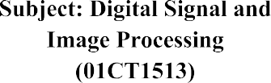 | AIM: Perform gray level operations images.
Experiment No:7 | 26 | 92400133058

AIM: Perform gray level operations images. Operations
- Read Digital Image
- Convert color image to grayscale image
- Image Negation
- Image Thresholding
- Image Gamma Correction

Gray Scale image
- Grayscale images are useful when color is not important for the task. They also make image processing easier because there is less data to handle. They are commonly used in image processing and computer vision.
- A grayscale image is an image where each pixel has only one value that represents its brightness. In an 8-bit grayscale image, the value usually ranges from 0 to 255, where 0 means black and 255 means white. Unlike a color image, it does not contain color information.
- The grayscale value of a pixel tells us how bright or dark that pixel is. A higher value means the pixel is brighter, while a lower value means it is darker.

Applications:
- Grayscale images are widely used in areas such as medical imaging, including X-rays and MRI scans, as well as computer vision, image processing, and document scanning. They are also used in black-and-white photography for artistic purposes.
- Grayscale images need less storage space than color images because they contain only one channel, while color images usually have three channels. This is useful when storage space is limited.

Image Negation
- Image negation is a basic operation used to create the opposite or negative version of an image. In a grayscale image, the intensity of each pixel is subtracted from the maximum intensity value, which is usually 255 for an 8-bit image. As a result, bright areas become dark and dark areas become bright. This gives the image a negative effect.
- For example, if a pixel has an intensity value of 100 in the original image, its value after negation will be 155, because 255 − 100 = 155.
This operation can be represented as:
\[ s = 255 - r \]
where r is the original pixel value and s is the new pixel value.

- Negated_pixel_value = Maximum_intensity_value –Original_pixel_value

Negated_pixel_value = 255 - Original_pixel_value Image Thresholding
Image thresholding is a technique used to divide an image into two parts: foreground (the object we are interested in) and background. This is done by choosing a threshold value and comparing each pixel with it.

- If the pixel value is greater than or equal to the threshold, it is changed to 255 (white).
- If the pixel value is less than the threshold, it is changed to 0 (black).

if pixel_value >= threshold: thresholded_pixel_value = 255 # Foregroundelse: thresholded_pixel_value = 0 # Background
In OpenCV:

_, thresholded_image = cv2.threshold( src_image, 128, 255, cv2.THRESH_BINARY)
Here, the threshold is 128. Therefore, pixels with values 128 or higher become white (255), while pixels with values below 128 become black (0).

OpenCV Thresholding Methods
- cv2.THRESH_BINARY: Simple binary thresholding. Pixels above the threshold become maxval, while pixels below the threshold become 0.
- cv2.THRESH_BINARY_INV: This is the reverse of binary thresholding. Pixels above the threshold become 0, while pixels below the threshold become maxval.
- cv2.THRESH_TRUNC: Pixels above the threshold are changed to the threshold value, while pixels below the threshold remain unchanged.
- cv2.THRESH_TOZERO: Pixels above the threshold remain unchanged, while pixels below the threshold become 0.
- cv2.THRESH_TOZERO_INV: The opposite of THRESH_TOZERO. Pixels above the threshold become 0, while pixels below the threshold remain unchanged.

Image Gamma Correction
- Gamma correction is used to adjust the brightness of an image. It changes the pixel values using a power function. It is mainly useful when an image looks too dark or too bright.
- The formula is: correected pixel = original pixel ^ (1/gamma)
- When gamma < 1, the image becomes brighter.
- When gamma > 1, the image becomes darker.
- When gamma = 1, the image stays the same.
By changing the gamma value, we can make the image look brighter or darker as needed.

Python Code
gamma_corrected_image = np.power(input_image / 255.0, gamma) * 255.0gamma_corrected_image = np.uint8(gamma_corrected_image)

What the code does
- input_image / 255.0 → Converts pixel values from 0–255 to 0–1.
- np.power(..., gamma) → Applies the gamma value to each pixel.
- * 255.0 → Converts the values back to the 0–255 range.
- np.uint8(...) → Converts the result into the proper 8-bit image format.
Finally, the function gives us the gamma-corrected image.

Code: import cv2

import numpy as np
import matplotlib.pyplot as plt
# Read image directly in grayscale
src_image = cv2.imread('images.jpg', cv2.IMREAD_GRAYSCALE)

# Check if image is loaded if src_image is None:
print("Image not found!") exit()

#
# 1. Image Negation #
negative_image = 255 - src_image
#
# 2. Thresholding #
_, thresholded_image = cv2.threshold( src_image, 128, 255, cv2.THRESH_BINARY
)
#
# 3. Gamma Correction #
gamma = 2.0

# Normalize image to range [0,1] normalized_image = src_image / 255.0

# Apply gamma correction
gamma_corrected_image = np.power(normalized_image, 1 / gamma)

# Convert back to range [0,255]
gamma_corrected_image = np.uint8(gamma_corrected_image * 255)
#
# Display Images #
plt.figure(figsize=(15, 5))

plt.subplot(1, 4, 1) plt.imshow(src_image, cmap='gray') plt.title("Original")
plt.axis('off')

plt.subplot(1, 4, 2) plt.imshow(negative_image, cmap='gray') plt.title("Negative")
plt.axis('off')

plt.subplot(1, 4, 3) plt.imshow(thresholded_image, cmap='gray') plt.title("Threshold")
plt.axis('off')
plt.subplot(1, 4, 4) plt.imshow(gamma_corrected_image, cmap='gray') plt.title("Gamma")
plt.axis('off') plt.show()

Output:
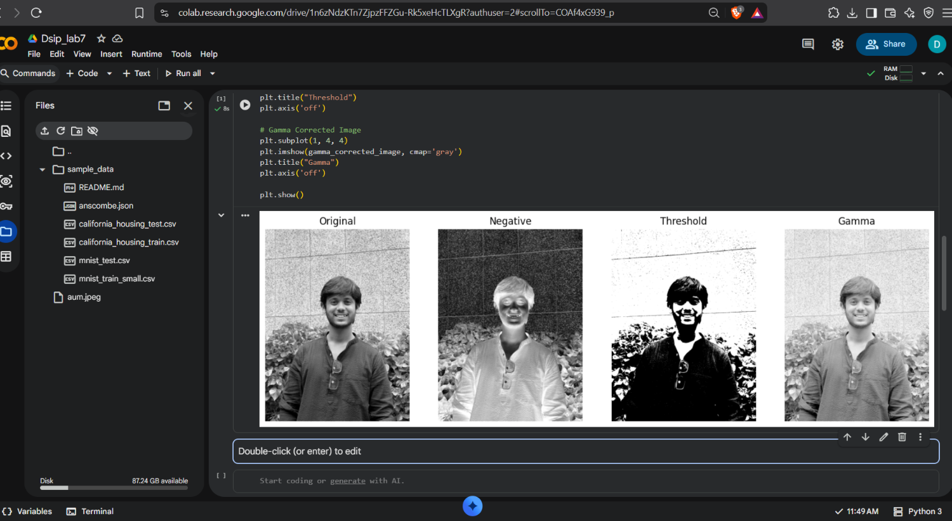

Observation
After applying the different image processing techniques, I observed that each method changes the original grayscale image in a different way. Image negation reverses the brightness, so dark areas become bright and bright areas become dark. Thresholding changes the grayscale image into a black-and-white image using a threshold value of 128. In gamma correction, the image becomes brighter, especially in the darker areas, when a gamma value of 2.0 is used. The effect of all three techniques can be easily noticed by comparing them with the original image.

Conclusion
From this experiment, I learned how basic image processing techniques can be used to change the appearance of an image. Image negation helps reverse the intensity values, thresholding helps separate the object from the background, and gamma correction helps adjust the brightness. Overall, this experiment helped me understand how changing pixel intensity values affects a grayscale image.

Github link: https://github.com/aumdave1979/DSIP/tree/main/Exp7

