Aim: Simulate discrete time sequences.

1). Unit Impulse Signal:

Program:
import numpy as np
import matplotlib.pyplot as plt

def unit_impulse(length, position): signal = np.zeros(length) signal[position] = 1
return signal

start, stop, step = -10, 10, 1
x = np.arange(start, stop + step, step)
signal1 = unit_impulse(len(x), abs(start)//step) plt.stem(x, signal1)
plt.xlabel('time')
plt.ylabel('amplitude') plt.title('unit impulse signal') plt.grid(True)
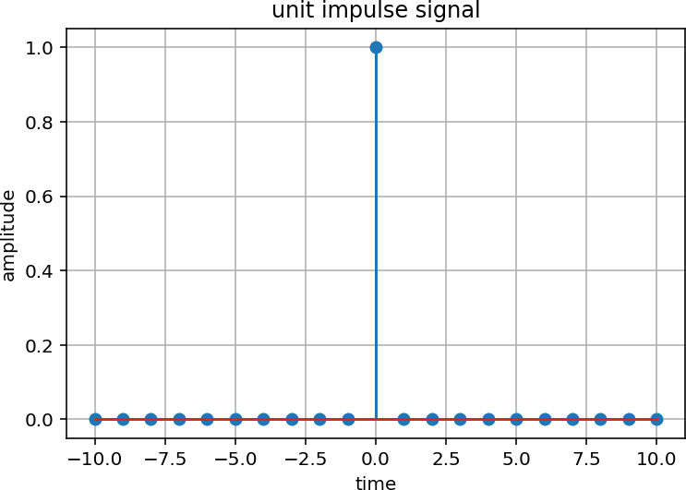
plt.show()
Conclusion:
From this experiment, I learned what a unit impulse signal is. A unit impulse signal has a value of 1 at one particular point and 0 at all other points. It appears as a sudden spike in the signal. This signal is important in signal processing because it is used to study and understand the behavior of discrete-time signals and systems.

Impulse Train:

Program:
import numpy as np
import matplotlib.pyplot as plt

def impulse(signal_length, period): impulse1 = np.zeros(signal_length) for n in range(signal_length):
if n % period == 0: impulse1[n] = 1
return impulse1
signal_length = 100
period = 10
impulse_signal = impulse(signal_length, period) plt.stem(impulse_signal)
plt.title('Impulse Train')
plt.xlabel('Sample') plt.ylabel('Amplitude') plt.show()
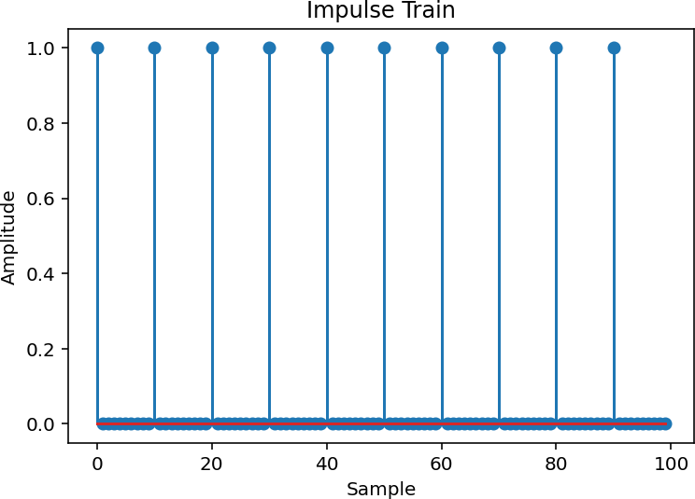
Conclusion:
From this experiment, I learned what an impulse train is. An impulse train consists of a series of impulses that occur at regular intervals. Each impulse has a value of 1 at a particular point and 0 at other points. It is useful in signal processing for representing periodic signals and studying the behavior of different systems.

​Continuous and Discrete Unit Step Signal:

Program:
import numpy as np
import matplotlib.pyplot as plt

def continuous(time):
unit_step = np.zeros_like(time) unit_step[time >= 0] = 1
return unit_step

def discrete(samples):
unit_step = np.zeros(samples) unit_step[samples // 2:] = 1 return unit_step

time = np.linspace(-5, 5, 1000) continuous_unit_step = continuous(time)

samples = 20
discrete_unit_step = discrete(samples)

plt.figure(figsize=(10, 6))
plt.subplot(2, 1, 1)
plt.plot(time, continuous_unit_step) plt.title('continuous unit step signal') plt.xlabel('time') plt.ylabel('amplitude')
plt.subplot(2, 1, 2) plt.stem(discrete_unit_step) plt.title('discrete unit step signal') plt.xlabel('sample') plt.ylabel('amplitude')

plt.tight_layout() plt.show()

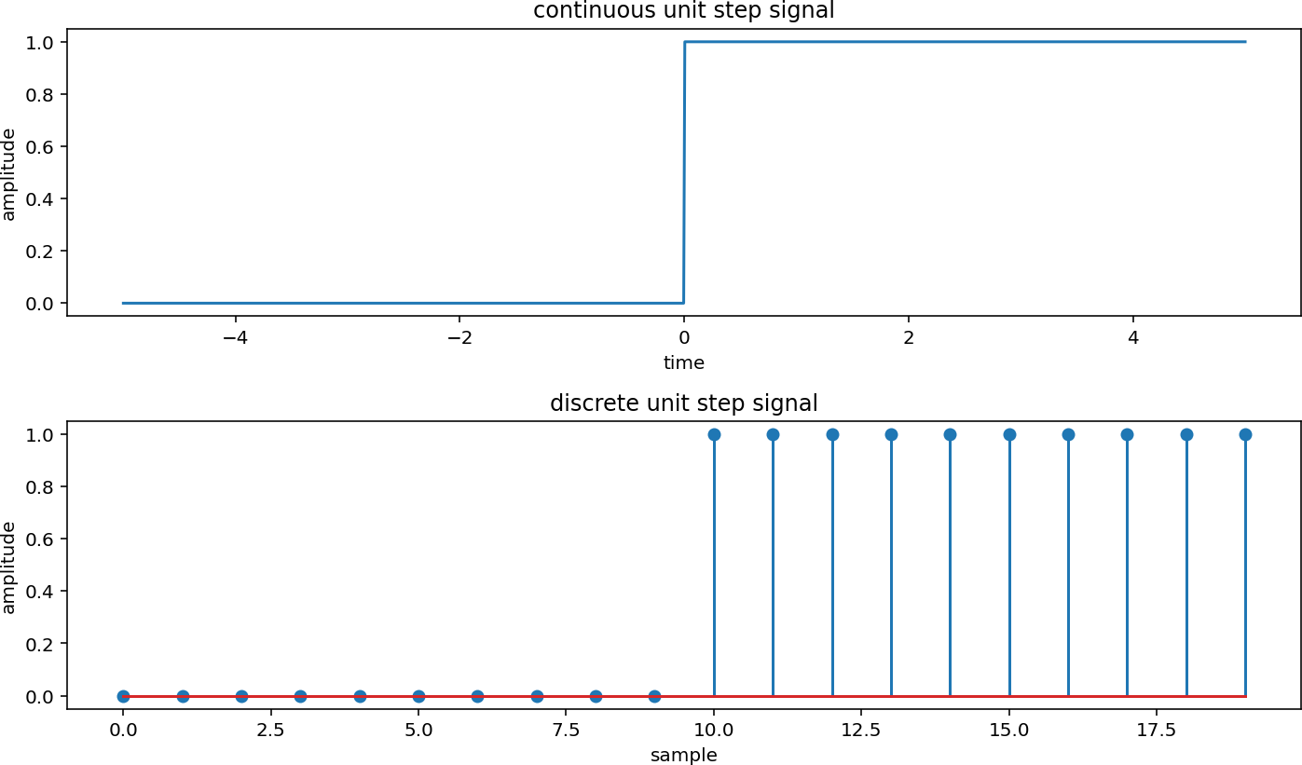
Conclusion:
From this experiment, I learned about continuous and discrete unit step signals. A unit step signal changes its value from 0 to 1 at a particular point. The continuous-time signal changes smoothly with time, while the discrete-time signal is represented only at specific sample points. Both signals are useful for understanding and analyzing different systems in signal processing.

Continuous and Discrete Ramp Signal: Program:
import numpy as np
import matplotlib.pyplot as plt

def continuous(time, slope): ramp = np.zeros_like(time)
ramp[time >= 0] = slope * time[time >= 0] return ramp

def discrete(samples, slope): ramp = np.zeros(samples)
ramp[samples // 2:] = slope * np.arange(samples // 2, samples) return ramp

time = np.linspace(-5, 5, 1000)
samples = 20
slope = 2

continuous_ramp = continuous(time, slope) discrete_ramp = discrete(samples, slope)

plt.figure(figsize=(10, 6))
plt.subplot(2, 1, 1) plt.plot(time, continuous_ramp)
plt.title('continuous ramp signal') plt.xlabel('time') plt.ylabel('amplitude')
plt.subplot(2, 1, 2) plt.stem(discrete_ramp) plt.title('discrete ramp signal') plt.xlabel('sample') plt.ylabel('amplitude')

plt.tight_layout() plt.show()
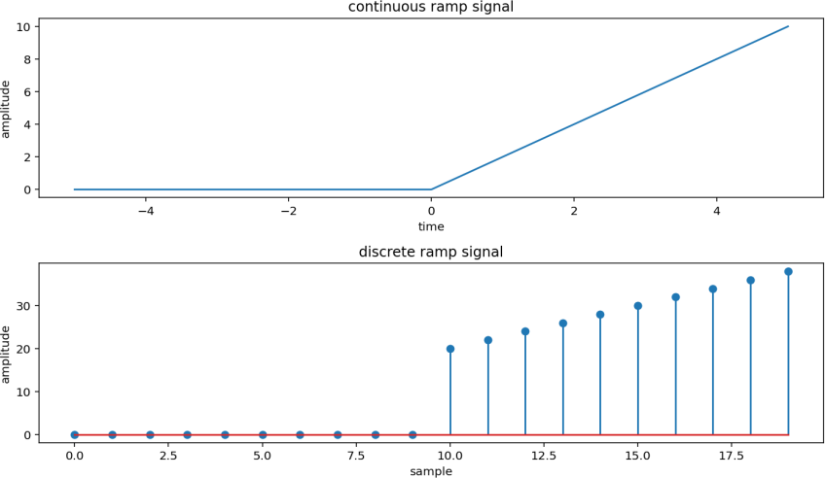
From this experiment, I learned about continuous and discrete ramp signals. A ramp signal starts from zero and increases gradually with time. The continuous ramp signal changes smoothly, while the discrete ramp signal increases at specific sample points. Both signals are useful for understanding and analyzing different types of signals in signal processing.

Continuous and Discrete Exponential Signal:
Program:
import numpy as np
import matplotlib.pyplot as plt

def continuous(time, amplitude, coefficient): return amplitude * np.exp(coefficient * time)

def discrete(samples, amplitude, coefficient):
return amplitude * np.exp(coefficient * np.arange(samples))

time = np.linspace(0, 5, 1000)
samples = 20
amplitude = 2
coefficient = -0.5

continuous_exponential = continuous(time, amplitude, coefficient) discrete_exponential = discrete(samples, amplitude, coefficient)

plt.figure(figsize=(10, 6))
plt.subplot(2, 1, 1)
plt.plot(time, continuous_exponential) plt.title('continuous exponential signal') plt.xlabel('time')
plt.ylabel('amplitude')

plt.subplot(2, 1, 2) plt.stem(discrete_exponential) plt.title('discrete exponential signal') plt.xlabel('sample') plt.ylabel('amplitude')

plt.tight_layout() plt.show()

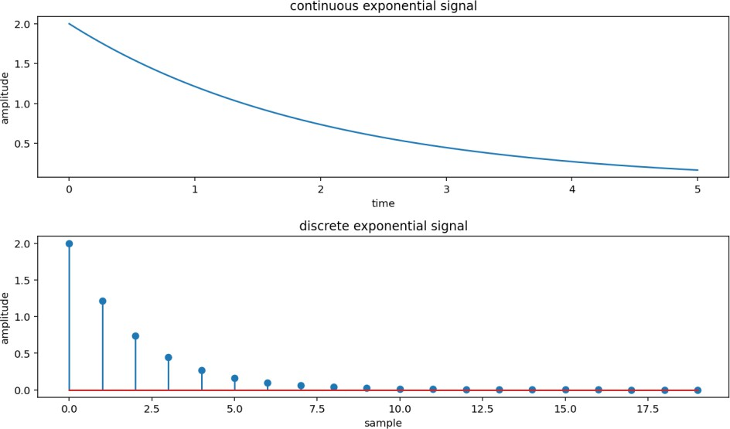

Conclusion:

From this experiment, I learned about continuous and discrete exponential signals. An exponential signal increases or decreases exponentially with time. The continuous exponential signal changes smoothly, while the discrete exponential signal is represented at specific sample points. Both types of signals are useful for understanding and analyzing signal behavior in signal processing.

Continuous and Discrete Parabolic Signal:

Program:
import numpy as np
import matplotlib.pyplot as plt

def continuous(time, coefficients): return np.polyval(coefficients, time)

def discrete(samples, coefficients):
return np.polyval(coefficients, np.arange(samples))

time = np.linspace(-5, 5, 1000)
samples = 20
coefficients = [1, 2, 1]

continuous_parabolic = continuous(time, coefficients) discrete_parabolic = discrete(samples, coefficients)

plt.figure(figsize=(10, 6))
plt.subplot(2, 1, 1)
plt.plot(time, continuous_parabolic) plt.title('continuous parabolic signal') plt.xlabel('time') plt.ylabel('amplitude')

plt.subplot(2, 1, 2) plt.stem(discrete_parabolic) plt.title('discrete parabolic signal') plt.xlabel('sample') plt.ylabel('amplitude')

plt.tight_layout() plt.show()
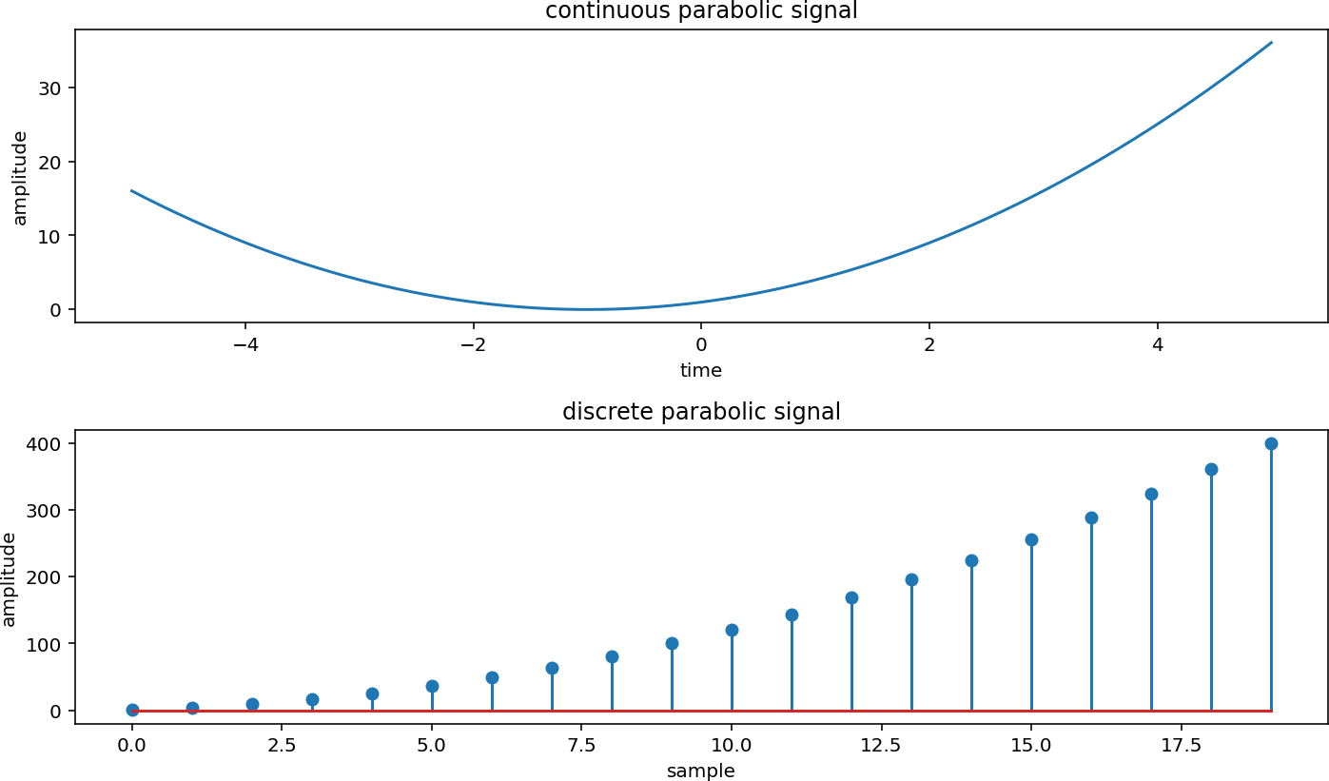

Conclusion:
From this experiment, I learned about continuous and discrete parabolic signals. A parabolic signal changes according to the square of time or the sample index, giving it a curved shape. The continuous parabolic signal changes smoothly with time, while the discrete parabolic signal is represented at specific sample points. Both signals help in understanding and analyzing different types of signals in signal processing.

Continuous and Discrete Sine Wave Signal:

Program:
import numpy as np
import matplotlib.pyplot as plt
def continuous(time, amplitude, frequency, phase):
return amplitude * np.sin(2 * np.pi * frequency * time + phase)
def discrete(samples, sampling_frequency, amplitude, frequency, phase): time = np.arange(samples) / sampling_frequency
return amplitude * np.sin(2 * np.pi * frequency * time + phase)

time = np.linspace(0, 1, 1000)
samples = 100
sampling_frequency = 10
amplitude = 1
frequency = 2
phase = 0

continuous_sine_wave = continuous(time, amplitude, frequency, phase) discrete_sine_wave = discrete(samples, sampling_frequency, amplitude, frequency, phase)

plt.figure(figsize=(10, 6))
plt.subplot(2, 1, 1)
plt.plot(time, continuous_sine_wave) plt.title('continuous sine wave signal') plt.xlabel('time') plt.ylabel('amplitude')

plt.subplot(2, 1, 2) plt.stem(discrete_sine_wave) plt.title('discrete sine wave signal') plt.xlabel('sample') plt.ylabel('amplitude')

plt.tight_layout() plt.show()

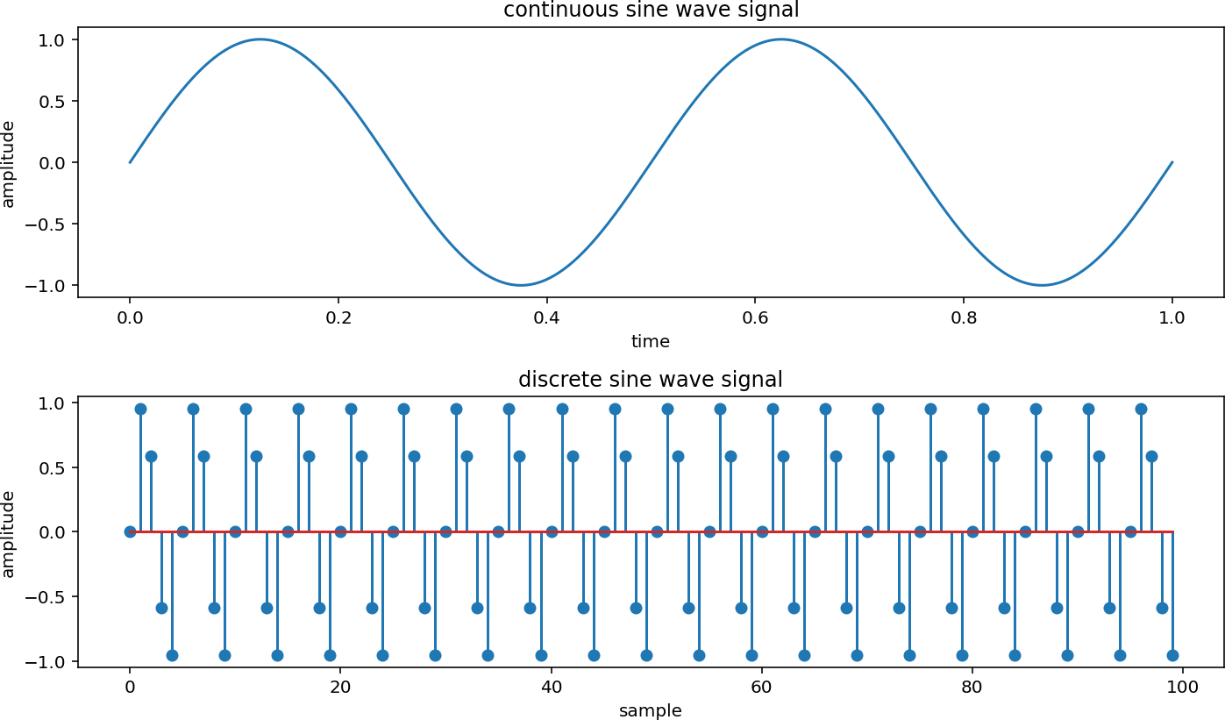

Conclusion: From this experiment, I learned about continuous and discrete sine signals. A sine signal is a periodic signal that repeats its pattern after a fixed interval. The continuous sine signal changes smoothly with time, while the discrete sine signal is represented at specific sample points. Both signals are useful for understanding and analyzing periodic signals in signal processing.

- y(t) = u(t) + u(t-1) + 3u(t+5):
Program:
import numpy as np
import matplotlib.pyplot as plt

def unit(x):
return np.where(x >= 0, 1, 0)

axis = np.linspace(-10, 10, 1000)
output_signal = unit(axis) + unit(axis - 1) + 3 * unit(axis + 5) plt.plot(axis, output_signal)
plt.title('y(t) = u(t) + u(t-1) + 3u(t+5)')

plt.xlabel('time') plt.ylabel('amplitude') plt.ylim([-0.5, 5.5]) plt.grid(True) plt.show()
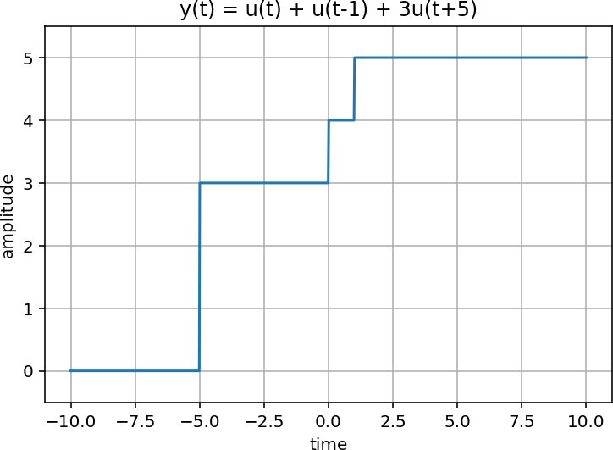

Conclusion:
This experiment showed me how we can combine multiple step signals together to create a new and more complex signal. Each step signal starts at a different time and contributes its own value, so the final signal changes in steps and looks like a staircase. This helped me understand how complex signals can be created by adding simple signals together.

9). y(t) = δ(t) + δ(t-1) + 3δ(t+5):
Program:
import numpy as np
import matplotlib.pyplot as plt
def unit(x, val):
result = np.zeros(len(x))

result[x == val] = 1 return result

n_axis = np.arange(-10, 11)
signal = unit(n_axis, 0) + unit(n_axis, 1) + 3 * unit(n_axis, -5) plt.stem(n_axis, signal)
plt.title('y(t) = delta(t) + delta(t-1) + 3delta(t+5)') plt.xlabel('time')
plt.ylabel('amplitude') plt.ylim([-0.5, 4.5]) plt.grid(True) plt.show()
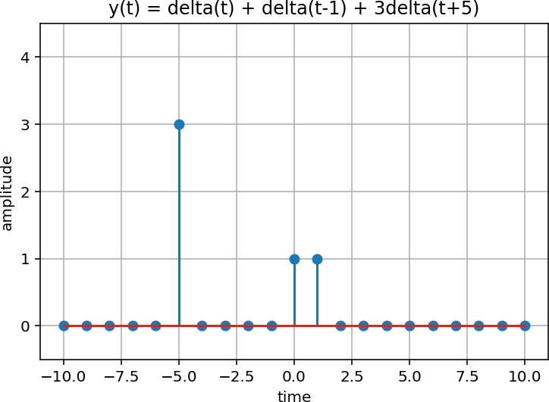

Conclusion:
This experiment showed me how multiple impulse signals can be combined to create a more complex signal. Each impulse occurs at a specific time with its own amplitude, while the signal remains zero at other points. This helped me understand that a signal made of separate spikes can be represented by adding shifted and scaled impulse signals.

GitHub Link:

