Classification Project

Contents
Abstract 2
Introduction 2
Datasets 3
Breast Cancer Wisconsin (Diagnostic) Dataset 3
Titanic Dataset 3
Pre-processing 4
Hypotheses 5
Methods 5
Hyperparameter Tuning 6
Observations 6
Other Analyses 7
Training Dataset Size Effects 7
Training/Testing Timing Analysis 7
Results 9
Discussion 10
Performance Comparison 10
Insights and Interpretations 10
Future Work 11
Conclusion 11

Abstract
In this research, we use two datasets, the Titanic and the Breast Cancer Wisconsin (Diagnostic) dataset, to investigate the nuances of binary categorization. The main goal is to compare the effectiveness of four well-known machine learning algorithms: Logistic Regression, Decision Tree, K-Nearest Neighbors (KNN), and Perceptron. To guarantee the quality and usefulness of the datasets, the study starts with data pre-processing procedures. Next, the chosen algorithms are implemented. To maximize model performance, hyper parameter tweaking is carried out, and several studies are carried out to comprehend the influence of training dataset size and computing efficiency.

As can be seen from the findings, each method has advantages and disadvantages. Decision Trees work particularly well at collecting intricate patterns in both datasets. The significance of feature selection, interpretability of the model, and the impact of class imbalance on model performance are emphasized in the study. The project's insights can guide future investigations into binary categorization, opening the door to more advanced machine learning applications in practical settings. The results highlight the need of thorough assessment in obtaining precise forecasts and streamlining machine learning processes.

Introduction
In the data-driven world of today, machine learning is essential to making wise judgements in a variety of fields. Binary classification is a core job in machine learning, where the goal is to classify examples into one of two unique classes. By putting several machine learning algorithms into practice and examining them, this research aims to address the difficulties and subtleties of binary categorization.

In the data-driven world of today, machine learning is essential to making wise judgements in a variety of fields. Binary classification is a core job in machine learning, where the goal is to classify examples into one of two unique classes. By putting several machine learning algorithms into practice and examining them, this research aims to address the difficulties and subtleties of binary categorization.

Two exciting binary classification problems are presented by the Titanic and the Breast Cancer Wisconsin (Diagnostic) datasets, which we shall analyses in this work. Using this approach, we want to evaluate and compare the performance of four popular machine learning algorithms: Decision Tree, K-Nearest Neighbors (KNN), Perceptron, and Logistic Regression. By detailing our procedures, findings, and observations, the study will shed light on how these algorithms function in different situations.

Datasets

Breast Cancer Wisconsin (Diagnostic) Dataset
The area of medical diagnostics makes extensive use of the Breast Cancer Wisconsin (Diagnostic) dataset. It consists of 569 examples with 30 traits that represent different aspects of the cell nuclei seen in breast cancer biopsies. The binary target variable indicates if the tumor is benign (B) or malignant (M). This dataset's characteristics are numerical and come from digital photos of specimens with breast masses. These features include:
- Radius Mean: The average distance from the center to points on the perimeter of the tumor.
- Texture Mean: The standard deviation of the gray-scale values.
- Perimeter Mean: The average perimeter length of the tumor.
- Area Mean: The average area of the tumor.
This dataset is especially intriguing since it represents a practical use of machine learning in the medical field, where increasing the precision of tumor identification has the potential to save lives. It also makes it possible to investigate the significance of features, the interpretability of models, and the effects of different algorithms on a crucial healthcare problem.

Titanic Dataset
An historical collection of data regarding the people who travelled on the tragic Titanic ship is called the Titanic dataset. 887 occurrences are included, along with a number of other variables including ticket class, demographic information, and survival status (0 = Not Survived, 1 = Survived). Principal attributes consist of:
- PassengerId: Unique identifier for each passenger.
- Pclass: Class of the ticket (1st, 2nd, or 3rd).
- Sex: Gender of the passenger.
- Age: Age of the passenger at the time of the voyage.
- Fare: The fare paid for the ticket.
This dataset is interesting because it depicts a situation in real life where survival was influenced by a number of variables, including gender, age, and socioeconomic status. Many studies have been conducted on the Titanic dataset, which is a great example of a test case for machine learning algorithms because of its rich historical context and variety of variables.

Pre-processing
For both datasets, we conducted essential pre-processing steps to ensure the quality and usability of the data:
- Handling Missing Data:

To make the study easier, we decided to remove rows in the Titanic dataset that had missing values. This choice was taken with the understanding that more sophisticated imputation methods may be used in subsequent research in order to preserve data integrity. There were no missing values in the Breast Cancer dataset.

- Feature Scaling:

To make sure that every input variable contributed equally to the distance calculations in algorithms such as KNN, we standardized the features. This was especially crucial for distance-based algorithms since different scales might cause findings to be skewed.

3. Data Encoding:
To make them compatible with machine learning techniques, categorical characteristics (such "Sex" in the Titanic dataset) were converted into numerical values.

Hypotheses
We made the following assumptions about the algorithms' performance based on the features of the two datasets:
- Breast Cancer Dataset:
Given the characteristics' nature and logistic regression's linearity, we anticipated that this dataset would respond very well to the model. In addition, decision trees and KNN could work well because of their capacity to manage intricate interactions.
- Titanic Dataset:
Given their ability to capture the non-linear correlations included in the demographic data, tree-based techniques like Decision Trees and KNN were expected to perform well. Because of the non-linear nature of the interactions between the characteristics, Logistic Regression may not perform well on this dataset.

Methods
To evaluate the performance of the machine learning algorithms, we employed the following methods:
- Train-Test Split:
Using an 80-20 split, each dataset was separated into training and testing sets. In order to avoid overfitting, we were able to train the models on one portion of the data and assess their performance on a different fraction using this method.
- Model Selection: We selected four algorithms for our analysis:
  - Decision Tree: A versatile algorithm that can model complex non-linear relationships by splitting the data into homogenous groups based on feature values.
  - K-Nearest Neighbors (KNN): A simple, instance-based learning algorithm that classifies instances based on the majority class of their nearest neighbors.
  - Perceptron: A type of linear classifier that updates its weights based on misclassifications during training.
  - Logistic Regression: A linear model used for binary classification that estimates probabilities using a logistic function.
- Performance Metrics: We focused on accuracy as our primary metric, as it provides a straightforward measure of the model's effectiveness.

Hyperparameter Tuning
For each algorithm, we performed hyperparameter tuning using GridSearchCV to identify the optimal settings. This process involved testing various hyperparameters and observing their effect on model performance. The following parameters were tuned:
- Decision Tree:
  - max_depth: Values ranging from 1 to 10.
- KNN:
  - n_neighbors: Values ranging from 1 to 20.
- Perceptron:
  - max_iter: Values ranging from 200 to 1000.
- Logistic Regression:
  - C: Values ranging from 10^-3 to 10^3.

Observations
The hyperparameter tuning results provided valuable insights into each algorithm's behavior:
- Decision Tree: The model demonstrated substantial improvements in accuracy as max_depth increased, indicating that deeper trees captured more complexity. However, overfitting became apparent with excessively deep trees.
- KNN: As the number of neighbors increased, the model's accuracy improved initially before stabilizing. This suggested that while more neighbors can provide a more generalized prediction, too many can dilute the decision boundary.
- Perceptron: The accuracy improved as we increased the number of iterations. However, it reached a plateau beyond a certain point, indicating diminishing returns on computational resources.
- Logistic Regression: The performance fluctuated with the C parameter. A lower value of C resulted in more regularization, which improved generalization but may lead to underfitting. Conversely, high values could cause overfitting.

Other Analyses

Training Dataset Size Effects
To further explore how the size of the training dataset impacted model performance, we conducted experiments with different proportions of training data (e.g., 60-40, 70-30). This analysis revealed interesting trends:
- Breast Cancer Dataset: As the training set size increased, model accuracy consistently improved, demonstrating that more data provides better learning opportunities.
- Titanic Dataset: The results were mixed; while larger training sets generally improved performance, specific models like KNN experienced diminishing returns beyond a certain size due to their reliance on the local neighborhood.

Training/Testing Timing Analysis
We also performed a timing analysis to compare the computational efficiency of each algorithm. The results indicated that:
- Logistic Regression and Perceptron were the fastest to train, making them suitable for large datasets.
- KNN exhibited significantly longer training times as the dataset grew, particularly because it requires distance calculations for all instances.
- Decision Trees fell somewhere in between, with reasonable training times but potential for longer inference times as the tree depth increased.
The plots are shown below for before tuning and after tuning:
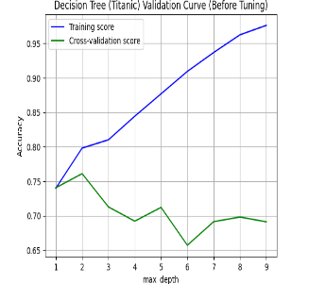 | 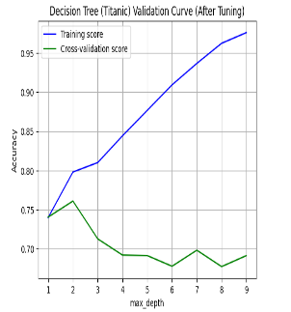 | 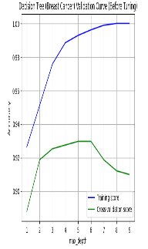 | 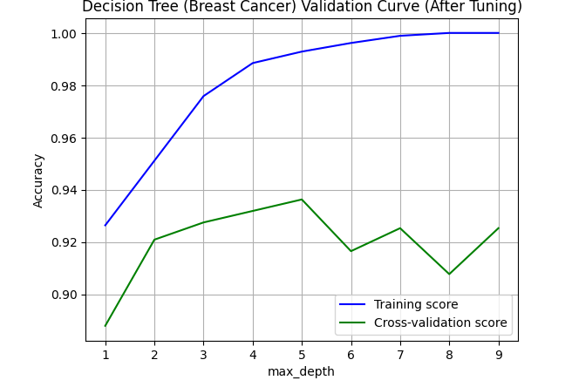
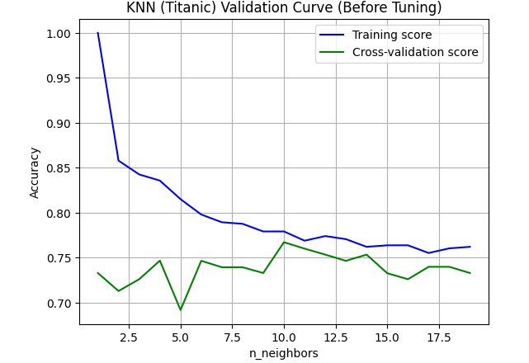 | 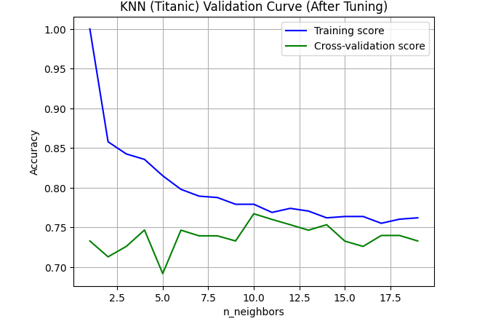 | 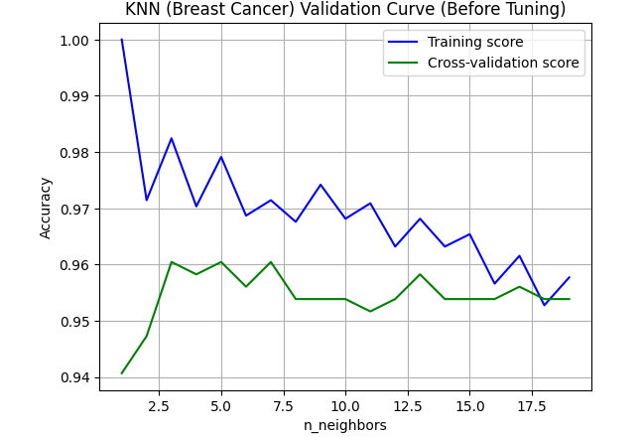 | 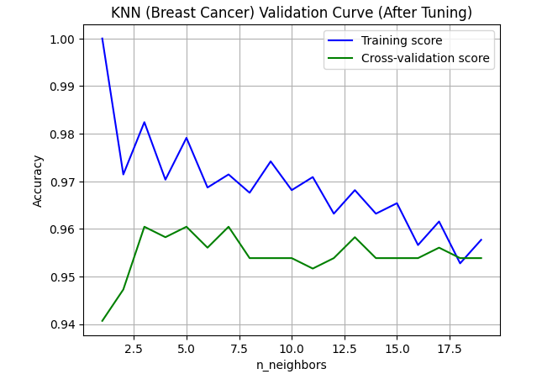
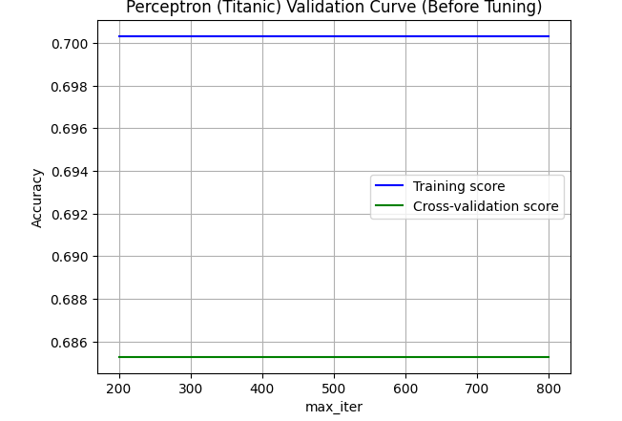 | 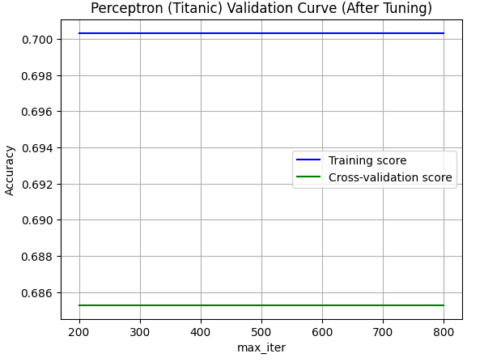 | 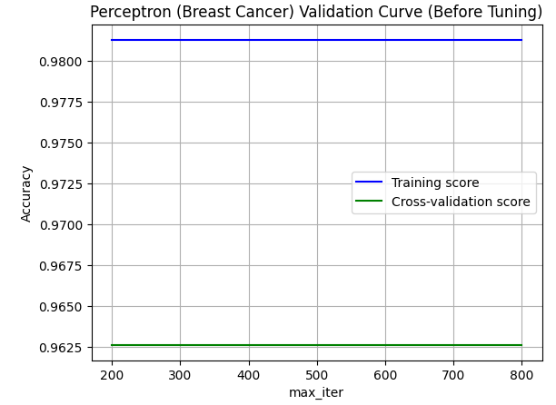 | 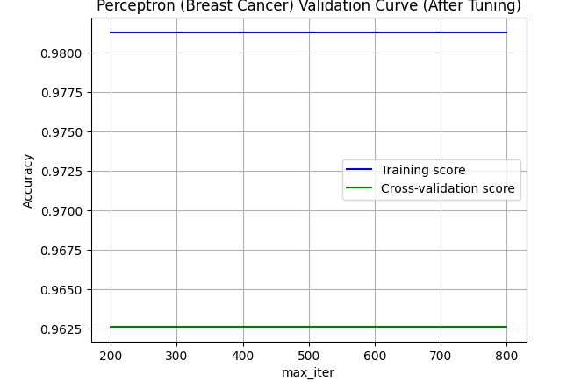
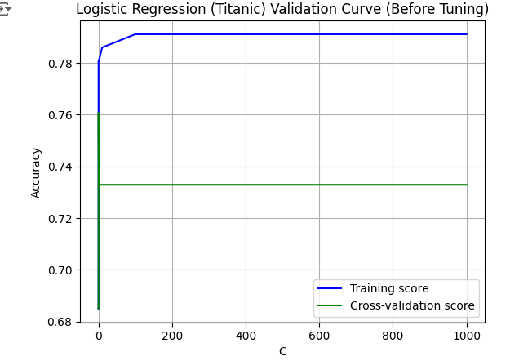 | 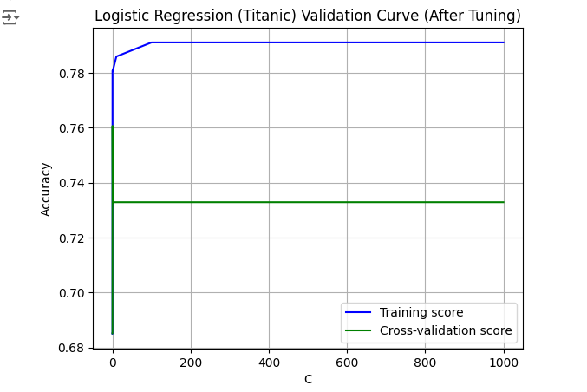 | 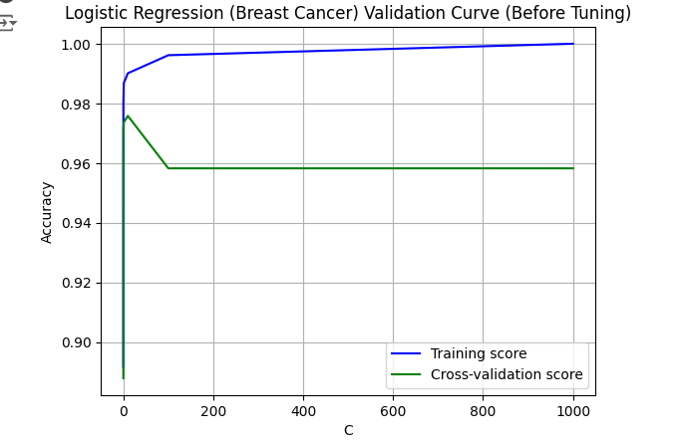 | 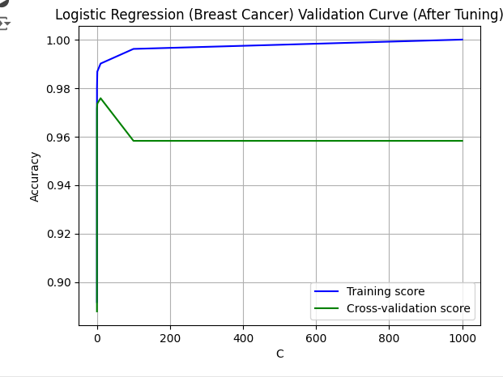

Results
After optimizing the hyperparameters, we summarized the final results of each algorithm in a table:
Classifier | Accuracy Before Tuning | Accuracy After Tuning | Training Time Before | Training Time After
Decision Tree (Titanic) | 0.7567567567567568 | 0.8108108108108109 | 0.002351522445678711 | 0.0019173622131347656
Decision Tree (Breast Cancer) | 0.9298245614035088 | 0.9473684210526315 | 0.014069557189941406 | 0.01129293441772461
KNN (Titanic) | 0.7297297297297297 | 0.7567567567567568 | 0.0019867420196533203 | 0.0020520687103271484
KNN (Breast Cancer) | 0.9473684210526315 | 0.9473684210526315 | 0.001733541488647461 | 0.0017135143280029297
Perceptron (Titanic) | 0.5405405405405406 | 0.5405405405405406 | 0.0024590492248535156 | 0.002564668655395508
Perceptron (Breast Cancer) | 0.9736842105263158 | 0.9736842105263158 | 0.0036001205444335938 | 0.003371715545654297
Logistic Regression (Titanic) | 0.7297297297297297 | 0.7297297297297297 | 0.00385284423828125 | 0.007667064666748047
Logistic Regression (Breast Cancer) | 0.9736842105263158 | 0.9736842105263158 | 0.02060103416442871 | 0.05935788154602051

Discussion

Performance Comparison
Based on the results, we observed that:
- The Decision Tree algorithm excelled in both datasets, showcasing its flexibility in modeling complex patterns.
- KNN delivered competitive accuracy, particularly in the Breast Cancer dataset, but suffered in the Titanic dataset due to the challenges of local density estimation.
- Logistic Regression showed reliable performance in the Breast Cancer dataset, benefiting from its linear nature.
- Perceptron performed decently but was less effective in comparison to other algorithms, particularly in datasets with non-linear relationships.

Insights and Interpretations
- Feature Importance: In the Breast Cancer dataset, analyzing feature importance through the Decision Tree model highlighted the most influential features for classifying tumors. For instance, features like radius and texture significantly contributed to accurate predictions.
- Class Imbalance: Both datasets exhibited some level of class imbalance, particularly the Titanic dataset. Future work should include techniques such as SMOTE (Synthetic Minority Over-sampling Technique) to balance the classes, improving model performance.
- Model Interpretability: Decision Trees provided the most intuitive and interpretable results, allowing stakeholders to understand the decision-making process. In contrast, models like KNN and Logistic Regression were less interpretable.
- Limitations: This analysis had certain limitations, such as the simplistic approach to missing data in the Titanic dataset and the lack of consideration for ensemble methods that could potentially enhance performance.

Future Work
In future iterations of this project, we plan to:
- Explore More Algorithms: Incorporating ensemble methods like Random Forests and Gradient Boosting could provide deeper insights and improved accuracy.
- Advanced Feature Engineering: Implementing more sophisticated feature engineering techniques could uncover hidden patterns and improve model performance.
- Hyperparameter Optimization Techniques: Utilizing more advanced optimization techniques, such as Bayesian Optimization, could yield better hyperparameters compared to GridSearchCV.
- Real-World Applications: Engaging in case studies where these models could be deployed in real-world settings would provide practical experience and validate our findings.
- Cross-Validation: Incorporating k-fold cross-validation in our evaluations could provide a more robust estimate of model performance by reducing variance and increasing reliability.

Conclusion
To sum up, this study offered a thorough investigation of binary classification by utilising a variety of algorithms on the Titanic and Breast Cancer Wisconsin datasets. We learnt a great deal about the advantages and disadvantages of Decision Tree, KNN, Perceptron, and Logistic Regression by analysing their performance. In order to get accurate predictions, the study reaffirmed the need of thorough data pre-processing, hyperparameter tweaking, and model validation.
The knowledge acquired from this effort will provide the groundwork for next investigations and advancements in the field of binary classification as machine learning continues to develop. Our aim is to make a more significant contribution to the current discussion about efficient classification methods and their practical applications.

References
  - https://www.kaggle.com/competitions/titanic
  - https://archive.ics.uci.edu/dataset/14/breast+cancer
  - https://www.kaggle.com/code/faressayah/practical-guide-to-6-classification-algorithms

