**Pizza Sales SQL Queries**

1. **KPI’s**
2. **Total Revenue:**





1. **Average Order Value:**





1. **Total Pizzas Sold:**





1. **Total Orders Placed:**





1. **Average Pizzas per Order:**





1. **Daily Trend for Total Orders:**

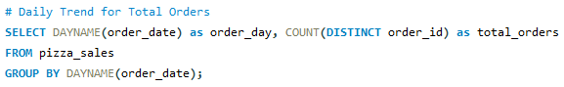

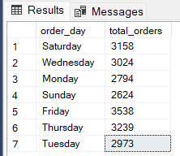

1. **Monthly Trend for Total Orders:**

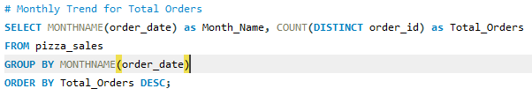

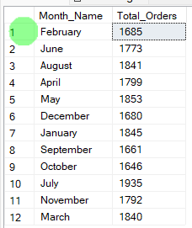

1. **Percentage of Pizza Sales by Pizza Category:**

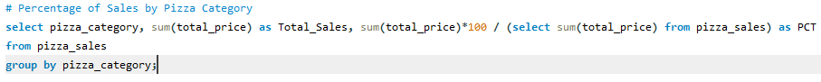

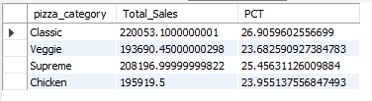

1. **Percentage of Sales by pizza size:**

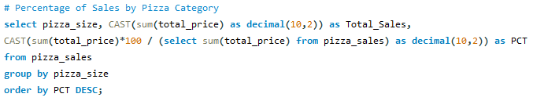

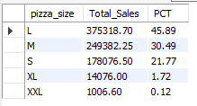

1. **Total Pizzas sold by Pizza Category:**

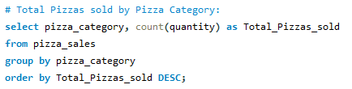

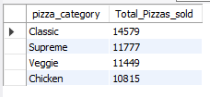

1. **TOP 5 pizza by Revenue:**

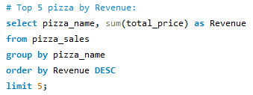

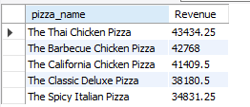

1. **Bottom 5 Pizza by Revenue:**

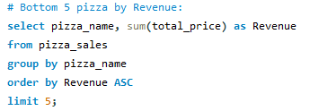

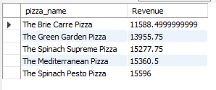

1. **TOP 5 pizza by Quantity:**

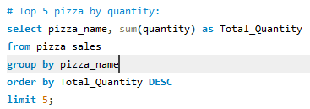

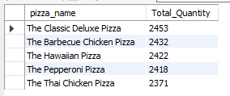

1. **Bottom 5 pizza by Quantity:**

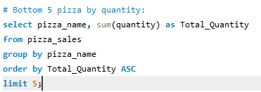

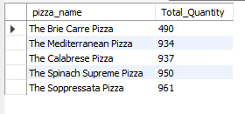

1. **TOP 5 pizza by TOTAL Order:**

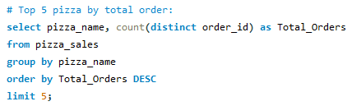

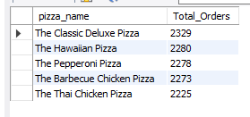

1. **Bottom 5 pizza by TOTAL Order:**

