AI-Based Face Recognition

Student Attendance System
Developer Documentation — End-to-End Technical Reference
Version 1.0

1. Project Overview
This system automates student attendance using face recognition. A camera mounted at the classroom entrance captures a live video feed; an AI pipeline detects faces, verifies liveness, generates a numeric identity vector (embedding) for each face, and matches it against enrolled students. Confirmed matches are written to an attendance record in real time, viewable through role-based web dashboards for admins, teachers, and students.
Primary goals: reduce manual attendance-taking time, produce a tamper-resistant and auditable attendance record, and give teachers a fast way to catch and correct AI mistakes rather than trusting the system blindly.

1.1 Objectives
- Automatically mark attendance with minimal manual intervention
- Prevent spoofing via printed photos or screens (liveness detection)
- Keep a human (teacher) in the loop for uncertain matches
- Provide role-appropriate dashboards for admin, teacher, and student
- Store biometric data responsibly (embeddings, not raw photos, for matching)

2. System Architecture
The system is split into four layers. The capture and AI processing layers run locally on a classroom PC to avoid streaming raw video off-site. The backend and presentation layers run centrally (cloud or on-premise school server) and are reached over a REST API.
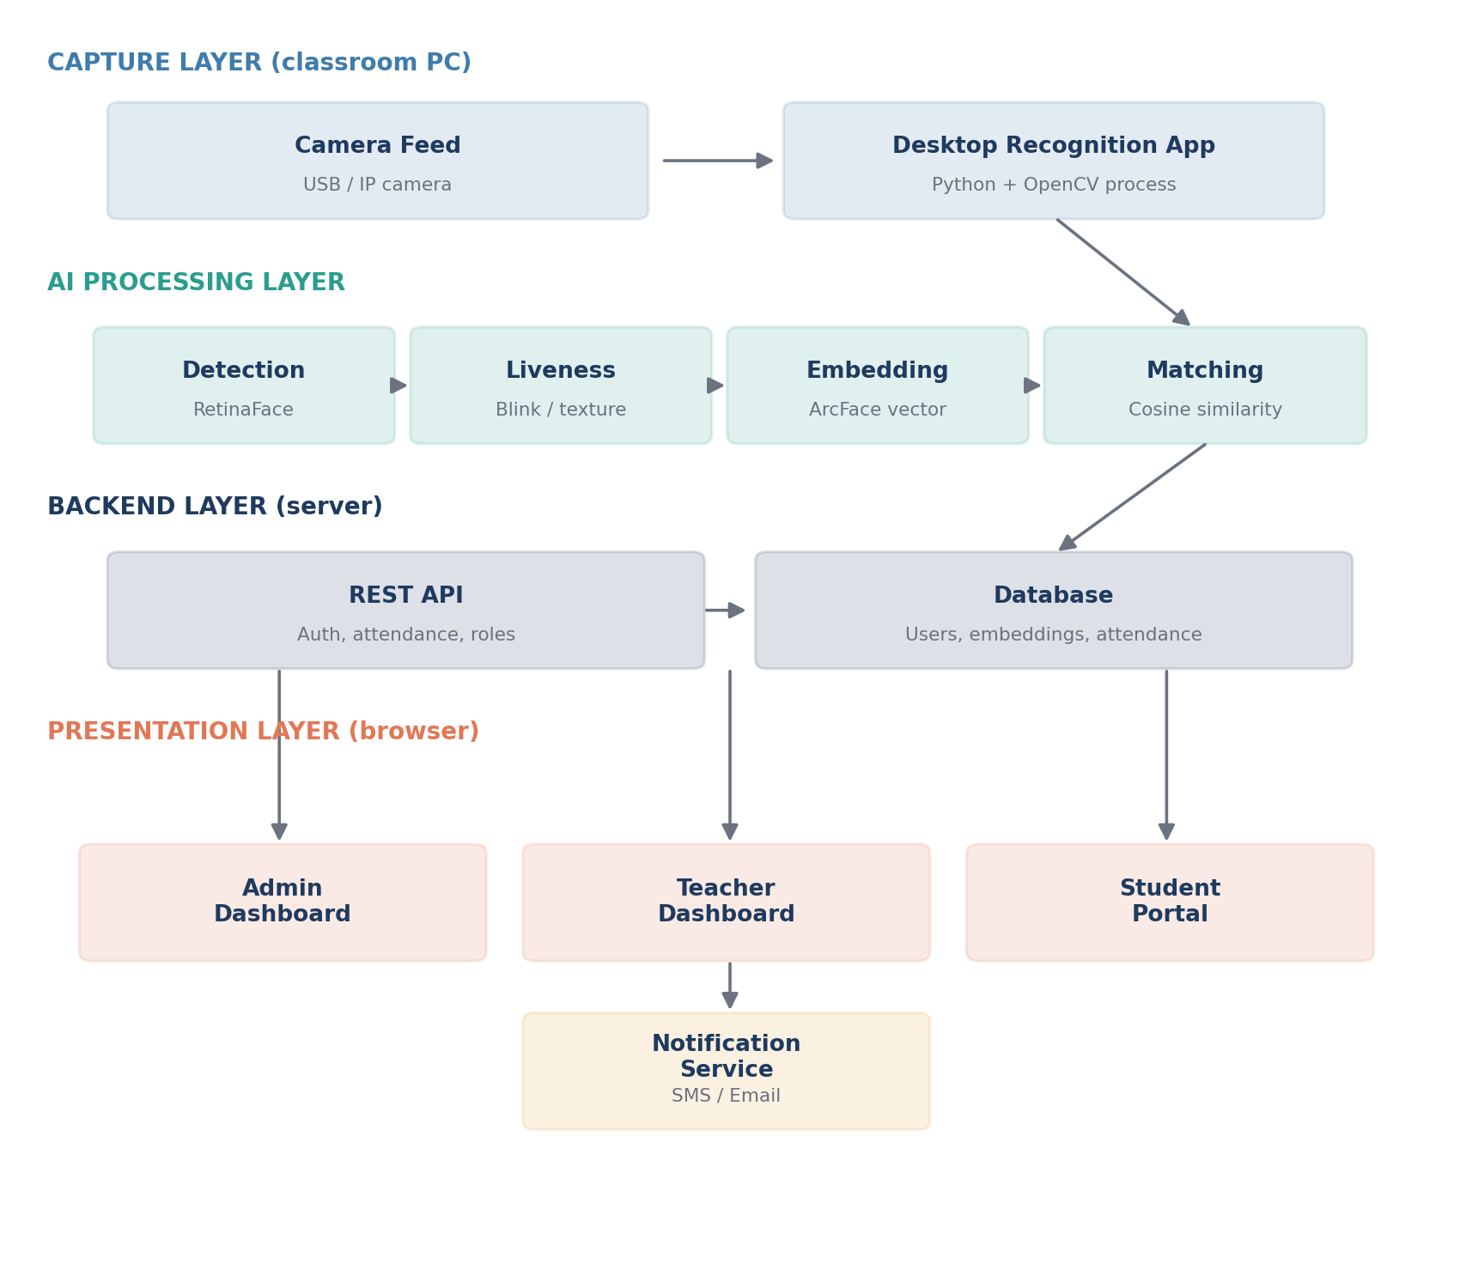
Figure 1 — Layered system architecture: capture, AI processing, backend, and presentation.

2.1 Layer Responsibilities
Layer | Responsibility | Runs On
Capture | Pull frames from camera, sample at intervals | Classroom PC
AI Processing | Detect, verify liveness, embed, match faces | Classroom PC
Backend | Auth, business logic, database, API | Cloud / school server
Presentation | Admin, teacher, student web dashboards | Any browser

3. Core Algorithms

3.1 Face Detection
Model: RetinaFace or MTCNN. Locates faces in a frame and outputs a bounding box, 5 facial landmarks, and a confidence score. Boxes below a detection-confidence threshold are discarded. Landmarks are used to align the face (rotate/crop so eyes are level) before recognition — alignment measurably improves matching accuracy.

3.2 Liveness Detection (Anti-Spoofing)
Combines two signals for robustness without extra hardware:
- Texture analysis — a CNN distinguishes real skin texture from paper/screen artifacts (moiré patterns, flat reflectance)
- Motion analysis — tracks blink rate and micro head movement across consecutive frames; a static photo shows no natural motion
A face that fails the liveness check is discarded before recognition ever runs on it.

3.3 Embedding Generation
Model: ArcFace (recommended) or FaceNet. Converts an aligned face into a 512-dimensional numeric vector, L2-normalized. Faces of the same person land close together in this vector space; different people land far apart — this is what makes numeric comparison possible without ever comparing raw pixels.

3.4 Matching
Cosine similarity is computed between the live embedding and every stored student embedding: similarity = (A · B) / (||A|| × ||B||). At scale, a vector index (FAISS or pgvector) finds the nearest neighbor in milliseconds instead of a full linear scan.

3.5 Confidence Decision
Similarity score | Action
≥ 0.85 | Auto-mark present, sync to dashboard immediately
0.60 – 0.85 | Send to teacher review queue (approve / reject)
< 0.60 | Discard — no record created

These thresholds are starting points and must be tuned per deployment (camera quality, lighting) using the precision/recall analysis in Section 4.

3.6 Session Deduplication
Each class period is a session. Before writing a record, the system checks whether (student_id, session_id) already exists; if so, the new detection is ignored. This prevents a student walking past the camera twice from being logged twice.

4. Precision, Accuracy, and Error Rates
Understanding these metrics is essential before deploying — a system that sounds '99% accurate' can still be unusable if that accuracy is measured under lab conditions that don't match your classroom.

4.1 Key Metrics Defined
Metric | Meaning
Precision | Of all faces the system marked present, what % were actually correct
Recall | Of all students actually present, what % did the system correctly detect
FAR (False Acceptance Rate) | % of the time the system wrongly matches one student's face to another student
FRR (False Rejection Rate) | % of the time the system fails to recognize a genuinely enrolled student
F1 Score | Harmonic mean of precision and recall — a single balanced accuracy figure

4.2 Published Benchmark Accuracy (Reference Only)
The chart below shows commonly-cited published accuracy figures for face recognition models on the LFW (Labeled Faces in the Wild) benchmark dataset. These numbers come from the models' original papers and public leaderboards, not from this project's own testing — real-world classroom accuracy will typically be lower due to non-ideal lighting, camera angle, and image quality. Treat these as a reference point for model selection, not a guarantee.
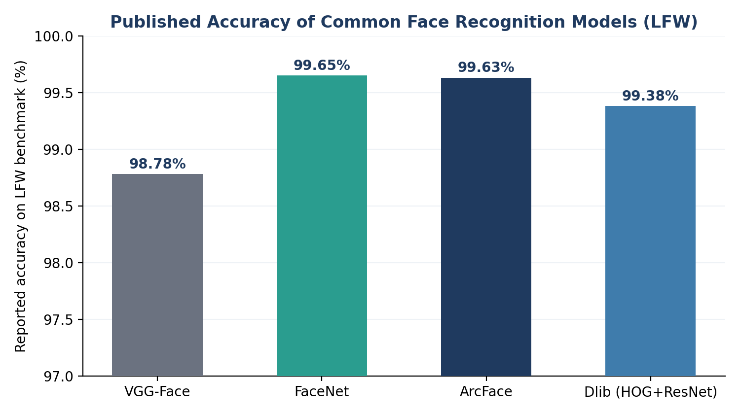
Figure 2 — Published LFW benchmark accuracy by model (reference figures; verify current numbers before citing).

4.3 Threshold Trade-off
Raising the confidence threshold reduces false accepts (FAR) but increases false rejects (FRR) — a genuinely present student may not get auto-marked. The chart below illustrates this trade-off conceptually; the actual curve for your deployment must be measured from your own test data, not assumed.
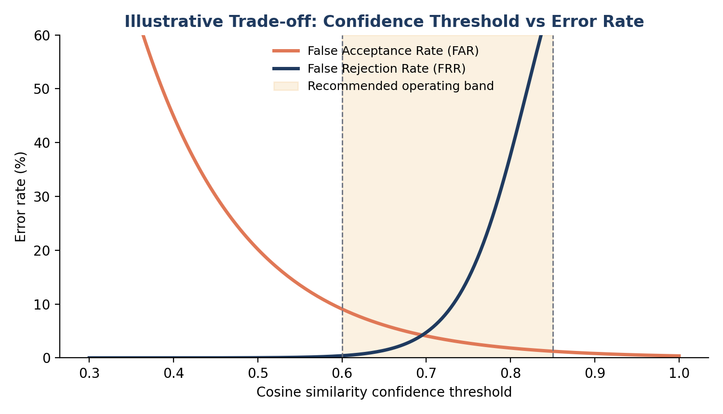
Figure 3 — Illustrative threshold trade-off curve (conceptual, not measured data).

4.4 Recommended Evaluation Process
- Collect a labeled test set from your actual camera (varied lighting, angles, distances)
- Run matching against this set and log every prediction with its true label
- Compute precision, recall, FAR, FRR at several thresholds (e.g. 0.5 to 0.95 in steps of 0.05)
- Pick the threshold that keeps FAR near-zero (misidentifying a student is worse than missing one) while keeping FRR tolerable, since a review queue catches most missed cases anyway

5. Harder Parts of the Project (Read Before Estimating Timeline)
These are the parts most likely to eat unplanned time. Budget extra time for these specifically.

5.1 Lighting and camera angle variance
A model that performs at 99% in a demo often drops noticeably in a real classroom with mixed daylight and fluorescent lighting, or students entering at an angle rather than facing the camera directly. Mitigate with: consistent camera placement, supplemental lighting near the entrance if needed, and testing across different times of day before trusting the system.

5.2 Liveness detection without extra hardware
Reliable anti-spoofing (blocking photos/videos held up to the camera) using only a standard webcam is genuinely difficult — texture-based models can be fooled by high-quality printed photos, and motion-based checks can be defeated with a short looping video. Combining both signals helps but won't be perfect; this is an active research area, not a solved problem.

5.3 Scaling recognition speed with student count
Comparing a live face against every stored embedding one by one becomes slow once you have hundreds of students. This requires moving from a naive loop to an indexed vector search (FAISS/pgvector) — a nontrivial infrastructure change if not planned from the start.

5.4 Threshold tuning is deployment-specific
There is no universal 'correct' confidence threshold. It depends on camera quality, lighting, and how many students are enrolled (more students = more chances for two embeddings to be accidentally close together). This requires real testing, not copying a number from a tutorial.

5.5 Partial occlusion (masks, hats, glasses glare)
Recognition accuracy drops meaningfully when part of the face is covered or glare obscures the eyes. Decide upfront whether you'll require an unobstructed face for enrollment/matching, or invest extra effort in mask-aware recognition models.

5.6 Handling network drops gracefully
If the classroom PC loses internet mid-class, attendance still needs to be captured. This requires a local-first write pattern (queue locally, sync when reconnected) rather than assuming the API call always succeeds — easy to forget until it fails in a real deployment.

5.7 Bias and fairness across students
Some recognition models perform unevenly across different skin tones, ages, and genders due to training data imbalance. This must be tested deliberately across your actual student population, not assumed away — deploying without this check risks systematically worse accuracy for some students.

5.8 Privacy and consent logistics
This is often harder organizationally than technically: getting documented consent from students/parents for biometric data collection, defining a data retention/deletion policy, and securing the embedding database all need to be resolved before deployment, not as an afterthought.

6. End-to-End Flows by Role

6.1 Admin
- First-run setup wizard creates the initial admin account
- Creates teacher and student accounts
- Enrolls students by capturing 3–5 face samples per student
- Configures confidence thresholds and session time windows
- Views school-wide attendance reports and audit logs of manual overrides

6.2 Teacher
- Logs in, sees only their assigned classes
- Opens a class session to start accepting attendance
- Watches live attendance populate as students are recognized
- Approves or rejects medium-confidence matches in the review queue
- Manually adds any student the camera missed
- Closes the session — unrecorded students are marked absent

6.3 Student
- Logs in to a read-only personal view
- Views their own attendance history and percentage
- Receives notifications if attendance drops below the configured threshold
- Can submit a correction request, routed to the teacher for approval

7. Development Timeline
A 6-week build plan for a working end-to-end MVP, assuming consistent part-time effort. Compress or stretch based on actual available hours.
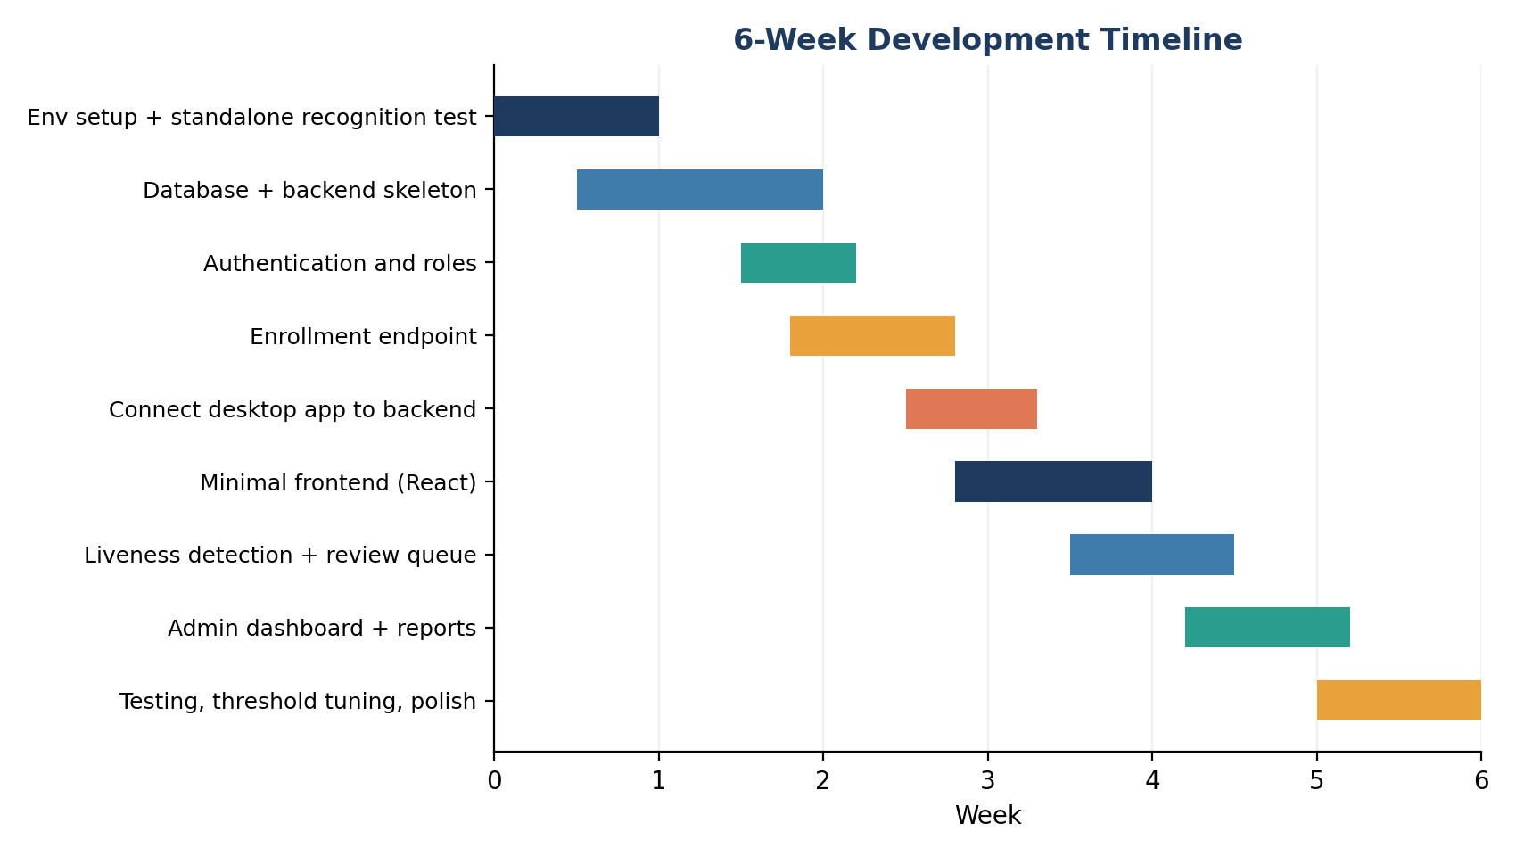
Figure 4 — Suggested 6-week development timeline.

8. Database Schema
Table | Key Columns
users | id, name, email, password_hash, role, created_at
classes | id, name, teacher_id (FK), schedule
students | id, user_id (FK, nullable), name, class_id (FK), roll_number
face_embeddings | id, student_id (FK), embedding_vector (512-dim), created_at
sessions | id, class_id (FK), start_time, end_time, status
attendance | id, student_id (FK), session_id (FK), timestamp, method, confidence_score
notifications_log | id, student_id (FK), type, sent_at, threshold_triggered

9. Core API Endpoints
Endpoint | Purpose
POST /auth/login | Authenticate, return JWT
POST /users | Admin creates a teacher/student account
POST /students/{id}/enroll | Upload face samples, generate embeddings
POST /sessions/start | Teacher opens a class session
POST /attendance/mark | Desktop app posts a confirmed match
GET /attendance/review-queue | Fetch medium-confidence matches
POST /attendance/review/{id} | Teacher approves/rejects a match
POST /attendance/manual | Teacher manually marks a student
POST /sessions/{id}/close | Close session, mark remaining absent
GET /reports/class/{id} | Attendance report for a class
GET /reports/student/{id} | Individual attendance history

10. Technology Stack
Component | Recommended Tool
Face detection | RetinaFace / MTCNN
Liveness detection | Custom CNN (texture) + blink detection (motion)
Embedding model | ArcFace (via InsightFace or DeepFace library)
Vector search | FAISS or PostgreSQL + pgvector
Desktop app | Python + OpenCV
Backend API | FastAPI (Python)
Database | PostgreSQL
Frontend | React
Notifications | Twilio (SMS), SendGrid (email)
Auth | JWT-based sessions

11. Security & Privacy Notes
- Store embeddings, not raw photos, wherever possible — embeddings cannot be reversed into a usable photo
- Encrypt the database at rest; use HTTPS for all API traffic
- Obtain explicit consent from students/parents before enrolling biometric data
- Provide a way to request deletion of stored face data
- Rate-limit the recognition API if it is ever exposed beyond the local network

12. Note on Sources
Benchmark accuracy figures in Section 4.2 and library/model names throughout this document are drawn from general knowledge of published research and well-known open-source projects (e.g. DeepFace, InsightFace, face_recognition). They were not verified against live web sources at the time of writing. Before citing any specific number or linking to a specific repository in your own report, verify it directly — model benchmarks and repository status change over time.

