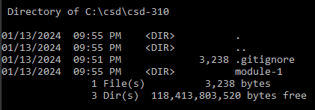

https://github.com/aumoore/csd-310.git

