Austin Moore

Module 5.2 Assignment

2/4/2024

CHAR_LENGTH – You would utilize this when you need to understand how long a string is.

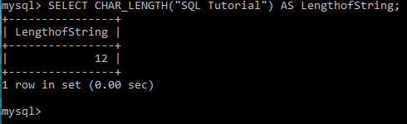

LOWER – This converts any uppercase characters to lower case. This can be utilized where strings aren’t as important and should be lower case.

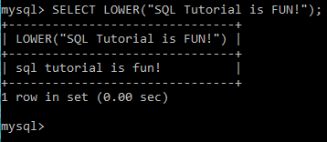

REVERSE – This function reverses the characters entered in the string.

