Austin Moore

2/11/2024

CSD310 Module 6.2 Assignment

https://github.com/aumoore/csd-310/tree/main/module-6

SQL Script Run:

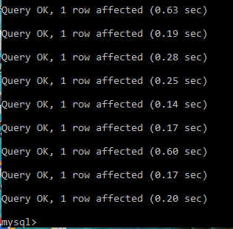

List of tables:

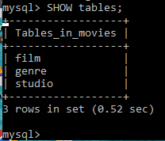

Connection test code:

