Link to github - https://github.com/aumoore/csd-340.git

Step 2

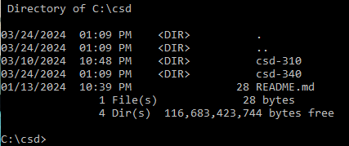

Step 3

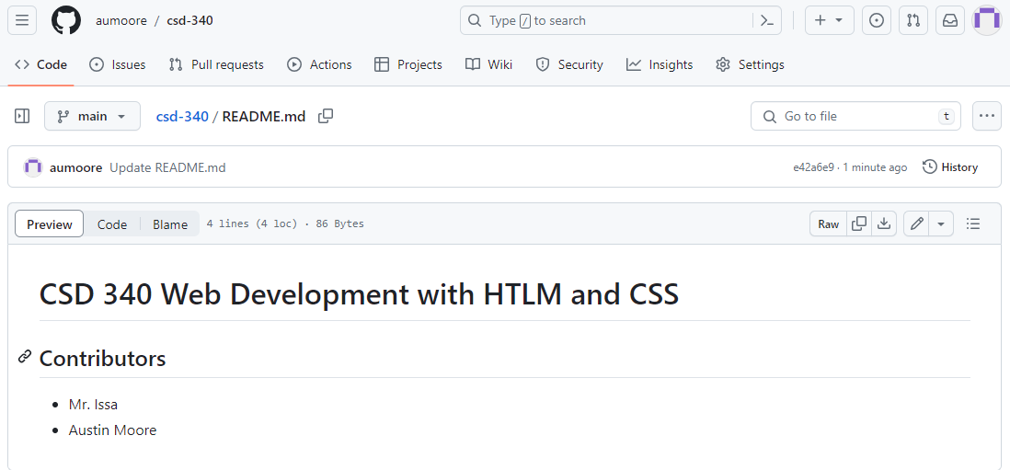

Step 4

