GitHub Link - <https://github.com/aumoore/csd-340>

Starter code errors:

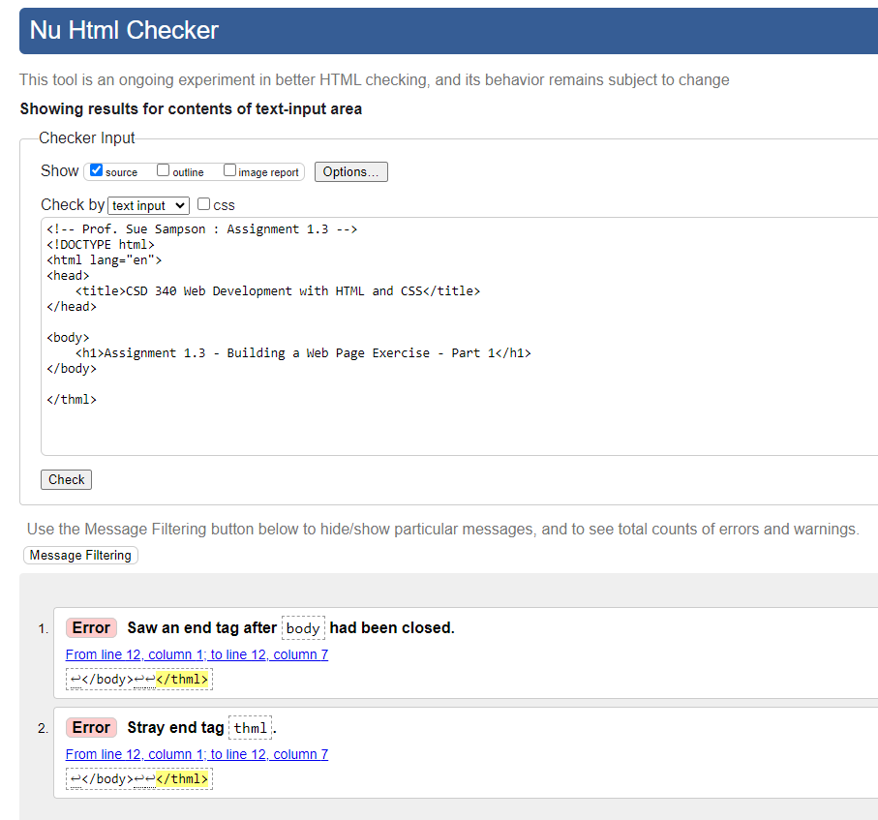

Starter code fixed:

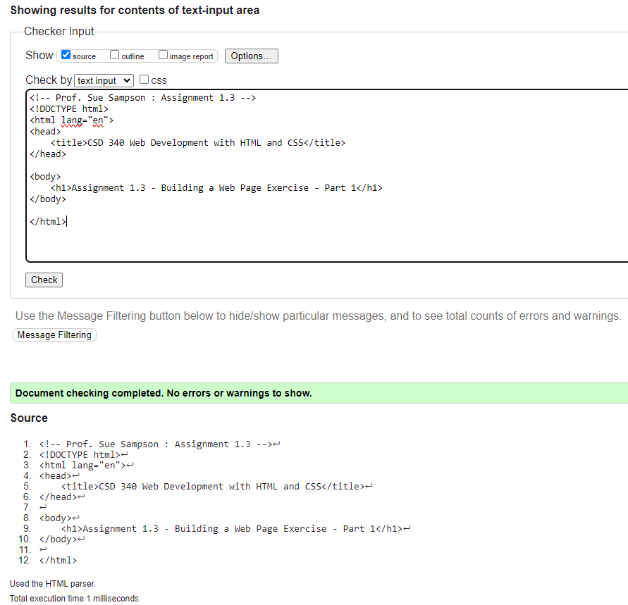

Code ran through browser:

