## [ 2CEIT509MOBILE APPLICATIONDEVELOPMENT]

**Assignment-2**

**Quiz App**

**themes.xml**

**For Setting Theme**

<resources xmlns:tools="http://schemas.android.com/tools">  
 <!-- Base application theme. -->  
 <style name="Theme.BasicMathApp" parent="Theme.MaterialComponents.DayNight.NoActionBar">  
 <!-- Primary brand color. -->  
 <item name="colorPrimary">@color/purple_500</item>  
 <item name="colorPrimaryVariant">@color/purple_700</item>  
 <item name="colorOnPrimary">@color/white</item>  
 <!-- Secondary brand color. -->  
 <item name="colorSecondary">@color/teal_200</item>  
 <item name="colorSecondaryVariant">@color/teal_700</item>  
 <item name="colorOnSecondary">@color/black</item>  
 <!-- Status bar color. -->  
 <item name="android:statusBarColor" tools:targetApi="l">?attr/colorPrimaryVariant</item>  
 <!-- Customize your theme here. -->  
 </style>  
</resources>

**customlayout.xml**

**For Correct Answer**

<?xml version="1.0" encoding="utf-8"?>  
  
<androidx.constraintlayout.widget.ConstraintLayout xmlns:android="http://schemas.android.com/apk/res/android"  
 xmlns:app="http://schemas.android.com/apk/res-auto"  
 android:layout_width="match_parent"  
 android:layout_height="wrap_content"  
 android:layout_marginLeft="22dp"  
 android:layout_marginRight="22dp"  
 android:background="@drawable/bg"  
 android:orientation="vertical">  
  
 <ImageView  
 android:id="@+id/imageView5"  
 android:layout_width="100dp"  
 android:layout_height="100dp"  
 android:layout_marginTop="16dp"  
 android:src="@drawable/correct_img"  
 app:layout_constraintEnd_toEndOf="parent"  
 app:layout_constraintStart_toStartOf="parent"  
 app:layout_constraintTop_toTopOf="parent"  
 app:srcCompat="@drawable/correct_img" />  
  
 <TextView  
 android:id="@+id/tvDialog_score"  
 android:layout_width="match_parent"  
 android:layout_height="wrap_content"  
 android:layout_marginTop="50dp"  
 android:layout_marginBottom="50dp"  
 android:gravity="center"  
 android:text="Score: 0"  
 android:textAlignment="center"  
 android:textColor="@android:color/black"  
 android:textSize="20sp"  
 android:textStyle="bold"  
 app:layout_constraintBottom_toTopOf="@+id/correct_ok"  
 app:layout_constraintEnd_toEndOf="parent"  
 app:layout_constraintStart_toStartOf="parent"  
 app:layout_constraintTop_toBottomOf="@+id/imageView5" />  
  
 <Button  
 android:id="@+id/correct_ok"  
 android:layout_width="wrap_content"  
 android:layout_height="wrap_content"  
 android:layout_gravity="center"  
 android:layout_marginBottom="32dp"  
 android:background="@drawable/button_bg"  
 android:text="Ok"  
 android:textColor="@android:color/white"  
 android:textSize="20sp"  
 android:textStyle="bold"  
 app:layout_constraintBottom_toBottomOf="parent"  
 app:layout_constraintEnd_toEndOf="parent"  
 app:layout_constraintStart_toStartOf="parent" />  
</androidx.constraintlayout.widget.ConstraintLayout>

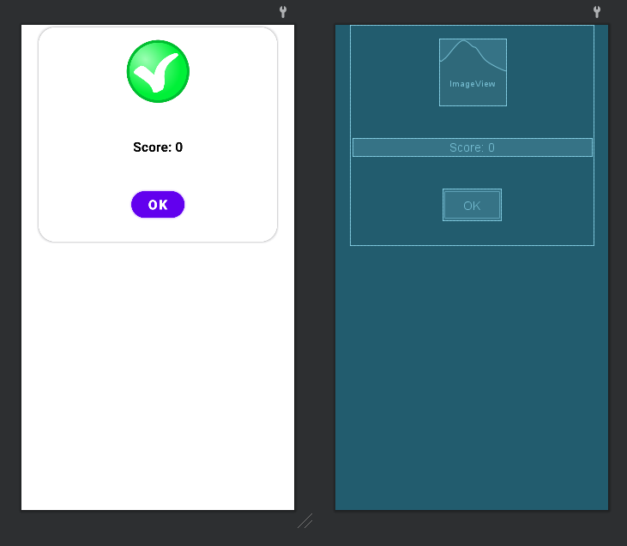

**customlayoutwronganswer.xml**

**For Wrong Answer**

<?xml version="1.0" encoding="utf-8"?>  
  
<androidx.constraintlayout.widget.ConstraintLayout xmlns:android="http://schemas.android.com/apk/res/android"  
 xmlns:app="http://schemas.android.com/apk/res-auto"  
 android:layout_width="match_parent"  
 android:layout_height="wrap_content"  
 android:layout_marginLeft="22dp"  
 android:layout_marginRight="22dp"  
 android:orientation="vertical">  
  
 <ImageView  
 android:id="@+id/imageView5"  
 android:layout_width="100dp"  
 android:layout_height="100dp"  
 android:layout_marginTop="16dp"  
 android:src="@drawable/wrong_img"  
 app:layout_constraintEnd_toEndOf="parent"  
 app:layout_constraintStart_toStartOf="parent"  
 app:layout_constraintTop_toTopOf="parent" />  
  
 <TextView  
 android:id="@+id/tv_wrongDialog_correctAns"  
 android:layout_width="match_parent"  
 android:layout_height="wrap_content"  
 android:layout_marginTop="50dp"  
 android:layout_marginBottom="50dp"  
 android:paddingStart="16dp"  
 android:paddingEnd="16dp"  
 android:text="Correct Ans: xyz"  
 android:textAlignment="center"  
 android:textColor="@android:color/black"  
 android:textSize="20sp"  
 android:textStyle="bold"  
 app:layout_constraintBottom_toTopOf="@+id/wrong_ok"  
 app:layout_constraintEnd_toEndOf="parent"  
 app:layout_constraintHorizontal_bias="0.0"  
 app:layout_constraintStart_toStartOf="parent"  
 app:layout_constraintTop_toBottomOf="@+id/imageView5"  
 app:layout_constraintVertical_bias="0.0" />  
  
 <Button  
 android:id="@+id/wrong_ok"  
 android:layout_width="wrap_content"  
 android:layout_height="wrap_content"  
 android:layout_gravity="center"  
 android:layout_marginBottom="32dp"  
 android:background="@drawable/button_bg"  
 android:text="Ok"  
 android:textColor="@android:color/white"  
 android:textSize="20sp"  
 android:textStyle="bold"  
 app:layout_constraintBottom_toBottomOf="parent"  
 app:layout_constraintEnd_toEndOf="parent"  
 app:layout_constraintStart_toStartOf="parent" />  
</androidx.constraintlayout.widget.ConstraintLayout>

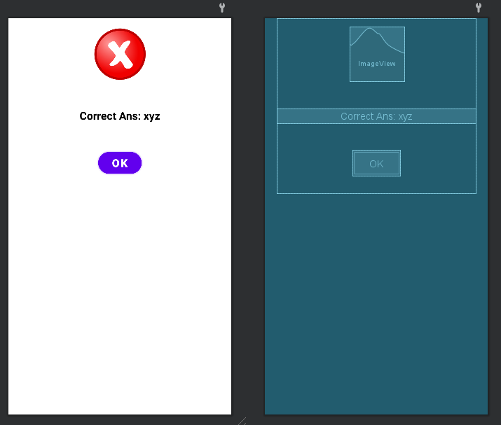

**customlayouttimeover.xml**

**For Time Over**

<?xml version="1.0" encoding="utf-8"?>  
  
<androidx.constraintlayout.widget.ConstraintLayout xmlns:android="http://schemas.android.com/apk/res/android"  
 xmlns:app="http://schemas.android.com/apk/res-auto"  
 android:layout_width="match_parent"  
 android:layout_height="wrap_content"  
 android:layout_marginLeft="22dp"  
 android:layout_marginRight="22dp"  
 android:background="@drawable/bg"  
 android:orientation="vertical">  
  
 <ImageView  
 android:id="@+id/imageView5"  
 android:layout_width="100dp"  
 android:layout_height="100dp"  
 android:layout_marginTop="16dp"  
 android:src="@drawable/time_over_img"  
 app:layout_constraintEnd_toEndOf="parent"  
 app:layout_constraintStart_toStartOf="parent"  
 app:layout_constraintTop_toTopOf="parent"  
 app:srcCompat="@drawable/time_over_img" />  
  
 <TextView  
 android:id="@+id/textView"  
 android:layout_width="match_parent"  
 android:layout_height="wrap_content"  
 android:layout_marginTop="50dp"  
 android:layout_marginBottom="50dp"  
 android:text="Time Over"  
 android:textAlignment="center"  
 android:textColor="@android:color/black"  
 android:textSize="20sp"  
 android:textStyle="bold"  
 app:layout_constraintBottom_toTopOf="@+id/timeOver_ok"  
 app:layout_constraintEnd_toEndOf="parent"  
 app:layout_constraintStart_toStartOf="parent"  
 app:layout_constraintTop_toBottomOf="@+id/imageView5" />  
  
 <Button  
 android:id="@+id/timeOver_ok"  
 android:layout_width="wrap_content"  
 android:layout_height="wrap_content"  
 android:layout_gravity="center"  
 android:layout_marginBottom="32dp"  
 android:background="@drawable/button_bg"  
 android:text="Ok"  
 android:textColor="@android:color/white"  
 android:textSize="20sp"  
 android:textStyle="bold"  
 app:layout_constraintBottom_toBottomOf="parent"  
 app:layout_constraintEnd_toEndOf="parent"  
 app:layout_constraintStart_toStartOf="parent" />  
</androidx.constraintlayout.widget.ConstraintLayout>

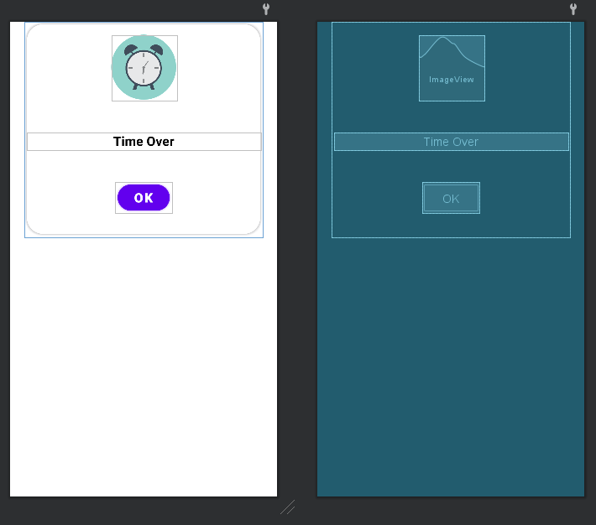

**HomeActivity.kt**

package com.example.quizapp  
  
import android.content.Intent  
import android.os.Bundle  
import androidx.appcompat.app.AppCompatActivity  
import androidx.appcompat.resources.Compatibility.Api21Impl.inflate  
import androidx.core.content.res.ComplexColorCompat.inflate  
import androidx.core.graphics.drawable.DrawableCompat.inflate  
  
  
class HomeActivity : AppCompatActivity() {  
 private lateinit var activityHomeBinding: ActivityHomeBinding  
 override fun onCreate(savedInstanceState: Bundle?) {  
 super.onCreate(savedInstanceState)  
 activityHomeBinding = ActivityHomeBinding.inflate(*layoutInflater*)  
 setContentView(activityHomeBinding.root)  
 activityHomeBinding.playQuizHomeBtn.setOnClickListener **{** val intent = Intent(this@HomeActivity, PlayActivity::class.*java*)  
 startActivity(intent)  
 **}** }  
}  
  
class ActivityHomeBinding {  
  
 val playQuizHomeBtn: Any  
 val root: Int  
}

**homeactivity.xml**

<?xml version="1.0" encoding="utf-8"?>  
  
  
<androidx.constraintlayout.widget.ConstraintLayout xmlns:android="http://schemas.android.com/apk/res/android"  
 xmlns:app="http://schemas.android.com/apk/res-auto"  
 xmlns:tools="http://schemas.android.com/tools"  
 android:layout_width="match_parent"  
 android:layout_height="match_parent"  
 tools:context=".HomeActivity">  
  
 <TextView  
 android:id="@+id/title"  
 android:layout_width="match_parent"  
 android:layout_height="wrap_content"  
 android:layout_marginTop="16dp"  
 android:fontFamily="cursive"  
 android:gravity="center_horizontal"  
 android:text="Basic Quiz App"  
 android:textColor="@color/black"  
 android:textSize="32sp"  
 android:textStyle="bold"  
 app:layout_constraintTop_toTopOf="parent" />  
  
 <Button  
 android:id="@+id/playQuiz_home_btn"  
 android:layout_width="250dp"  
 android:layout_height="wrap_content"  
 android:background="@drawable/button_bg"  
 android:padding="16dp"  
 android:text="Play Quiz"  
 android:textSize="20sp"  
 android:textStyle="bold"  
 app:layout_constraintBottom_toBottomOf="parent"  
 app:layout_constraintEnd_toEndOf="parent"  
 app:layout_constraintStart_toStartOf="parent"  
 app:layout_constraintTop_toTopOf="parent" />  
</androidx.constraintlayout.widget.ConstraintLayout>

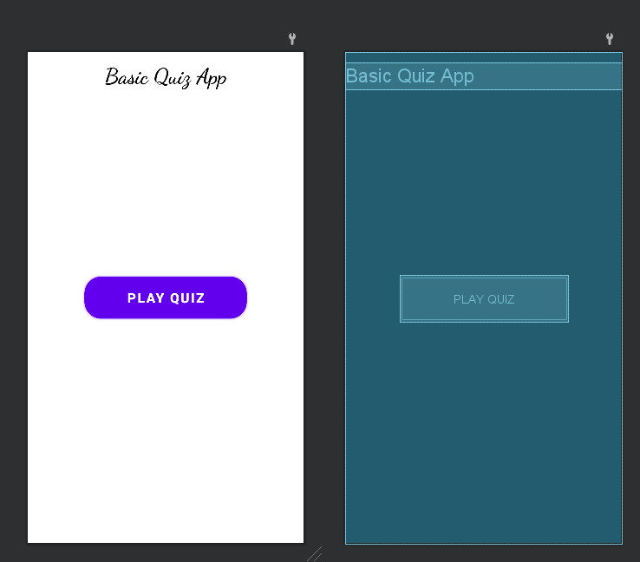

**PlayActivity.kt**

package com.example.quizapp  
  
  
import android.annotation.SuppressLint  
import android.content.Intent  
import android.content.res.ColorStateList  
import android.graphics.Color  
import android.os.Bundle  
import android.os.CountDownTimer  
import android.widget.*  
import androidx.appcompat.app.AlertDialog  
import androidx.appcompat.app.AppCompatActivity  
  
import java.util.*  
import java.util.concurrent.TimeUnit  
import android.view.LayoutInflater as LayoutInflater1  
  
class PlayActivity : AppCompatActivity() {  
  
 private lateinit var activityPlayBinding: ActivityPlayBinding  
  
 // timer  
 private var countDownTimer: CountDownTimer? = null  
 private val countDownInMilliSecond: Long = 30000  
 private val countDownInterval: Long = 1000  
 private var timeLeftMilliSeconds: Long = 0  
 private var defaultColor: ColorStateList? = null  
  
 private var score = 0  
 private var correct = 0  
 private var wrong = 0  
 private var skip = 0  
 private var qIndex = 0  
 private var updateQueNo = 1  
  
 // create string for question, answer and options  
 private var questions = *arrayOf*(  
 "Q.1. If a computer has more than one processor then it is known as?",  
 "Q.2. Full form of URL is?",  
 "Q.3. One kilobyte (KB) is equal to",  
 "Q.4. Father of ‘C’ programming language?",  
 "Q.5. SUMPS stands for",  
 "Q.6. What is a floppy disk used for",  
 "Q.7. Which operating system is developed and used by Apple Inc?",  
 "Q.8. Random Access Memory (RAM) is which storage of device?",  
 "Q.9. Who is the founder of the Internet?",  
 "Q.10. Which one is the first search engine in internet?")  
  
 private var answer = *arrayOf*(  
 "Multiprocessor",  
 "Uniform Resource Locator",  
 "1,024 bytes",  
 "Dennis Ritchie",  
 "Switched mode power supply",  
 "To store information",  
 "iOS",  
 "Primay",  
 "Tim Berners-Lee",  
 "Archie")  
  
 private var options = *arrayOf*(  
 "Uniprocess",  
 "Multiprocessor",  
 "Multithreaded",  
 "Multiprogramming",  
 "Uniform Resource Locator",  
 "Uniform Resource Linkwrong",  
 "Uniform Registered Link",  
 "Unified Resource Link",  
 "1,000 bits",  
 "1,024 bytes",  
 "1,024 megabytes",  
 "1,024 gigabytes",  
 "Dennis Ritchie",  
 "Prof Jhon Kemeny",  
 "Thomas Kurtz",  
 "Bill Gates",  
 "Switched mode power supply",  
 "Start mode power supply",  
 "Store mode power supply",  
 "Single mode power supply",  
 "To unlock the computer",  
 "To store information",  
 "To erase the computer screen",  
 "To make the printer work",  
 "Windows",  
 "Android",  
 "iOS",  
 "UNIX",  
 "Primay",  
 "Secondary",  
 "Teriary",  
 "Off line",  
 "Vint Cerf",  
 "Charles Babbage",  
 "Tim Berners-Lee",  
 "None of these",  
 "Google",  
 "Archie",  
 "Altavista",  
 "WAIS")  
  
 override fun onCreate(savedInstanceState: Bundle?) {  
 super.onCreate(savedInstanceState)  
 activityPlayBinding = ActivityPlayBinding.inflate(*layoutInflater*)  
 setContentView(activityPlayBinding.root)  
  
 initViews()  
 }  
  
 @SuppressLint("SetTextI18n")  
 private fun showNextQuestion() {  
  
 checkAnswer()  
  
 activityPlayBinding.apply **{** if (updateQueNo < 10) {  
 tvNoOfQues.text = "${updateQueNo + 1}/10"  
 updateQueNo++  
 }  
 if (qIndex <= questions.size - 1) {  
 tvQuestion.text = questions[qIndex]  
 radioButton1.text = options[qIndex * 4] // 2*4=8  
 radioButton2.text = options[qIndex * 4 + 1] // 2*4+1=9  
 radioButton3.text = options[qIndex * 4 + 2] // 2*4+2=10  
 radioButton4.text = options[qIndex * 4 + 3] // 2*4+3=11  
 } else {  
 score = correct  
 val intent = Intent(this@PlayActivity, ResultActivity::class.*java*)  
 intent.putExtra("correct", correct)  
 intent.putExtra("wrong", wrong)  
 intent.putExtra("skip", skip)  
 startActivity(intent)  
 finish()  
 }  
 radiogrp.clearCheck()  
 **}** }  
  
 @SuppressLint("SetTextI18n")  
 private fun checkAnswer() {  
  
 activityPlayBinding.apply **{** if (radiogrp.checkedRadioButtonId == -1) {  
 skip++  
 timeOverAlertDialog()  
  
 } else {  
 val checkRadioButton =  
 findViewById<RadioButton>(radiogrp.checkedRadioButtonId)  
 val checkAnswer = checkRadioButton.*text*.toString()  
 if (checkAnswer == answer[qIndex]) {  
 correct++  
 txtPlayScore.text = "Score : $correct"  
 correctAlertDialog()  
 countDownTimer?.cancel()  
 } else {  
 wrong++  
 wrongAlertDialog()  
 countDownTimer?.cancel()  
 }  
  
 }  
 qIndex++  
 **}** }  
  
 @SuppressLint("SetTextI18n")  
 private fun initViews() {  
  
 activityPlayBinding.apply **{** tvQuestion.text = questions[qIndex]  
 radioButton1.text = options[0]  
 radioButton2.text = options[1]  
 radioButton3.text = options[2]  
 radioButton4.text = options[3]  
  
 // check options selected or not  
 // if selected then selected option correct or wrong  
 nextQuestionBtn.setOnClickListener **{** if (radiogrp.checkedRadioButtonId == -1) {  
 Toast.makeText(this@PlayActivity,  
 "Please select an options",  
 Toast.*LENGTH_SHORT*)  
 .show()  
 } else {  
 showNextQuestion()  
 }  
 **}** tvNoOfQues.text = "$updateQueNo/10"  
 tvQuestion.text = questions[qIndex]  
  
 defaultColor = quizTimer.textColors  
  
  
 timeLeftMilliSeconds = countDownInMilliSecond  
  
 statCountDownTimer()  
 **}** }  
  
 private fun statCountDownTimer() {  
 countDownTimer = object : CountDownTimer(timeLeftMilliSeconds, countDownInterval) {  
 override fun onTick(millisUntilFinished: Long) {  
  
 activityPlayBinding.apply **{** timeLeftMilliSeconds = millisUntilFinished  
 val second = TimeUnit.*MILLISECONDS*.toSeconds(timeLeftMilliSeconds).toInt()  
  
 // %02d format the integer with 2 digit  
 val timer = String.*format*(Locale.getDefault(), "Time: %02d", second)  
 quizTimer.text = timer  
  
 if (timeLeftMilliSeconds < 10000) {  
 quizTimer.setTextColor(Color.*RED*)  
 } else {  
 quizTimer.setTextColor(defaultColor)  
 }  
 **}** }  
  
 override fun onFinish() {  
 showNextQuestion()  
  
 }  
 }.start()  
 }  
  
 @SuppressLint("SetTextI18n")  
 private fun correctAlertDialog() {  
 val builder = AlertDialog.Builder(this@PlayActivity)  
 val view = LayoutInflater1.from(this@PlayActivity).inflate(R.layout.correct_dialoag, null)  
 builder.setView(view)  
 val tvScore = view.findViewById<TextView>(R.id.*tvDialog_score*)  
 val correctOkBtn = view.findViewById<Button>(R.id.*correct_ok*)  
 "Score : $correct".*also* **{** tvScore.text = **it }** val alertDialog = builder.create()  
 correctOkBtn.setOnClickListener **{** timeLeftMilliSeconds = countDownInMilliSecond  
 statCountDownTimer()  
 alertDialog.dismiss()  
 **}** alertDialog.show()  
 }  
  
 @SuppressLint("SetTextI18n")  
 private fun wrongAlertDialog() {  
 val builder = AlertDialog.Builder(this@PlayActivity)  
 val view = LayoutInflater1.from(this@PlayActivity).inflate(R.layout.wrong_dialog, null)  
 builder.setView(view)  
  
 val tvWrongDialogCorrectAns = view.findViewById<TextView>(R.id.*tv_wrongDialog_correctAns*)  
 val wrongOk = view.findViewById<Button>(R.id.*wrong_ok*)  
 tvWrongDialogCorrectAns.text = "Correct Answer : " + answer[qIndex]  
 val alertDialog = builder.create()  
  
 wrongOk.setOnClickListener **{** timeLeftMilliSeconds =  
 countDownInMilliSecond  
 statCountDownTimer()  
 alertDialog.dismiss()  
 **}** alertDialog.show()  
 }  
  
 @SuppressLint("SetTextI18n")  
 private fun timeOverAlertDialog() {  
 val builder = AlertDialog.Builder(this@PlayActivity)  
 val view = LayoutInflater1.from(this@PlayActivity).inflate(R.layout.time_over_dialog, null)  
 builder.setView(view)  
 val timeOverOk = view.findViewById<Button>(R.id.*timeOver_ok*)  
 val alertDialog = builder.create()  
 timeOverOk.setOnClickListener **{** timeLeftMilliSeconds = countDownInMilliSecond  
 statCountDownTimer()  
 alertDialog.dismiss()  
 **}** alertDialog.show()  
 }  
}

**playactivity.xml**

<?xml version="1.0" encoding="utf-8"?>  
  
  
  
<androidx.constraintlayout.widget.ConstraintLayout xmlns:android="http://schemas.android.com/apk/res/android"  
 xmlns:app="http://schemas.android.com/apk/res-auto"  
 xmlns:tools="http://schemas.android.com/tools"  
 android:layout_width="match_parent"  
 android:layout_height="match_parent"  
 tools:context=".PlayActivity">  
  
  
 <TextView  
 android:id="@+id/title"  
 android:layout_width="match_parent"  
 android:layout_height="wrap_content"  
 android:layout_marginTop="16dp"  
 android:fontFamily="cursive"  
 android:gravity="center_horizontal"  
 android:text="Basic Quiz App"  
 android:textColor="@color/black"  
 android:textSize="32sp"  
 android:textStyle="bold"  
 app:layout_constraintTop_toTopOf="parent" />  
  
 <TextView  
 android:id="@+id/txt_play_score"  
 android:layout_width="wrap_content"  
 android:layout_height="wrap_content"  
 android:layout_marginStart="16dp"  
 android:layout_marginTop="16dp"  
 android:text="Score - 00"  
 android:textColor="@color/black"  
 android:textSize="16sp"  
 android:textStyle="bold"  
 app:layout_constraintStart_toStartOf="parent"  
 app:layout_constraintTop_toBottomOf="@+id/title" />  
  
 <TextView  
 android:id="@+id/tv_noOfQues"  
 android:layout_width="wrap_content"  
 android:layout_height="wrap_content"  
 android:layout_marginTop="16dp"  
 android:layout_marginEnd="16dp"  
 android:text="1/10"  
 android:textColor="@color/black"  
 android:textSize="16sp"  
 android:textStyle="bold"  
 app:layout_constraintEnd_toEndOf="parent"  
 app:layout_constraintTop_toBottomOf="@+id/title" />  
  
  
 <TextView  
 android:id="@+id/quiz_timer"  
 android:layout_width="wrap_content"  
 android:layout_height="wrap_content"  
 android:text="Time - 00"  
 android:textColor="@color/black"  
 android:textSize="22sp"  
 android:textStyle="bold"  
 app:layout_constraintEnd_toEndOf="parent"  
 app:layout_constraintStart_toStartOf="parent"  
 app:layout_constraintTop_toBottomOf="@+id/txt_play_score" />  
  
 <TextView  
 android:id="@+id/tv_question"  
 android:layout_width="match_parent"  
 android:layout_height="wrap_content"  
 android:layout_marginStart="16dp"  
 android:layout_marginTop="32dp"  
 android:layout_marginEnd="16dp"  
 android:background="@drawable/bg"  
 android:paddingStart="22dp"  
 android:paddingTop="30dp"  
 android:paddingEnd="22dp"  
 android:paddingBottom="30dp"  
 android:text="Question"  
 android:textColor="@android:color/black"  
 android:textSize="16sp"  
 android:textStyle="bold"  
 app:layout_constraintEnd_toEndOf="parent"  
 app:layout_constraintStart_toStartOf="parent"  
 app:layout_constraintTop_toBottomOf="@+id/quiz_timer" />  
  
 <RadioGroup  
 android:id="@+id/radiogrp"  
 android:layout_width="match_parent"  
 android:layout_height="wrap_content"  
 app:layout_constraintBottom_toTopOf="@+id/nextQuestionBtn"  
 app:layout_constraintEnd_toEndOf="parent"  
 app:layout_constraintHorizontal_bias="0.0"  
 app:layout_constraintStart_toStartOf="parent"  
 app:layout_constraintTop_toBottomOf="@+id/tv_question"  
 app:layout_constraintVertical_bias="0.095">  
  
 <RadioButton  
 android:id="@+id/radioButton1"  
 android:layout_width="match_parent"  
 android:layout_height="wrap_content"  
 android:layout_marginStart="16dp"  
 android:layout_marginTop="40dp"  
 android:layout_marginEnd="16dp"  
 android:background="@drawable/bg"  
 android:padding="16dp"  
 android:text="Option 1"  
 android:textColor="@color/black"  
 app:layout_constraintEnd_toEndOf="parent"  
 app:layout_constraintHorizontal_bias="0.0"  
 app:layout_constraintStart_toStartOf="parent"  
 app:layout_constraintTop_toBottomOf="@+id/textView6" />  
  
 <RadioButton  
 android:id="@+id/radioButton2"  
 android:layout_width="match_parent"  
 android:layout_height="wrap_content"  
 android:layout_marginStart="16dp"  
 android:layout_marginTop="8dp"  
 android:layout_marginEnd="16dp"  
 android:background="@drawable/bg"  
 android:padding="16dp"  
 android:text="Option 2"  
 android:textColor="@color/black"  
 app:layout_constraintEnd_toEndOf="parent"  
 app:layout_constraintHorizontal_bias="0.0"  
 app:layout_constraintStart_toStartOf="parent"  
 app:layout_constraintTop_toBottomOf="@+id/radioButton1" />  
  
 <RadioButton  
 android:id="@+id/radioButton3"  
 android:layout_width="match_parent"  
 android:layout_height="wrap_content"  
 android:layout_marginStart="16dp"  
 android:layout_marginTop="8dp"  
 android:layout_marginEnd="16dp"  
 android:background="@drawable/bg"  
 android:padding="16dp"  
 android:text="Option 3"  
 app:layout_constraintEnd_toEndOf="parent"  
 app:layout_constraintHorizontal_bias="0.0"  
 app:layout_constraintStart_toStartOf="parent"  
 app:layout_constraintTop_toBottomOf="@+id/radioButton2" />  
  
 <RadioButton  
 android:id="@+id/radioButton4"  
 android:layout_width="match_parent"  
 android:layout_height="wrap_content"  
 android:layout_marginStart="16dp"  
 android:layout_marginTop="8dp"  
 android:layout_marginEnd="16dp"  
 android:background="@drawable/bg"  
 android:padding="16dp"  
 android:text="@string/option_4"  
 app:layout_constraintEnd_toEndOf="parent"  
 app:layout_constraintHorizontal_bias="0.0"  
 app:layout_constraintStart_toStartOf="parent"  
 app:layout_constraintTop_toBottomOf="@+id/radioButton3" />  
 </RadioGroup>  
  
 <Button  
 android:id="@+id/nextQuestionBtn"  
 android:layout_width="250dp"  
 android:layout_height="wrap_content"  
 android:layout_marginBottom="22dp"  
 android:background="@drawable/button_bg"  
 android:padding="16dp"  
 android:text="Next Question"  
 android:textColor="#ffff"  
 android:textSize="16sp"  
 android:textStyle="bold"  
 app:layout_constraintBottom_toBottomOf="parent"  
 app:layout_constraintEnd_toEndOf="parent"  
 app:layout_constraintStart_toStartOf="parent" />  
</androidx.constraintlayout.widget.ConstraintLayout>

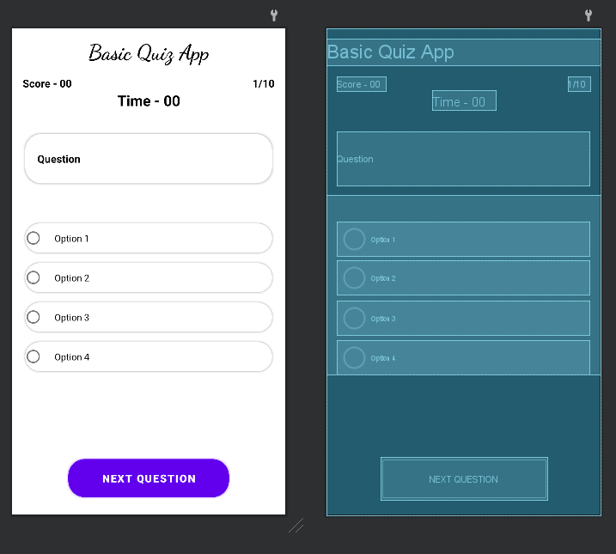

**OpenResultActivity.kt**

package com.example.quizapp  
  
import android.annotation.SuppressLint  
import android.os.Bundle  
import android.widget.Toast  
import androidx.appcompat.app.AppCompatActivity  
  
*/**  
 * Created by Techpass Master.  
 * Website - www.techpassmaster.com  
 * Youtube - Techpass Master  
 */*class ResultActivity : AppCompatActivity() {  
 private lateinit var activityResultBinding: ActivityResultBinding  
 var totalScore = 0  
 var correct = 0  
 var wrong = 0  
 var skip = 0  
 var isKey = false  
 @SuppressLint("SetTextI18n")  
 override fun onCreate(savedInstanceState: Bundle?) {  
 super.onCreate(savedInstanceState)  
 activityResultBinding = ActivityResultBinding.inflate(*layoutInflater*)  
 setContentView(activityResultBinding.root)  
 totalScore = *intent*.*extras*!!.getInt("correct")  
 wrong = *intent*.*extras*!!.getInt("wrong")  
 skip = *intent*.*extras*!!.getInt("skip")  
 initializeViews()  
 }  
 @SuppressLint("SetTextI18n")  
 private fun initializeViews() {  
 activityResultBinding.apply **{** tvScore.text = "Score: $totalScore"  
 tvright.text = "Correct: $totalScore"  
 tvwrong.text = "Wrong: $wrong"  
 tvSkip.text = "Skip: $skip"  
 if (totalScore >= 6) {  
 activityResultBinding.emojiReactionImg.setImageResource(R.drawable.smile_img)  
 Toast.makeText(this@ResultActivity, "Wow Great", Toast.*LENGTH_SHORT*).show()  
 } else {  
 emojiReactionImg.setImageResource(R.drawable.angry_img)  
 Toast.makeText(this@ResultActivity, "Need Improvement", Toast.*LENGTH_SHORT*).show()  
 }  
 tvPlayAgain.setOnClickListener **{** finish()  
 **}  
 }** }  
}

**activitresultlayout.xml**

<?xml version="1.0" encoding="utf-8"?>  
  
  
<LinearLayout xmlns:android="http://schemas.android.com/apk/res/android"  
 xmlns:app="http://schemas.android.com/apk/res-auto"  
 android:layout_width="match_parent"  
 android:layout_height="match_parent"  
 android:gravity="center"  
 android:orientation="vertical">  
  
 <TextView  
 android:id="@+id/txt_result_title"  
 android:layout_width="match_parent"  
 android:layout_height="wrap_content"  
 android:layout_marginTop="30dp"  
 android:gravity="center"  
 android:text="Your Quiz Result"  
 android:textColor="@android:color/black"  
 android:textSize="24sp"  
 android:textStyle="bold" />  
  
 <ImageView  
 android:id="@+id/emoji_ReactionImg"  
 android:layout_width="120dp"  
 android:layout_height="120dp"  
 android:layout_marginTop="30dp"  
 android:src="@drawable/angry"  
 app:srcCompat="@drawable/angry" />  
  
 <LinearLayout  
 android:layout_width="match_parent"  
 android:layout_height="wrap_content"  
 android:layout_marginTop="30dp"  
 android:layout_marginBottom="16dp"  
 android:background="@android:color/white"  
 android:orientation="horizontal">  
  
 <LinearLayout  
 android:layout_width="0dp"  
 android:layout_height="wrap_content"  
 android:layout_gravity="center"  
 android:layout_weight="1"  
 android:gravity="center"  
 android:orientation="vertical">  
  
 <TextView  
 android:id="@+id/tvright"  
 android:layout_width="wrap_content"  
 android:layout_height="wrap_content"  
 android:gravity="center"  
 android:padding="12dp"  
 android:text="Correct: 0"  
 android:textColor="@android:color/black"  
 android:textSize="16sp"  
 android:textStyle="bold" />  
  
 <TextView  
 android:id="@+id/tvwrong"  
 android:layout_width="wrap_content"  
 android:layout_height="wrap_content"  
 android:gravity="center"  
 android:padding="12dp"  
 android:text="Wrong: 0"  
 android:textColor="@android:color/black"  
 android:textSize="16sp"  
 android:textStyle="bold" />  
 </LinearLayout>  
  
 <LinearLayout  
 android:layout_width="0dp"  
 android:layout_height="wrap_content"  
 android:layout_gravity="center"  
 android:layout_weight="1"  
 android:gravity="center"  
 android:orientation="vertical">  
  
 <TextView  
 android:id="@+id/tvScore"  
 android:layout_width="wrap_content"  
 android:layout_height="wrap_content"  
 android:gravity="center"  
 android:padding="12dp"  
 android:text="Score: 0"  
 android:textColor="@android:color/black"  
 android:textSize="16sp"  
 android:textStyle="bold" />  
  
 <TextView  
 android:id="@+id/tvSkip"  
 android:layout_width="wrap_content"  
 android:layout_height="wrap_content"  
 android:gravity="center"  
 android:padding="12dp"  
 android:text="Skip: 0"  
 android:textColor="@android:color/black"  
 android:textSize="16sp"  
 android:textStyle="bold" />  
  
 </LinearLayout>  
 </LinearLayout>  
  
 <LinearLayout  
 android:layout_width="match_parent"  
 android:layout_height="match_parent"  
 android:layout_margin="16dp"  
 android:gravity="bottom"  
 android:orientation="vertical">  
  
 <TextView  
 android:id="@+id/tvPlayAgain"  
 android:layout_width="match_parent"  
 android:layout_height="wrap_content"  
 android:layout_marginTop="10dp"  
 android:background="@drawable/bg"  
 android:gravity="center"  
 android:padding="16sp"  
 android:text="Play Again"  
 android:textColor="@android:color/black"  
 android:textSize="18sp"  
 android:textStyle="bold" />  
  
 <TextView  
 android:layout_width="match_parent"  
 android:layout_height="wrap_content"  
 android:layout_marginTop="10dp"  
 android:background="@drawable/bg"  
 android:gravity="center"  
 android:padding="16sp"  
 android:text="Share Score"  
 android:textColor="@android:color/black"  
 android:textSize="18sp"  
 android:textStyle="bold" />  
  
 <TextView  
 android:layout_width="match_parent"  
 android:layout_height="wrap_content"  
 android:layout_marginTop="10dp"  
 android:background="@drawable/bg"  
 android:gravity="center"  
 android:padding="16sp"  
 android:text="Rate App"  
 android:textColor="@android:color/black"  
 android:textSize="18sp"  
 android:textStyle="bold" />  
  
 <TextView  
 android:layout_width="match_parent"  
 android:layout_height="wrap_content"  
 android:layout_marginTop="10dp"  
 android:background="@drawable/bg"  
 android:gravity="center"  
 android:padding="16sp"  
 android:text="Home"  
 android:textColor="@android:color/black"  
 android:textSize="18sp"  
 android:textStyle="bold" />  
 </LinearLayout>  
</LinearLayout>

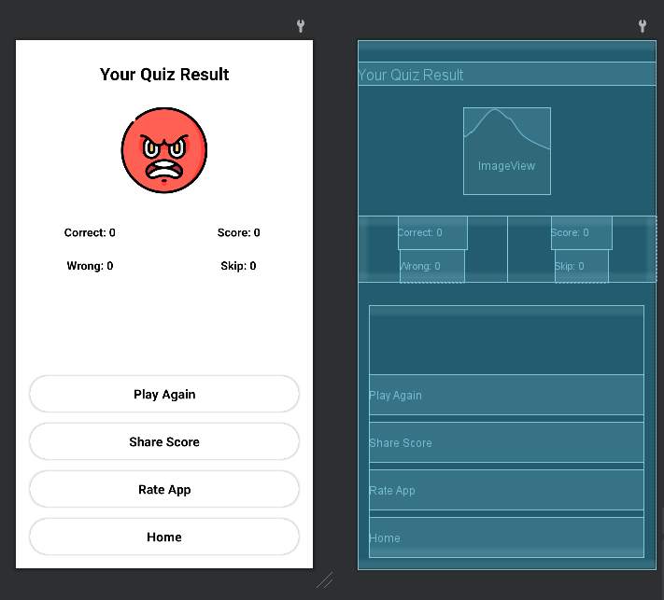

**OUTPUT:-**

