aumtech.ai · EdNex Platform
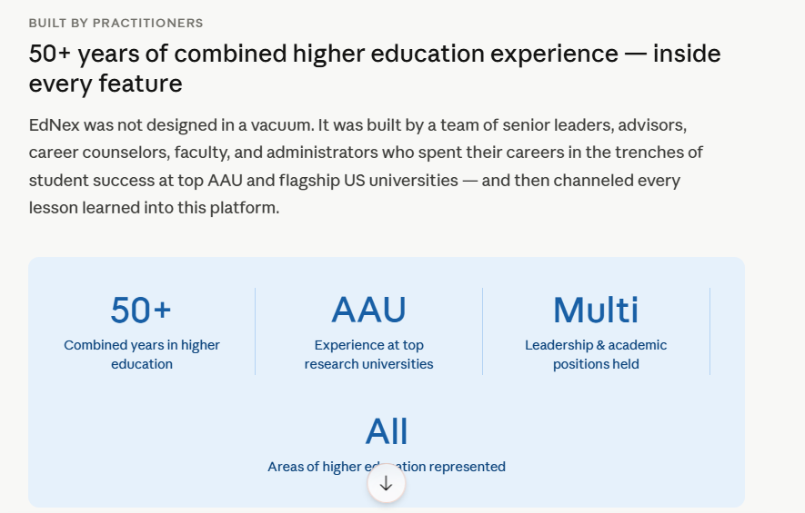
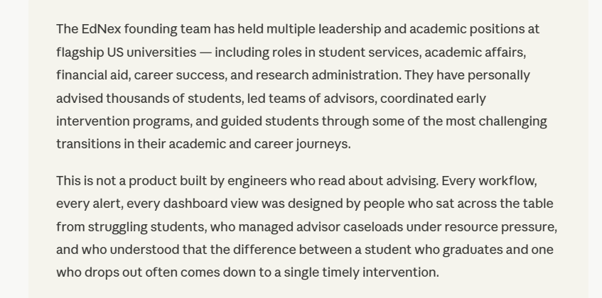
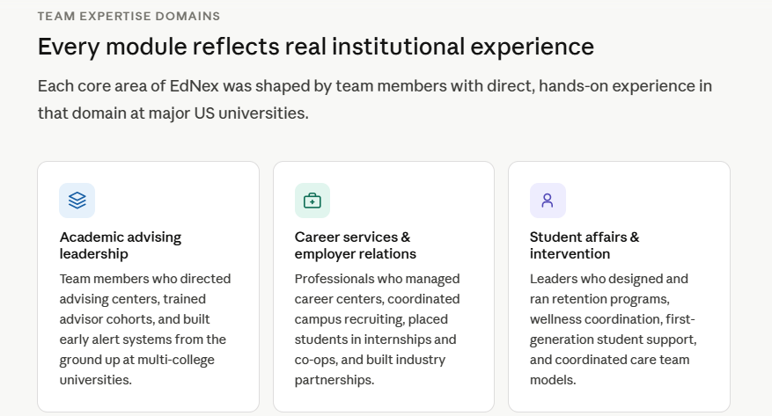
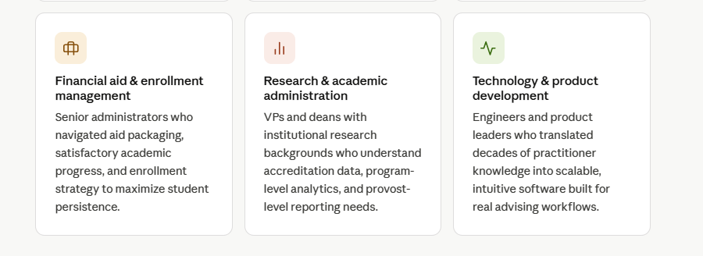
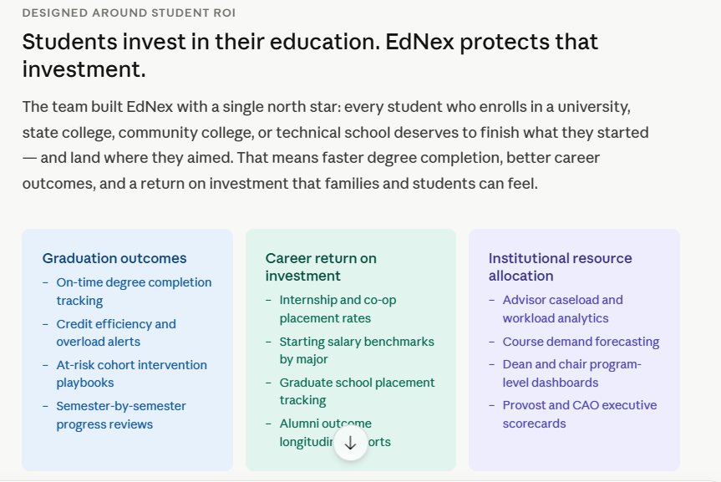
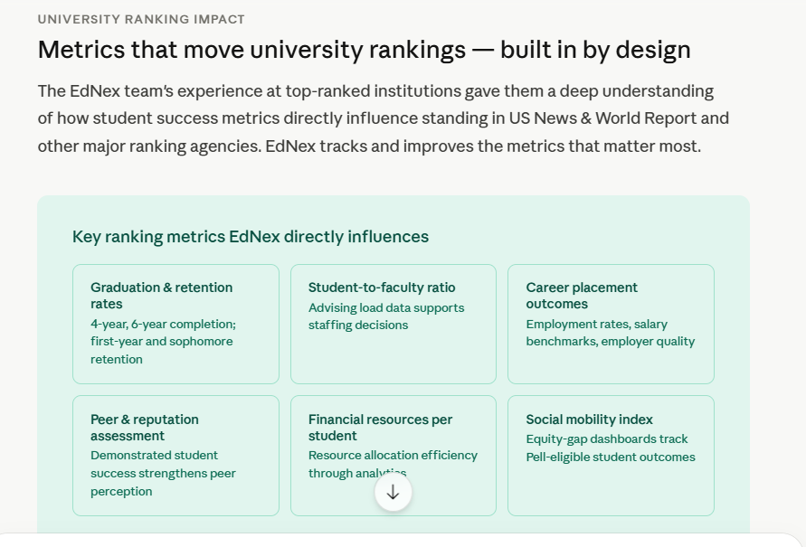
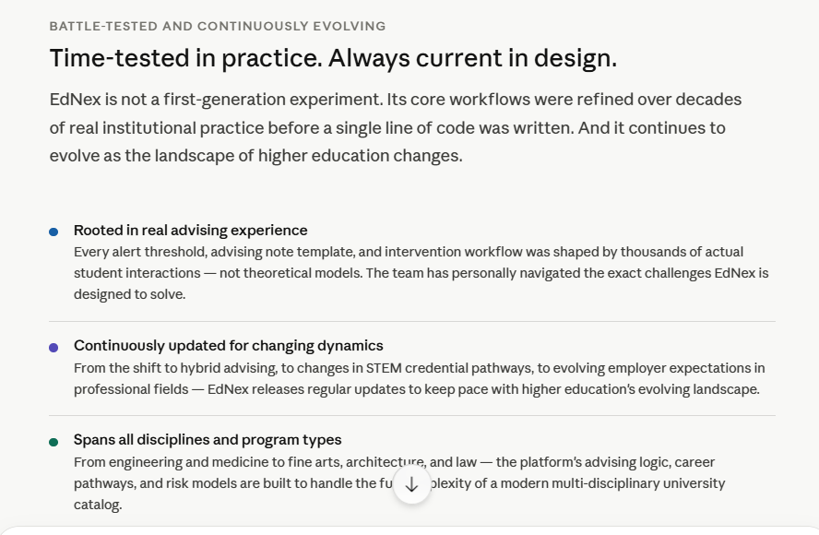
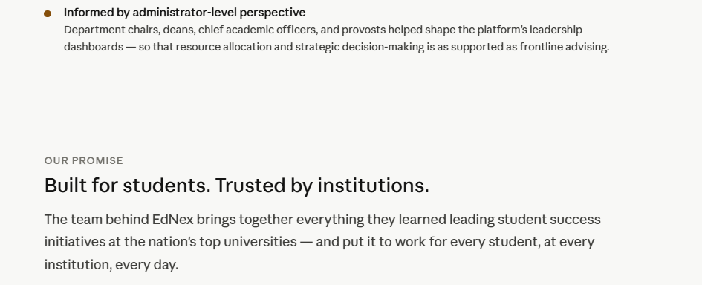
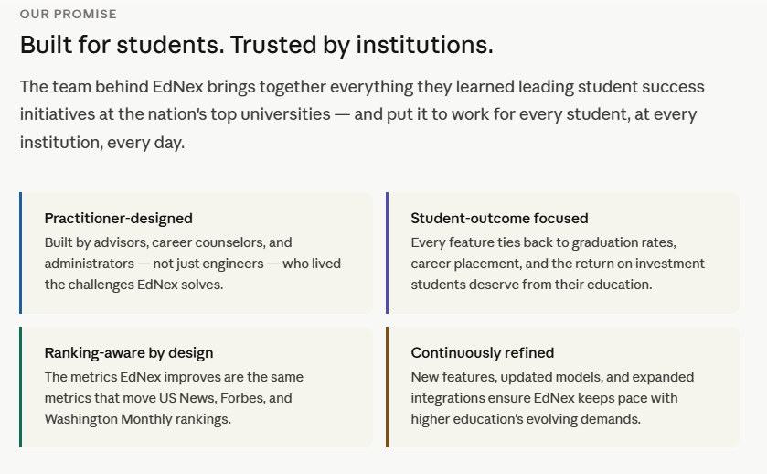

The intelligence layer for student success
EdNex unifies academic advising, career readiness, early intervention, and institutional analytics into a single platform — purpose-built for every student, every program, and every institution.
Academic SuccessCareer ReadinessEarly Alert & RetentionInstitutional AnalyticsAll Programs & Disciplines
The problem we solve
Student success is fragmented. EdNex connects it.
Across universities, advising teams, career centers, faculty, and student affairs operate in silos. Students fall through the cracks not because of a lack of resources, but because those resources can't see or communicate with each other. EdNex changes that.
40%
of students who struggle never connect with an advisor
67%
of employers say graduates lack career readiness skills
1 in 3
students do not complete their degree within 6 years
5+
disconnected systems the average advising team uses daily
EdNex gives every advisor, career counselor, and faculty member a unified, real-time picture of every student — so no one is invisible, and no opportunity is missed.
— EdNex platform philosophy
Platform modules
Everything student success requires, in one platform
EdNex is built around four interconnected modules that share a single student record, a unified workflow engine, and institution-wide analytics.
Academic Advising Hub
Degree audit, course planning, what-if analysis, graduation roadmaps, and advisor caseload management across all majors and programs.
Career Success Studio
Career exploration, résumé builder, employer matching, internship and co-op tracking, interview prep, and alumni mentorship networks.
Early Alert & Intervention
Predictive risk scoring, attendance and grade-flag triggers, coordinated care teams, progress reports, and automated outreach workflows.
Institutional Intelligence
Enrollment trends, retention dashboards, equity gap analytics, program-level outcomes, accreditation reporting, and executive scorecards.
Holistic Student Profile
A unified 360° view of every student: academics, extracurriculars, financial aid flags, wellness indicators, and engagement history.
Engagement & Appointments
Self-service scheduling, walk-in queuing, virtual advising, group campaigns, nudge messaging, and service utilization tracking.
Academic success features
Built for every discipline — from pre-med to architecture
EdNex supports institutions with complex multi-disciplinary catalogs including engineering, STEM, fine arts, architecture, law, medicine, dentistry, and all professional programs.
Degree planning
- Multi-year graduation roadmaps by major
- What-if major/minor exploration
- Real-time degree audit with credit mapping
- Transfer credit equivalency engine
- Professional licensure requirement tracking
Risk & retention
- Predictive success scoring updated weekly
- Grade and attendance flag automation
- Faculty-initiated progress reports
- Coordinated care team case management
- First-generation and equity-gap dashboards
Advising workflows
- Caseload assignment and balancing tools
- Appointment notes with structured templates
- Automated pre-registration checklists
- Integrated messaging and nudge campaigns
- Advisor performance and activity reports
Career success features
From classroom to career — every step connected
EdNex bridges the gap between academic milestones and career outcomes, making career development a continuous thread through every semester.
Career exploration
- Major-to-career pathway mapping
- Occupational outlook and salary data
- Skills gap assessment and learning plans
- Interest and strength profiling tools
- Alumni career outcome comparisons
Employer & opportunity hub
- Job, internship, and co-op board
- Employer relationship management
- On-campus recruiting coordination
- Research, fellowship, and grant postings
- Outcome tracking and placement reporting
Readiness development
- AI-assisted résumé and cover letter builder
- Mock interview scheduling and feedback
- Professional milestone badge tracking
- Mentorship matching with alumni network
- Graduate and professional school prep
Student journey
Supporting students from day one through graduation and beyond
EdNex meets students at every critical moment in their academic journey with the right intervention, resource, or opportunity.
1
Enrollment & orientation
Pre-enrollment advising, placement assessment integration, first-semester roadmap generation, and orientation task completion tracking.
2
Early academic milestones
Proactive outreach for at-risk students, major declaration workflows, financial aid progress flags, and learning community coordination.
3
Mid-program development
Internship and research opportunity matching, skills portfolio building, academic standing review, and graduate school exploration.
4
Pre-graduation & career launch
Graduation application workflows, licensure exam prep tracking, employer recruiting, job offer logging, and outcomes survey automation.
5
Alumni & institutional outcomes
Alumni mentorship network activation, placement rate reporting, program accreditation data exports, and longitudinal outcome analytics.
Who EdNex serves
Designed for every institution
Whether you lead a flagship research university or a regional community college, EdNex scales to your mission, your structure, and your students.
Research universities
Multi-college complexity, professional programs, graduate schools
State colleges
Regional access, workforce alignment, transfer pathways
Community colleges
Two-year programs, dual enrollment, continuing education
Technical schools
CTE programs, certifications, industry credentialing
Professional schools
Law, medicine, dental, pharmacy, and allied health
Technology & integration
Built to connect — not replace — your existing stack
EdNex integrates natively with leading SIS, LMS, financial aid, and HR systems so your teams work in one place without rebuilding what already works.
SIS & LMS connectors
- Banner, PeopleSoft, Workday Student
- Canvas, Blackboard, Moodle, D2L
- Real-time grade and enrollment sync
- FERPA-compliant data handling
AI & data engine
- Predictive risk models trained per institution
- Natural language advisor note summaries
- Intelligent appointment routing
- Equity-aware algorithmic design
Security & compliance
- FERPA, SOC 2 Type II, WCAG 2.1 AA
- SSO via SAML 2.0 and OAuth
- Role-based access and audit trails
- Cloud-native with 99.9% SLA uptime
Ready to transform student success at your institution?
Join leading universities and colleges already using EdNex to close equity gaps, improve retention, and launch students into meaningful careers.
Request a demo ↗Explore pricing & implementation ↗
EdNex is a product of aumtech.ai · Built for higher education · Trusted by institutions nationwide
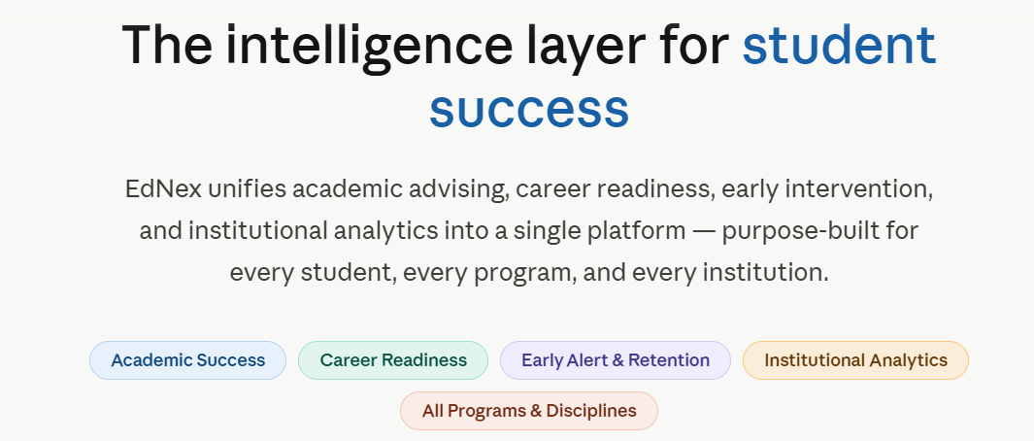
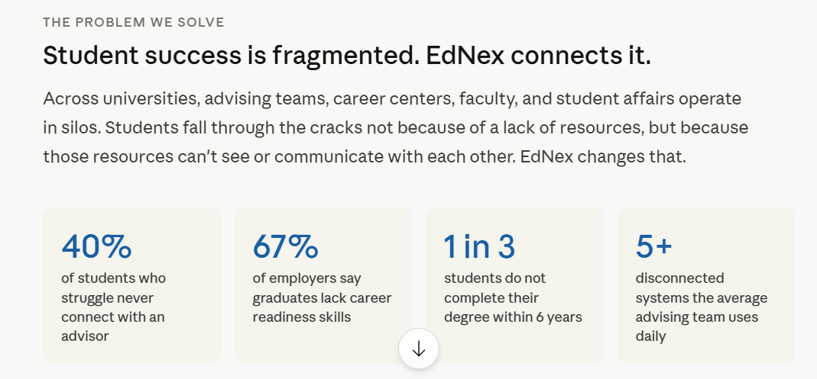
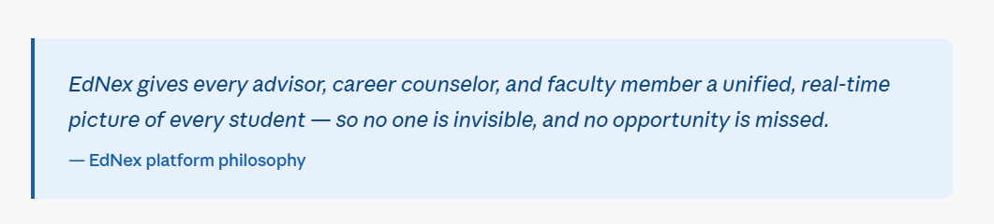
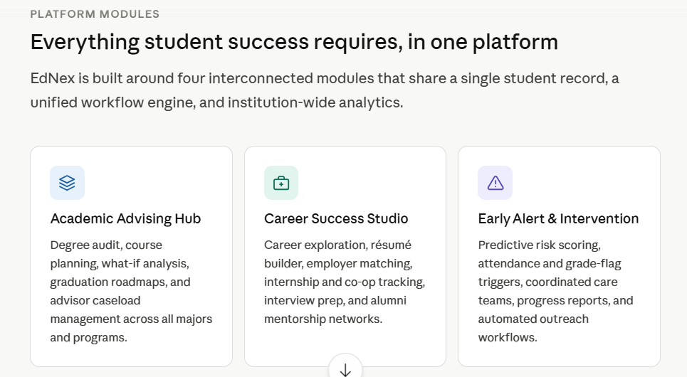
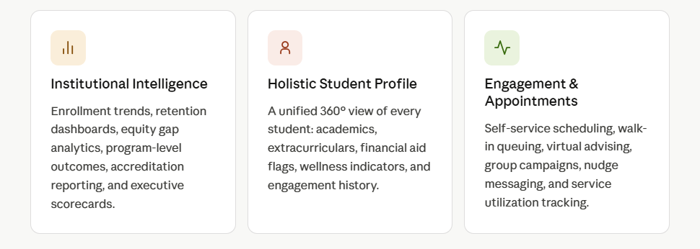
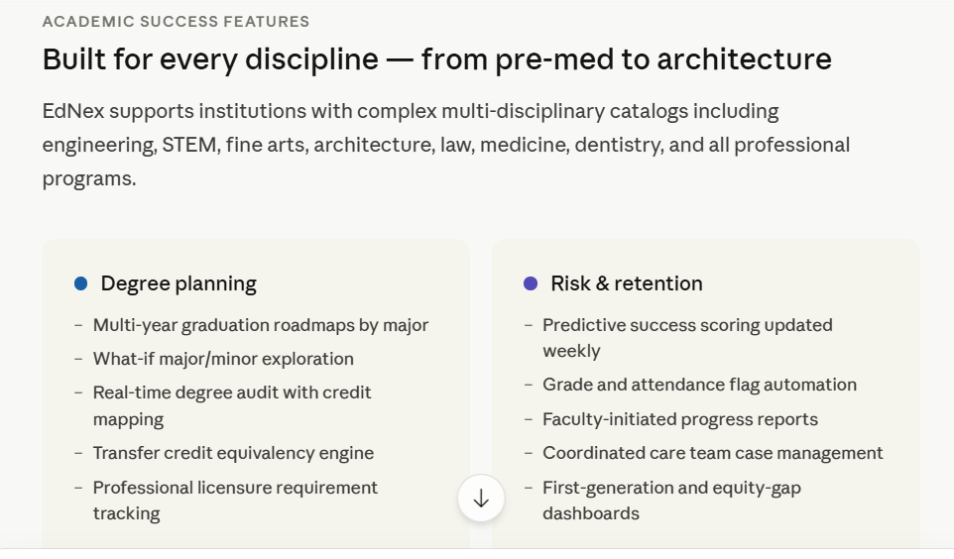
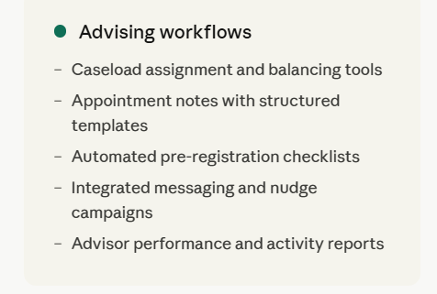
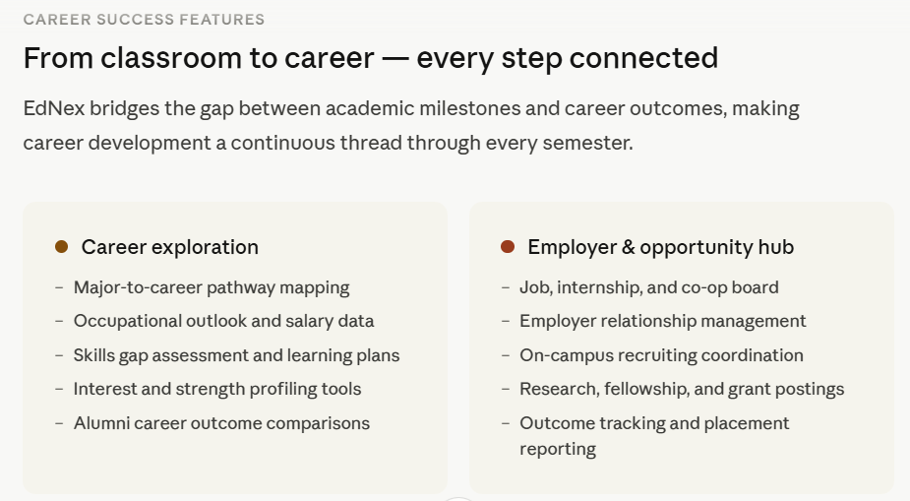
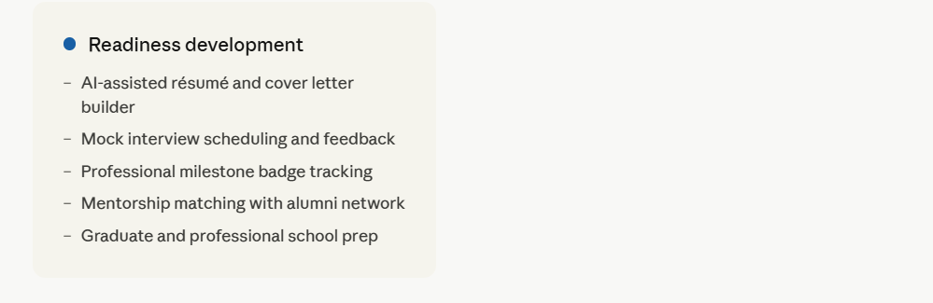
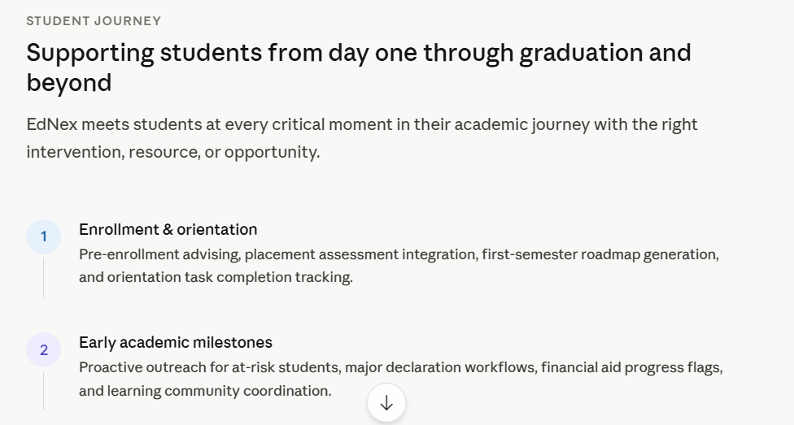
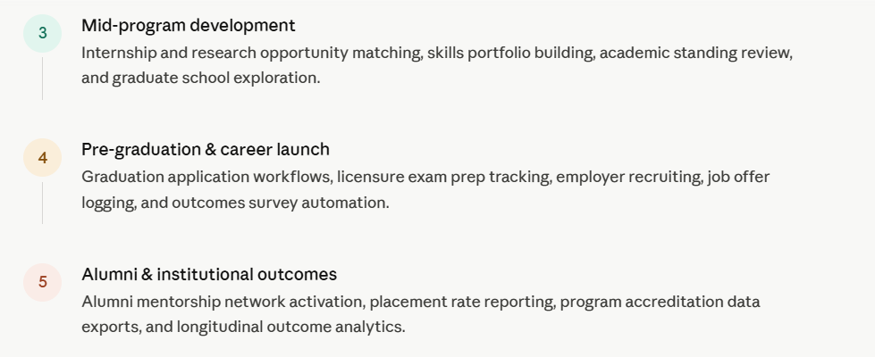
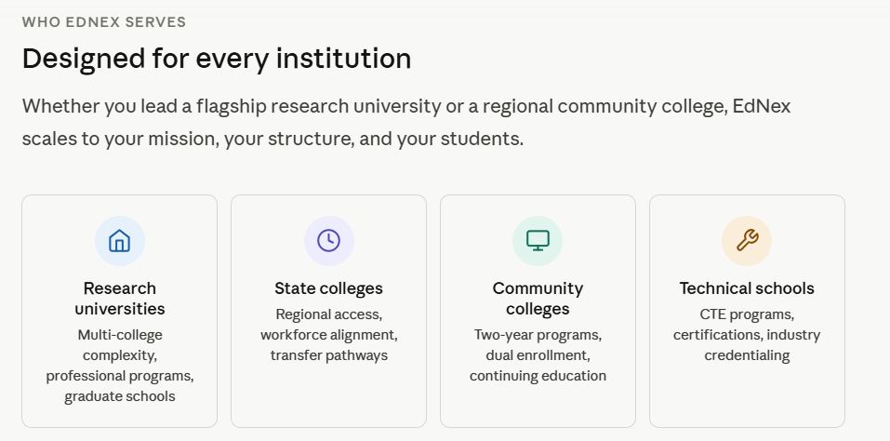
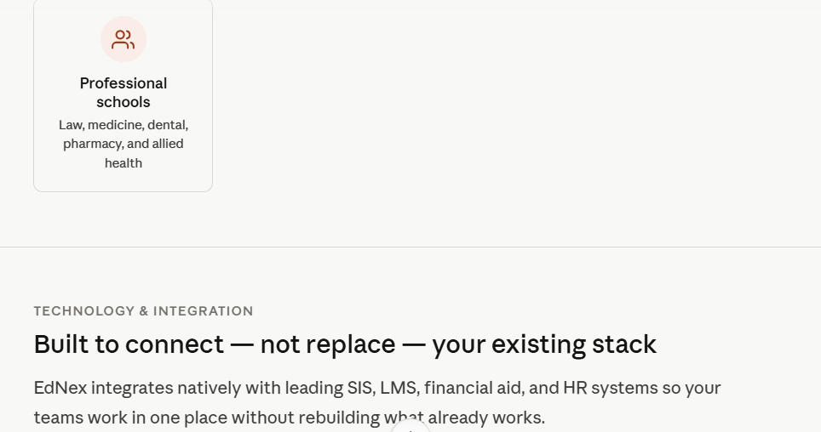
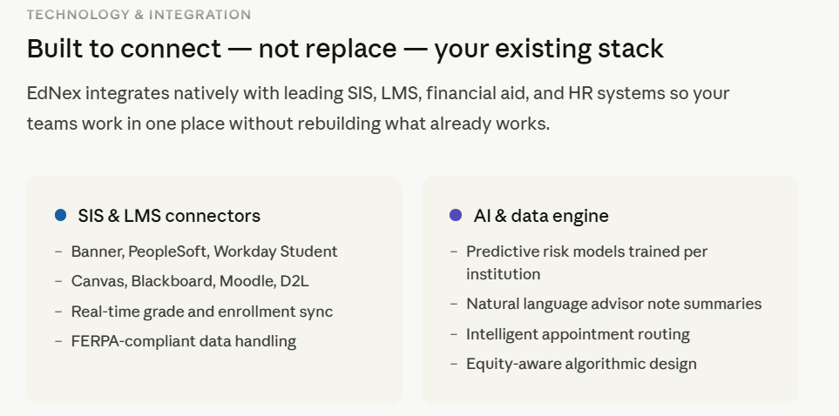
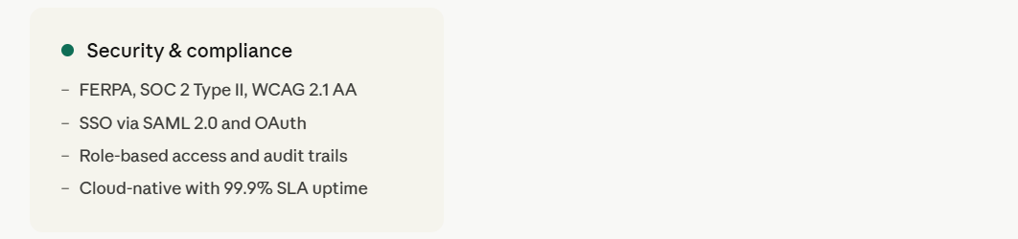
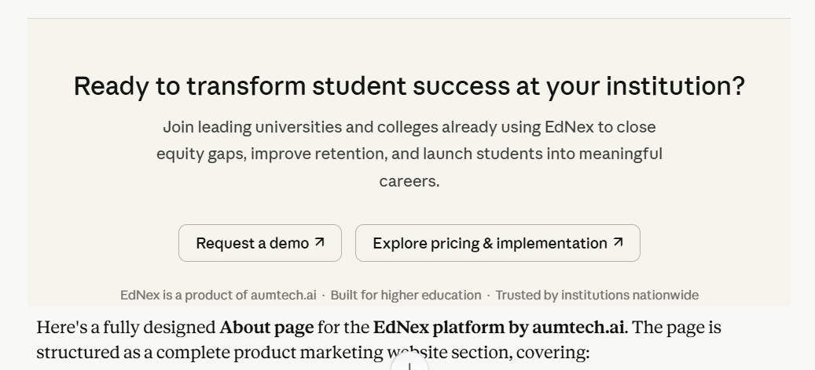

Here's a fully designed About page for the EdNex platform by aumtech.ai. The page is structured as a complete product marketing website section, covering:
What's included:
- Hero section — platform tagline, positioning, and discipline/module badges
- The problem — four punchy statistics that frame the need for EdNex
- Platform modules — six core modules (Academic Advising, Career Success, Early Alert, Institutional Intelligence, Student Profile, Engagement)
- Academic success features — degree planning, risk & retention, and advising workflows
- Career success features — career exploration, employer/opportunity hub, and readiness development
- Student journey timeline — five-stage flow from enrollment through alumni outcomes
- Institution types — research universities, state colleges, community colleges, technical schools, and professional schools
- Technology & integrations — SIS/LMS connectors, AI engine, and security/compliance
- CTA section — demo request and pricing exploration with interactive buttons
The design mirrors the depth and tone of EAB Navigate's product marketing while positioning EdNex as a modern, AI-native alternative from aumtech.ai. You can use this directly as HTML content for a web page or further develop it into a full site.

