CHAPTER 1
INTRODUCTION
A Cosmetic online shopping system is a web-based system where users can view various cosmetic products along with their category. The project provides users with a flexible and attractive GUI and shows them a list of products and carries out all the shopping activities online. This project is developed for users to have a brief look at the cosmetics products without actually visiting the store. The website displays different kinds of products of different brands and categories so that user can easily get their expected cosmetic products.

  - Business Concept

This project intends to offer an efficient, informative, and user-friendly website for beauty lovers who are looking for trusted cosmetics in local areas. In this system, cosmetics name, category, brand, price and description are shown. Besides, the system lets users not only give rating and review on products but also view review and rating that were given by other customers. As the admin side, the system lets admin to manage bad reviews that were given by bad customers such as attackers.

  - Problem Background

To buy cosmetics online, the current real products and its prices will be needed to know. Before the internet, customers had to go to shops and if they were not satisfied with one place, they had to go to another place to find and buy cosmetics. Even if customer searches for one place, customer won’t be able to know about the product in a comprehensive way. After analysing these problems, the system is created.

  - Purpose of the Project

The purpose of this project is to create a functional website for users to buy cosmetics. Users of this website will be able to use interface in order to search cosmetic product. One of the main purposes of this project is to purchase the beauty product easily and confidently. They will also be able to know products through available other options by category or brand, or by using a well-executed search function. The website will be maintained and managed by administrator. They will have the authority to manage reviews, rating and orders.

  - Objectives

- To provide the good user interface to ease of use
- To make it easy for users to find any cosmetic product information that they want
- To make it easy to buy online without having to go anywhere
- To buy a variety of beauty cosmetics products in one place
- To reduce time spent

  - The Scope and Limitations of the Project

- Cosmetics Online shopping system can be managed easily.
- Particular product and services can be accessed easily and quickly.
- This system is easy to handle and user friendly.
- Time required for accessing any product detail is very little.
- User can view details of the products without going anywhere.
- It is convenient for users as this system provides accurate cost and description of the products.
- Reviews can only be viewed if approved by the admin.
- This system lets users to pay with cash on delivery.

CHAPTER 2
SYSTEM DESIGN

2.1 Data Flow Diagram of Cosmetics Online Shopping System

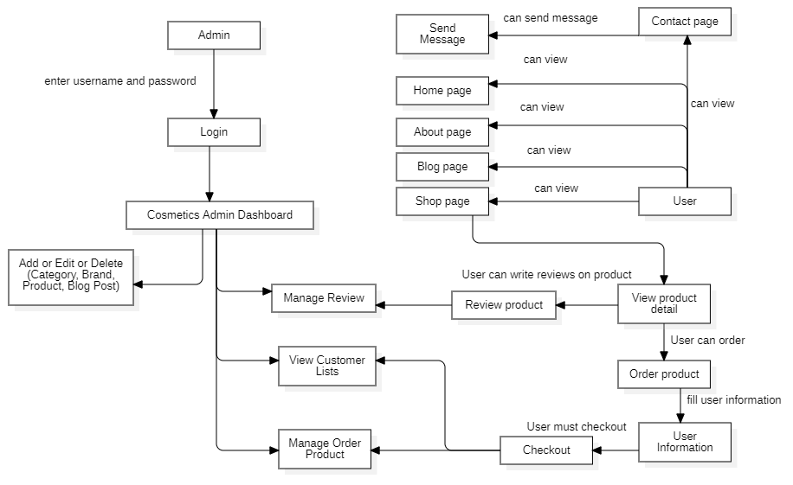

Figure (2.1) Data Flow Diagram of Cosmetics Online Shopping System

Firstly, admin must log in to add, edit or delete category, brand, product and post. And admin can view or manage orders and reviews that sent from users. However, admin does not need to log in to view or delete message that sent from users because these messages must be viewed and deleted in admin’s email. User can order products. But, before they order the product, they must fill their information and then check out. And, they can write reviews on products. Besides, users can send messages to admin in the contact page.

2.2 System Flow Diagram

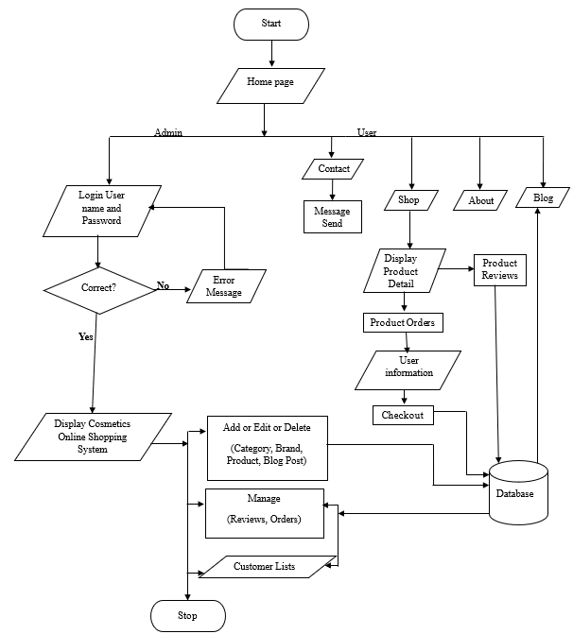

Figure (2.2) System Flow Diagram of Cosmetics Online Shopping System

In the above system flow diagram, the admin needs to log in. And also, admin needs to input user name and password. If the password is wrong, error message will be responded. If the password is correct, the admin can see the whole system. And then, admin can process all functions and run this system. Next, admin can display result and stop this system. However, admin does not need to log in to view sent message or delete sent message. In this flowchart, users can see home page, about page, shop page, blog page and contact page. Users can order products in shop page. Before they order, they must fill their information. And then, they must check out for order. Besides, users can view product’s details and they can write reviews on products in product detail page. And, users can send message in the contact page.

2.3 Class Diagram

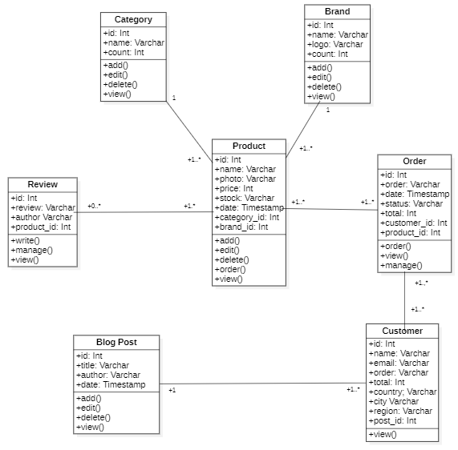

Figure (2.3) Class Diagram for the Cosmetics Online Shopping System

The system has seven classes such as Category page, Blog Page, Product page, Review page, Order page, Customer page and Post page. A product has one brand and one category. A category and a brand have one or more products. A product has one or more orders. An order has one or more products. A product has zero or more reviews. A review has one or more products. An order has one or more customers. A customer has one or more products. A blog post can be viewed one or more customers.

2.4 Use case Diagram for Admin
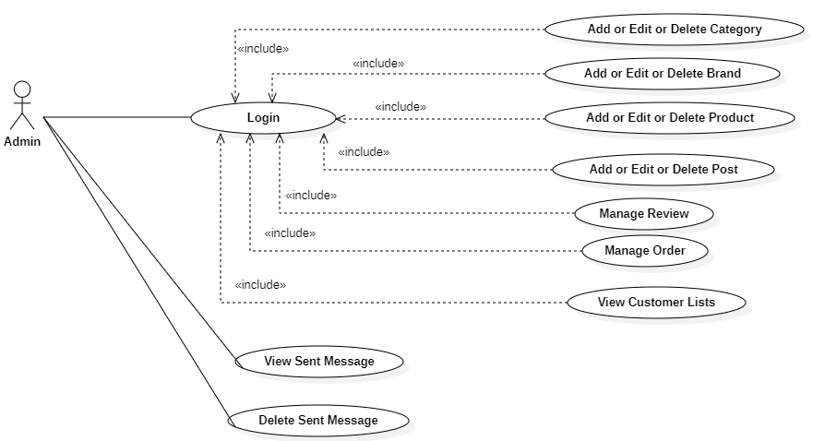

Figure (2.4) Use case Diagram for Admin in the Cosmetics Online Shopping System

In this system, there are ten use cases. Firstly, admin must log in to the system, and then admin can manage all the functionalities of Cosmetics Online Shopping System. Finally, admin logs out from the system. Admin does not need to log in to view or delete sent message.

2.5 Use case Diagram for User
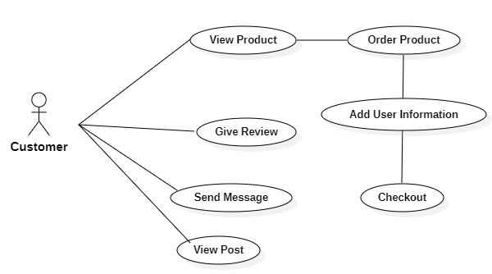

Figure (2.5) Use case Diagram for User in the Cosmetics Online Shopping System

In this system, there are six use cases. Users can view home page, about page and blog page. Before they order products, they must fill their information and then they must check out. Besides, users can write reviews on products in product detail page. In contact page, users can view contact information of the shop and send message.

2.6 Sequence Diagram for Admin

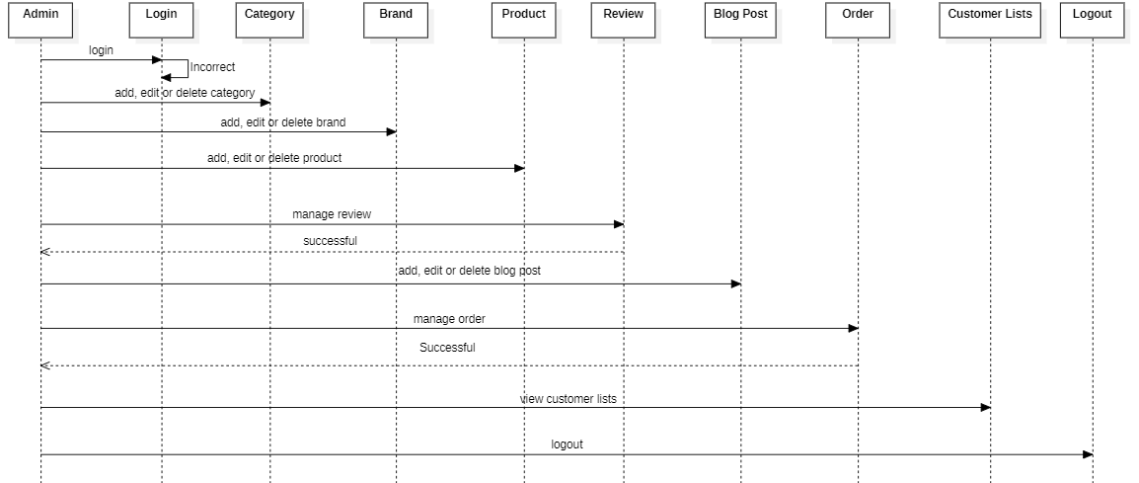

Figure (2.6) Sequence Diagram for Admin in the Cosmetics Online Shopping System

The admin has to log in to enter the system. And, the admin can add, edit or delete category, brand, product and post. The admin can also view or manage orders and reviews and view customer lists. Finally, the admin can log out the system.

2.7 Sequence Diagram for User

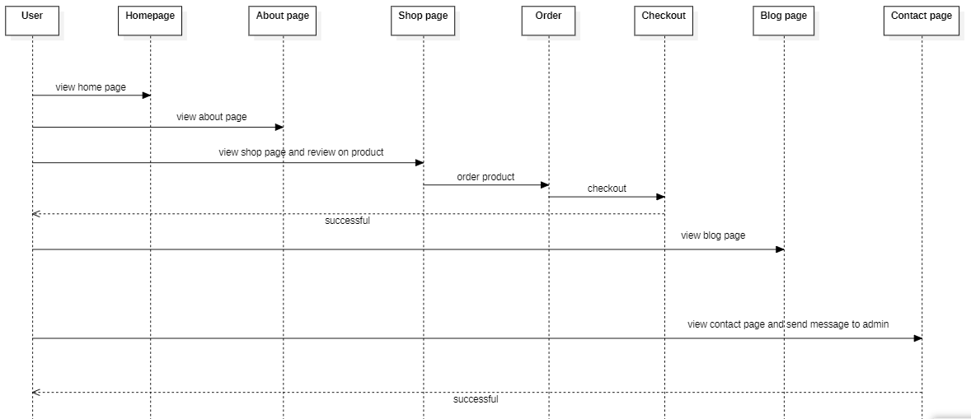

Figure (2.7) Sequence Diagram for User in the Cosmetics Online Shopping System

Users can view home page, about page and blog page. They can view and buy products. Before they order the product, they must fill their information and then check out. Users can also write reviews on product and send messages in contact page.

2.8 Entity Relationship (ER) Diagram

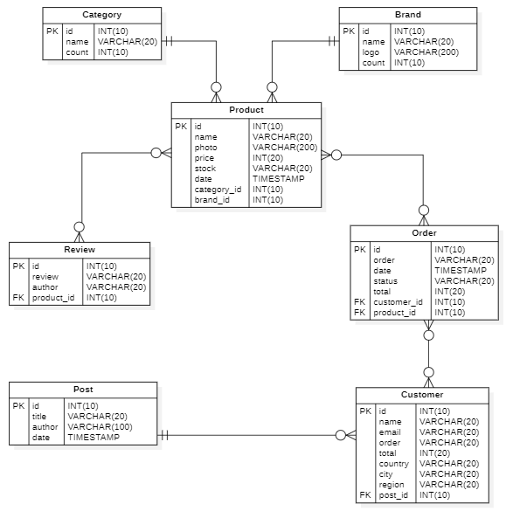

Figure (2.8) ER Diagram for the Cosmetics Online Shopping System

In this ER diagram, there are seven tables in the database. These are Category table, Brand table, Product table, Review table, Order table, Customer table and Post table. A product has one brand and one category. A product has one or more orders. A category and a brand have one or more products. An order has one or more products. A product has zero or more reviews. A review has one or more products. An order has one or more customers. A customer has one or more products. A blog post can be seen one or more customers.
2.9 Database of the Table Design

In this Database Table Design, there are seven tables. These are Product Category table, Product Brand table, Product Review table, Product table, Post table, Order table and Customer table.

Table (2.1) Product Category Table
Field Name | Data Type | Key
Id | INT (10) | Primary Key
Name | VARCHAR (20)
Count | INT (10)

Table (2.2) Product Brand Table
Field Name | Data Type | Key
Id | INT (10) | Primary Key
Name | VARCHAR (20)
Logo | VARCHAR (200)
Count | INT (10)

Table (2.3) Product Table
Field Name | Data Type | Key
Id | INT (10) | Primary Key
Photo | VARCHAR (200)
Name | VARCHAR (20)
Price | INT (20)
Stock | VARCHAR (20)
Date | TIMESTAMP
Category_Id | INT (10) | Foreign Key
Brand_Id | INT (10) | Foreign Key

Table (2.4) Product Review Table
Field Name | Data Type | Key
Id | INT (10) | Primary Key
Author | VARCHAR (20)
Review | VARCHAR (20)
Product_Id | INT (10) | Foreign Key

Table (2.5) Order Table
Field Name | Data Type | Key
Id | INT (10) | Primary Key
Order | VARCHAR (20)
Date | TIMESTAMP
Status | VARCHAR (20)
Total | INT (20)
Customer_Id | INT (10) | Foreign Key
Product_Id | INT (10) | Foreign Key

Table (2.6) Customer Table
Field Name | Data Type | Key
Id | INT (10) | Primary Key
Name | VARCHAR (20)
Email | VARCHAR (20)
Order | INT (10)
Total | INT (20)
Country | VARCHAR (20)
City | VARCHAR (20)
Region | VARCHAR (20)
Post_id | INT (10) | Foreign Key

Table (2.7) Post Table
Field Name | Data Type | Key
Id | INT (10) | Primary Key
Title | VARCHAR (20)
Author | VARCHAR (20)
Date | TIMESTAMP

CHAPTER 3
IMPLEMENTATION

3.1 Home Page

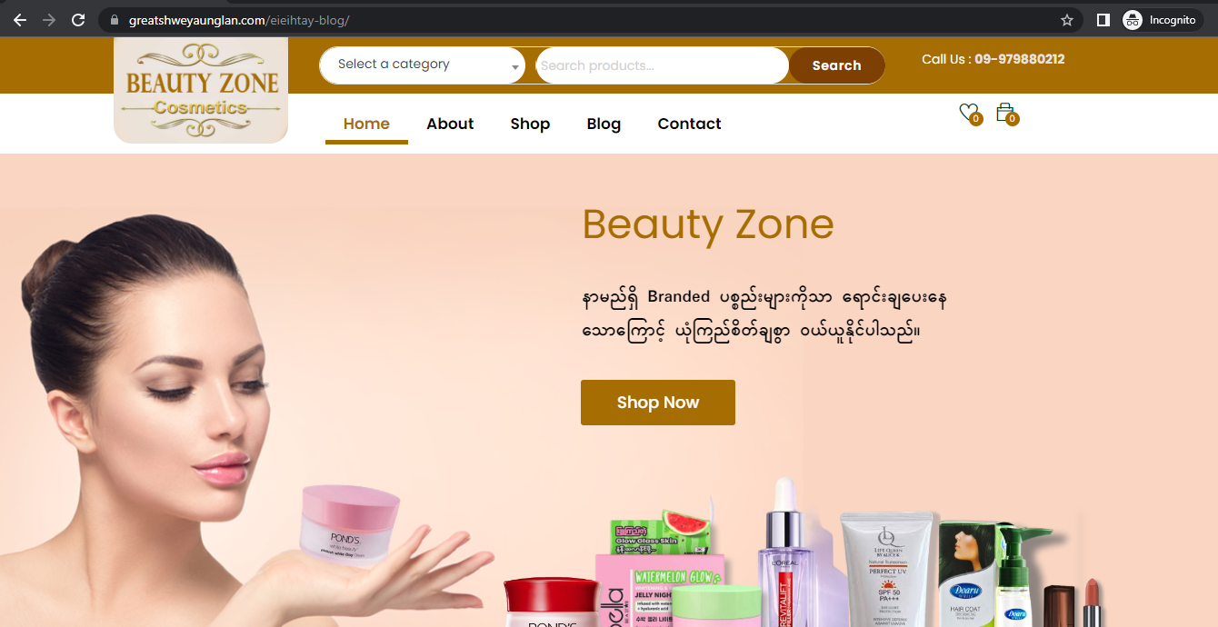

Figure (3.1) Home Page

This is home page of the system. Users can view Beauty Zone Cosmetics Online Shopping System. They can view latest products and order or buy products in the system from this page.

3.2 About Page

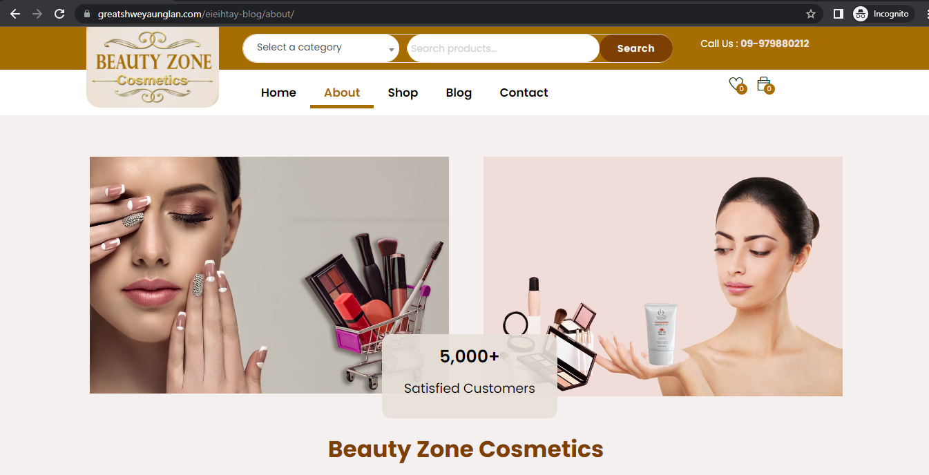

Figure (3.2) About Page

This is about page of the system. Users can view about Beauty Zone Cosmetics Online Shopping System in this page. On the about page, this system says that customers can easily find products by selecting product categories and brands. In addition, it has been mentioned that product contents can be accessed and read in one place.

3.3 Shop Page

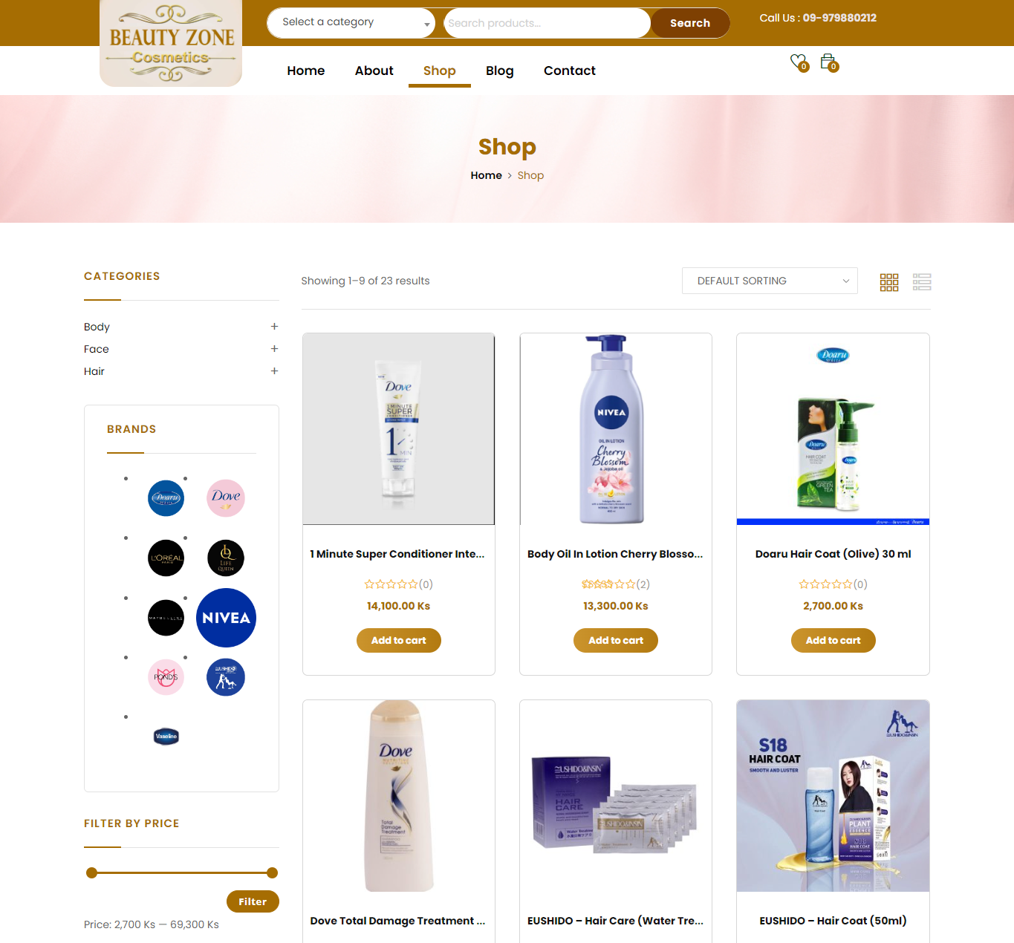

Figure (3.3) Shop Page

This is the shop page of the system. Users can view all products and order or buy products in the system from this page. They can search product from category and brand. Besides, they can also search products by filtering price.

3.4 Product Detail Page

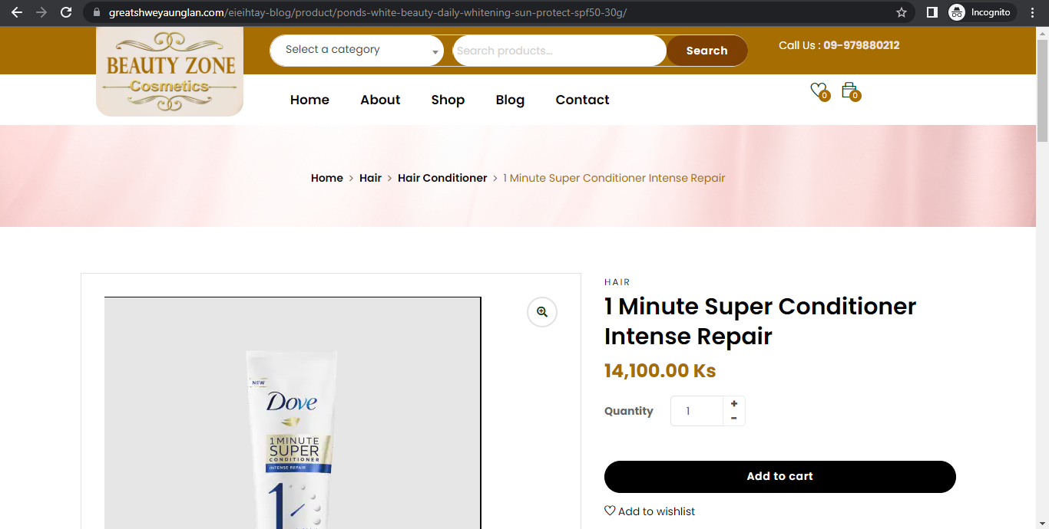

Figure (3.4) Product Detail Page

This is product detail page of the system. Users can view the details of the clicked product from shop page. Besides, users can view product name, price, brand, category and description. If the customer wants to place an order, they must click the add to cart button.

3.5 Shopping Cart Page

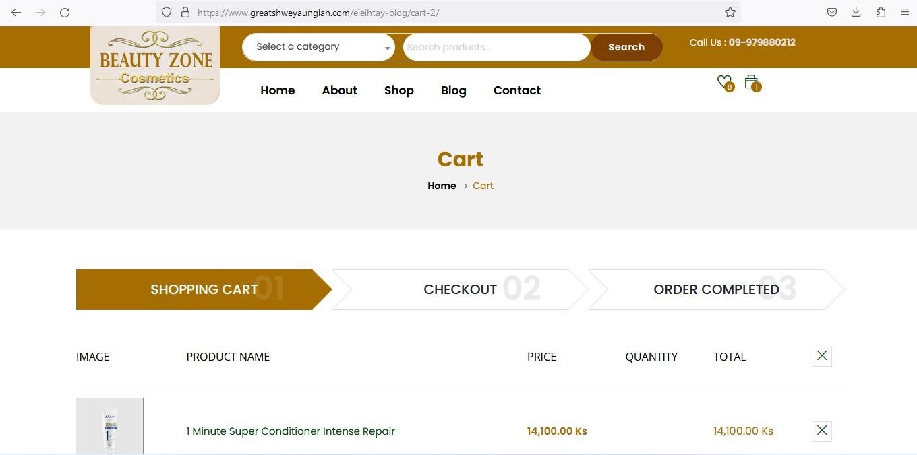

Figure (3.5) Shopping Cart

If the customer orders the products, the customer can see ordered product in the shopping cart in this page.

3.6 Order Page

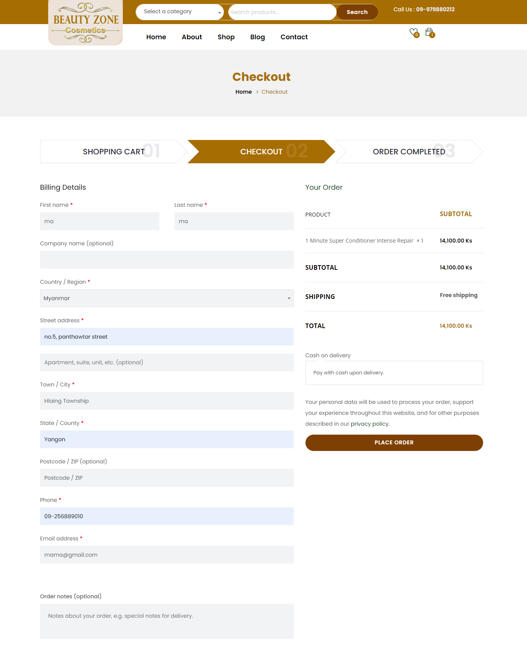

Figure (3.6) Product Order Page
If the customer orders the product, they must fill their information such as name, country, street address, town or city, state, phone and email address. And then, they must click the place order button. After placing the order, the order complete message will be displayed.

3.7 Order Completed Page

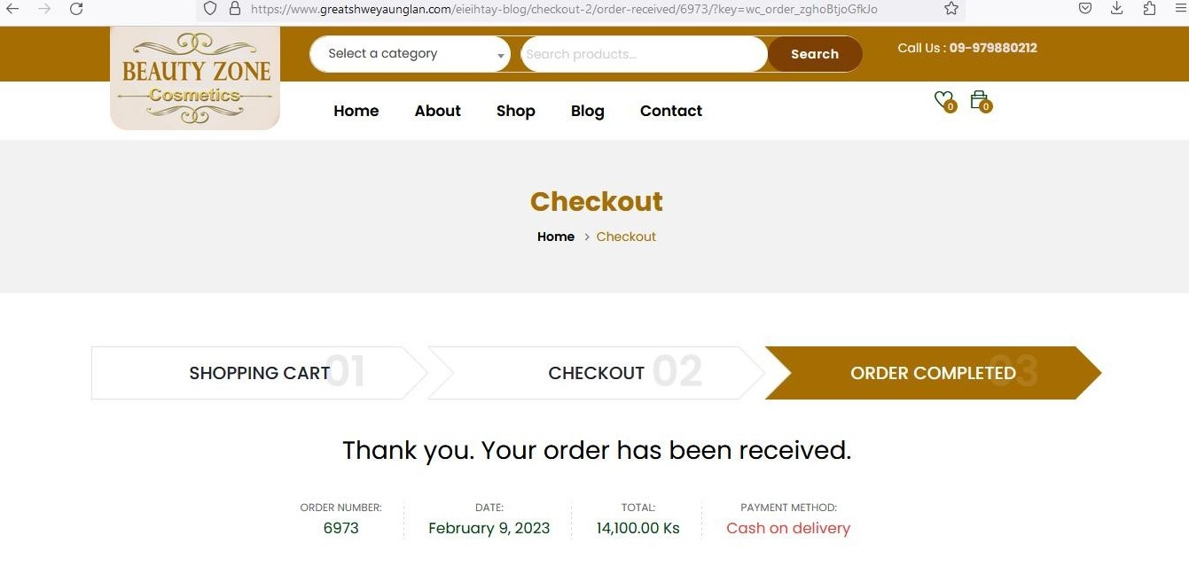
Figure (3.7) Order Completed

After ordering the product, order completed message will be shown to the customer. The customer can view order number, order date, total and payment method in this page.

3.8 Review Page
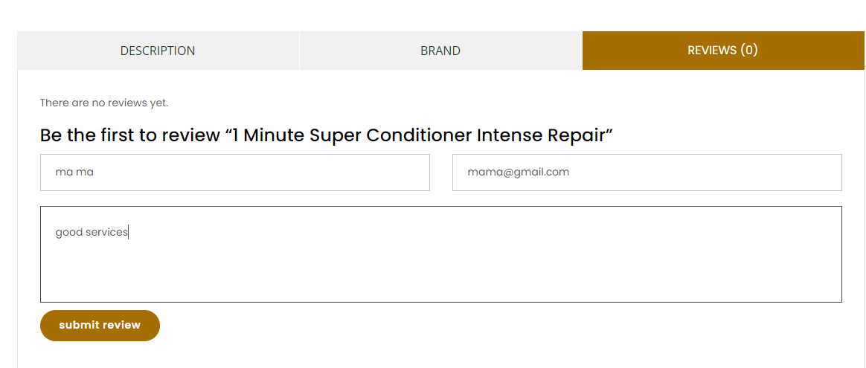
Figure (3.8) Product Review

If the user wants to write review on product, the user must fill name and email. And then, user can write a review on product and send. However, other people’s reviews can only be viewed after the admin approves the review.

3.9 Blog Page

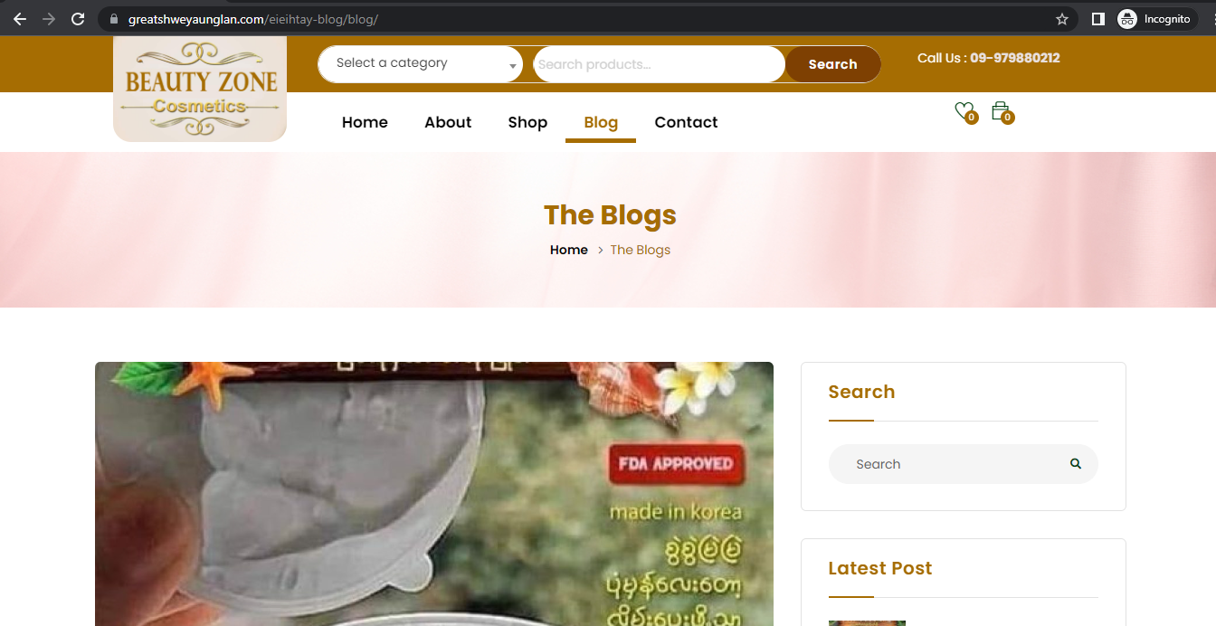

Figure (3.9) Blog Page

This is blog page of the system. Users can view all posts of Beauty Zone Cosmetics Online Shopping System from this page.

3.10 Blog Detail Page

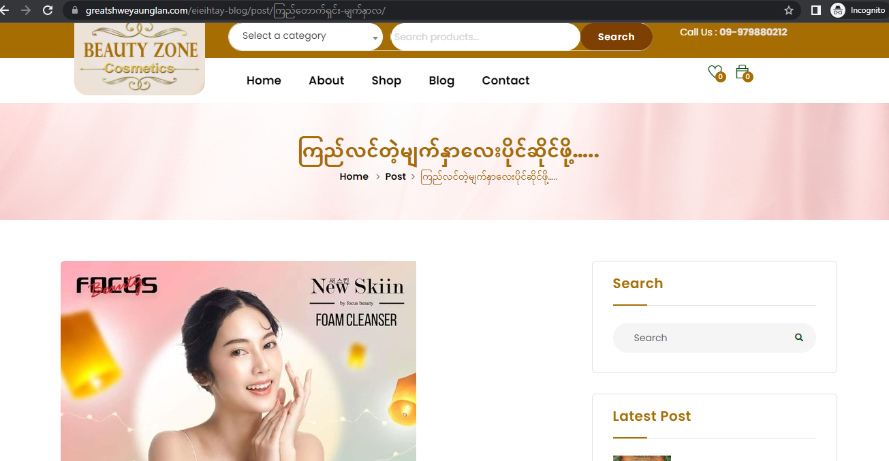

Figure (3.10) Blog Detail Page

This is blog detail page of the system. Users can view the details of chosen post from blog page.

3.11 Contact Page

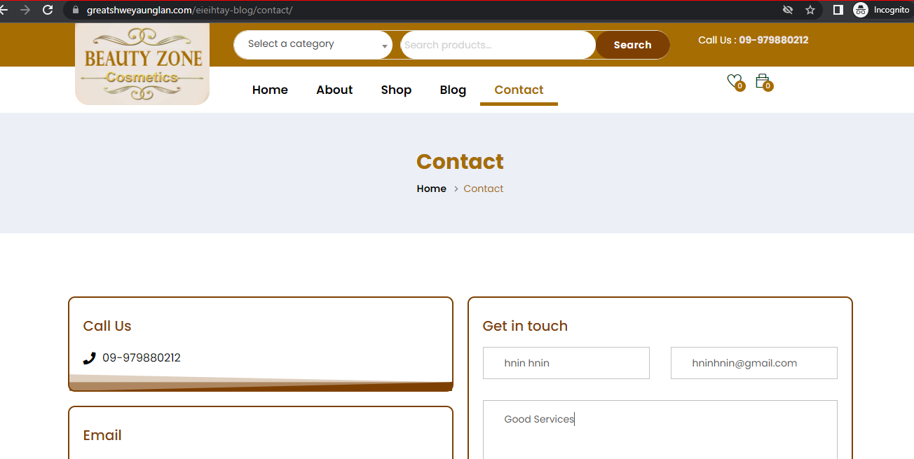

Figure (3.11) Contact Page

This is contact page of the system. Users can view contact information of Beauty Zone Cosmetics Online Shopping System. They can send message from the “Get in touch” form in the system.

3.12 Admin Login Page

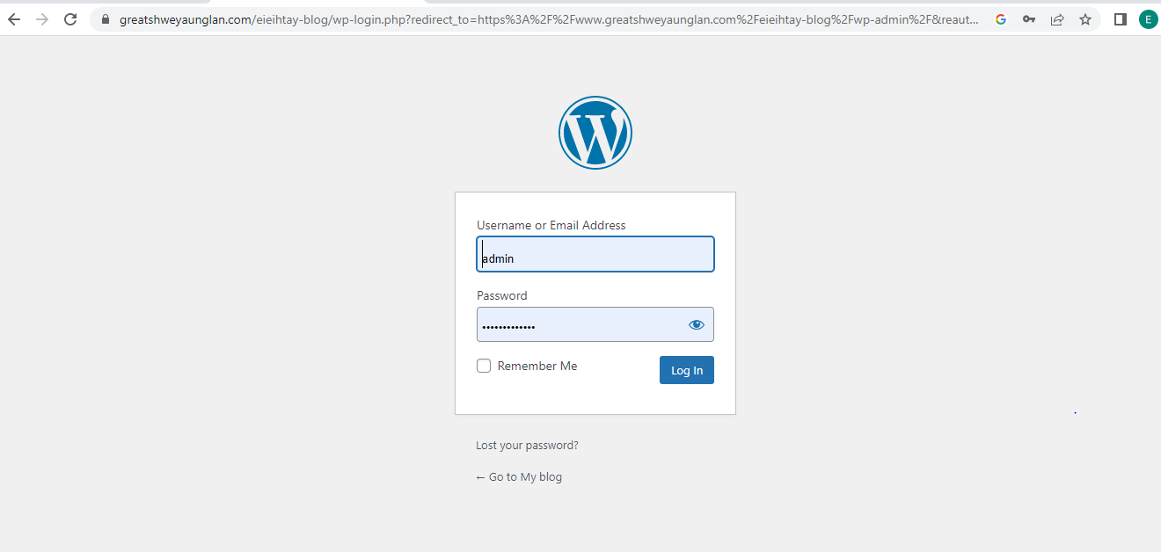

Figure (3.12) Admin Login Page

This is Admin login page of the system. Admin needs to log in by using the Username and Password from the own website. If it is correct, it will be taken to the admin dashboard.

3.13 Admin Login Error Page

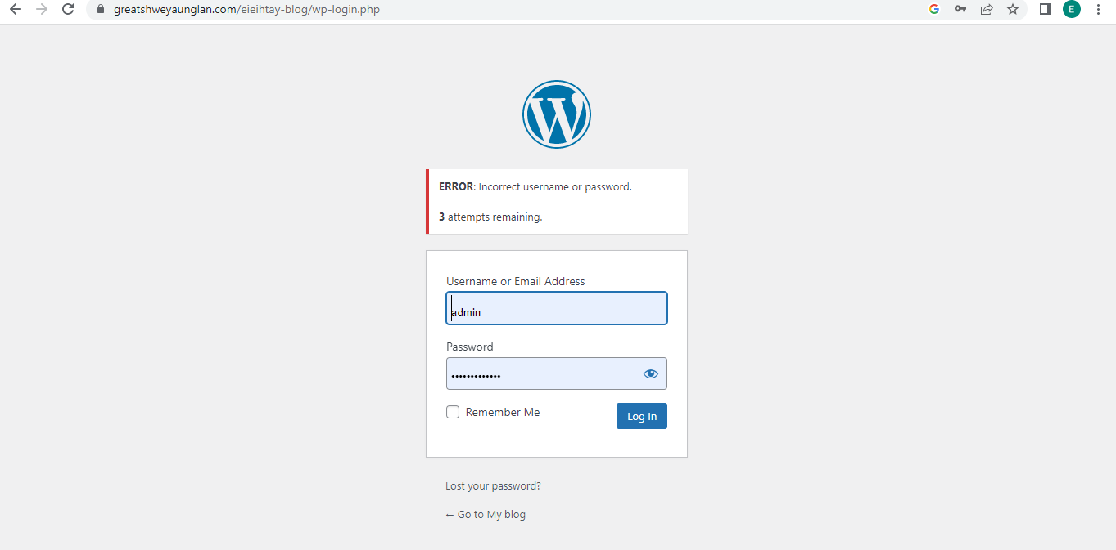

Figure (3.13) Admin Login Error Page

If admin’s username or password is incorrect, it will show errors in this page.
.

3.14 Product Category

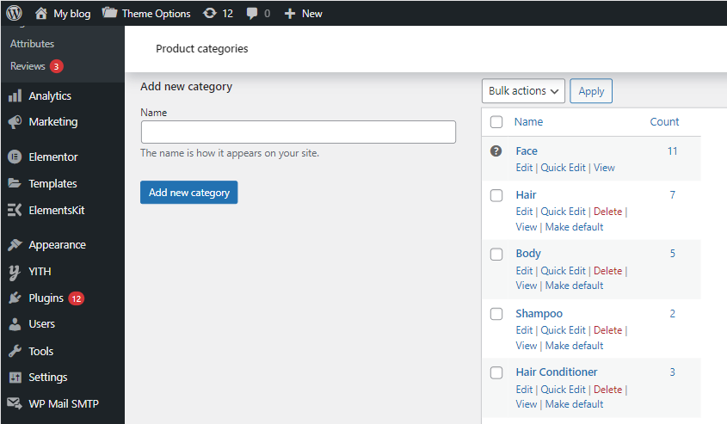

Figure (3.14) Product Category

In this page, the administrator can create, edit or delete the product category. As an admin, if the admin wants to add a category, the admin must add category name.

3.15 Product Brand

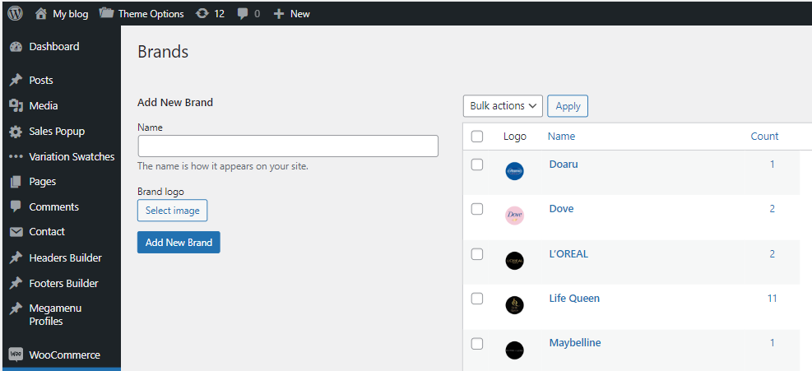

Figure (3.15) Product Brand

In this page, the administrator can create, edit or delete the product brand. As an admin, if the admin wants to add a brand, the admin must add brand name and brand logo.

3.16 Product Lists

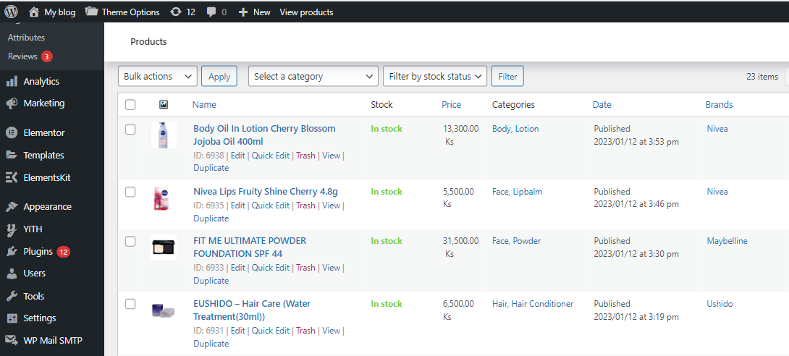

Figure (3.16) Product Lists

In this page, the administrator can create, edit or delete the products. Before the admin create a product, the admin must create category and brand. If admin create a product, the admin adds the attributes such as name, stock, price, categories, brands and date. Admin can manage product by filtering category, product type and stock status. Stock status has on stock, on backorder and out of stock. On stock is the state of having stock. On backorder is a situation where the item is placed again because the stock is out of stock. Out of stock is a situation where the stock is currently out of stock and no more items will be ordered.

3.17 Product Review

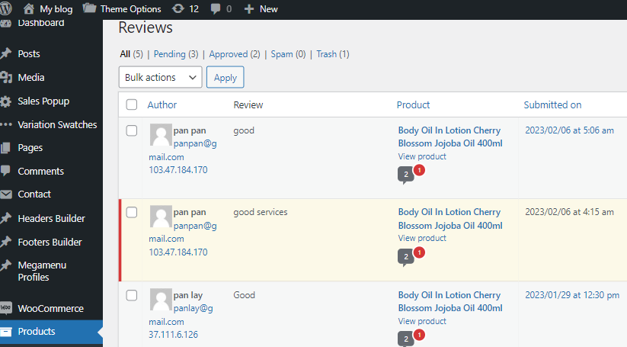

Figure (3.17) Product Review

In this page, the administrator can view and manage the product reviews. Product reviews can only be seen on the user side after the admin approves them. Admin can view the attributes such as author, review, product and submitted on date.

3.18 Product Order

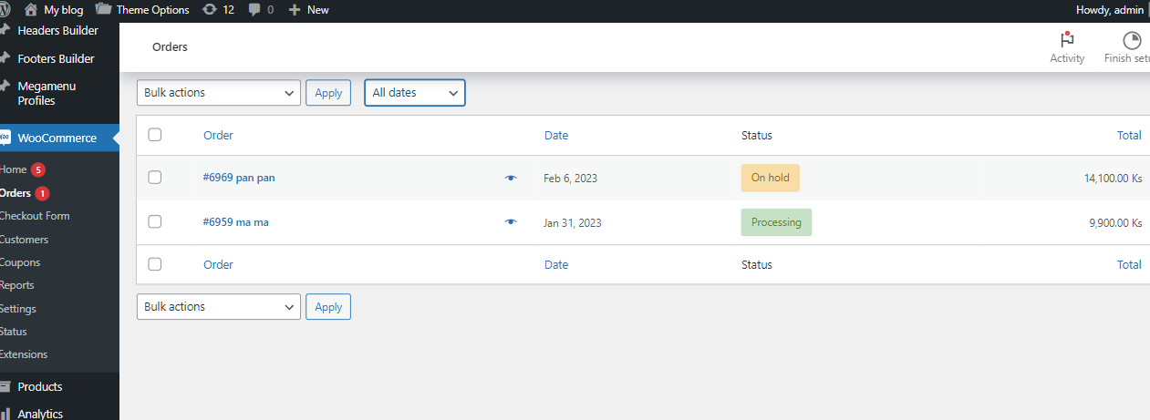

Figure (3.18) Product Order

In this page, the administrator can view, manage status or delete the product order. Besides, the admin can filter by date and see the orders. The admin can manage status. Status has states such as processing, on hold, completed, cancel, pending payment, refunded, fail and draft. The status of processing is when the order is placed by the customer. The status of being ready to send the order to the customer is on hold status. After sending the order to the customer, the status is completed. The status when the customer cancels the order is the cancellation status. In the case of two orders, one of them has been sent to the customer, and in the other case, the value of the product left to be sent is pending payment status. The situation in which the customer is asked if the ordered item is out of stock and the day it will arrive is a draft situation. After the draft situation, the customer said that they can wait the order. That situation is the situation of being refunded. When the item is delivered, the condition of not being able to contact the customer is called fail condition.

3.19 Admin Blog Post

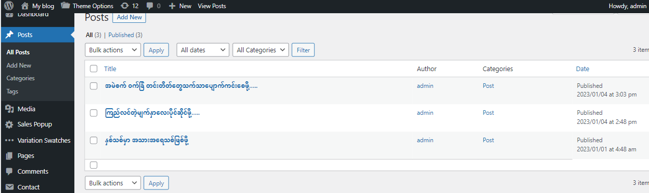

Figure (3.19) Admin Blog Post

In this page, the administrator can create, edit or delete cosmetics posts. The admin creates only blog posts related cosmetics. If admin create a post, the admin adds the attributes such as title, author, categories and published date. Besides, the admin can filter by category and see the posted posts, and filter by date to see the posts.

3.20 Customer Lists

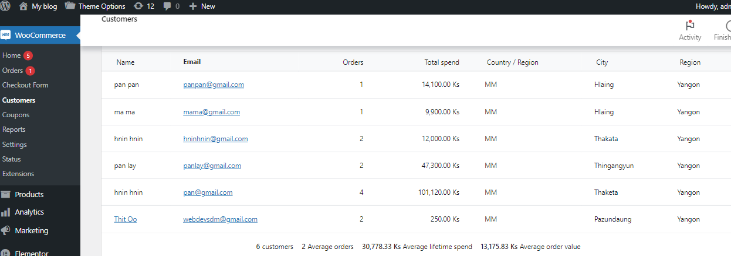

Figure (3.20) Customer Lists Page

In this page, the administrator can view the list of customers who orders their products. In the customer lists, admin can view the attributes such as customer name, email, orders, total spend, country or region, city and region.

CHAPTER 4
CONCLUSION

4.1 Conclusion
This internship project develops a Cosmetics Online Shopping System for ladies who loves beauty to buy or order cosmetics. By using this system, the users can save time to go to the shop. The system will be useful for user to view products, buy products and search items by brands or category. Besides, users can view products by filtering price. This system is implemented to be convenient to make reviews on product and leave message to admin. Administrator can add, update and delete product category, product brands, products and posts. And then, admin can view and manage orders and customers’ reviews. Admin can manage the payment that cash on deliver payment method of the product.

4.2 Lesson Learned
I have got many experiences in developing this project. These experiences are:
- Problem solving skills
- Getting knowledge and applying the use of Wordpress, Elementor Page Builder, WooCommerce Plugin
- Getting higher level of discussion skills and presentation skills

4.3 Further Extension
This website can be created into android application to make it easy for android users to use. Besides, online payment system can be added instead of cash on delivery. There is a section that the system will recommend which one is right for customers when customers just select their skin tone or hair type. Besides, customers write down their skin problem and send it to the system, the system immediately response a recommendation for which one to be used.

REFERENCES

[1] CSS, Wordpress, Elementor Page Builder, My SQL
[2] https://elements.envato.com/
[3] www.youtube.com
[5] https://www.w3school.com
[6] www.stackoverflow.com

