1.  
a.

No. of 1st Stumble on the Left = 76

No. of 1st Stumble on the right = 75

An approximate test with null hypothesis that the drunkards 1st stumbles are equally likely to be to the left or right returns a p-value of 0.9351 so we cannot reject the null hypothesis that drunkards are equally likely to stumble on the left or on the right.

No. of 1st Stumble on the dominant side = 107

No. of 1st stumble opposite to the dominant side = 44

Total no. of stumbles = 107+44

An approximate test with null hypothesis that the drunkards 1st stumbles are equally likely to be on the dominant and non-dominant side(probability=.5) returns a p-value of 2.946e-07 so we can reject the null hypothesis that drunkards are equally likely to stumble on the dominant or non-dominant side. So, they are more likely to stumble on the same side as their dominant side.

b.

The table corresponding to first stumble on the dominant vs non-dominant side for male and female is

|  |  |  |
| --- | --- | --- |
|  | Non- Dominant | Dominant |
| Female | 24 | 59 |
| Male | 20 | 48 |

An approximate test with null hypothesis males and females are equally likely to stumble on the dominant side returns a p value of .9468 so we cannot reject the null hypothesis that they are equally likely.

c.

|  |  |  |  |  |  |  |  |  |  |  |  |  |  |
| --- | --- | --- | --- | --- | --- | --- | --- | --- | --- | --- | --- | --- | --- |
| No of Drinks | 2 | 3 | 4 | 5 | 6 | 7 | 8 | 9 | 10 | 11 | 12 | 13 | 14 |
| Non-Dominant Stumble-count | 1 | 2 | 8 | 5 | 4 | 8 | 2 | 8 | 2 | 3 | 1 | 0 | 0 |
| Dominant stumble - count | 4 | 2 | 8 | 15 | 14 | 15 | 13 | 9 | 14 | 2 | 6 | 2 | 3 |

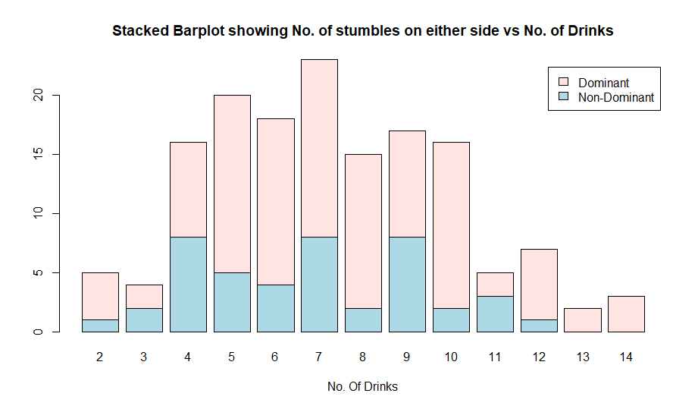

So as the number of drinks increases the probability of fall in the dominant side increases.

2.

a.)

Mean for Smokers = 3.276862

Variance for smokers = 0.5624795

Mean for Non smokers = 3.276862

Mean for Non- smoker = 0.7233869

For non-smokers Q-Q plot is

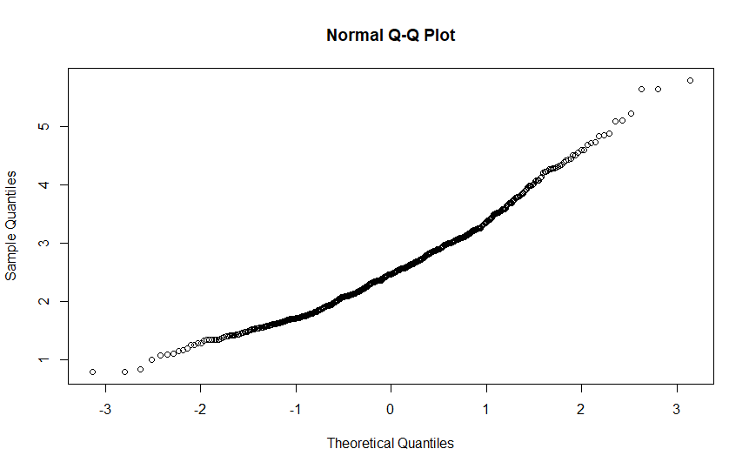

For smokers q-q plot is

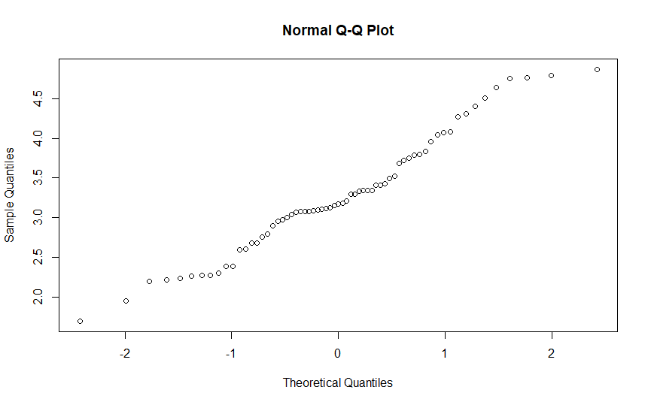

Both of them show 45 degree line.

A variance test gives a p value of 0.2094 so we can not reject the null

hypothesis that the variances are equal.

With normality assumption Assuming equal variance a unpaired t test gives a p value of 1.993e-10 so we can reject the null hypothesis that the average forced expiratory volume is equal for both smokers and non -smokers.

With normality assumption Assuming unequal variance a unpaired t test gives a p value of 3.074e-10 so we can reject the null hypothesis that the average forced expiratory volume is equal for both smokers and non -smokers. It agrees with the previous result.

b.

mean for male = 2.812446

variance for male = 1.007208

mean for female = 2.45117

variance for female = 0.4169749

A variance test gives a p value of 6.217e-15 so we can reject the null hypothesis that the variances are equal.

With normality assumption Assuming unequal variance a unpaired t test gives a p value of 5.604e-08 so we can reject the null hypothesis that the average

forced expiratory volume is equal for both male and female.

c.

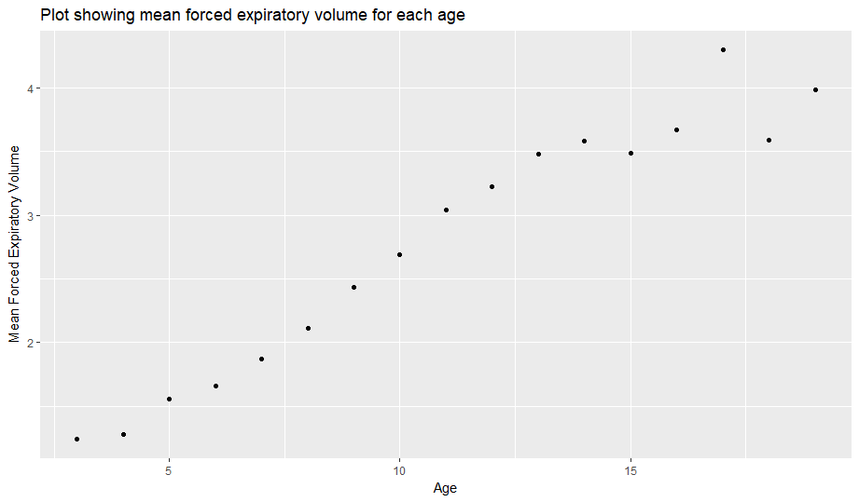

As we can see from the picture with increasing age the mean expiratory volume increases.