Hybrid Movie Recommendation System
Collaborative Filtering + Content-Based (NLP) + Autoencoder
Project Proposal & Technical Design Document
COMP813 — Artificial Intelligence, 2026 Semester 2
Final Project (Individual)
Aung Kyaw Zay Ya
Student ID: 24265298
Auckland University of Technology
September 2026

Table of Contents
1. Introduction 3
1.1 Project Overview 3
1.2 Motivation and Problem Statement 3
1.3 Project Context and Scope 3
2. Objectives 3
3. Dataset 4
3.1 MovieLens ml-latest-small 4
3.2 TMDB Overview Metadata (for the Content-Based model) 4
3.3 Data Preprocessing Plan 4
4. Proposed Methodology 4
4.1 Baseline Model: Collaborative Filtering (SVD) 4
4.2 Deep Model: Autoencoder-based Collaborative Filtering (AutoRec) 5
4.3 Content-Based Model: NLP (TF-IDF + Cosine Similarity) 5
4.4 Hybrid Combination Strategy 5
4.5 Adaptive Personalization: Automatic Preference Learning 5
5. System Architecture 5
6. Evaluation Plan 6
7. Responsible AI / Ethics Considerations 7
8. Project Timeline 7
9. Expected Deliverables 7
10. References 7

1. Introduction

1.1 Project Overview
This document proposes a Hybrid Movie Recommendation System for the COMP813 final project. The system recommends movies to a user by combining three complementary techniques: a Collaborative Filtering baseline (matrix factorization / SVD), a deep learning model (an autoencoder-based collaborative filter, AutoRec), and a Content-Based model that uses Natural Language Processing (NLP) on movie plot summaries. The purpose of this document is to fix the project's scope, dataset, architecture and evaluation plan before implementation begins, so that it can be reviewed and approved by the course tutor.

1.2 Motivation and Problem Statement
Recommender systems are one of the most widely deployed applications of machine learning, used by almost every media and e-commerce platform to help users navigate large catalogues. A pure Collaborative Filtering (CF) system is accurate for popular, well-rated items but performs poorly for new or rarely-rated items — the classic “cold-start” problem. A pure Content-Based system solves cold-start (a new movie's plot text is available immediately) but tends to over-specialise, recommending only near-duplicates of what a user has already watched. Combining the two into a hybrid system is a well-established way to offset each method's weaknesses (Koren et al., 2009; Sedhain et al., 2015), and doing so here also lets the project connect two areas of the COMP813 syllabus — Unsupervised Learning / representation learning (matrix factorisation, autoencoders) and Natural Language Processing (TF-IDF text similarity) — in a single, coherent system.

1.3 Project Context and Scope
This is an individual submission for the COMP813 capstone project (60% of the final grade). In scope: data acquisition and preprocessing, the three recommendation models described above, their hybrid combination, quantitative and qualitative evaluation, and a short responsible-AI discussion. Out of scope: a production web/mobile front-end, real-time serving infrastructure, and A/B testing with live users — these are noted only as future work.

2. Objectives
The project's objectives are directly aligned with the COMP813 final project goals:
- Implement a Collaborative Filtering baseline using matrix factorisation (SVD).
- Implement one deep learning model taught in COMP813 — an autoencoder — adapted for collaborative filtering (AutoRec).
- Implement a Content-Based recommender using NLP techniques (TF-IDF vectorisation and cosine similarity) over movie plot summaries.
- Combine all three into a hybrid recommender and evaluate it with systematic experiments (hyperparameter variation, baseline comparison, ablation).
- Report results with both quantitative metrics (RMSE, MAE, Precision@K, Recall@K, NDCG) and qualitative examples (sample recommendation lists).
- Demonstrate and discuss how the system learns each user's preferences automatically from their rating history, with no manually-coded rules, and how it can adapt as new ratings arrive.
- Critically discuss responsible-AI considerations: popularity bias, cold-start fairness, and recommendation diversity.

3. Dataset

3.1 MovieLens ml-latest-small
The primary dataset is MovieLens ml-latest-small, a standard benchmark dataset for recommender-systems research (Harper & Konstan, 2015), obtained from the official GroupLens repository (https://grouplens.org/datasets/movielens/latest/).
File | Description | Size
ratings.csv | User ratings (0.5–5 stars) | 100,836 ratings
movies.csv | Movie titles and genres | 9,742 movies
links.csv | Mapping to IMDb / TMDB IDs | 9,742 rows
tags.csv | Free-text tags applied by users | 3,683 tags

The dataset covers 610 users and 9,742 movies, giving a rating-matrix density of about 1.7% — a realistic level of sparsity for collaborative filtering.

3.2 TMDB Overview Metadata (for the Content-Based model)
MovieLens does not include plot text, which the Content-Based model requires. Plot overviews were obtained from the TMDB 5000 Movie Dataset (originally published on Kaggle: https://www.kaggle.com/datasets/tmdb/tmdb-movie-metadata, sourced from The Movie Database, https://www.themoviedb.org) and reduced to a clean overview_plot.csv containing tmdbId, title, overview and genres. Movies were joined to MovieLens via the tmdbId in links.csv.
Metric | Value
Movies with a matched plot overview | 3,537 / 9,742 (36.3%)
Ratings covered by content-matched movies | 70,194 / 100,836 (69.6%)

Coverage is not complete because TMDB's top-5000 list under-represents obscure titles; this asymmetry (popular movies over-represented in text metadata) is itself revisited in the Responsible AI section as a source of popularity bias.

3.3 Data Preprocessing Plan
- Load and clean ratings.csv, movies.csv and overview_plot.csv; verify no missing/duplicate IDs.
- Join MovieLens movieId to TMDB overview text through links.csv (tmdbId).
- Build the sparse user-item rating matrix (610 × 9,742) for the CF and AutoRec models.
- Clean and tokenise overview text (lowercasing, stop-word removal) for the TF-IDF model.
- Split ratings into train / validation / test sets (e.g. 70/15/15) for model fitting and hyperparameter selection.

4. Proposed Methodology

4.1 Baseline Model: Collaborative Filtering (SVD)
A matrix-factorisation baseline is trained with scikit-surprise's SVD implementation, following Koren et al. (2009). This decomposes the sparse rating matrix into low-dimensional user and item latent-factor vectors and predicts a rating as their dot product. This is the classical CF technique and serves as the point of comparison for the deep model.

4.2 Deep Model: Autoencoder-based Collaborative Filtering (AutoRec)
AutoRec (Sedhain et al., 2015) is implemented in PyTorch. Each user's (or item's) rating vector is passed through an encoder to a low-dimensional latent representation and a decoder that reconstructs the full rating vector, with the loss computed only over observed ratings. This is the project's “new technology” component — representation learning via autoencoders, distinct from the regression (Assignment 1) and CNN image classification (Assignment 2) already completed in this course. Latent-dimension size and hidden-layer width will be swept as the main hyperparameter experiment.

4.3 Content-Based Model: NLP (TF-IDF + Cosine Similarity)
Movie overview text is vectorised with TF-IDF (term frequency – inverse document frequency). Pairwise cosine similarity between movie vectors gives a content-similarity score, from which “movies similar to X” recommendations are derived. This model requires no rating history, so it functions for newly-added or rarely-rated movies (cold-start).

4.4 Hybrid Combination Strategy
The final recommendation score blends the CF/AutoRec predicted rating with the content-similarity score using a weighted sum, with the weight tuned on the validation set:
score(u, i) = α · CF_score(u, i) + (1 − α) · Content_score(u, i)
For a movie with no matched overview text (30.4% of the catalogue), the system falls back to the CF/AutoRec score alone (α = 1) — a practical, defensible design choice given the real coverage gap in the metadata, and one that is discussed explicitly as a limitation rather than hidden.

4.5 Adaptive Personalization: Automatic Preference Learning
A key property of the SVD and AutoRec models is that they do not encode any hand-written rule about what a user likes (e.g. “this user likes Action”). Instead, each user is represented by a latent preference embedding — a vector of numbers — that the model infers purely from the pattern of ratings that user has given. Two users who rate similar sets of movies highly end up with similar embeddings, and the model has discovered this similarity on its own from the data.
This also means the system is naturally adaptive: as a user rates more movies, their embedding can be refreshed by periodically retraining the model on the updated rating matrix, so the recommendations evolve with the user's changing taste without any manual reconfiguration. Implementing a full continuous/online retraining pipeline is beyond the scope of a solo submission, so for this project the retraining step is demonstrated as a scheduled batch process (re-running training on the updated ratings file) rather than a live streaming system; Figure 1 shows this as the “Periodic Retraining Trigger” feedback loop, and it is discussed in the report as a natural extension toward a production system.

5. System Architecture
Figure 1 shows the logical data flow of the system: two external datasets feed a shared preprocessing stage; three modelling branches (baseline CF, deep AutoRec, content-based NLP) run in parallel and are combined by the Hybrid Recommendation Engine, whose output is both returned to the user and passed to the Evaluation and Responsible-AI analysis modules. The dashed arrows show the adaptive-personalization feedback loop described in Section 4.5: new ratings from the user flow back into the Periodic Retraining Trigger, which refreshes the User-Item Rating Matrix and the learned User Preference Embeddings, so future recommendations reflect the user's latest behaviour.
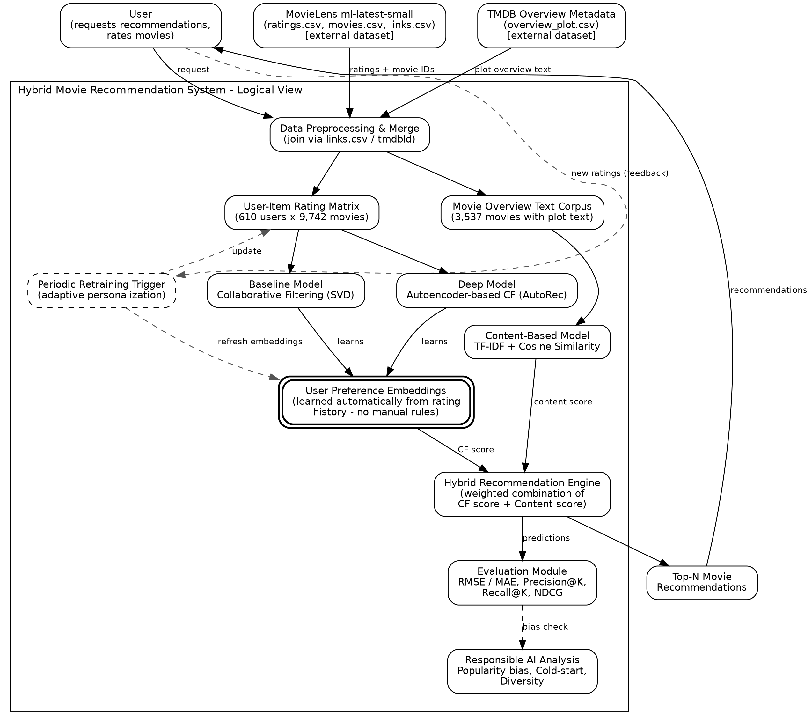
Figure 1: Logical architecture of the Hybrid Movie Recommendation System

Component Description
Component | Role
Data Preprocessing & Merge | Joins MovieLens and TMDB data via links.csv; builds the rating matrix and text corpus
Baseline Model (SVD) | Classical matrix-factorisation collaborative filter; comparison point for the deep model
Deep Model (AutoRec) | Autoencoder-based collaborative filter implemented in PyTorch
Content-Based Model (TF-IDF) | NLP-based similarity over movie plot text; covers cold-start items
User Preference Embeddings | Latent vector per user, learned automatically from rating history by SVD/AutoRec (Section 4.5)
Hybrid Recommendation Engine | Weighted combination of CF and content scores into a final ranked list
Evaluation Module | Computes RMSE/MAE and ranking metrics (Precision@K, Recall@K, NDCG)
Responsible AI Analysis | Checks popularity bias, cold-start fairness and recommendation diversity
Periodic Retraining Trigger | Re-runs training on updated ratings so embeddings adapt to evolving user taste (Section 4.5)

6. Evaluation Plan
Metric | Measures | Applies to
RMSE / MAE | Rating-prediction error | SVD, AutoRec
Precision@K / Recall@K | Relevance of the top-K recommended list | SVD, AutoRec, Hybrid
NDCG@K | Ranking quality (position-sensitive) | SVD, AutoRec, Hybrid
Qualitative examples | Sample recommendation lists for selected users | All models
Coverage / popularity bias | Share of catalogue ever recommended; average item popularity | Hybrid

Planned experiments: (1) baseline SVD vs. AutoRec vs. Hybrid, compared on identical train/test splits; (2) a latent-dimension / hidden-layer sweep for AutoRec; (3) a sweep of the hybrid weight α; (4) an ablation removing the content-based component to quantify its effect on cold-start items specifically.

7. Responsible AI / Ethics Considerations
- Popularity bias: both CF and TF-IDF coverage (Section 3.2) skew toward well-known movies; the Hybrid model's recommendation diversity and catalogue coverage will be measured and reported, not just accuracy.
- Cold-start fairness: new or obscure movies with no ratings and no matched plot text cannot currently be recommended; this limitation is stated explicitly rather than masked by aggregate accuracy figures.
- Filter-bubble risk: a purely accuracy-optimised recommender can over-narrow a user's exposure; diversity metrics are reported alongside accuracy so this trade-off is visible.

8. Project Timeline
Week | Dates | Milestone
1 | 8 – 14 Sep | Proposal review with tutor; environment setup; data preprocessing
2 | 15 – 21 Sep | Baseline SVD model implemented and evaluated
3 | 22 – 28 Sep | TF-IDF content-based model implemented
4 | 29 Sep – 5 Oct | AutoRec (PyTorch) implemented and tuned
5 | 6 – 12 Oct | Hybrid combination, full evaluation, ablations
6 | 13 – 19 Oct | Report writing, video recording, code cleanup
7 | 20 – 23 Oct | Final review and submission (due Fri 23 Oct 2026)

9. Expected Deliverables
In line with the COMP813 final project requirements (60 marks total):
Deliverable | Content | Marks
Final Report (PDF) | 6–8 pages, CVPR template, covering Introduction, Related Work, Data, Methods, Experiments, Conclusion | 40
Code (ZIP) | Runnable, documented scripts/notebooks with README; reproduces reported results | 15
Video Demonstration | 2–5 minute walkthrough of the code running and representative results | 5

10. References
Harper, F. M., & Konstan, J. A. (2015). The MovieLens Datasets: History and Context. ACM Transactions on Interactive Intelligent Systems, 5(4), Article 19.
Koren, Y., Bell, R., & Volinsky, C. (2009). Matrix Factorization Techniques for Recommender Systems. Computer, 42(8), 30–37.
Sedhain, S., Menon, A. K., Sanner, S., & Xie, L. (2015). AutoRec: Autoencoders Meet Collaborative Filtering. In Proceedings of the 24th International Conference on World Wide Web Companion (WWW '15 Companion), 111–112.
The Movie Database (TMDB). TMDB 5000 Movie Dataset. Kaggle. https://www.kaggle.com/datasets/tmdb/tmdb-movie-metadata
GroupLens Research. MovieLens ml-latest-small. https://grouplens.org/datasets/movielens/latest/

