Hybrid Chatbot Testing Plan and Test Execution Documentation

Project: Hybrid Chatbot for Medical Haematology
Document Type: Testing Documentation
Prepared For: Dissertation Appendix / Supervisor Review
Date: 03 May 2026

1. Test Plan
This document recorded the unit-level and feature-level testing approach used for the Hybrid Chatbot for Medical Haematology. The scope covered the sequential intent classifier, report-analysis layer, retrieval-based routing, API behavior, admin monitoring flows, HTTPS deployment behavior, and retraining support exports.

1.1 Objectives
• Verify that the BiLSTM intent models classified supported hematology prompts correctly.
• Verify that rule-based safety, entity detection, model auto-switching, and retrieval routing behaved consistently.
• Verify that the report model analyzed numeric CBC-style report phrases, sex-specific HGB/HCT phrases, and pediatric or age-aware phrases within bounded support rules.
• Verify that the admin and MLOps support features exported the correct retraining evidence.

1.2 Test Environment
Item | Value
Operating environment | Windows 11 local development and Docker-based deployment
Backend | FastAPI
ML runtime | PyTorch BiLSTM intent classifier
Storage | PostgreSQL
Test framework | pytest
Latest automated suite | 50 passed

1.3 Entry and Exit Criteria
Entry criteria: features implemented, datasets merged, model artifacts generated, and test environment available.
Exit criteria: all planned cases executed, no blocking failures remaining, regression suite passing, and evidence captured.

2. Test Case Catalogue

2.1 Core inference and routing cases
ID | Component | Objective | Task | Expected Result | Actual Result | Status / Evidence
UT-01 | Preprocessing | Normalize text for downstream inference. | Input mixed-case query with punctuation. | Normalized lowercase phrase is produced consistently. | Passed in `test_preprocessing.py`. | Pass | Automated
UT-02 | Predictor rule layer | Detect greeting phrases before model inference. | Submit `hi` to the predictor. | Intent resolves to `greeting` with rule priority. | Passed in `test_predictor_rules.py` and API smoke checks. | Pass | Automated + smoke
UT-03 | Predictor rule layer | Detect social small-talk phrases. | Submit `how are u` to the predictor. | Intent resolves to `small_talk` instead of `incomplete_query`. | Passed in `test_predictor_rules.py`. | Pass | Automated
UT-04 | Safety rule layer | Block unsafe treatment language. | Submit phrase containing `prescribe` or `inject`. | Intent resolves to `unsafe_medical_request`. | Passed in `test_predictor_rules.py` and route tests. | Pass | Automated
UT-05 | Entity detection | Recognize MCV as an RBC-report entity. | Submit `What is MCV?`. | Entity rule maps to canonical MCV question. | Passed in `test_entity_detection.py`. | Pass | Automated
UT-06 | Entity detection | Recognize aPTT as coagulation entity. | Submit `What is aPTT?`. | Entity rule maps to coagulation knowledge. | Passed via routing tests and smoke checks. | Pass | Automated + smoke
UT-07 | Routing layer | Prioritize direct sample-collection retrieval. | Submit `Which tube is used for CBC?` with `sample_collection` intent. | EDTA/lavender-top answer is returned instead of generic CBC info. | Passed in `test_routing_engine.py`. | Pass | Automated
UT-08 | Routing layer | Return CBC sample rejection criteria. | Submit `What are the rejection criteria for a CBC sample?`. | Rejection-criteria answer mentions wrong tube / clotted sample style conditions. | Passed in `test_routing_engine.py`. | Pass | Automated
UT-09 | Routing layer | Return CBC stability guidance. | Submit `How long is a CBC sample stable?`. | Stability answer references validated limits and SOP. | Passed in `test_routing_engine.py`. | Pass | Automated
UT-10 | Model advisory | Auto-switch report questions from general to report model. | Submit `How do I read this CBC report?` while `general` is selected. | Model advisory recommends / routes to `report`. | Passed in `test_model_advisory.py` and UI smoke checks. | Pass | Automated + smoke

2.2 Report-analysis and prompt cases
ID | Component | Objective | Task | Expected Result | Actual Result | Status / Evidence
UT-11 | Model advisory | Auto-switch workflow questions from report to general model. | Submit `Which tube is used for coagulation tests?` while `report` is selected. | Model advisory recommends / routes to `general`. | Passed in `test_model_advisory.py` and UI smoke checks. | Pass | Automated + smoke
UT-12 | Report analysis | Interpret numeric WBC results. | Submit `WBC is 13.7`. | Intent resolves to `report_numeric_result_analysis` and response marks high range. | Passed in `test_report_analysis.py` and manual runtime verification. | Pass | Automated + manual
UT-13 | Report analysis | Interpret printed report flag text. | Submit `My report shows anemia`. | Intent resolves to `report_flag_result_analysis` with bounded non-diagnostic explanation. | Passed in `test_report_analysis.py` and runtime verification. | Pass | Automated + manual
UT-14 | Report analysis | Apply adult age context without exposing internal note. | Submit `in my report WBC is 13.37 age is 51`. | Adult range is applied, but no internal age-note sentence is displayed. | Verified after age-aware retraining and response cleanup. | Pass | Manual + regression
UT-15 | Report analysis | Apply pediatric age context. | Submit `WBC is 13 age is 10`. | Pediatric range is applied and result is interpreted within pediatric criteria. | Passed in `test_report_analysis.py` and runtime verification. | Pass | Automated + manual
UT-16 | Report analysis | Apply sex-specific HGB range. | Submit `Adult male HGB is 13.0`. | Male reference interval is used for HGB. | Passed in `test_report_analysis.py` and runtime verification. | Pass | Automated + manual
UT-17 | Report analysis | Apply sex-specific HCT range. | Submit `Female HCT is 45`. | Female reference interval is used for HCT. | Passed in `test_report_analysis.py` and runtime verification. | Pass | Automated + manual
UT-18 | Report analysis | Prevent age-only phrases from being treated as report analysis. | Submit `age is 43`. | Intent resolves to `incomplete_query`. | Passed in `test_report_predictor.py` and runtime verification. | Pass | Automated + manual

2.3 API, admin, export, and deployment cases
ID | Component | Objective | Task | Expected Result | Actual Result | Status / Evidence
UT-19 | API layer | Return stable chat response schema. | POST `/chat` with `Hello`. | JSON response includes `intent`, `response`, `lang`, and model metadata. | Passed in `test_api.py`. | Pass | Automated
UT-20 | API layer | Expose report-analysis preview rows. | GET `/admin/api/report-analysis-preview`. | Preview returns report-analysis retraining candidates in JSON. | Passed in `test_api.py`. | Pass | Automated
UT-21 | Admin trace API | Trace end-to-end inference layers. | POST `/admin/api/trace` with `What is aPTT?`. | Trace returns preprocessing, classifier, retrieval, and final route fields. | Validated through admin trace runtime checks. | Pass | Manual + API
UT-22 | Export pipeline | Export accepted reviewed samples. | GET `/admin/api/export-reviewed`. | CSV file is generated for retraining. | Validated through admin export flow. | Pass | Manual
UT-23 | Export pipeline | Export report-analysis failure candidates. | GET `/admin/api/export-report-analysis-errors`. | CSV file contains low-confidence / fallback report-analysis rows. | Validated through admin export flow and store logic. | Pass | Manual + code review
UT-24 | HTTPS deployment | Build redirect URL correctly. | Request `http://localhost:8000/admin?x=1` while HTTPS is enabled. | Redirect points to HTTPS target preserving path and query. | Passed in `test_https_redirect.py`. | Pass | Automated
UT-25 | Certificate monitoring | Classify near-expiry certificate severity. | Evaluate certificate status with low remaining days. | Admin warning level becomes warn/danger based on days remaining. | Passed in `test_certificate_warning.py` and `test_ssl_utils.py`. | Pass | Automated
UT-26 | Split pipeline | Load fixed train/validation/test splits correctly. | Read split metadata and split files. | Split rows and ratios remain reproducible for model training. | Passed in `test_split_utils.py`. | Pass | Automated

3. Automated Test Evidence
The following figures provide screenshot-style evidence for the automated regression tests that covered the advisory and report-analysis cases listed in the test catalogue.

Automated model-advisory regression evidence
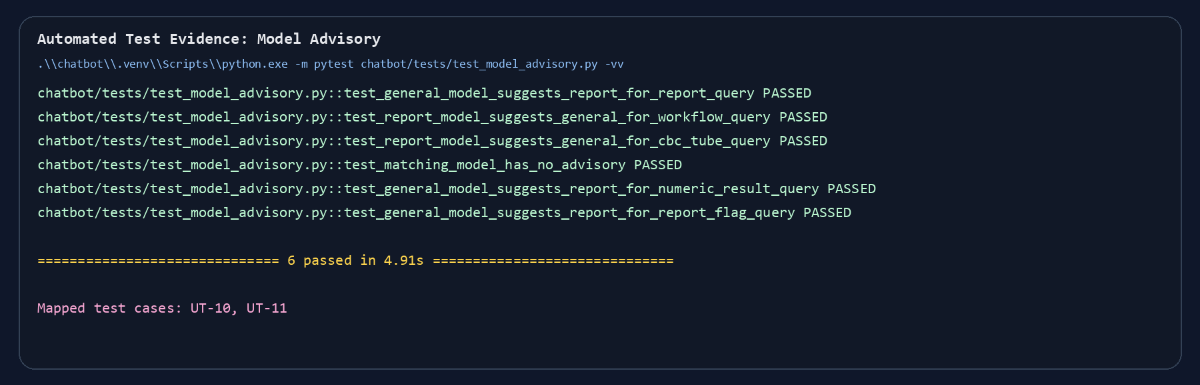
Figure A1 Automated pytest evidence covering UT-10 and UT-11.

Automated report-analysis regression evidence
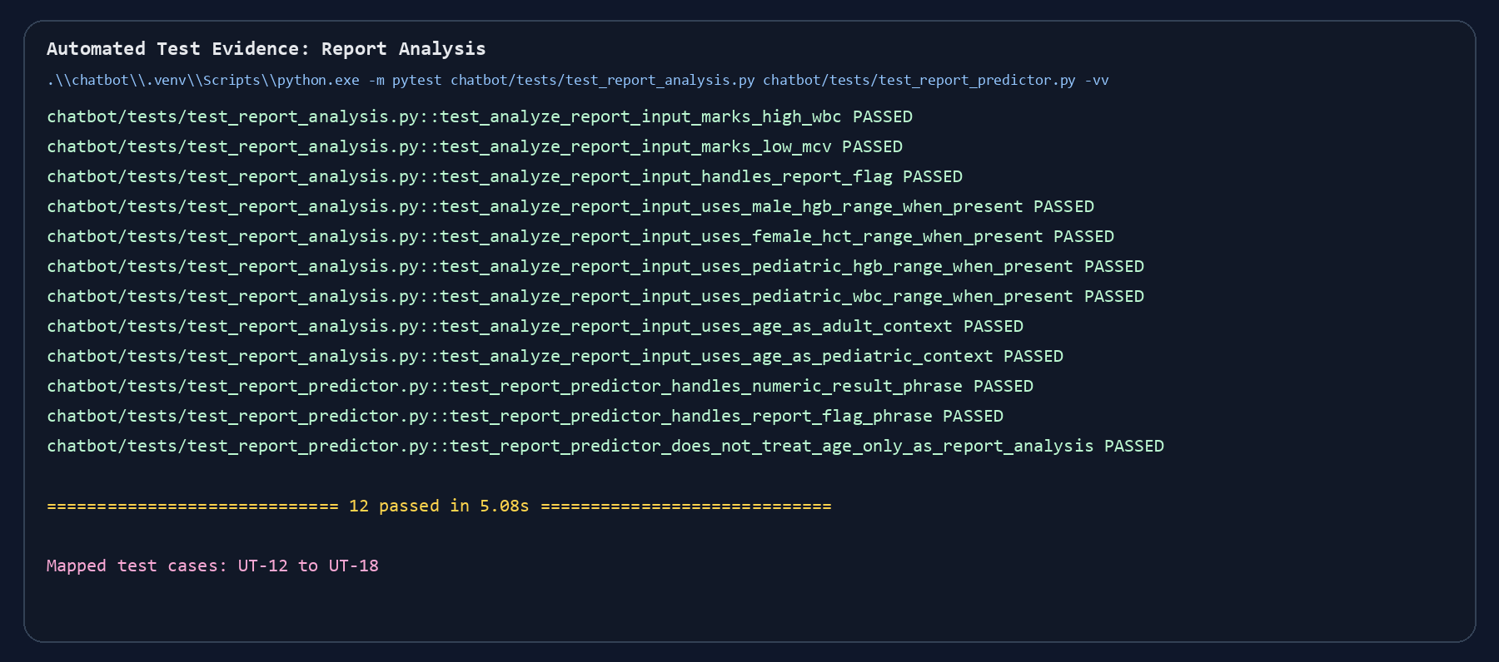
Figure A2 Automated pytest evidence covering UT-12 to UT-18.

4. Detailed Test Execution Examples

4.1 UT-12 Report numeric result analysis
Test Case: UT-12 | Component: Report analysis | Designed By: Project Author
Data Source: Code / API / Prompt Input | Objective: Interpret numeric WBC results. | Tester: Project Author
Test Case | Description | Tasks | Expected Result | Actual Result
UT-12 | Interpret numeric WBC results. | Submit `WBC is 13.7`. | Intent resolves to `report_numeric_result_analysis` and response marks high range. | Passed in `test_report_analysis.py` and manual runtime verification. Status: Pass.
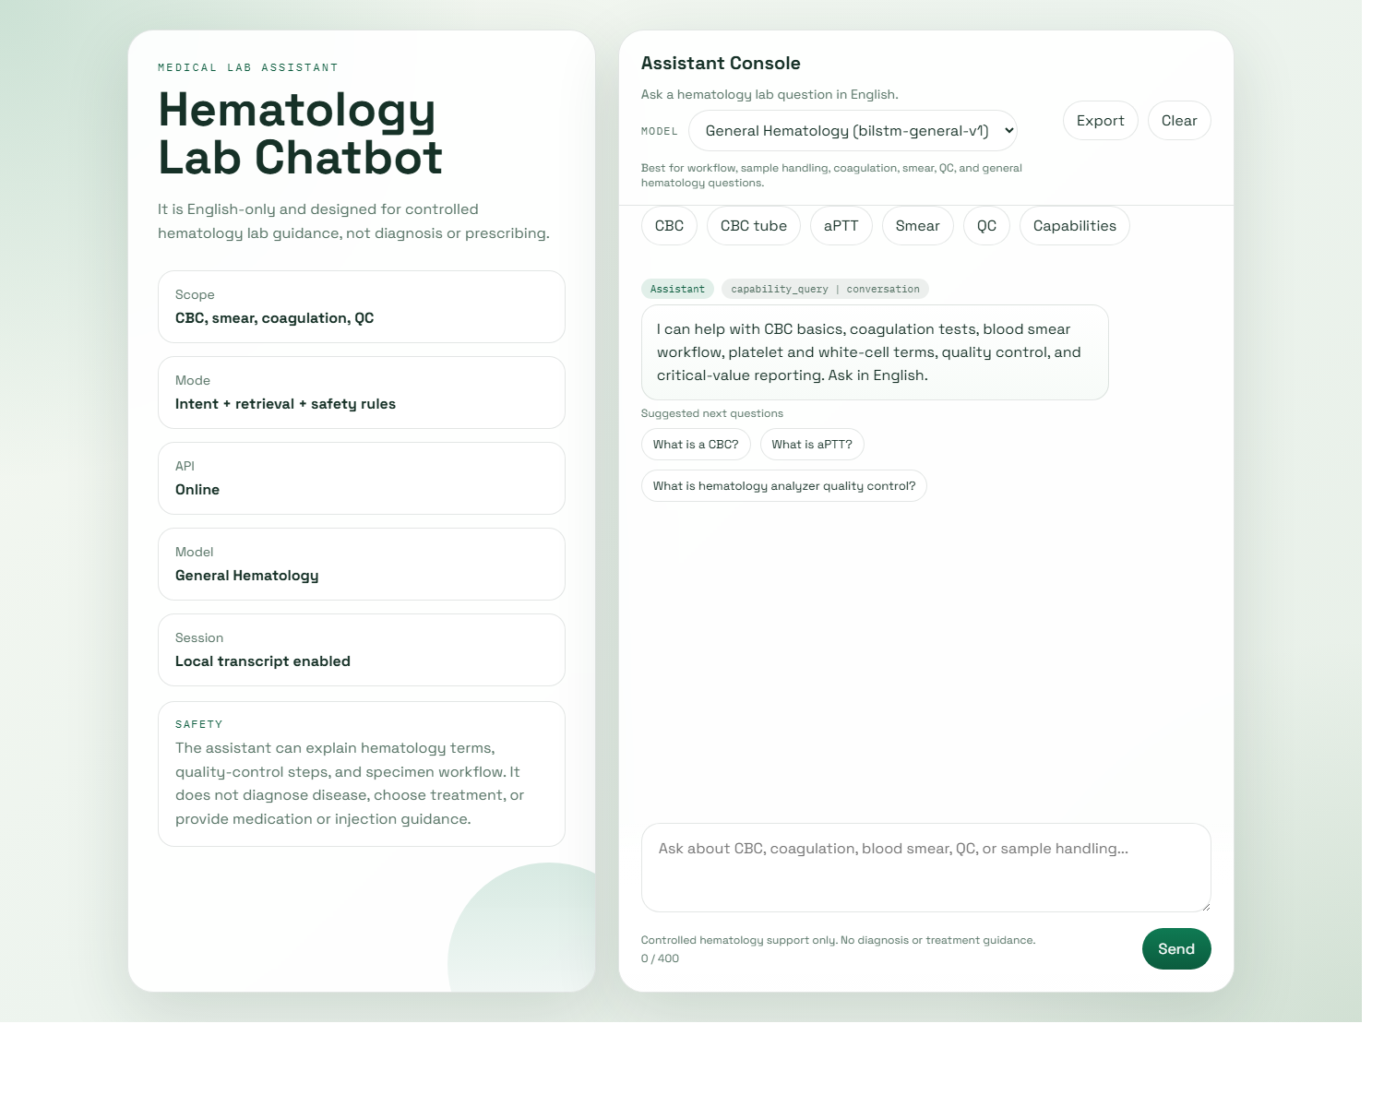
Figure T1 Supporting interface or evidence for UT-12

4.2 UT-15 Pediatric report analysis
Test Case: UT-15 | Component: Report analysis | Designed By: Project Author
Data Source: Code / API / Prompt Input | Objective: Apply pediatric age context. | Tester: Project Author
Test Case | Description | Tasks | Expected Result | Actual Result
UT-15 | Apply pediatric age context. | Submit `WBC is 13 age is 10`. | Pediatric range is applied and result is interpreted within pediatric criteria. | Passed in `test_report_analysis.py` and runtime verification. Status: Pass.
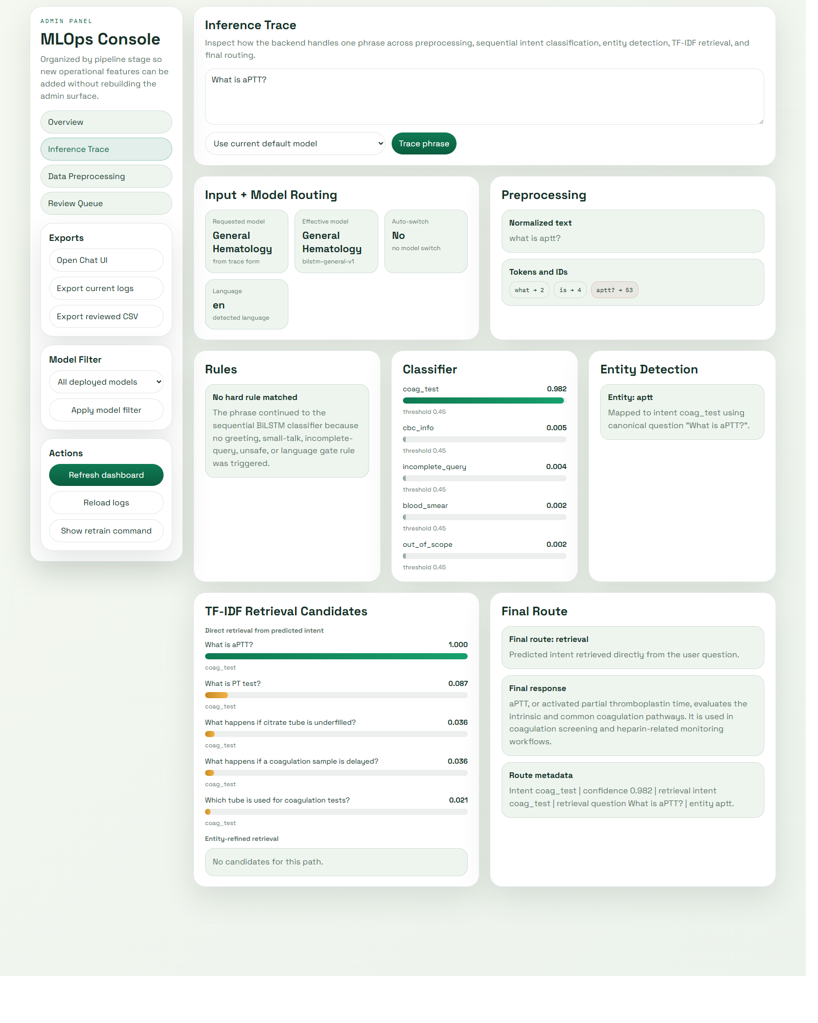
Figure T2 Supporting interface or evidence for UT-15

4.3 UT-20 Report-analysis preview API
Test Case: UT-20 | Component: API layer | Designed By: Project Author
Data Source: Code / API / Prompt Input | Objective: Expose report-analysis preview rows. | Tester: Project Author
Test Case | Description | Tasks | Expected Result | Actual Result
UT-20 | Expose report-analysis preview rows. | GET `/admin/api/report-analysis-preview`. | Preview returns report-analysis retraining candidates in JSON. | Passed in `test_api.py`. Status: Pass.
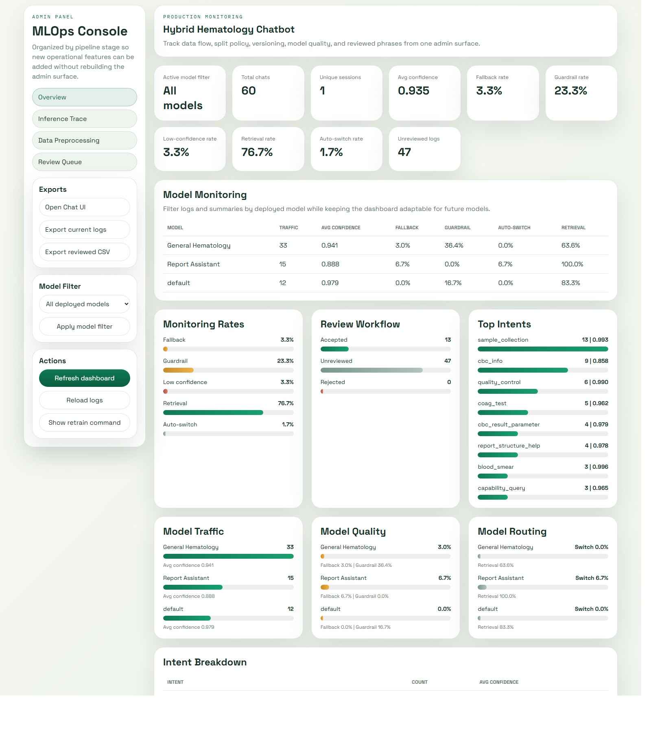
Figure T3 Supporting interface or evidence for UT-20

4.4 UT-24 HTTPS redirect and deployment validation
Test Case: UT-24 | Component: HTTPS deployment | Designed By: Project Author
Data Source: Code / API / Prompt Input | Objective: Build redirect URL correctly. | Tester: Project Author
Test Case | Description | Tasks | Expected Result | Actual Result
UT-24 | Build redirect URL correctly. | Request `http://localhost:8000/admin?x=1` while HTTPS is enabled. | Redirect points to HTTPS target preserving path and query. | Passed in `test_https_redirect.py`. Status: Pass.

Figure T4 Supporting interface or evidence for UT-24

5. Execution Summary
Metric | Value
Planned cases | 26
Passed | 26
Failed | 0
Blocked | 0
Automated regression suite | 50 passed

6. Residual Risks and Notes
The report-analysis layer remained bounded and did not attempt diagnosis, treatment recommendation, or unrestricted clinical reasoning.
Reference intervals remained generalized for assistant support and had to defer to the printed report range and local laboratory policy.
Pediatric support remained deliberately simplified and should be documented as bounded laboratory assistance rather than clinical decision support.

