REQUIREMENT : BOOK A SPECIFIC TIME SLOT

Pseudocode:
- bookSlot()
- INPUT facility, date, start_time, end_time, user_id
- SET booking_id = 0
- IF (facility, date, start_time, end_time) != “reserved” THEN
  - OUTPUT “Facility : “ + facility
  - OUTPUT “Date : “ + date
  - OUTPUT “Time : " + start_time + " to " + end_time
  - OUTPUT "Fee: RM" + fee
  - OUTPUT "Confirm? (Y/N)"
  - INPUT answer
  - IF answer == “Y” THEN
    - booking_id++
    - OUTPUT “Booking successful!”
    - OUTPUT "Booking ID: " + booking_id
  - ELSE
    - OUTPUT "Booking cancelled."
  - END IF
- ELSE
  - OUTPUT “ Slot not available”
- END IF
- RETURN

Flowchart:
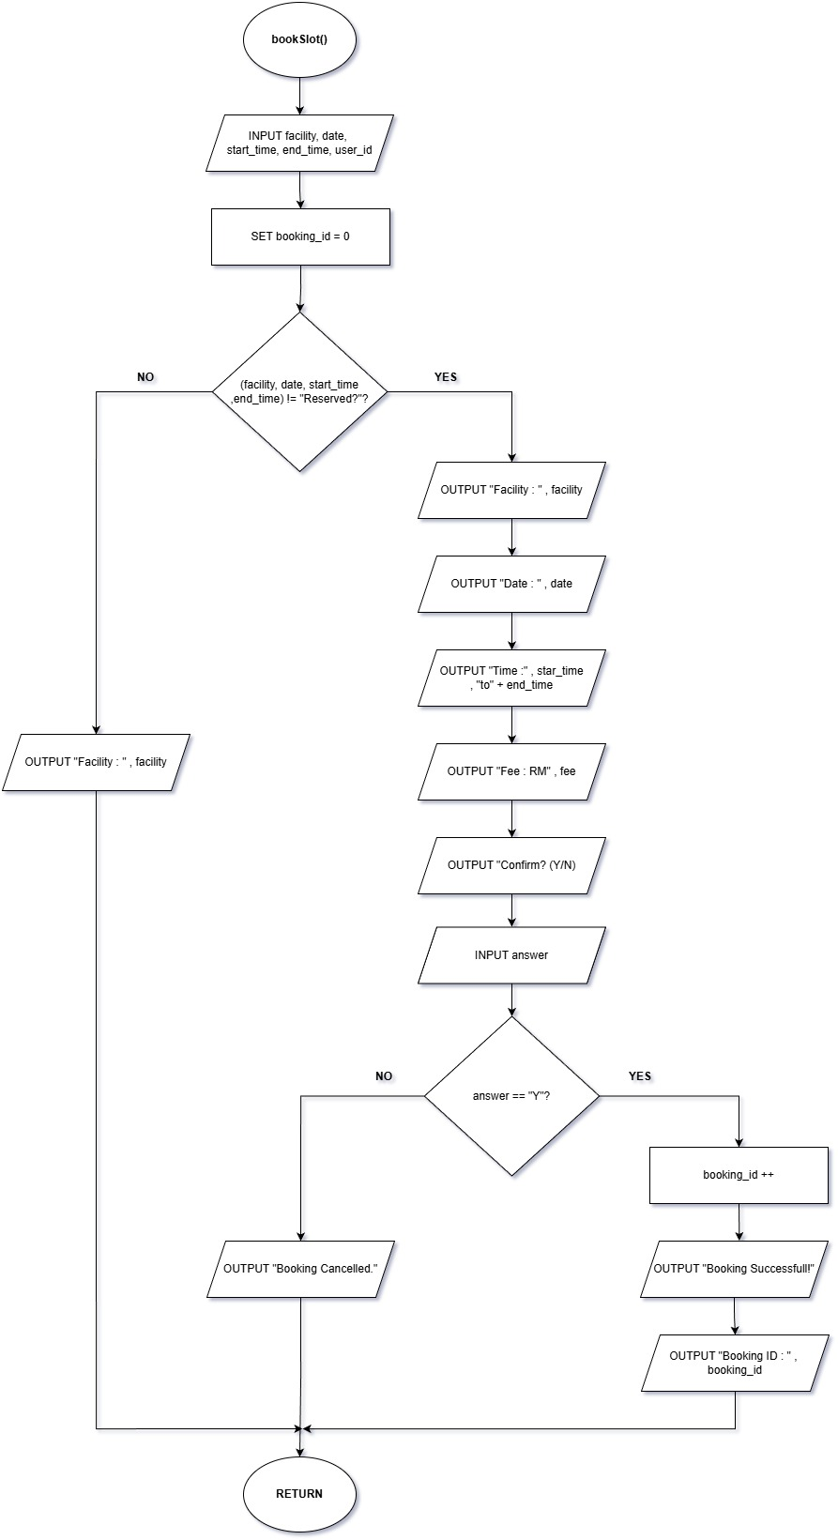
REQUIREMENT : ONLINE PAYMENT PROCESS

Pseudocode:
- payOnline()
- INPUT booking_id, card_number, expiry, name
- SET booking = booking_id
- IF booking == NULL THEN
  - OUTPUT “Invalid booking ID”
  - RETURN
- END IF
- IF booking == “Reserved” THEN
  - OUTPUT “Payment not allowed”
  - RETURN
- END IF
- SET totalPrice = booking_fee
- IF (card_number, expiry) == “Not Valid” THEN
  - OUTPUT “Invalid card details”
  - RETURN
- END IF
- IF(expiry < current month && year) THEN
  - OUTPUT “Card has expired”
  - RETURN
- END IF
- IF(payment_gateway == “Success” THEN
  - SET booking_status = “Paid”
  - SET payment_date = current_date
  - OUTPUT “Receipt”
  - OUTPUT "Booking ID: " + booking_id
  - OUTPUT "Amount: RM" + total_amount
  - OUTPUT "Status: Paid"
  - OUTPUT "Date: " + payment_date
  - OUTPUT “Payment successful!”
- ELSE
  - OUTPUT “Payment failed : Card declined”
- END IF
- RETURN

Flowchart:
