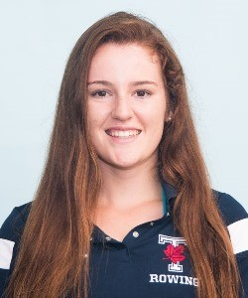Dear Trin,

Athletics play a fundamental role in the Trin experience. Not only do they provide a physical outlet to balance academic demands, but equally important is their social component. Athletics provide the opportunity to meet fellow Trins across res and non-res from different years. They also provide the chance to have lots of fun, generate College spirit and represent Trinity in campus-wide competitions. From involvement in intramural to Varsity, athletics are central to my university experience. Over the past two years, I have participated in Trinity Intramurals, Varsity Rowing, and even seized the opportunity to step out of my own comfort zone and try my hand at football in Conversat Bowl!

As a Co-Head of Trinity College Athletics, I will encourage and support all Members of College’s athletic endeavors – whether it’s getting involved in a sport you are familiar with or trying something completely new. Additionally, I hope to partner with TCMHI to emphasize the importance and synergies of physical and mental wellbeing, through events like De-stressing Yoga or Energizing Bootcamps. I also envision organizing some fun, outdoor pick-up games in the quad or quiddich pitch, like volleyball, soccer, or touch football to name only a few.

I sincerely hope you will elect me as on of the Co-Heads of Trin Athletics for the coming year. I will support fellow members with whom I will work collaboratively to encourage participation in all aspects of College athletics.

Thank you,

Lauren

[lauren.adolphe@mail.utoronto.ca](mailto:lauren.adolphe@mail.utoronto.ca)