**DevOps(CI & CD) Documentation**

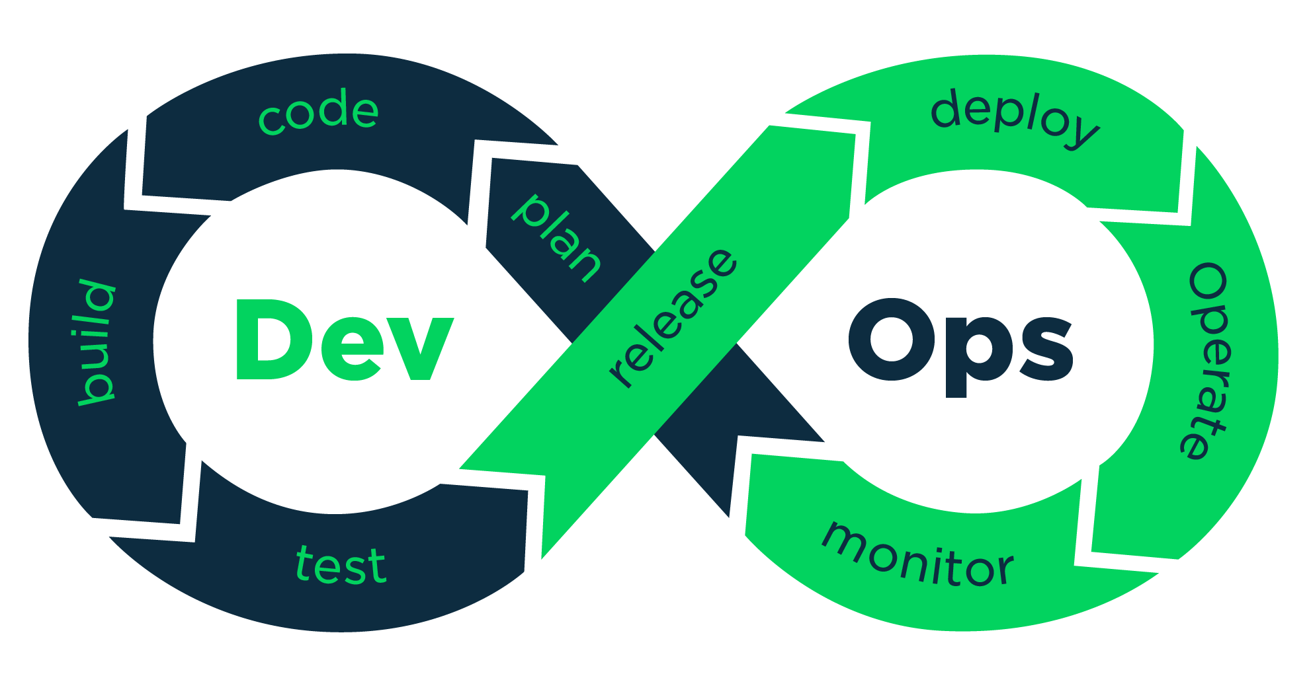

**Jenkins Installation**

**✕Official Installation Guide:** [Installing Jenkins](https://www.jenkins.io/doc/book/installing/).

**✓Docker Image:** <https://hub.docker.com/r/jenkins/jenkins>

**✓Install Jenkins On Docker:** <https://github.com/jenkinsci/docker/blob/master/README.md>

**Single command to install jenkins:** (just changed port 8080 → 8090)

*docker run -p 8090:8080 -p 50000:50000 -v jenkins_home:/var/jenkins_home jenkins/jenkins:lts-jdk11*

**Initial plugin list (auto installed):**

1. Folders.
2. OWASP markup formatter.
3. Build timeout.
4. Credentials binding.
5. Time stamper.
6. Workspace cleanup.
7. Ant.
8. Gradle.
9. Pipeline.
10. Github branch source.
11. Pipeline: github groovy libraries.
12. pipeline: stage view.
13. Git.
14. SSH build agents.
15. Matrix authorization strategy.
16. PAM authentication.
17. LDAP.
18. Email extension.
19. Mailer.

**Dashboard login:**

**Name:** admin.

**Password:** e10245b2739d4282abbcc77a5e652b8b. (auto generated)

**System Configuration**

**JDK version:** Open jdk 11.

**Learning Topics From Tutorials**

run on apache server like tomcat.

can change home directory.

has CLI command feature.

**Create User+Manage+Assign Roles:**

create new users.

configure users.

create new roles (Roles Strategy Plugin).

assign users to roles.

control user access to projects.

**Basic Configuration:**

**Plugins:**

**Credentials+SSH Integration:**

**Udemy - Learn DevOps CI CD with Jenkins using Pipelines and Docker**

**Introduction**

Installation.

Build nodejs app using jenkins+docker.

**Jenkins & DevOps Way**

Infrastructure as code and automation.

Job DSL.

Jenkins job pipeline.

Running build, test, deploy in docker.

**Integration**

Email.

Slack/Discord.

Github & bitbucket.

Jfrog.

Custom API.

Sonar.

**Advance Jenkins Usage**

Jenkins slaves.

Blue ocean.

SSH-agent plugin.

Security best practices.

Authentication & authorization strategies.

Onelogin integration.

**DevOps Fundamentals- CICD with AWS +Docker+Ansible+Jenkins**

What are Hosting Servers and Application Servers?  
Demo to understand what Deployment is?  
How code developed is hosted on the servers and accessed through browser?  
Demo on Jenkins Job creation for deployment of app in Server.  
Drawbacks with current design and why to choose Linux OS.  
  
  
Create and Launch AWS Linux Instance to manage Jenkins.  
Connect to Linux Server through SSH.  
Install JAVA on Linux Server.  
Install Jenkins, Maven and GIT to have job for Deployment.  
  
Create new Linux server (App Server) in AWS for Deploying App.  
Create User in Server which can manage deploy.  
Connect Jenkins server to App Server through SSH Plugin.  
Create a Jenkin Job which deploys app into App Server.  
  
Install Docker in App Server.  
Create a Docker file which Install TomCat Server and Deploy App.  
Create Image from the file and deploy into Container.  
Access the App through public Ip:port which is running on Container.  
  
Install Ansible and its need for Deployment.  
Create Ansible Playbook to automate all docker related commands.  
Fix the problems of stopping and starting containers through Ansible yml file.  
Create SSH Key and hosts file for establishing connection through Ansible.  
Pass the Ansible Playbook commands into Jenkins Job for automatic Deployment in App server.  
  
Create another Linux App Server B through AWS.  
Create User in Server which can manage deploy.  
Establish connection to App Server B from App server A through Ssh keys.  
Ping the App Server B from Server A through Ansible command for connection check.  
Develop a yml playbook file which pushes the docker image to Docker Hub in Server A.  
Modify the Jenkins job to deploy the App into Server B through Ansible Commands.  
  
Adding Post build action run automated tests after new Code successfully Deployed.  
What is Pipeline and understand the basics of Jenkin Pipeline.  
Creating the JenkinsFile with the complete job configuration design to run end to end deployment process.  
Checkin the JenkiFile into Code repo and automate the complete CI/CD process through Jenkins!!

**Tutorials & Guides**

**Courses I am following:**

1. https://youtu.be/89yWXXIOisk

2. https://youtu.be/FX322RVNGj4

3. https://youtu.be/p7-U1_E_j3w

4. https://youtu.be/7KCS70sCoK0

5. https://youtu.be/04rFWt45U3k

6. https://youtu.be/QaDNk1a8xFU

7. https://youtu.be/EYA2YNHHPls

8. https://youtu.be/3a8KsB5wJDE

9. https://youtu.be/gT9qnZi3f74

10. https://youtu.be/KG47Y8uUtVI

11. https://youtu.be/rb5OL-QQPw4

12. [Jenkins Tutorial (tutorialspoint.com)](https://www.tutorialspoint.com/jenkins/index.htm)

13. <https://youtu.be/HTlAssPBKBs>

14. <https://medium.com/facademy/setup-jenkins-for-private-repository-9060f54eeac9>

15. https://levelup.gitconnected.com/basics-of-ci-cd-a98340c60b04

16.

**Selenium**

**Official Documentation:**

[**The Selenium Browser Automation Project | Selenium**](https://www.selenium.dev/documentation/)

Browser based testing platform.

CI Algorithm:

CD Algorithm: