**Automate Development To Deployment**

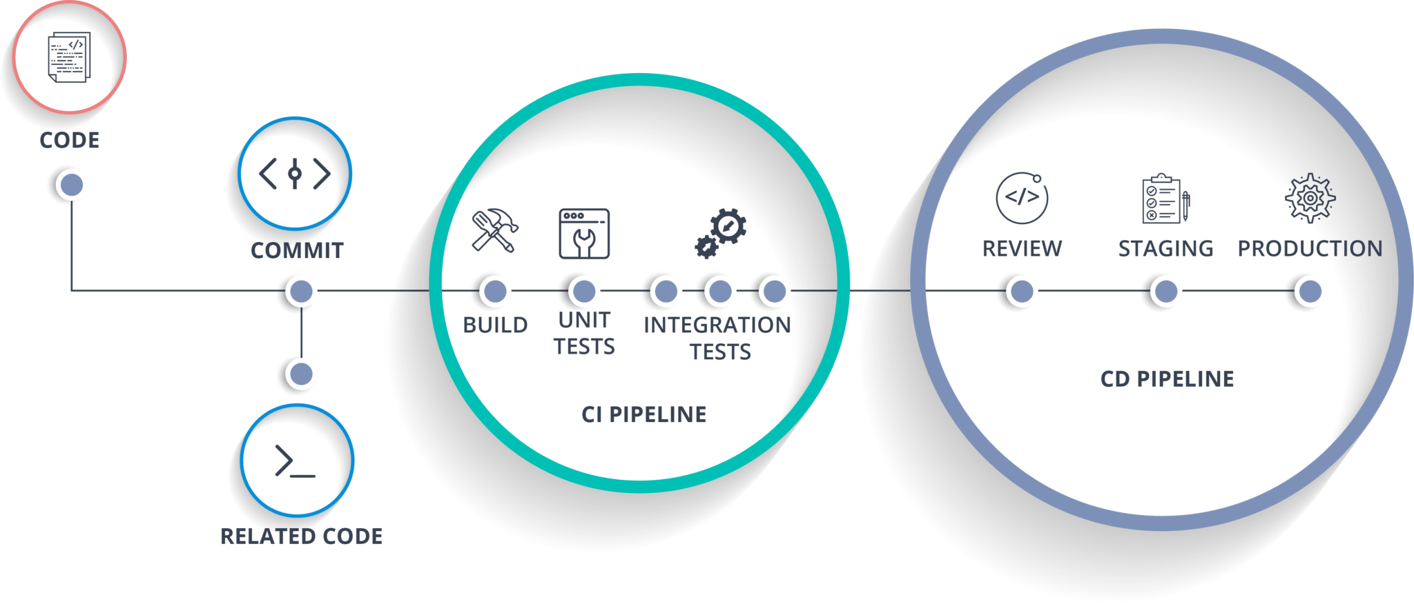

**Technologies**

**Platform**:

Linux (For DevOps).

Windows (For development).

**Planning**:

Click Up.

**Milestone tracking**:

Github project (Kanban board).

**Coding**:

JavaScript.

MySQL.

Flutter.

**Code analysis:**

Sonar.

**Source code management (S C M)**:

Github.

**DevOps**:

Docker. (Deploy)

Jenkins: (Build/Rebuild)

**Scripting**: (Automation)

Shell scripting.

Pipeline scripting.

**Testing**:

Selenium.

Postman.

Browser.

Emulator.

**Notification**:

Email/Discord.

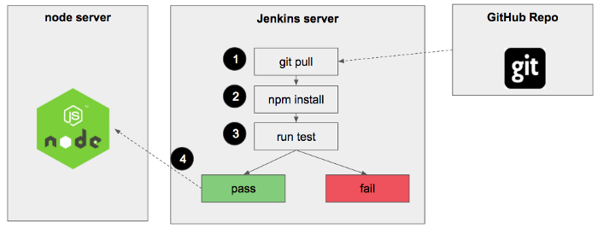

Simple diagram to show a nodejs project automation

Flow Chart of complete CI&CD Process:

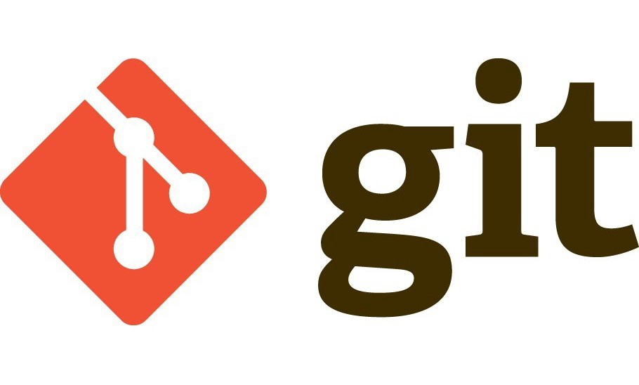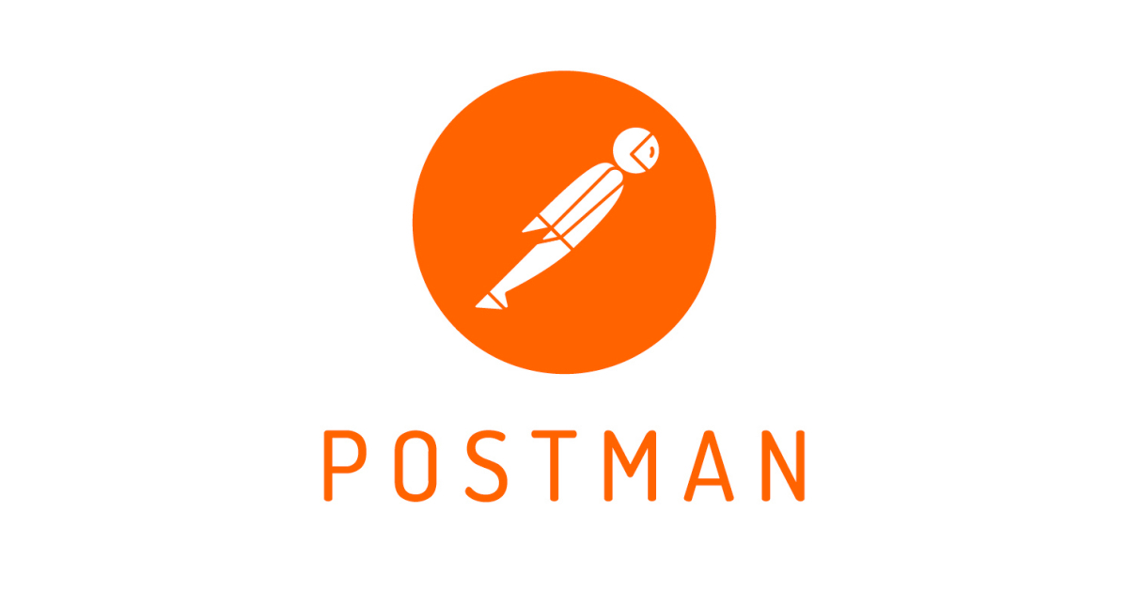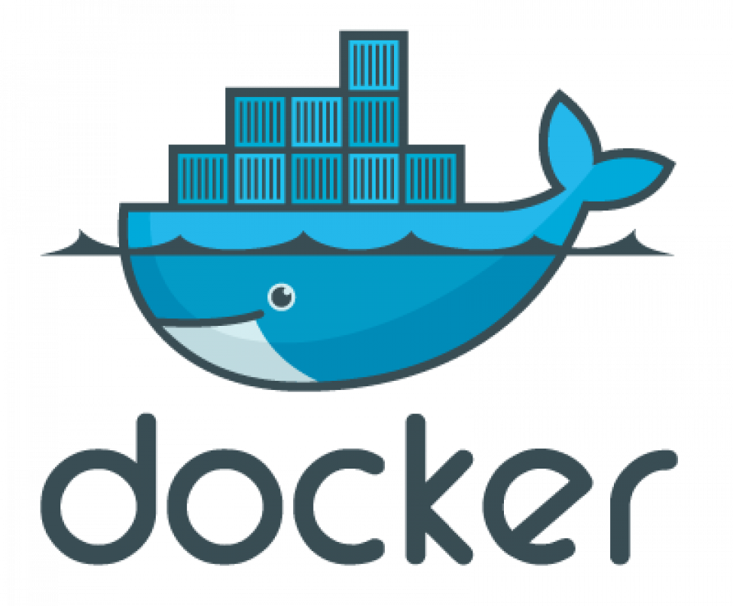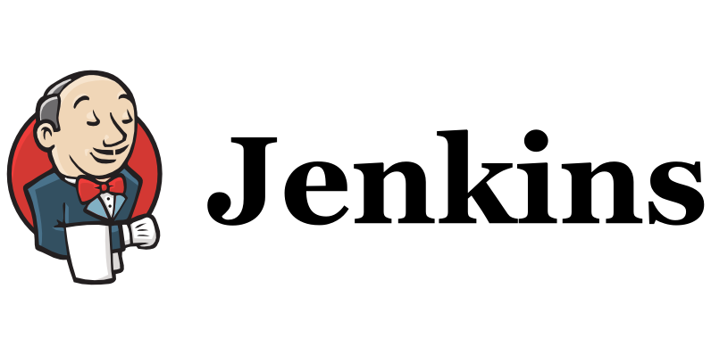

Developer

Build Server

Test Server

Production Server

build

code

commit

push

pull

test

error

pass

notify

deploy

review

error

pass

fail

pass