Current Built: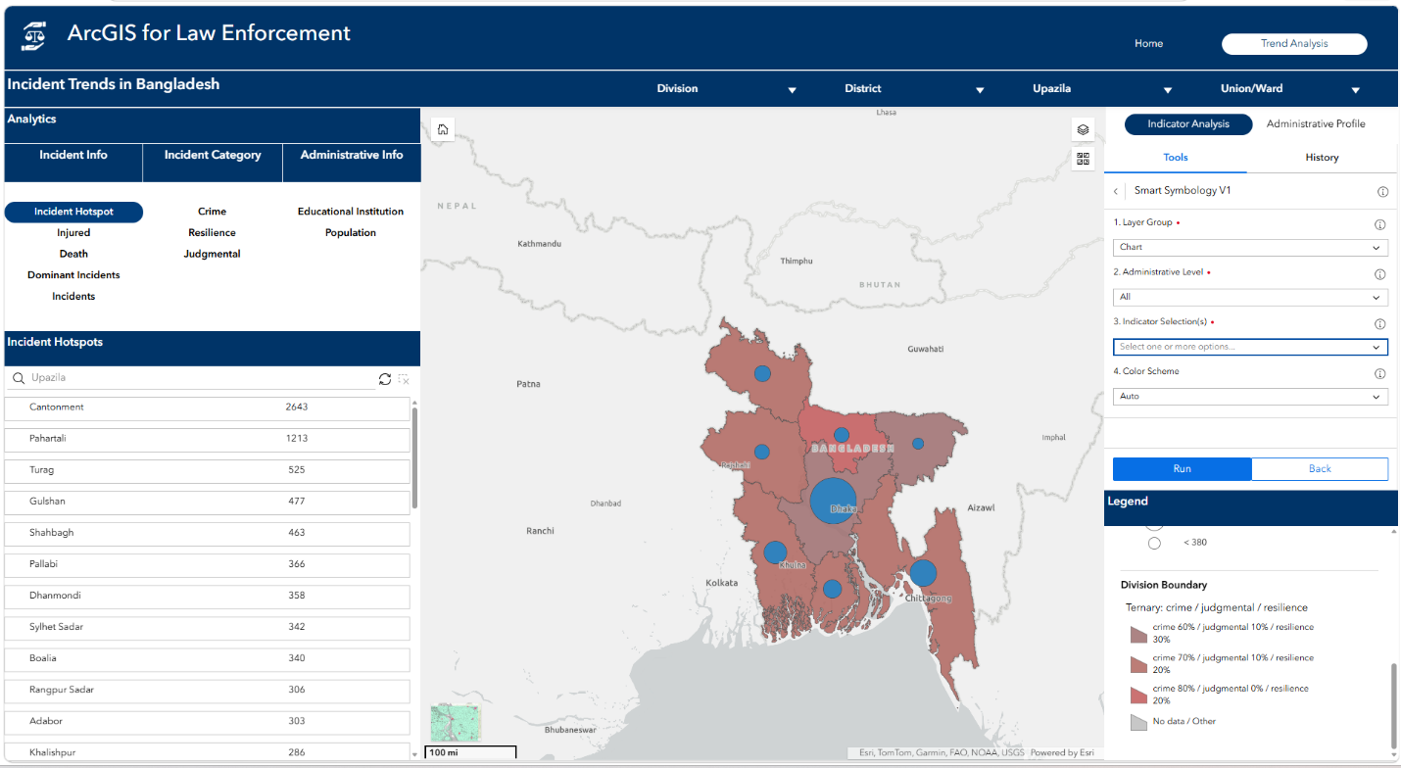

Sample Idea for Regeneration: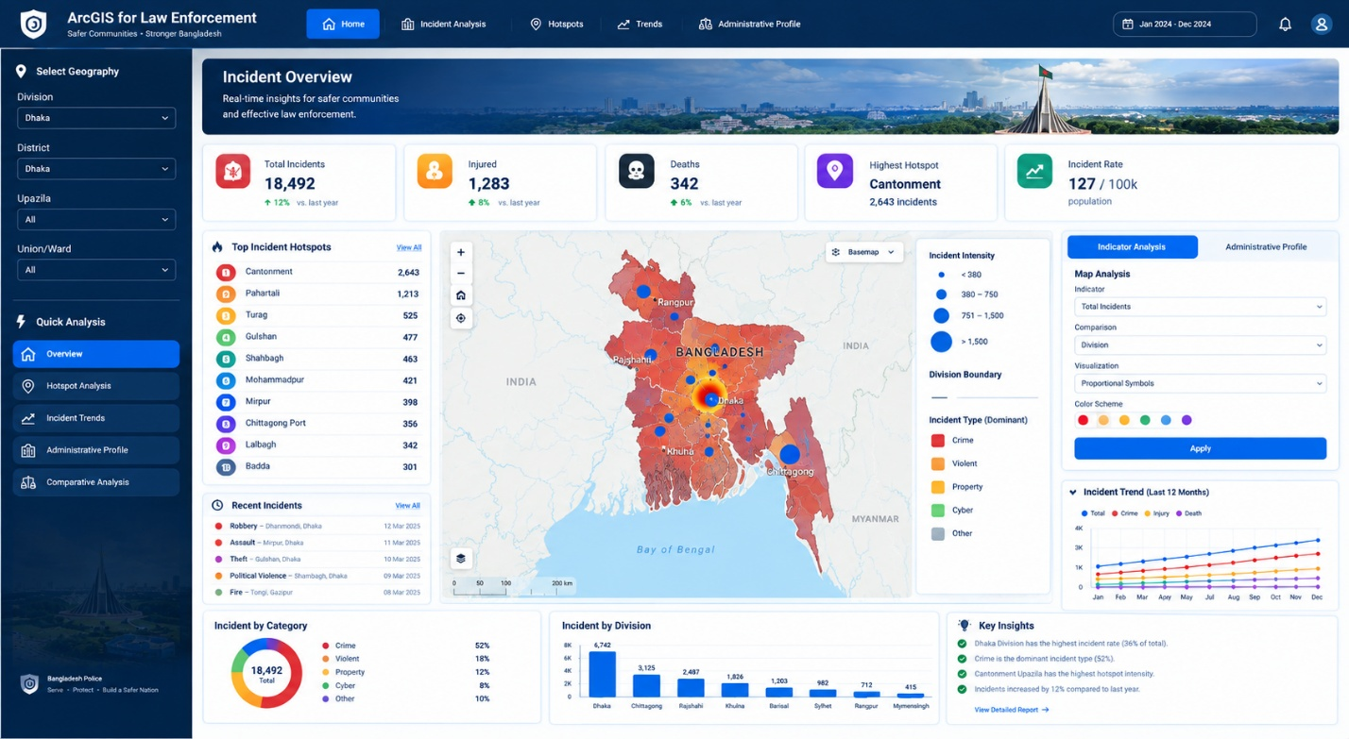
Sample legend for Bivarite and Ternary:
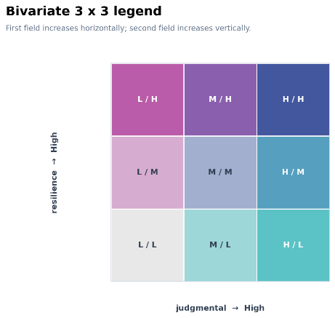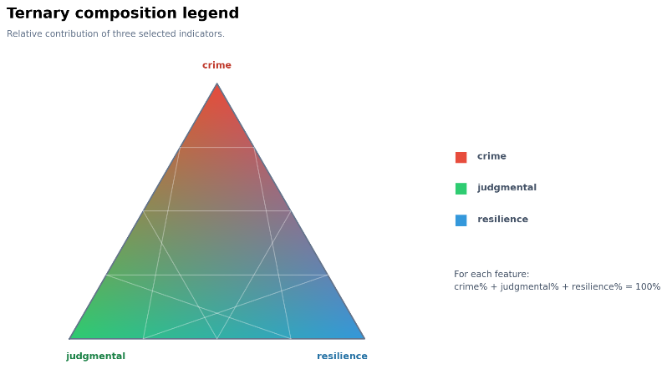
For these two symbology should come like this with applied colors and indicators, not like the current legends style as you can see in the current built legend section.
Layers in the Web Map:
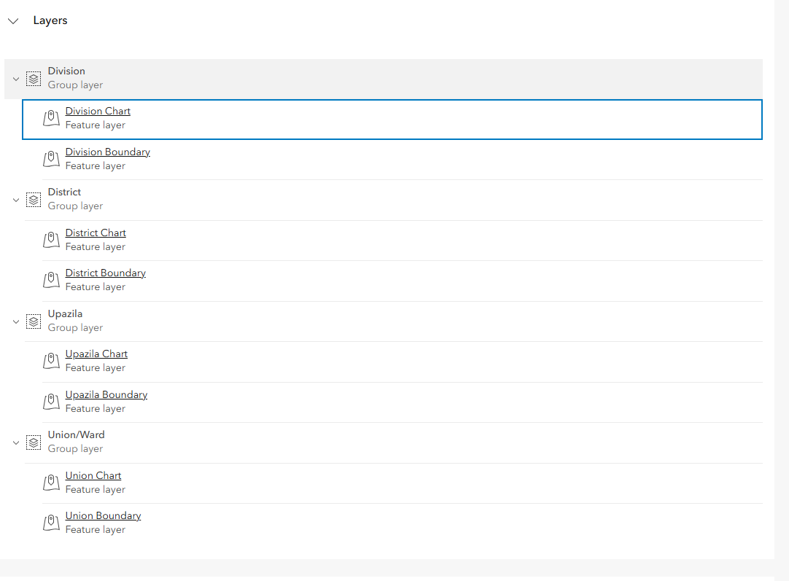

Table of Actual field names in the web map layers(Division to Union)
Group | Parameter (UI Label) | Actual Field Name
Incident | Total Incidents | Total_Incidents
Incident | Crime | Crime
Incident | Judgmental | Judgmental
Incident | Resilience | Resilience
Incident | Death | Total_Death
Incident | Injured | Total_Injured
Demography | Population | Population
Demography | Male Population | Male_Population
Demography | Female Population | Female_Population
Demography | Floating Population | Floating_Population
Demography | Age 0-14 | Age_0_14
Demography | Age 15-34 | Age_15_34
Demography | Age 35-64 | Age_35_64
Demography | Age 65 Plus | Age_65_Plus
Demography | Muslim Population | Muslim_Population
Demography | Hindu Population | Hindu_Population
Demography | Other Religion Population | Other_Religion_Population
Socio-Economic | Total Households | Total_Households
Socio-Economic | Pucca Households | Pucca_Households
Socio-Economic | Semi Pucca Households | Semi_Pucca_Households
Socio-Economic | Kutcha Jhupri Households | Kutcha_Jhupri_Households
Socio-Economic | Employed Youth | Employed_Youth
Socio-Economic | Household Work Youth | Household_Work_Youth
Socio-Economic | Looking For Job Youth | Looking_For_Job_Youth
Socio-Economic | Not Working Youth | Not_Working_Youth
Socio-Economic | Agriculture Employment | Agriculture_Employment
Socio-Economic | Industry Employment | Industry_Employment
Socio-Economic | Service Employment | Service_Employment
Socio-Economic | Internet Users Youth | Internet_Users_Youth
Point of Interest | Kindergarten | Kindergarten
Point of Interest | School | School
Point of Interest | Madrasha | Madrasha
Point of Interest | College | College
Point of Interest | University | University
Point of Interest | Total Educational Institutions | Total_Educational
Point of Interest | Market | Market

In this table I have categorize the actual field names with Indicator Groups. And also renamed the actual field in Parameters so in the web app it doesn’t visualize the actual field names as there can be lower case, underscores exists.
Task:
I want to build a Crime Analysis Web application using these: HTML, CSS, JS, Arcgis map sdk for Javascript, Calcite .
My requirements:
- Style should be like the generated idea.
- I need to add a webmap ( window.APP_CONFIG={
portalUrl:"https://dev.esribangladesh.com/portal",
webmapId:"88891e0cbc8c4ddc91afa166916c0004",
oauthAppId:"YOUR_ENTERPRISE_APP_ID"
};)
- There should be interactive with map and other list and charts and relevant elemnts filters like the current builts (Division to Union Level). Filter will work like a definition query used in arcgis, also zoom to that particular location and also filter all layers. If filter cleared then zoom to earlier zoom extent.
- Left side a panel with analytics of the Indicator groups and actual field, analytics with value table, charts(You have to include as my current state is only ranking table) Also make it like I can see all administrative level(Division to Union) analysis according to my zooming with web map. Like my current zoom level is division level the analytics show Division levels only, so continuously I can zoom to union level then the analytics will change accordingly. Also keep button/filter or anything relevant to see the analytics with manual interaction without zooming of web map. You have to make this with professional understanding as I am building a production level application
- Right side a symbology tool and legend will be kept. The symbology tool will work as like as the given script but the web app should not rely on published tool in portal. Built a tool in the app so that it could interact with the web map on the fly to change symbology. In the web map there is 4 levels admin boundary with relevant field exists. Field names
Field Name | Alias | Type | Meaning
adm4_en | ADM4_EN | String | Union
adm3_en | ADM3_EN | String | Upazila
adm2_en | ADM2_EN | String | District
adm1_en | ADM1_EN | String | Division
college | College | Short Integer | Total College
school | School | Short Integer | Total School
kindergarten | Kindergarten | Short Integer | Total Kindergarten
university | University | Short Integer | Total University
madrasha | Madrasha | Short Integer | Total Madrasha
total_educational | Total_Educational | Short Integer | Total Educational Institutions
crime | Crime | Long Integer | Total Crime
total_crime | Total Incidents | Long Integer | Total Incidents
total_population | Population | Long Integer | Total Population
judgmental | Judgmental | Long Integer | Total Judgmental
resilience | Resilience | Long Integer | Total Resilience
dominant_crime | Dominant Crime | String | Total Dominant Crime
dominant_count | Dominant Count | Long Integer | Total Dominant Count
total_death | Total Death | Long Integer | Total Death
total_injured | Total Injured | Long Integer | Total Injured
Population | Total Population | Long Integer | Total Population
Male_Population | Male Population | Long Integer | Total Male Population
Female_Population | Female Population | Long Integer | Total Female Population
Age_0_14 | Age 0 14 | Long Integer | Total Population Age 0 14
Age_15_34 | Age 15 34 | Long Integer | Total Population Age 15 34
Age_35_64 | Age 35 64 | Long Integer | Total Population Age 35 64
Age_65_Plus | Age 65 Plus | Long Integer | Total Population Age 65 Plus
Floating_Population | Floating Population | Long Integer | Total Floating Population
Total_Households | Total Households | Long Integer | Total Households
Pucca_Households | Pucca Households | Long Integer | Total Households
Semi_Pucca_Households | Semi Pucca Households | Long Integer | Total Semi Pucca Households
Kutcha_Jhupri_Households | Kutcha Jhupri Households | Long Integer | Total Kutcha Jhupri Households
Employed_Youth | Employed Youth | Long Integer | Total Employed Youth
Household_Work_Youth | Household Work Youth | Long Integer | Total Household Work Youth
Looking_For_Job_Youth | Looking For Job Youth | Long Integer | Total Looking For Job Youth
Not_Working_Youth | Not Working Youth | Long Integer | Total Not Working Youth
Agriculture_Employment | Agriculture Employment | Long Integer | Total Agriculture Employment
Industry_Employment | Industry Employment | Long Integer | Total Industry Employment
Service_Employment | Service Employment | Long Integer | Total Service Employment
Muslim_Population | Muslim Population | Long Integer | Total Muslim Population
Hindu_Population | Hindu Population | Long Integer | Total Hindu Population
Other_Religion_Population | Other Religion Population | Long Integer | Total Other Religion Population
Internet_Users_Youth | Internet Users Youth | Long Integer | Total Internet Users Youth
Market | Market | Long Integer | Total Market

The layers in webmap also two group one is Chart and another is Polygon like,
Division Chart
Division Polygon
Continuously for Upazila to union levels.
Here if you read the pyt tool(attached in the chat) you will understand the scenario. Indicators Groups and and fields has mild changes from the tool, you can compare the changes with this (Table of Actual field names in the web map layers(Division to Union)) table, so need this update. Rest of the functionality should be same.
Now you know everything about the application requirements. My Goal of this application is to identify any scenario has impacts to which indicators (Table of Actual field names in the web map layers(Division to Union, here fields are the indictors)). Like I want to see where educational institution and population is higher, I can see with apply the tool for polygon layers, for this two layer tool will apply bivariate symbology which will give me understanding of where is high and where is low, then if I want to see the scenario for crime, judgment and resilience, then I can apply in Chart group then on the top of the polygon group layers chart groups symbology shows where which value is high and which is low, , through these I can see a relation with these three indicators with education and population. This is a sample scenario, by this way I can see relation of any indicators with others and take a understanding of what to do next. Make all code very readable and easier to modify and change. Like I can change webmap, layers, indicator groups, data, so make the code as a way that in future I can modify easily and make another app for different scenario from crime. Another thing in the tool in chart the symbology is applying chart and size, where size means the total of the selected indicators, in the tool if I select chart group then give a optional selection if I want to see another indicator for chart size rather than the total of selected indicators, if optional is not selected then size of chart should be based on the selected indicator sum. I hope you understand everything, If you have any confusion please ask for clarifications. Another clarifications the chart and polygon group are mainly assigned to clarify where(Layer group) the symbology to apply and there is no point feature all are polygon

