Image Capturing using Blink Detection

Domain: Artificial Intelligence - Embedded Systems

Keval Lakhani Aunsh Chaudhari Kena Kothari

Department of Computer Engineering Department of Computer Engineering Department of Computer Engineering

D.J. Sanghvi College of Engineering D.J. Sanghvi College of Engineering D.J. Sanghvi College of Engineering

Mumbai, India Mumbai, India Mumbai, India

[kevallakhani95@yahoo.in](mailto:kevallakhani95@yahoo.in) [aunsh04@gmail.com](mailto:aunsh04@gmail.com) kenakothari94@gmail.com

*Abstract*—This paper explains the working of a device inspired by ‘Google Glass’. It shows the method of capturing an image using eye blink detection i.e. a voluntary eye blink triggering the event of clicking a picture. With the help of the credit card sized computer called Raspberry Pi, the infrared technique has been employed. Once, an eye blink is accurately detected, the Pi operating system sends a signal to the USB camera to click a picture. Further, the image captured is swiftly sent to a smartphone via Bluetooth where the captured image is stored and can be viewed in the gallery. An audio component serves as feedback enabling text to speech conversion. Integrating several components, this project can serve purposes such as aiding the disabled as well as a discreet spying technology.

Keywords—Raspberry Pi, eye blink detection, image capture, closed-loop system

# PROBLEM DEFINITION

Is handsfree image capture possible and feasible? Answering this question in the best possible way, the device built comprises of an efficient eye blink detection system that requires minimum effort on behalf of the photographer. It implements the infrared detection mechanism to accurately register eye blinks to trigger image capture and to ensure easy and fluid transmission of the picture clicked, Bluetooth transfers it to a smartphone.

Raspberry Pi. It is difficult to imagine the various applications that this small chip that functions as a computer, can provide. In this project, it serves as the base for all the operations performed – from the eye blink detection using the IR LED and detector to enabling Bluetooth transmission using a dongle. The Pi operating system also allows the use of a USB camera to click images at will, thanks to the numerous USB ports available.

The aim of this project to provide a hands-free and user-friendly image capturing experience. Using IR technique, blinks can be accurately registered and the event of clicking a photograph is triggered. With the help of the device proposed, photographs can be clicked at the user’s will without any manual or external assistance.

The solution to the problem statement lies in the successful construction and implementation of a device that comprises of - spectacles upholding infrared equipment (sensor and detector) and a camera. The system further consists of the Raspberry Pi to detect a change in the signal and a Bluetooth module that successfully transfers the captured image to a smartphone.

Eye blink detection using Infrared technology

Raspberry Pi

Camera

Bluetooth module

Image transferred to Smartphone

Fig.1. Procedure workflow

Safe, non-contact, invisible indicator of eyelid closure over the eye gives this device a good touch. Another way this device will prove to be useful is for spying purposes. As we all know, a spy works under dangerous circumstances. They work secretly and often risk their lives. Imagine yourself as a spy and in an area where world’s most wanted criminals are meeting. Obviously you will focus more on not being seen yourself but you also need to capture their images and take them back to the bureau.

Our device helps them to capture these images hands-free so that they can protect themselves well. All they have to do is blink and the image gets captured. For security purposes, this image is sent to the smartphone directly. It can also be uploaded on a web data server with an internet connection. Also, we are planning to implement steganography i.e. data encrypted inside an image. Using this function, spies will be able to send messages encrypted inside an image to their bureau. This could prove to be of great help for them.

# Literature survey

There are various techniques of detecting eye blinks namely detecting eye blinks using Infrared (IR), detecting eye blinks using Electrooculogram, and detecting eye blinks using Image Processing technique.

In the paper written by Alice Frigario, Tessa Hadlock, Elizabeth Murray, and James Heaton, a technique to detect an eye blink using the infrared mechanism is illustrated. The paper focuses on the construction of infrared-based blink detecting glasses for facial pacing. The objective of the experiment performed by them was to test a simple blink detection system in order to be used as a part of a closed-loop system. The device is basically standard safety glasses with an infrared emitter/detector pair placed across the palpebral fissure of the eye. This setup ensured that the IR beam is interrupted when the eyelids are closed. This system implemented in the paper looks to combat the problem of the loss of eye blink due to facial paralysis. They assumed multiple gaze positions and facial expressions while testing the device. The infrared LED was positioned at the nasal aspect of the eye along with a matching phototransistor whereas the detector component was placed at the temporal aspect. The IR beam remains unbroken while the eye is open, but once the eyelid interrupts it, the drop in voltage confirms the eye has been blinked. This procedure works well in typical indoor and outdoor lighting conditions.

To understand the working of detection of an eye blink using electrooculogram, let us first gain knowledge about the method used to capture the signals. Electrodes serve as an ideal equipment to measure the smallest of electrical activities. Four electrodes are placed on the upper, lower, left and right side of each eye. The reference electrode is placed at mastoid and the ground electrode is placed at frontal lobe. The vertical and horizontal signal are calculated by subtracting lower part signal from upper part signal and non-dominant signal from dominant signal respectively.

For detecting voluntary eye blinks which can trigger the system, we can set a threshold value for the Amplitude axis in the Vertical EOG so that whenever the electric signal’s amplitude goes beyond the threshold value, the system considers it as a voluntary blink and it triggers an event. In this way, the eye-blink detection mechanism is implemented using an Electrooculogram.

Though the mechanism seems reliable, there are many disadvantages of this system as well. First, there are times when the event is triggered involuntarily since the sensors sometimes pick up faulty signals. Second, the entire equipment of Electrooculogram is obtrusive and is not user-friendly, hence leaving no space for other components in the setup. Third, the required equipment components are very costly and cannot be replaced easily. Hence, this method is not a completely efficient method for eye-blink detection.

Also, the paper written by Aree A. Mohammed and Shereen A. Anwer illustrated concepts of Image Processing. We understood various methods of implementing Image Processing technique to detect an eye blink. Even this method has its own advantages and disadvantages. The first step in this process is the intialization where a video of the individual’s face is taken and correspondingly, a process Frame method is used to create frames from this captured video. The resultant colored frames are converted to gray scale by eliminating the component of luminance. Next, for face detection we use the Haar classifier that detects an object on the basis of a facial feature. The feature is detected if the classifier is regionalizing a particular area that has the highest probability of containing the sensed feature. Moving forward, the classifier detects the face and marks it with a colored rectangle that is later useful to approximate an axis for eye detection. The detection of the eyes involves training the Haar classifiers. Once the face is detected, the AdaBoost and Haar feature algorithms train the classifier with the help of two sets of images. The first one contains the image scene, whereas the second does not contain the object at all. Consequently, having trained the Cascade classifer, the eyes are detected along the axis of the face recognition rectangle and another colored rectangle is formed bordering the eyes, showing that the eyes have been detected successfully.

Eye tracking relates to extracting features, parts of the eye in order to determine their movement. The two parts that are most important in this method are – the corneal reflection and pupil-center. With the backing of an accurate location of these features and the mathematical trignometric calculations involved, the point of regard for a pair of eyes can be found. The data obtained at the end of this procedure must be used in a sensible way because eye movements can either be voluntary or involuntary and experimental results must be evaluated accordingly. Finally, coming to the crux of the matter at hand, eye blink detection is performed using the frames that have been detected earlier. With the help of these frames, the status of the eye can be determined – whether it is open or closed.

Applying binarization to frames, thresholding is performed. In binary frames, 0 represents the black color and 1 represents the white color for each pixel. To check if the eye is blinking, the length and width of the portion below the eyebrows is determined. Keeping a count on the number of gray and black points, if the number black points detected are greater than a predetermined number, the eye is closed else it is open. The eye blink detection mechanism in this technique is subject to lighting conditions as well as the distance between the detector and the eye. If the distance is long, the process of recognition is extremely difficult. The accuracy differs depending on the lighting of the environment – natural or artificial. A significant takeaway from the IP technique is that the detection efficiency can be improved by applying the Medium Blur Filter on the binary frames. The filter aids in noise detection that is a typical pre-processing method to improve accuracy of blink detection.

# Proposed architecture with modular description

Power Source

Image obtained from camera

Infrared emitter and detector

Raspberry Pi module

Camera

Bluetooth dongle

Audio o/p to user

Smartphone

Fig.2. Proposed Architecture

The proposed architecture comprises of the following key modular components:

*A) Spectacles*

The IR detector transmitter pair can be placed atop the standard safety glasses.

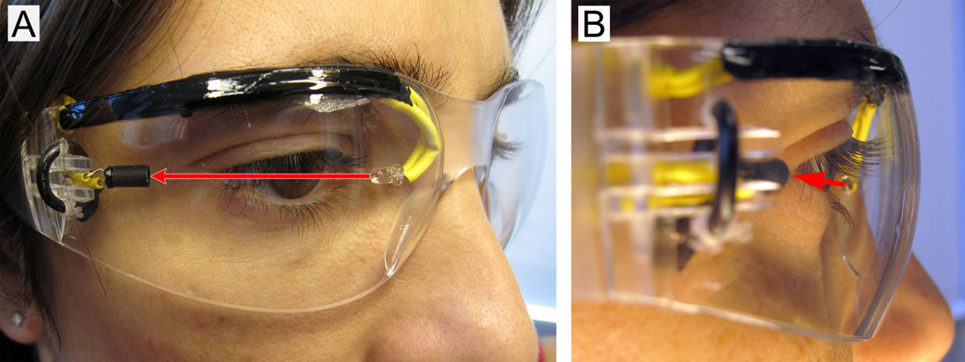

Fig.3. Spectacles with IR mechanism mounted

*B) Raspberry Pi*

Using the Raspberry Pi 2 model, we have placed it on the side of the subject’s head. We are using the Raspberry Pi Wheezy operating system. We are using a 4GB SD card to store any images and packages installed. The inbuilt memory is 1 GB RAM. The Pi has an audio port that allows for the usage of earphones. There are four USB ports and it represents a 40 pin configuration.

*C) USB Camera*

Using the camera of a webcam, we place it on the top of the subject’s head to click a picture of what the individual is looking at. The camera is attached to one of the USB ports of the Raspberry Pi. With the help of the Pi, the fswebcam command is called and the image is clicked. The image clicked is stored on the SD card of the Raspberry Pi.

*D) Bluetooth dongle*

The Bluetooth dongle is instrumental for ensuring wireless image transfer from the images stored on the SD card of the Pi to the smartphone. It is inserted into one of the USB ports provided by the Pi.

*E) Earphones*

This component serves as the medium for the Raspberry Pi to speak when the image has been captured and further when the image is transferred to the smartphone via Bluetooth. The earphones are connected to the audio port available on the Raspberry Pi.

*F) Smartphone*

The smartphone is important as it stores the captured image. Any mobile operating system will support the implementation of this project. Via Bluetooth, the image captured by the USB camera is transferred to the device paired in the range of Bluetooth.

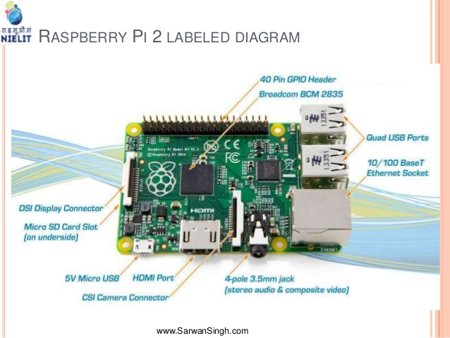

Fig. 4. Raspberry Pi 2 module

# Expected Outcome

The project at hand implements a simple procedure – that of an image being clicked and thereafter sent to the smartphone. To understand the expected outcome of the task at hand, let us go through the process step by step –

First, we are using an infrared LED for the beam emission and the IR detector of a proximity sensor as part of IR detection mechanism. They are connected to the corresponding pins on the Raspberry Pi. If the eye is kept open, the green light on the proximity sensor board remains on whereas once the eye is blinked, due to the obstruction of the eyelid, the beam does not reach the detector. This causes the green light on the proximity sensor to go off. Thus, the light on the board acts as valid measure and detector of whether the subject has blinked the eye or no.

With the help of this visual understanding of whether the infrared beam has been obstructed or no, the Raspberry Pi also processes the same by gauging the change in voltage due to sudden drop when the eye blinks. We are using the Raspberry Pi Wheezy OS and executing a program in Python. Once the eye is blinked, the Pi registers it as it is, and triggers the camera to click a picture. The USB camera mounted on the head sends the picture back to the Pi which stores the image on the SD card. Although this is not observed visually, it takes place efficiently and swiftly. The Bluetooth dongle connected to the Pi, then takes control and detects devices in the network radius. The captured image is sent to the smartphone and can be viewed easily.

The outcome is that any time and place, an individual can click a picture of the object he wants and get it stored on his or her phone without any manual use of the phone i.e. basically taking the effort of holding the phone and clicking one. In the proposed device, the individual can click a picture in a handsfree and user friendly manner because all that it needs is a blink, which is biometrically relevant for any human being. The earphones serve as a form of audio output. Since the individual is clicking a picture without the smartphone in hand, there must be some way that he or she gets to know that the picture wished to be taken has been captured and sent to the smartphone too. The Pi provides this feature through text to speech recognition – where every time an image is clicked, the user is alerted saying so and even once the image is stored in the phone, he gets an audio message confirming so.

1. Table Styles

| Input | Output | | |
| --- | --- | --- | --- |
|  | Subhead | Subhead |
| copy | More table copya |  |  |

stored on his or her phone without any manual use of the phone i.e. basically taking the effort of holding the phone and clicking one. In the proposed device, the individual can click a picture in a handsfree and user friendly manner because all that it needs is a blink, which is biometrically relevant for any human being. The earphones serve as a form of audio output. Since the individual is clicking a picture without the smartphone in hand, there must be some way that he or she gets to know that the picture wished to be taken has been captured and sent to the smartphone too. The Pi provides this feature through text to speech recognition – where every time an image is clicked, the user is alerted saying so and even once the image is stored in the phone, he gets an audio message confirming so.