MPC PROJECT WRITEUP

# The Model

The model in the classroom is used. At the current time step values from the previous timestamp is used in the following formula. Model includes vehicle location (x,y), orientation, velocity, cross track error, psi error.

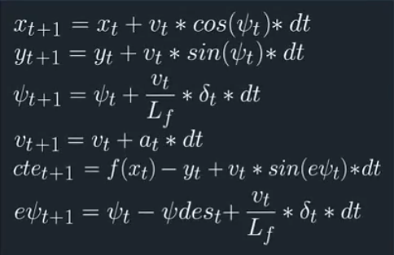

# Timestep Length and Elapsed Duration (N & dt)

N= 10 dt=0.1

I thought setting timestep equal to latency is chosen. I tried different number of time steps. For slow speeds setting N higher creates too long-time horizon. If these parameters are changed drive becomes unstable.

# Polynomial Fitting and MPC Preprocessing

The waypoints transformed to vehicle coordinates by assuming vehicle at the origin. This makes polynomial fitting simpler. See main.cpp 107.

# Model Predictive Control with Latency

To handle the latency actuations are applied one step later. Choosing dt equal to latency makes this possible.

Also, to avoid oscillations use of high penalty for steering is resulted well. Additionally, extra penalty for velocity and delta resulted in more controlled behavior in curbs. Currently tested for maximum speed of 80.

# The vehicle must successfully drive a lap around the track.

Can drive successfully with max speed of 80.