Test of bluetooth loggers - Experiment 1 Second batch
Aurore Ponchon
17/03/2022

First experiment: measuring the signal strength at fixed distances 14/03/2022
This experiment was run with a horizontal position of the stationary loggers. Antennas are not opposite or facing mobile loggers anymore.

Figures for stationary loggers according to tests
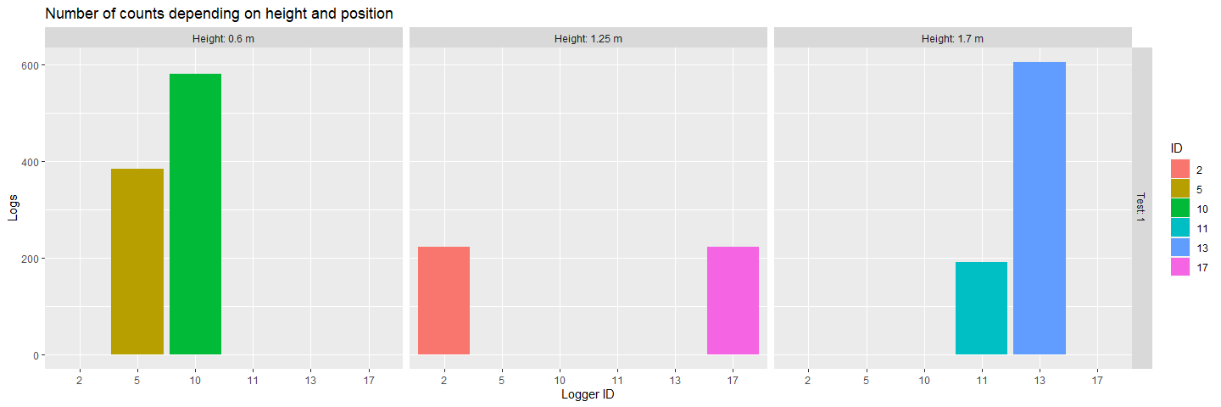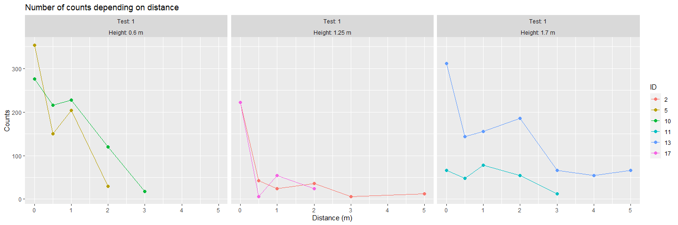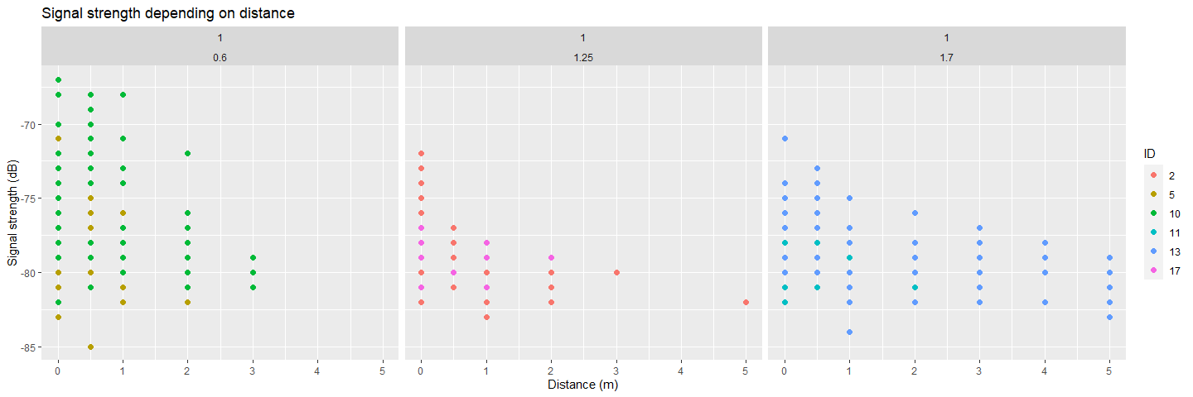

Figures for mobile loggers according to tests
