Northern gannets Rouzic 2022

Aurore Ponchon

## 1- Importing data from Movebank

The dataset is stored on the online database Movebank. It can be downloaded directly from the web as long as the user has an account. Each time the dataset is downloaded, the last locations are added, as some of the devices are still emitting.

## 2- Processing location data

Movebank datasets contain a lot of information that are not all necessary for the analysis so data were filtered. Some data from other files were added, such as individual serology. Then, I calculated distances and time between locations and added a few variables to summarize time spent on land and at-sea. We illustrate the raw data locations by some descriptive plots.

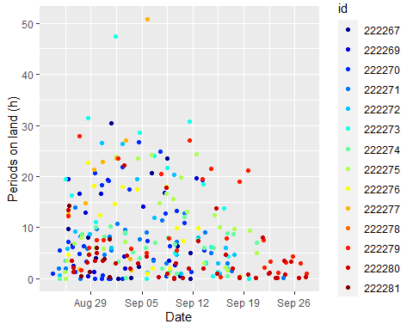

## 3- Interpolation

As data has irregular time intervals between consecutive locations, we linearly interpolated data to have one location every 15min., as 96% of data have a time interval of less than 15min. We then compared each raw trip with interpolations. It appears that for at least 5 individuals (222269, 222272, 222276, 222279,222280), interpolation badly recreates trips, as reconstituted trips cross Brittany without following the coastline. Illustrated maps are bounded at > 47° N to have a better focus on the study area before migration.

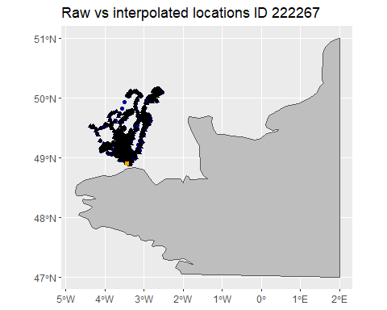

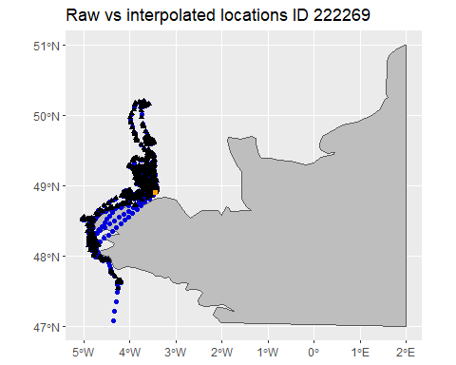

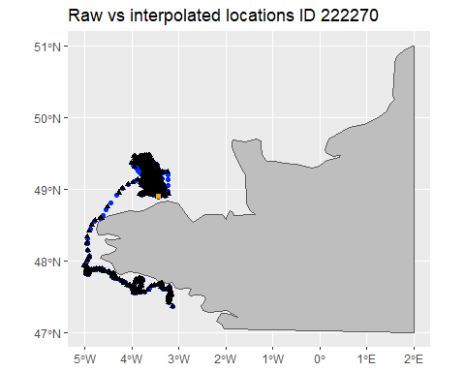

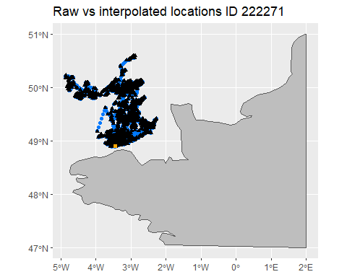

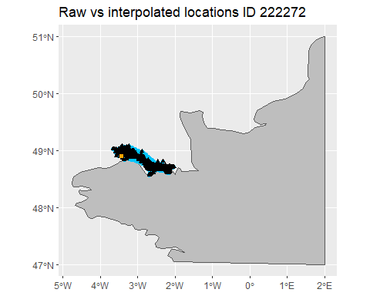

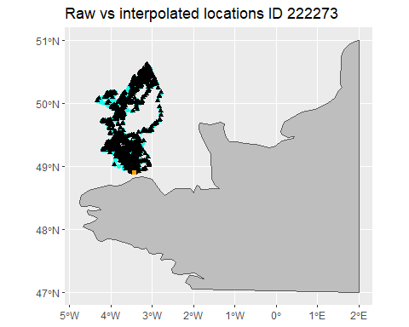

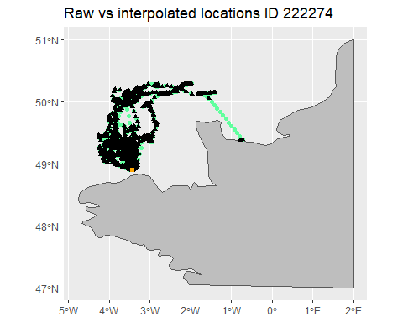

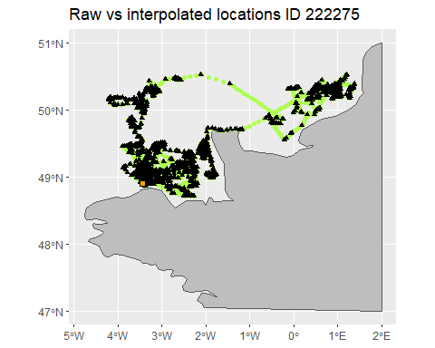

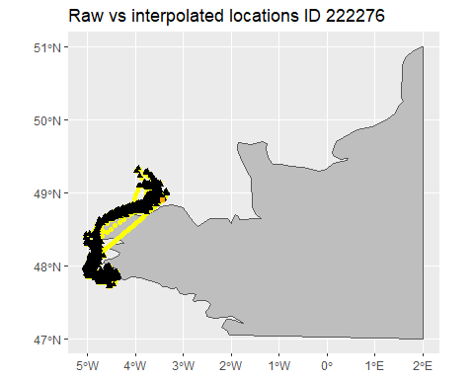

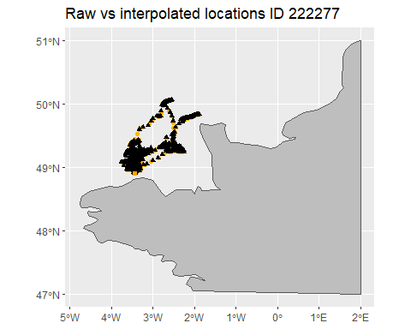

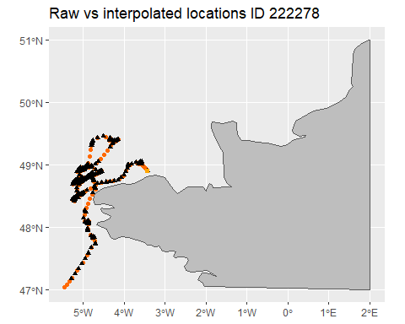

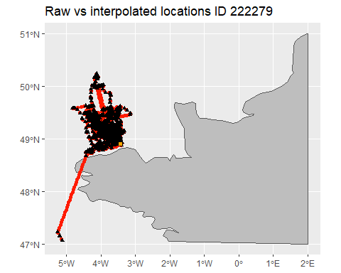

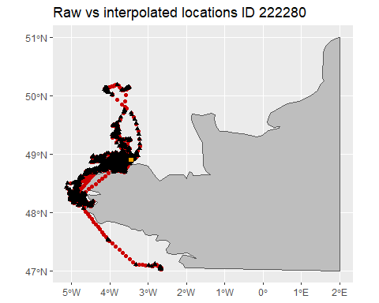

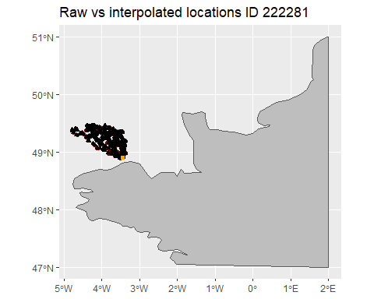

## 4- Summary of clean trips

At-sea trips retained are at least >1h long, >1km from the colony and have more than 4 locations.

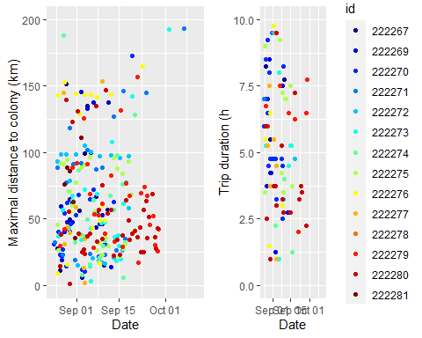

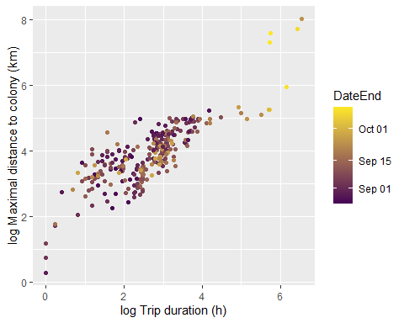

## 5- Effect of time on trip charateristics (GLMM)

According to GLMM, no effect of day on maximal distance, weak effect on trip duration and no effect on the total distance travelled during a trip.

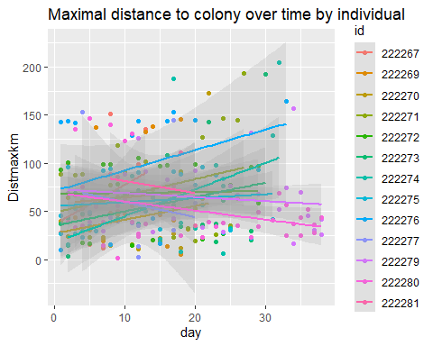

Linear mixed model fit by REML. t-tests use Satterthwaite's method [  
lmerModLmerTest]  
Formula: log(Distmaxkm) ~ day + (1 | id)  
 Data: trips.interp.nomigr  
  
REML criterion at convergence: 649  
  
Scaled residuals:   
 Min 1Q Median 3Q Max   
-4.5182 -0.6217 0.0827 0.7413 1.8289   
  
Random effects:  
 Groups Name Variance Std.Dev.  
 id (Intercept) 0.01412 0.1188   
 Residual 0.59046 0.7684   
Number of obs: 274, groups: id, 13  
  
Fixed effects:  
 Estimate Std. Error df t value Pr(>|t|)   
(Intercept) 3.819e+00 9.223e-02 5.947e+01 41.409 <2e-16 ***  
day 4.448e-03 4.915e-03 2.406e+02 0.905 0.366   
---  
Signif. codes: 0 '***' 0.001 '**' 0.01 '*' 0.05 '.' 0.1 ' ' 1  
  
Correlation of Fixed Effects:  
 (Intr)  
day -0.777

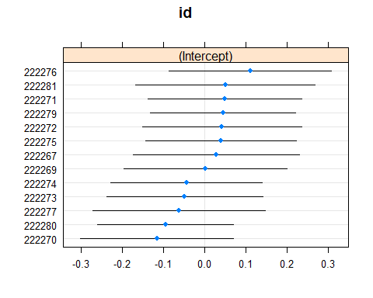

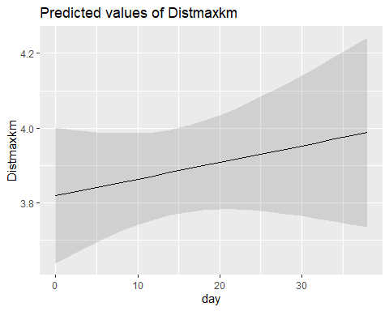

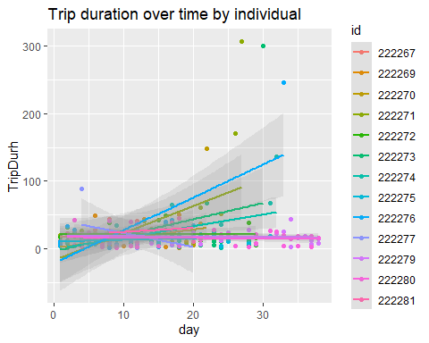

Linear mixed model fit by REML. t-tests use Satterthwaite's method [  
lmerModLmerTest]  
Formula: log(TripDurh) ~ day + (1 | id)  
 Data: trips.interp.nomigr  
  
REML criterion at convergence: 748.4  
  
Scaled residuals:   
 Min 1Q Median 3Q Max   
-2.7933 -0.6051 0.1661 0.5627 3.1639   
  
Random effects:  
 Groups Name Variance Std.Dev.  
 id (Intercept) 0.03519 0.1876   
 Residual 0.84280 0.9180   
Number of obs: 274, groups: id, 13  
  
Fixed effects:  
 Estimate Std. Error df t value Pr(>|t|)   
(Intercept) 2.441e+00 1.158e-01 4.881e+01 21.082 <2e-16 ***  
day 1.187e-02 5.939e-03 2.575e+02 1.999 0.0466 *   
---  
Signif. codes: 0 '***' 0.001 '**' 0.01 '*' 0.05 '.' 0.1 ' ' 1  
  
Correlation of Fixed Effects:  
 (Intr)  
day -0.740

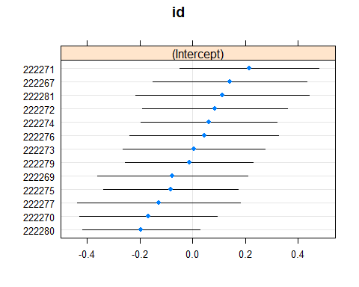

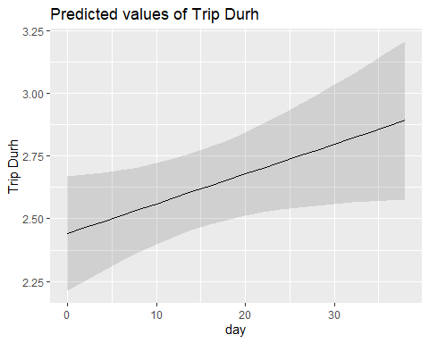

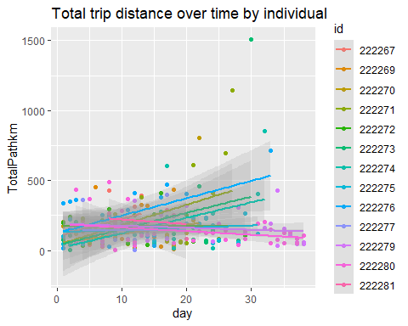

Linear mixed model fit by REML. t-tests use Satterthwaite's method [  
lmerModLmerTest]  
Formula: log(TotalPathkm) ~ day + (1 | id)  
 Data: trips.interp.nomigr  
  
REML criterion at convergence: 727.6  
  
Scaled residuals:   
 Min 1Q Median 3Q Max   
-4.4047 -0.6330 0.1201 0.6510 2.7265   
  
Random effects:  
 Groups Name Variance Std.Dev.  
 id (Intercept) 0.006181 0.07862   
 Residual 0.796779 0.89263   
Number of obs: 274, groups: id, 13  
  
Fixed effects:  
 Estimate Std. Error df t value Pr(>|t|)   
(Intercept) 4.732e+00 1.017e-01 7.645e+01 46.505 <2e-16 ***  
day 5.472e-03 5.611e-03 2.091e+02 0.975 0.331   
---  
Signif. codes: 0 '***' 0.001 '**' 0.01 '*' 0.05 '.' 0.1 ' ' 1  
  
Correlation of Fixed Effects:  
 (Intr)  
day -0.816

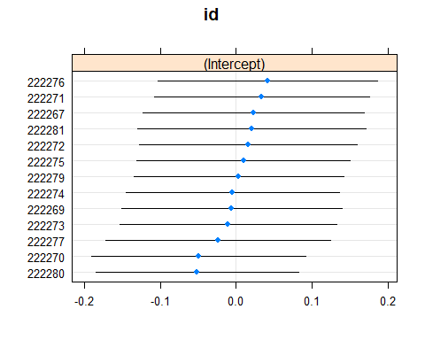

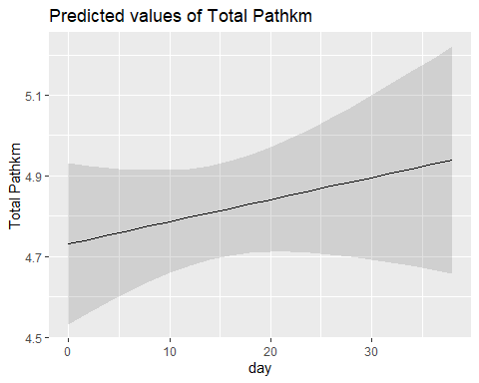

## 6- Effect of time on colony attendance (GLMM)

According to GLMM, no effect of day on duration of periods on land at the colony.

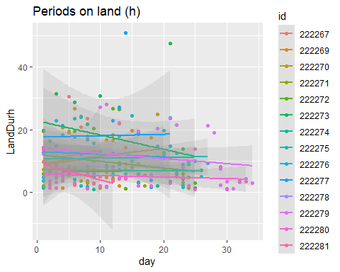

Linear mixed model fit by REML. t-tests use Satterthwaite's method [  
lmerModLmerTest]  
Formula: log(LandDurh) ~ day + (1 | id)  
 Data: lands  
  
REML criterion at convergence: 610.8  
  
Scaled residuals:   
 Min 1Q Median 3Q Max   
-2.28564 -0.63153 0.04934 0.79782 2.05935   
  
Random effects:  
 Groups Name Variance Std.Dev.  
 id (Intercept) 0.07316 0.2705   
 Residual 0.71652 0.8465   
Number of obs: 235, groups: id, 14  
  
Fixed effects:  
 Estimate Std. Error df t value Pr(>|t|)   
(Intercept) 2.146528 0.124879 40.124879 17.189 <2e-16 ***  
day -0.012777 0.006932 232.555898 -1.843 0.0666 .   
---  
Signif. codes: 0 '***' 0.001 '**' 0.01 '*' 0.05 '.' 0.1 ' ' 1

