Northern gannets Rouzic 2022

Aurore Ponchon

## 1- Importing data from Movebank

The dataset is stored on the online database Movebank. It can be downloaded directly from the web as long as the user has an account. Each time the dataset is downloaded, the last locations are added, as some of the devices are still emitting.

## 2- Processing location data

Movebank datasets contain a lot of information that are not all necessary for the analysis so data were filtered. Some data from other files were added, such as individual serology. Then, I calculated distances and time between locations and added a few variables to summarize time spent on land and at-sea. I illustrate the raw data locations by some descriptive plots.

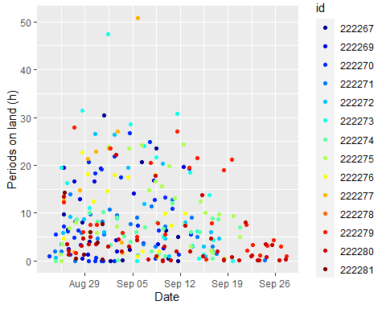

## 3- Interpolation

As data has irregular time intervals between consecutive locations, I linearly interpolated data to have one location every 15min., as 96% of data have a time interval of less than 15min. I then compared each raw trip with interpolations. It appears that for at least 5 individuals (222269, 222272, 222276, 222279,222280), interpolation badly recreates trips, as reconstituted trips cross Brittany without following the coastline. Illustrated maps are bounded at > 47° N to have a better focus on the study area before migration.

## 4- Summary of clean trips

At-sea trips retained are at least >1h long, >1km from the colony and have more than 4 locations.

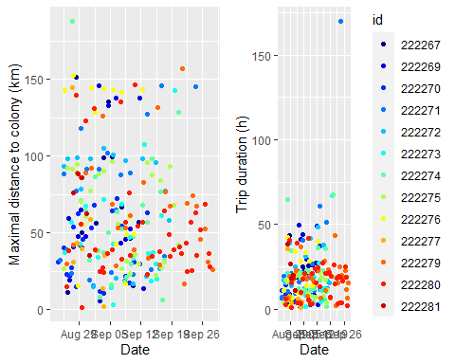

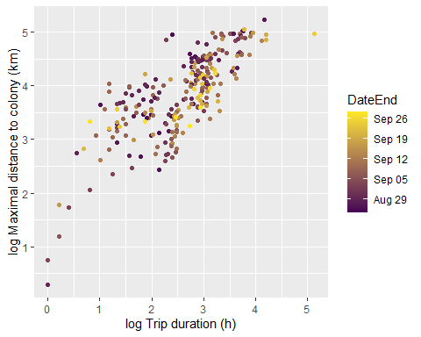

## 5- Effect of time on trip charateristics (GLMM)

According to GLMM, no effect of day on maximal distance, weak effect on trip duration and no effect on the total distance travelled during a trip.

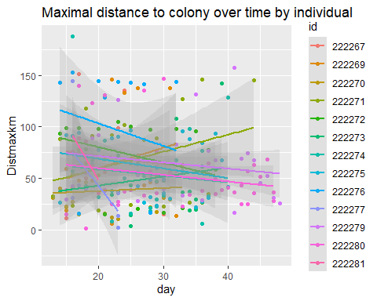

Linear mixed model fit by REML. t-tests use Satterthwaite's method [  
lmerModLmerTest]  
Formula: log(Distmaxkm) ~ day + (1 | id)  
 Data: trips.interp.nomigr  
  
REML criterion at convergence: 596.6  
  
Scaled residuals:   
 Min 1Q Median 3Q Max   
-4.7237 -0.5216 0.0681 0.7104 1.9221   
  
Random effects:  
 Groups Name Variance Std.Dev.  
 id (Intercept) 0.03008 0.1734   
 Residual 0.55361 0.7441   
Number of obs: 257, groups: id, 13  
  
Fixed effects:  
 Estimate Std. Error df t value Pr(>|t|)   
(Intercept) 3.940354 0.161823 134.013954 24.350 <2e-16 ***  
day -0.002975 0.005638 229.319522 -0.528 0.598   
---  
Signif. codes: 0 '***' 0.001 '**' 0.01 '*' 0.05 '.' 0.1 ' ' 1  
  
Correlation of Fixed Effects:  
 (Intr)  
day -0.906

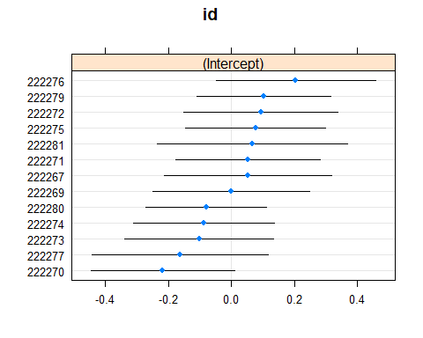

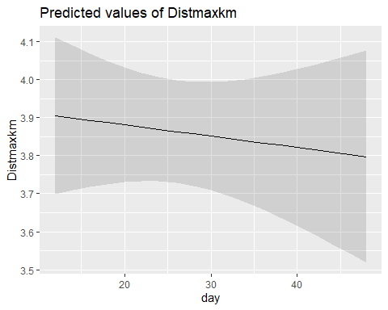

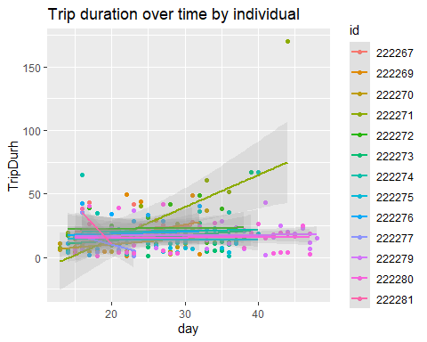

Linear mixed model fit by REML. t-tests use Satterthwaite's method [  
lmerModLmerTest]  
Formula: log(TripDurh) ~ day + (1 | id)  
 Data: trips.interp.nomigr  
  
REML criterion at convergence: 646.3  
  
Scaled residuals:   
 Min 1Q Median 3Q Max   
-3.0683 -0.6025 0.1749 0.6403 2.6184   
  
Random effects:  
 Groups Name Variance Std.Dev.  
 id (Intercept) 0.04732 0.2175   
 Residual 0.66863 0.8177   
Number of obs: 257, groups: id, 13  
  
Fixed effects:  
 Estimate Std. Error df t value Pr(>|t|)   
(Intercept) 2.297e+00 1.809e-01 1.240e+02 12.697 <2e-16 ***  
day 1.079e-02 6.242e-03 2.383e+02 1.729 0.0851 .   
---  
Signif. codes: 0 '***' 0.001 '**' 0.01 '*' 0.05 '.' 0.1 ' ' 1  
  
Correlation of Fixed Effects:  
 (Intr)  
day -0.894

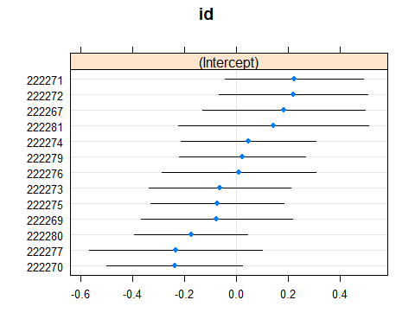

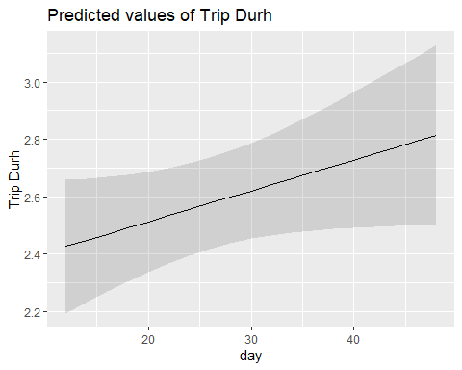

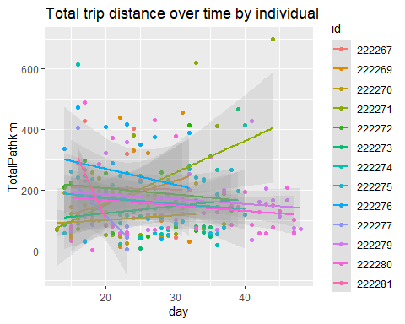

Linear mixed model fit by REML. t-tests use Satterthwaite's method [  
lmerModLmerTest]  
Formula: log(TotalPathkm) ~ day + (1 | id)  
 Data: trips.interp.nomigr  
  
REML criterion at convergence: 632  
  
Scaled residuals:   
 Min 1Q Median 3Q Max   
-4.6175 -0.6183 0.1325 0.6889 2.0644   
  
Random effects:  
 Groups Name Variance Std.Dev.  
 id (Intercept) 0.01981 0.1408   
 Residual 0.64329 0.8021   
Number of obs: 257, groups: id, 13  
  
Fixed effects:  
 Estimate Std. Error df t value Pr(>|t|)   
(Intercept) 4.838e+00 1.696e-01 1.370e+02 28.526 <2e-16 ***  
day 1.807e-05 5.982e-03 2.006e+02 0.003 0.998   
---  
Signif. codes: 0 '***' 0.001 '**' 0.01 '*' 0.05 '.' 0.1 ' ' 1  
  
Correlation of Fixed Effects:  
 (Intr)  
day -0.924

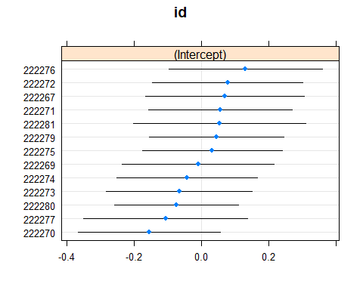

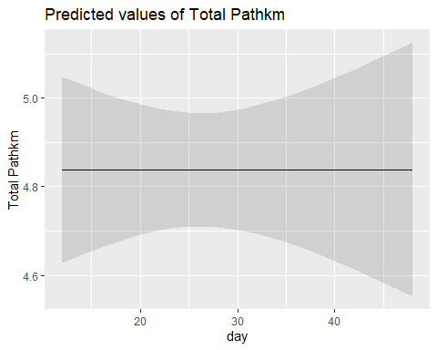

## 6- Effect of time on colony attendance (GLMM)

According to GLMM, no effect of day on duration of periods on land at the colony.

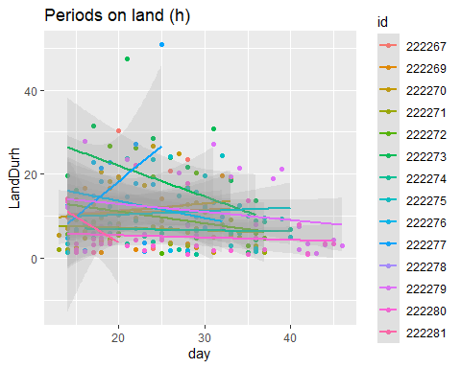

Linear mixed model fit by REML. t-tests use Satterthwaite's method [  
lmerModLmerTest]  
Formula: log(LandDurh) ~ day + (1 | id)  
 Data: lands  
  
REML criterion at convergence: 609.6  
  
Scaled residuals:   
 Min 1Q Median 3Q Max   
-2.32427 -0.65816 0.07213 0.79657 2.07848   
  
Random effects:  
 Groups Name Variance Std.Dev.  
 id (Intercept) 0.07234 0.2690   
 Residual 0.71315 0.8445   
Number of obs: 235, groups: id, 14  
  
Fixed effects:  
 Estimate Std. Error df t value Pr(>|t|)   
(Intercept) 2.369146 0.198287 142.924378 11.948 <2e-16 ***  
day -0.015086 0.007059 232.964871 -2.137 0.0336 *   
---  
Signif. codes: 0 '***' 0.001 '**' 0.01 '*' 0.05 '.' 0.1 ' ' 1

