Northern gannets Bass Rock 2022

Aurore Ponchon

## 1- Importing data

GPS data are stored as individual excel files w. I calculated distances and time between locations and added a few variables to summarize time spent on land and at-sea. I illustrate the raw data locations by some descriptive plots.

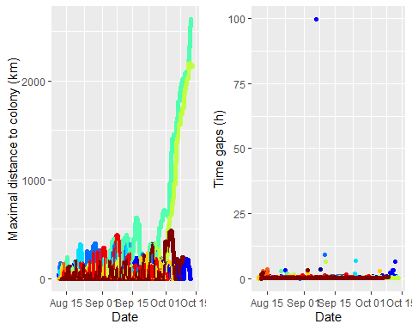

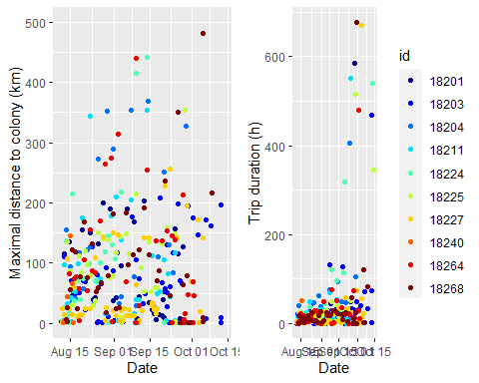

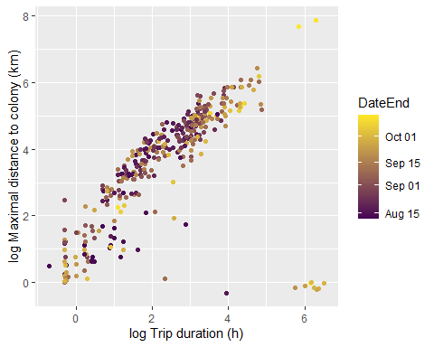

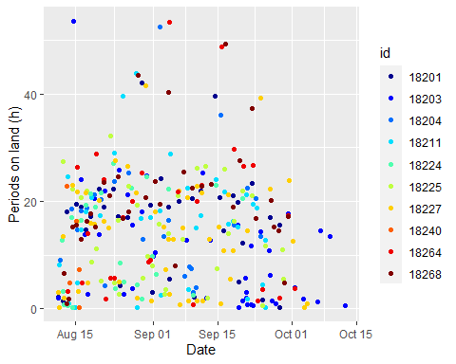

## 2- Interpolation

As data has irregular time intervals between consecutive locations, we linearly interpolated data to have one location every 15min. We then compared each raw trip with interpolations.

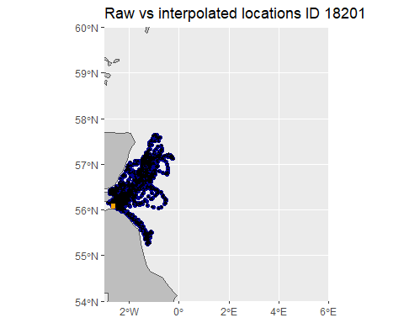

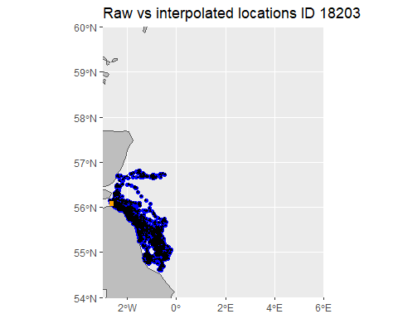

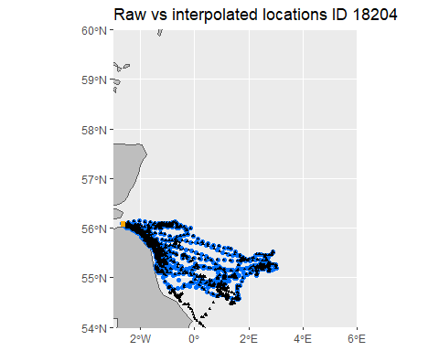

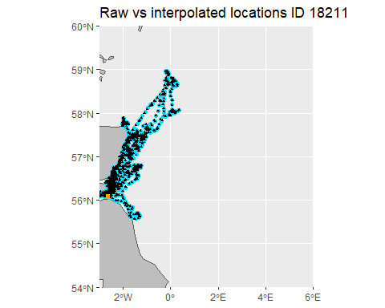

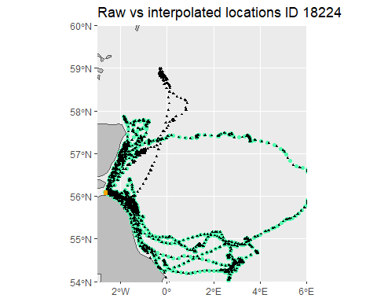

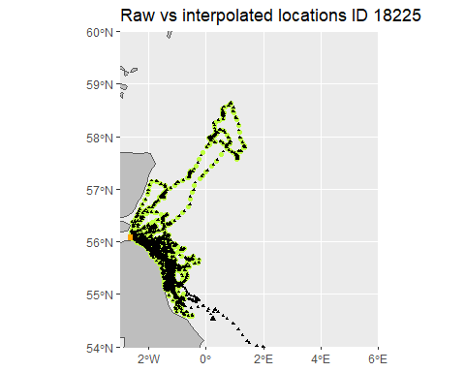

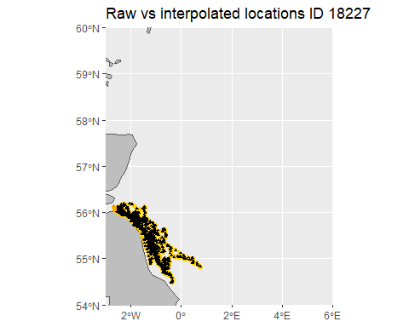

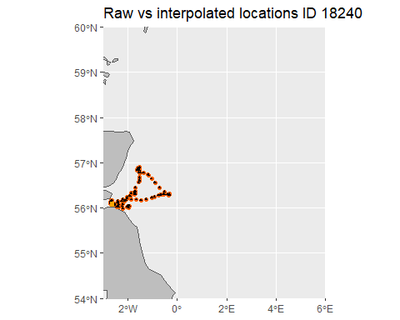

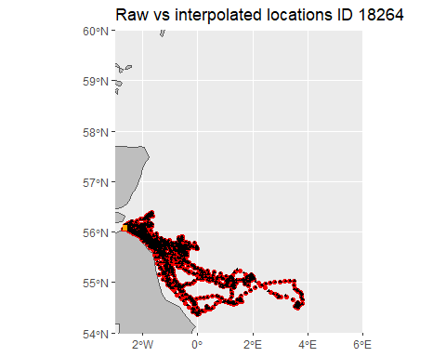

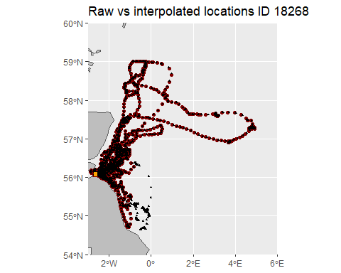

## 3- Summary of clean trips

At-sea trips retained are at least >1h long, >1km from the colony and have more than 4 locations.

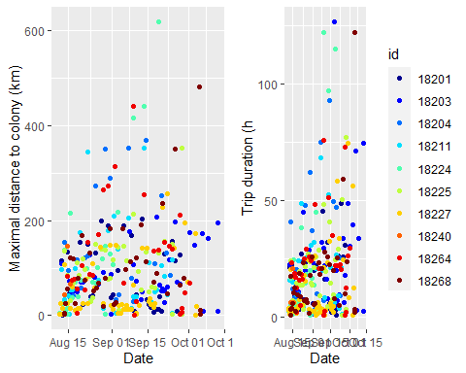

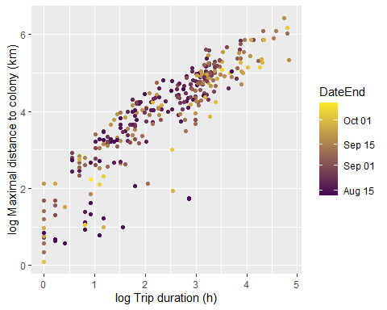

## 5- Effect of time on trip charateristics (GLMM)

According to GLMM, no effect of day on maximal distance, weak effect on trip duration and no effect on the total distance travelled during a trip.

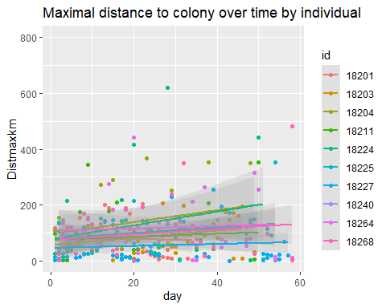

Linear mixed model fit by REML. t-tests use Satterthwaite's method [  
lmerModLmerTest]  
Formula: log(Distmaxkm) ~ day + (1 | id)  
 Data: trips.interp.nomigr  
  
REML criterion at convergence: 1044  
  
Scaled residuals:   
 Min 1Q Median 3Q Max   
-2.9441 -0.4449 0.1643 0.6654 1.9222   
  
Random effects:  
 Groups Name Variance Std.Dev.  
 id (Intercept) 0.08814 0.2969   
 Residual 1.59845 1.2643   
Number of obs: 310, groups: id, 10  
  
Fixed effects:  
 Estimate Std. Error df t value Pr(>|t|)   
(Intercept) 3.916e+00 1.605e-01 2.862e+01 24.398 <2e-16 ***  
day 3.796e-03 4.601e-03 3.078e+02 0.825 0.41   
---  
Signif. codes: 0 '***' 0.001 '**' 0.01 '*' 0.05 '.' 0.1 ' ' 1  
  
Correlation of Fixed Effects:  
 (Intr)  
day -0.652

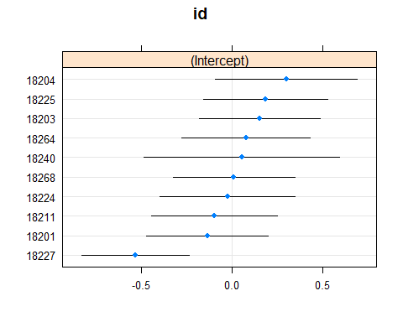

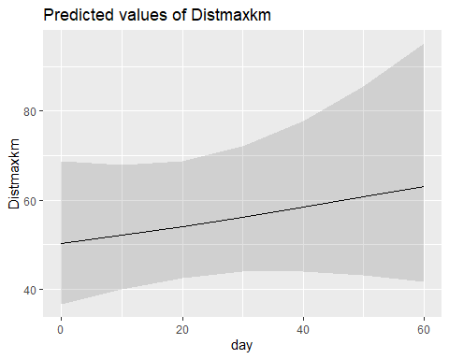

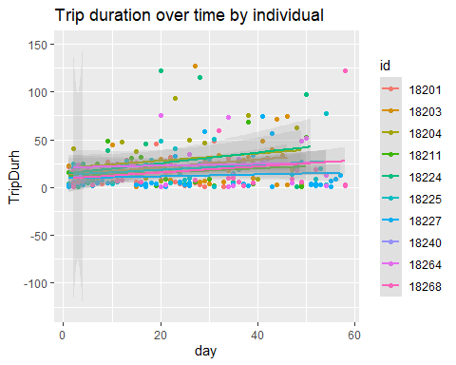

Linear mixed model fit by REML. t-tests use Satterthwaite's method [  
lmerModLmerTest]  
Formula: log(TripDurh) ~ day + (1 | id)  
 Data: trips.interp.nomigr  
  
REML criterion at convergence: 960.4  
  
Scaled residuals:   
 Min 1Q Median 3Q Max   
-2.4297 -0.6755 0.1498 0.7474 2.1883   
  
Random effects:  
 Groups Name Variance Std.Dev.  
 id (Intercept) 0.0837 0.2893   
 Residual 1.2133 1.1015   
Number of obs: 310, groups: id, 10  
  
Fixed effects:  
 Estimate Std. Error df t value Pr(>|t|)   
(Intercept) 2.272e+00 1.460e-01 2.524e+01 15.563 1.9e-14 ***  
day 6.050e-03 4.015e-03 3.075e+02 1.507 0.133   
---  
Signif. codes: 0 '***' 0.001 '**' 0.01 '*' 0.05 '.' 0.1 ' ' 1  
  
Correlation of Fixed Effects:  
 (Intr)  
day -0.623

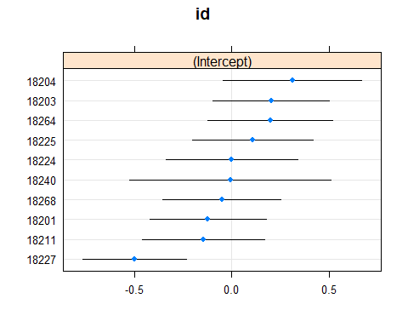

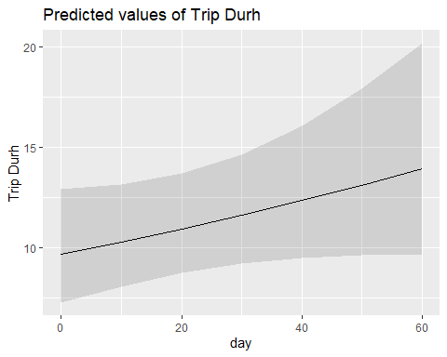

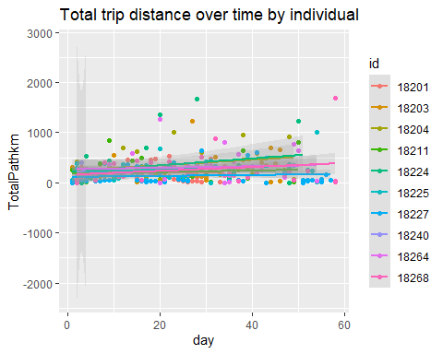

Linear mixed model fit by REML. t-tests use Satterthwaite's method [  
lmerModLmerTest]  
Formula: log(TotalPathkm) ~ day + (1 | id)  
 Data: trips.interp.nomigr  
  
REML criterion at convergence: 1070.8  
  
Scaled residuals:   
 Min 1Q Median 3Q Max   
-2.9636 -0.4857 0.1527 0.6905 1.9200   
  
Random effects:  
 Groups Name Variance Std.Dev.  
 id (Intercept) 0.1025 0.3201   
 Residual 1.7419 1.3198   
Number of obs: 310, groups: id, 10  
  
Fixed effects:  
 Estimate Std. Error df t value Pr(>|t|)   
(Intercept) 4.784e+00 1.695e-01 2.783e+01 28.216 <2e-16 ***  
day 4.571e-03 4.805e-03 3.077e+02 0.951 0.342   
---  
Signif. codes: 0 '***' 0.001 '**' 0.01 '*' 0.05 '.' 0.1 ' ' 1  
  
Correlation of Fixed Effects:  
 (Intr)  
day -0.644

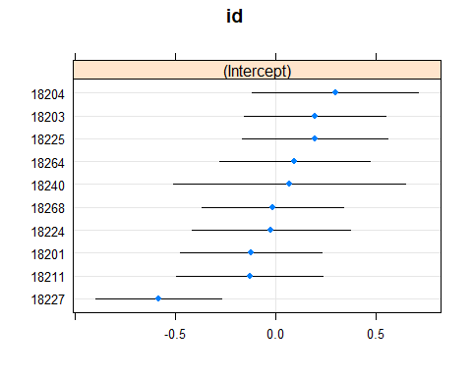

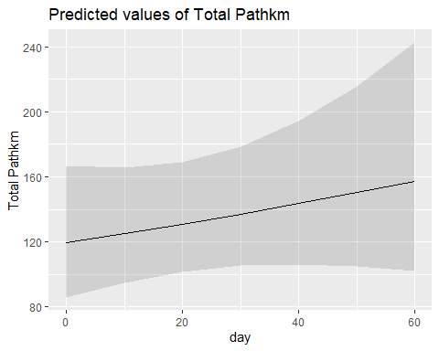

## 6- Effect of time on colony attendance (GLMM)

According to GLMM, no effect of day on duration of periods on land at the colony.

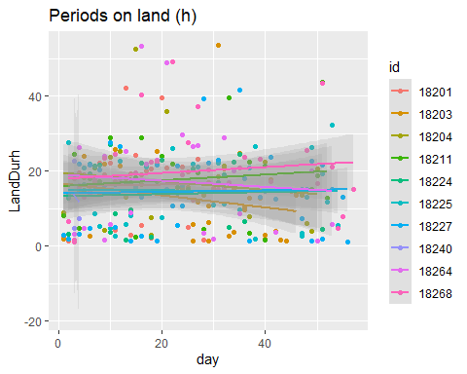

Linear mixed model fit by REML. t-tests use Satterthwaite's method [  
lmerModLmerTest]  
Formula: log(LandDurh) ~ day + (1 | id)  
 Data: lands  
  
REML criterion at convergence: 798.7  
  
Scaled residuals:   
 Min 1Q Median 3Q Max   
-2.9534 -0.5792 0.3523 0.6870 1.9221   
  
Random effects:  
 Groups Name Variance Std.Dev.  
 id (Intercept) 0.02166 0.1472   
 Residual 0.80039 0.8946   
Number of obs: 299, groups: id, 10  
  
Fixed effects:  
 Estimate Std. Error df t value Pr(>|t|)   
(Intercept) 2.490135 0.106366 44.088912 23.411 <2e-16 ***  
day -0.001407 0.003425 295.750171 -0.411 0.682   
---  
Signif. codes: 0 '***' 0.001 '**' 0.01 '*' 0.05 '.' 0.1 ' ' 1

