Descriptive Report

William Murrah

4/9/2021

source("code/cleanGSS2018.R")  
  
summary(gss)

## ballot usetech happy partyid   
## Min. :1.000 Min. : 0.00 Min. :1.000 independent :414   
## 1st Qu.:1.000 1st Qu.: 15.00 1st Qu.:1.000 strong democrat :379   
## Median :2.000 Median : 60.00 Median :2.000 democrat :351   
## Mean :2.002 Mean : 55.15 Mean :1.844 left independent:307   
## 3rd Qu.:3.000 3rd Qu.: 90.00 3rd Qu.:2.000 republican :271   
## Max. :3.000 Max. :100.00 Max. :3.000 (Other) :513   
## NA's :936 NA's :4 NA's :110   
## rincome race sex degree   
## Min. : 0.000 white:1692 male :1051 Min. :0.000   
## 1st Qu.: 0.000 black: 383 female:1294 1st Qu.:1.000   
## Median : 9.000 other: 270 Median :1.000   
## Mean : 6.176 Mean :1.684   
## 3rd Qu.:12.000 3rd Qu.:3.000   
## Max. :12.000 Max. :4.000   
## NA's :134   
## educ age marital hrs2   
## less than hs : 87 Min. :18.00 Min. :1.00 Min. : 6.00   
## some hs : 211 1st Qu.:34.00 1st Qu.:1.00 1st Qu.:40.00   
## hs grad : 656 Median :48.00 Median :2.00 Median :40.00   
## some college :1312 Mean :49.13 Mean :2.67 Mean :45.91   
## college degree: 72 3rd Qu.:63.00 3rd Qu.:5.00 3rd Qu.:50.00   
## NA's : 7 Max. :99.00 Max. :9.00 Max. :99.00   
## NA's :2291   
## hrs1 wrkstat id unhappy   
## Min. : 1.00 Min. :1.000 Min. : 1 Min. :0.000   
## 1st Qu.:35.00 1st Qu.:1.000 1st Qu.: 588 1st Qu.:0.000   
## Median :40.00 Median :2.000 Median :1176 Median :0.000   
## Mean :41.87 Mean :2.963 Mean :1175 Mean :1.039   
## 3rd Qu.:50.00 3rd Qu.:5.000 3rd Qu.:1762 3rd Qu.:2.000   
## Max. :99.00 Max. :9.000 Max. :2348 Max. :9.000   
## NA's :952

## Explore Distributions

pairs.panels(gss[ , c("usetech", "happy", "rincome")])

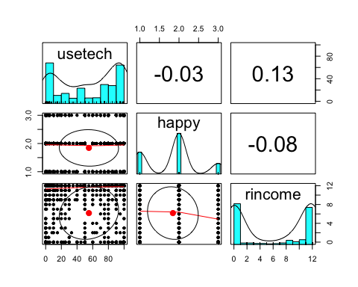

describe(gss[ , c("usetech", "happy", "rincome")])

## vars n mean sd median trimmed mad min max range skew kurtosis  
## usetech 1 1409 55.15 37.83 60 56.42 51.89 0 100 100 -0.23 -1.52  
## happy 2 2341 1.84 0.65 2 1.81 0.00 1 3 2 0.16 -0.67  
## rincome 3 2211 6.18 5.60 9 6.22 4.45 0 12 12 -0.09 -1.89  
## se  
## usetech 1.01  
## happy 0.01  
## rincome 0.12

aggregate(rincome ~ race + sex, data = gss,   
 FUN = function(x) c(M = mean(x), SD = sd(x), n = length(x)))

## race sex rincome.M rincome.SD rincome.n  
## 1 white male 6.646648 5.705549 716.000000  
## 2 black male 6.405405 5.615622 148.000000  
## 3 other male 7.991228 5.208053 114.000000  
## 4 white female 5.626561 5.551836 881.000000  
## 5 black female 6.133028 5.473498 218.000000  
## 6 other female 5.552239 5.320647 134.000000

library(tables)  
M <- function(x) mean(x, na.rm = TRUE)  
SD <- function(x) sd(x, na.rm = TRUE)  
n <- function(x) round(length(x))  
tabular((rincome)*(M + SD) + 1 ~ (race * sex) + 1, data = gss)

##   
## race   
## white black other   
## sex sex sex   
## male female male female male female All   
## rincome M 6.647 5.627 6.405 6.133 7.991 5.552 6.176  
## SD 5.706 5.552 5.616 5.473 5.208 5.321 5.597  
## All 768.000 924.000 157.000 226.000 126.000 144.000 2345.000