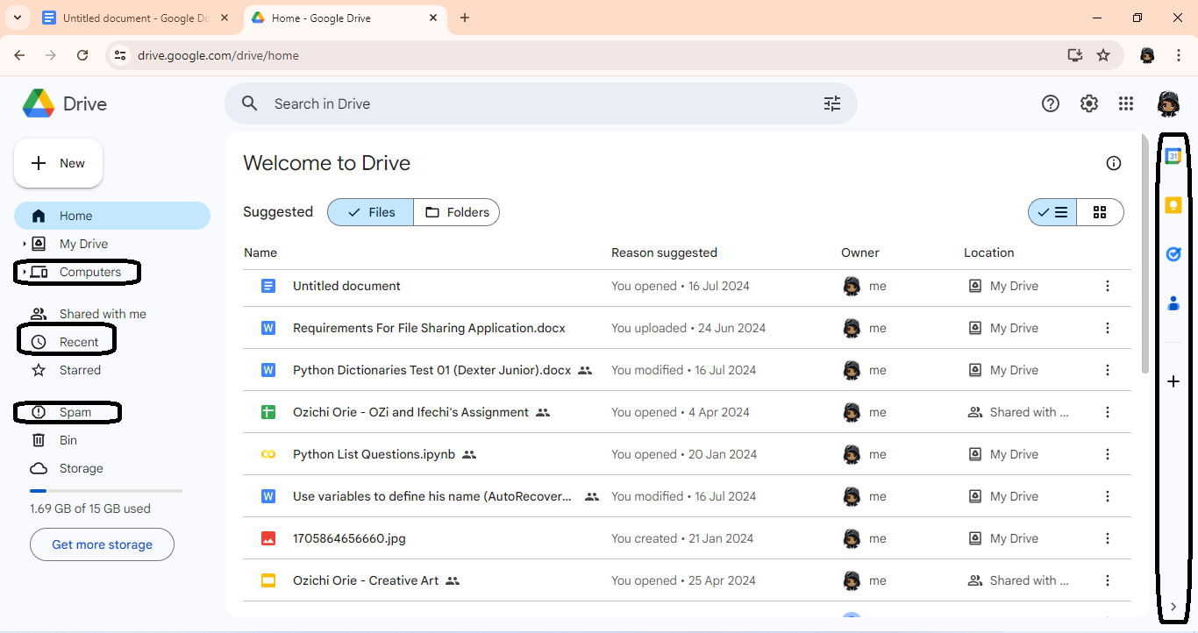

Home - Google Drive: <https://drive.google.com/drive/home>

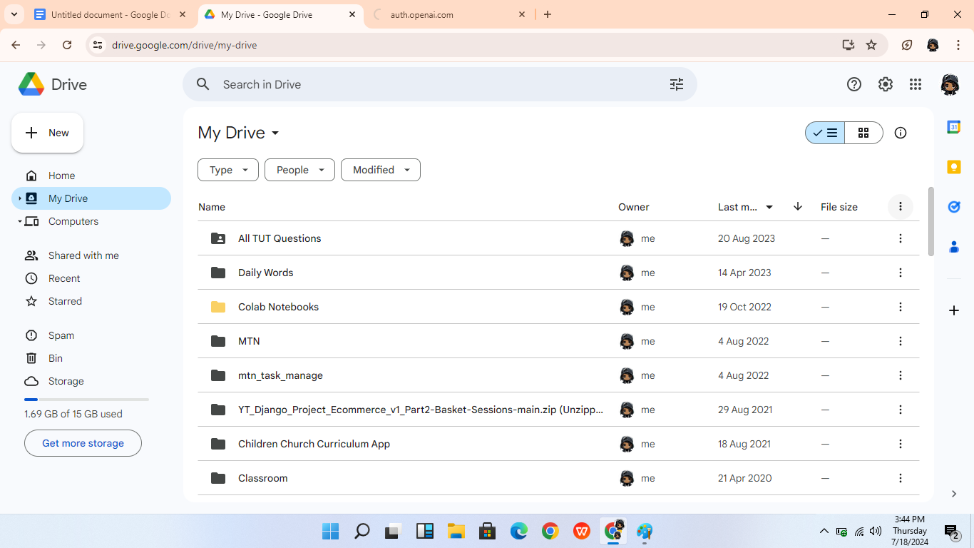

My Drive - Google Drive: <https://drive.google.com/drive/my-drive> (Same as above)

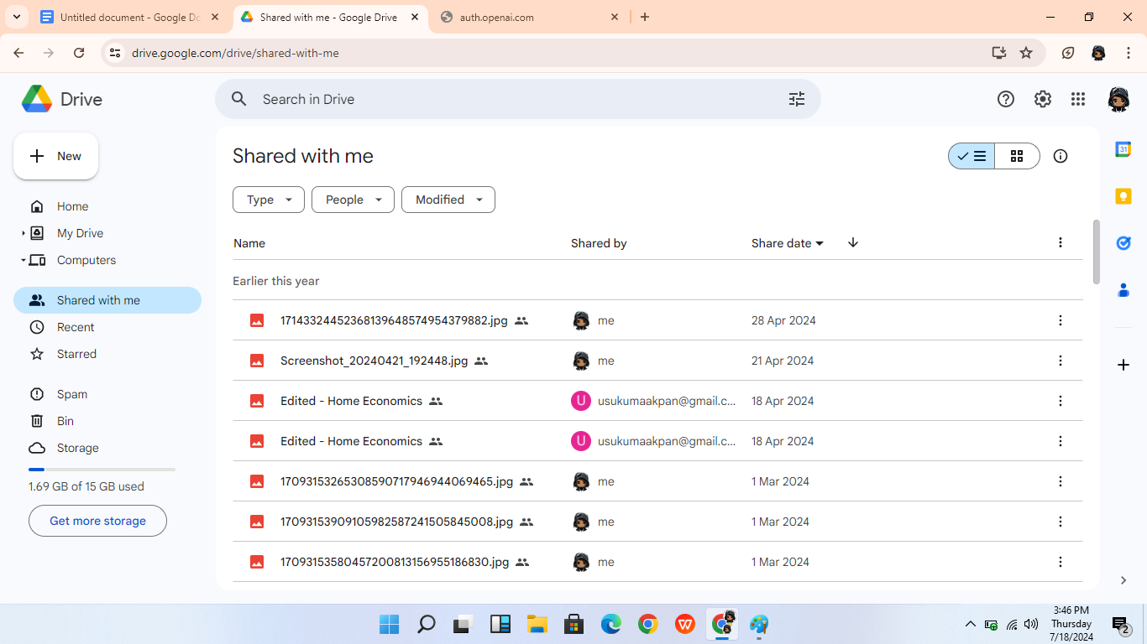

Shared with me - Google Drive: <https://drive.google.com/drive/shared-with-me>

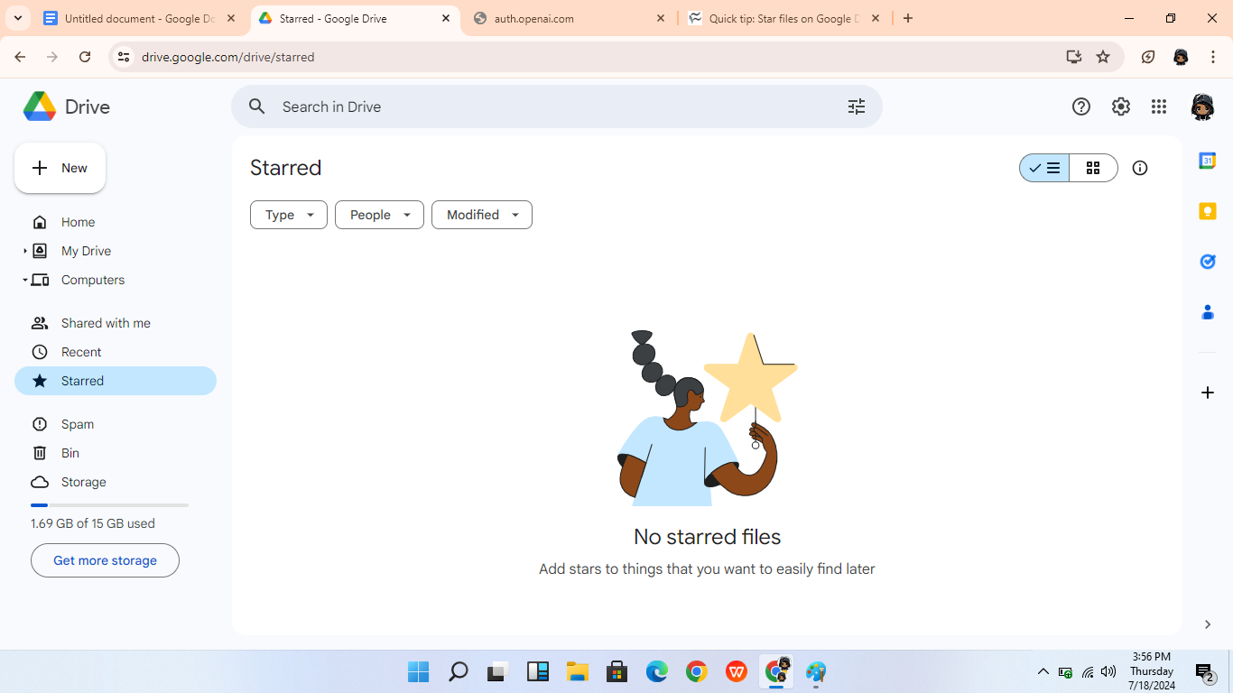

Starred - Google Drive: <https://drive.google.com/drive/starred> (Same as home page)

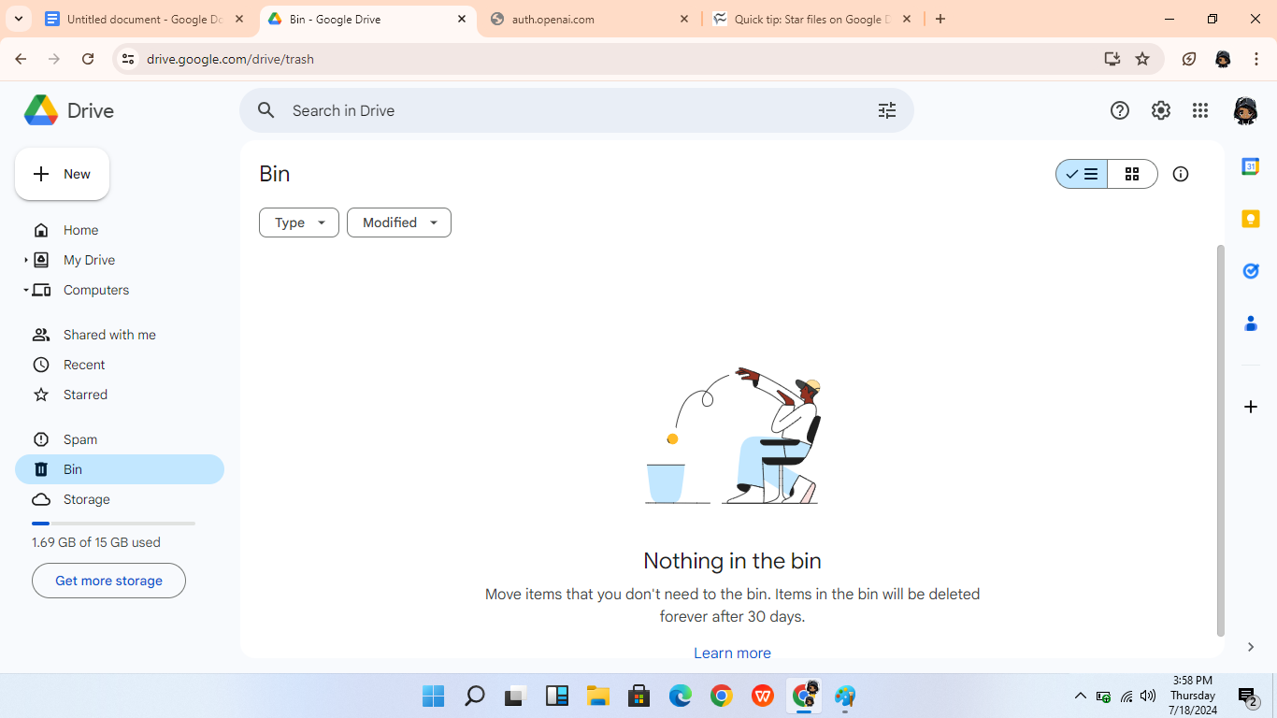

Bin - Google Drive: <https://drive.google.com/drive/trash> (Same as home page but without Learn more option)

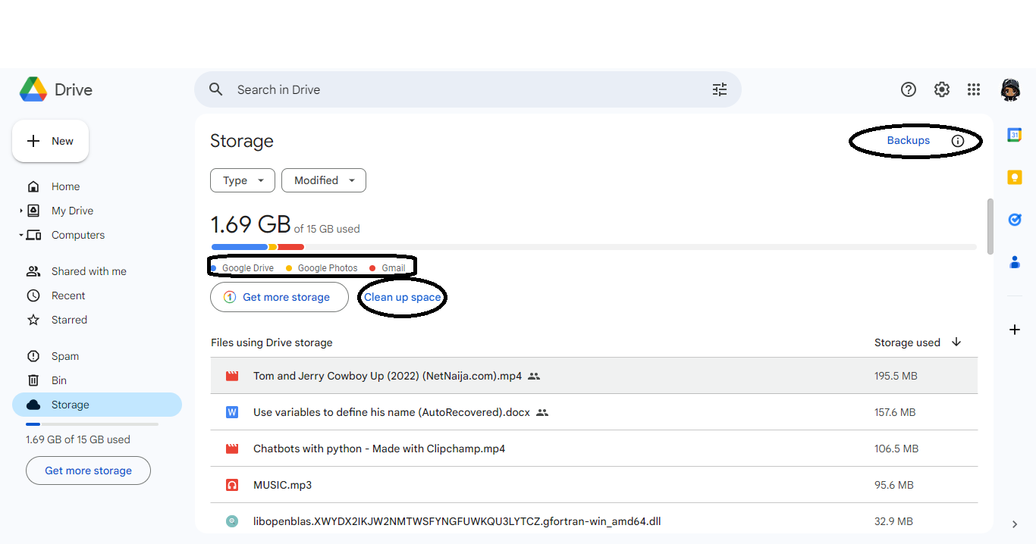

Storage - Google Drive: <https://drive.google.com/drive/quota> (Same as home page)

1. Open files
2. Spam
3. New files