Jimmy Tran

He

CSC 4710

6 December 2017

Project Answers

1. Query:

SELECT customer_id FROM mydb.tbl_customer_vehicle

GROUP BY customer_id

HAVING count(*)>2

;

Screenshot:

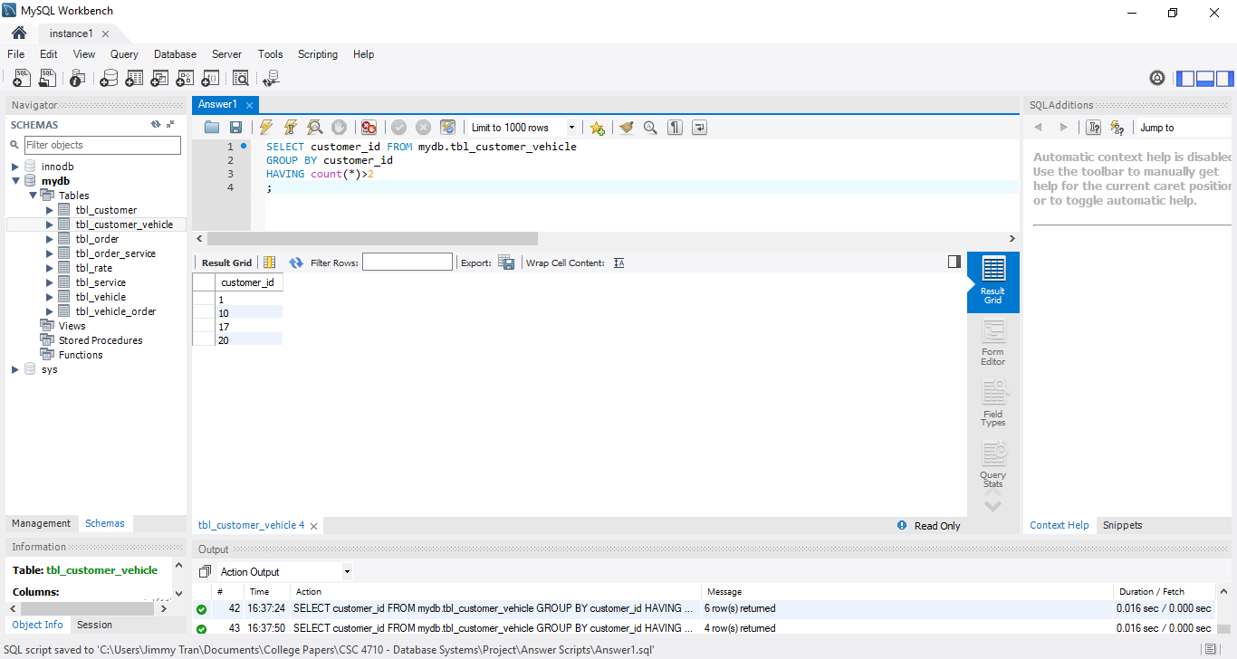

2. Query:

SELECT order_id,count(service_id) FROM tbl_order_service

GROUP BY order_id

;

Screenshot:

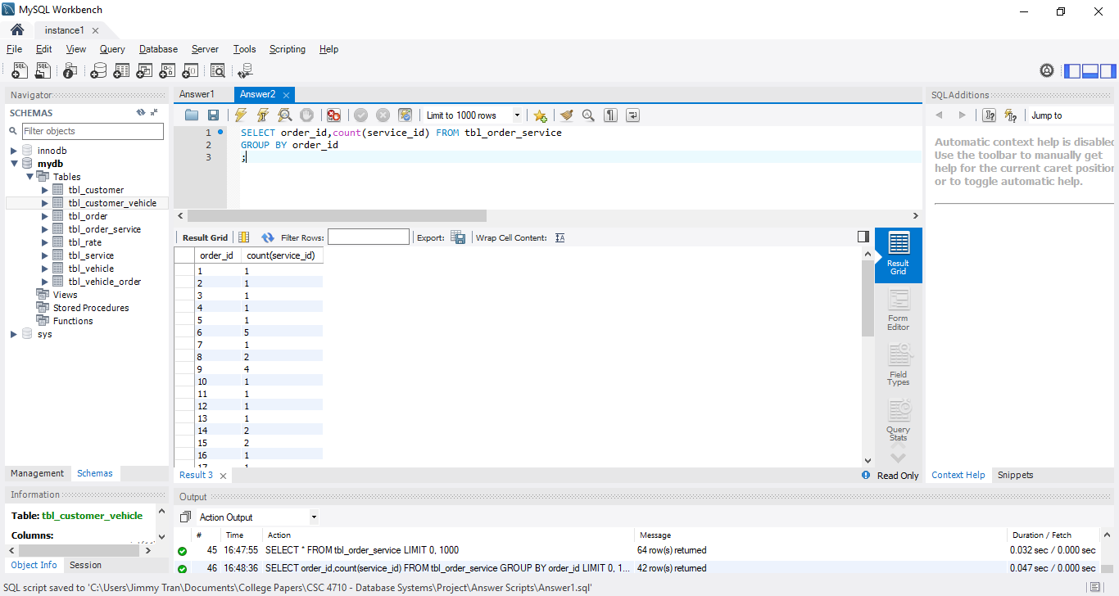

3. Query:

SELECT tbl_customer.first_name,tbl_customer.last_name

FROM tbl_customer_vehicle

INNER JOIN tbl_customer ON tbl_customer_vehicle.customer_id=tbl_customer.customer_id

GROUP BY first_name

HAVING count(*)>2

;

Screenshot:

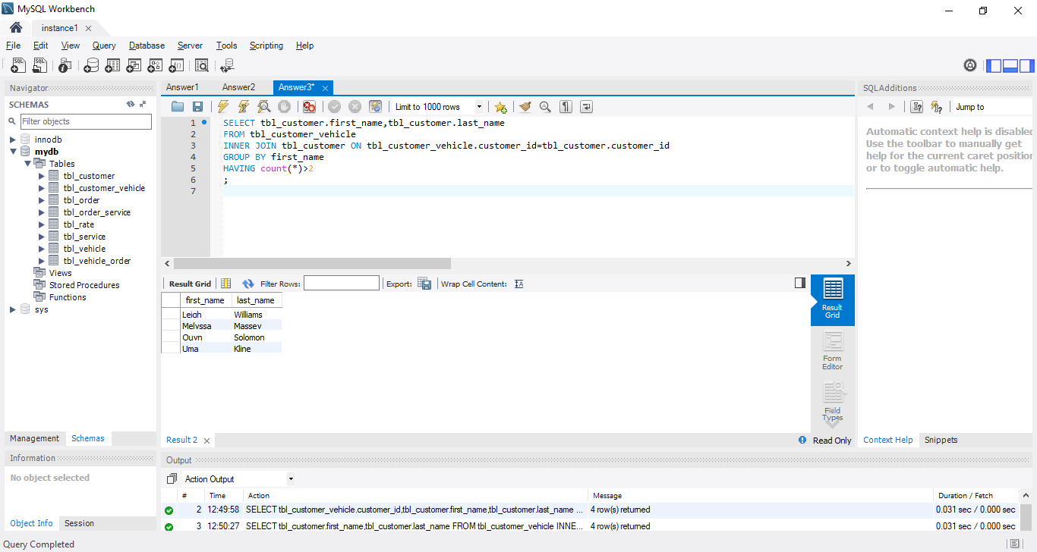

4. Query:

SELECT service_id,name,part_cost

FROM tbl_service

WHERE part_cost>500

;

Screenshot:

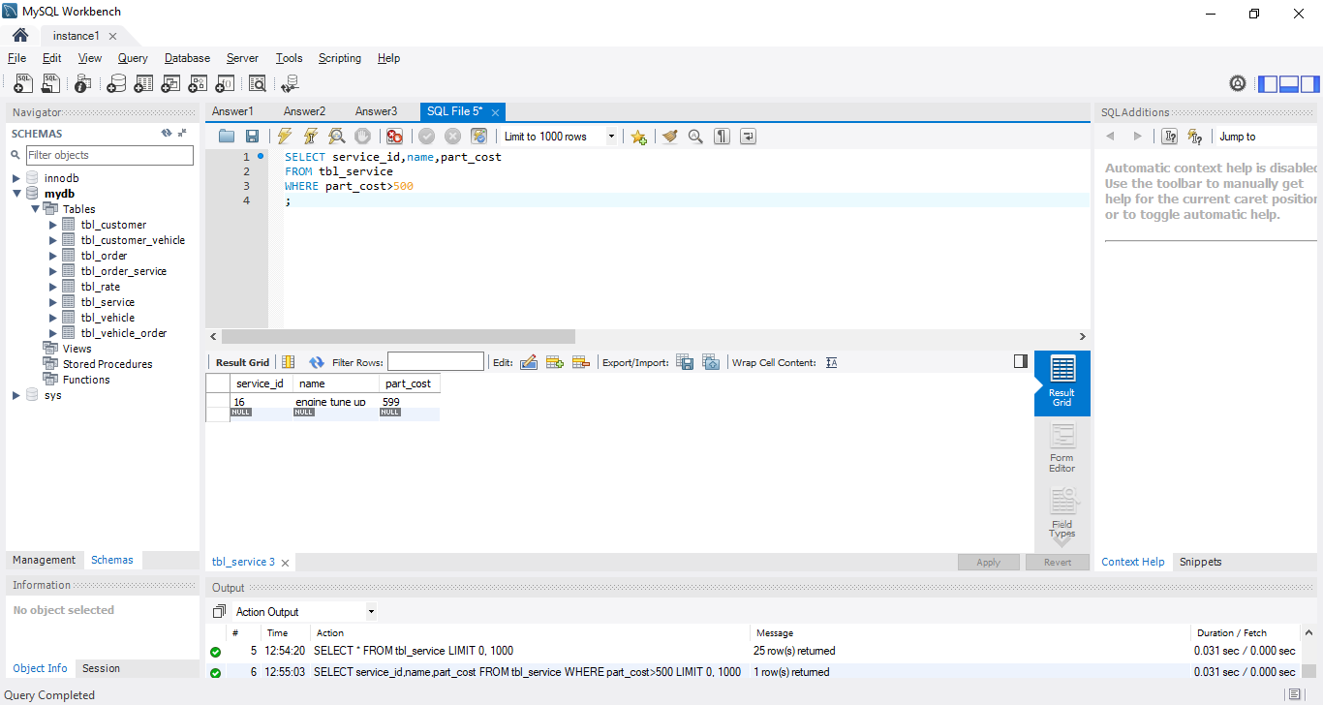

5. Query:

SELECT tbl_service.service_id, tbl_service.name, COUNT(tbl_order_service.service_id), tbl_service.part_cost*COUNT(tbl_order_service.service_id)

FROM tbl_service

INNER JOIN tbl_order_service ON tbl_service.service_id=tbl_order_service.service_id

GROUP BY tbl_service.service_id

;

Screenshot:

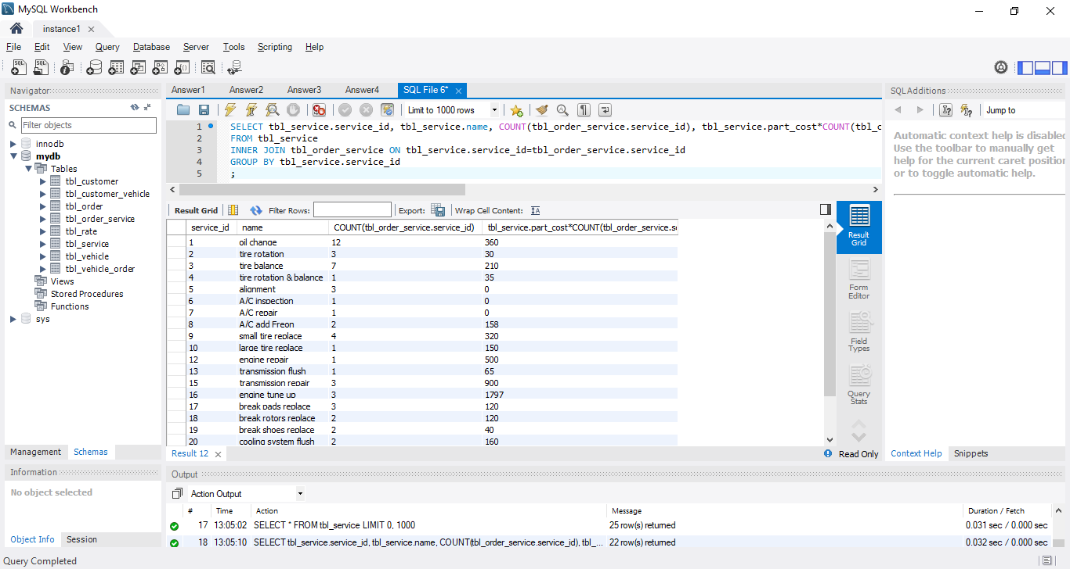

6. Query:

SELECT cus.first_name, cus.last_name, costSum.customer_id, costSum.costCount from

(

SELECT customer_id, sum(cost) AS costCount

FROM

(

SELECT cu.customer_id,(part_cost+labor_hour*labor_cost_per_hour) AS cost

FROM tbl_customer_vehicle AS cu

LEFT JOIN tbl_vehicle_order AS ve ON ve.vehicle_id = cu.vehicle_id

LEFT JOIN tbl_order_service AS ord ON ord.order_id = ve.order_id

LEFT JOIN tbl_service AS se ON se.service_id = ord.service_id

LEFT JOIN tbl_rate AS ra ON ra.rate_id = se.rate_id

) AS customerCost

GROUP BY customer_id

) AS costSum

LEFT JOIN tbl_customer AS cus ON cus.customer_id = costSum.customer_id

ORDER BY costSum.costcount DESC

LIMIT 1

;

Screenshot:

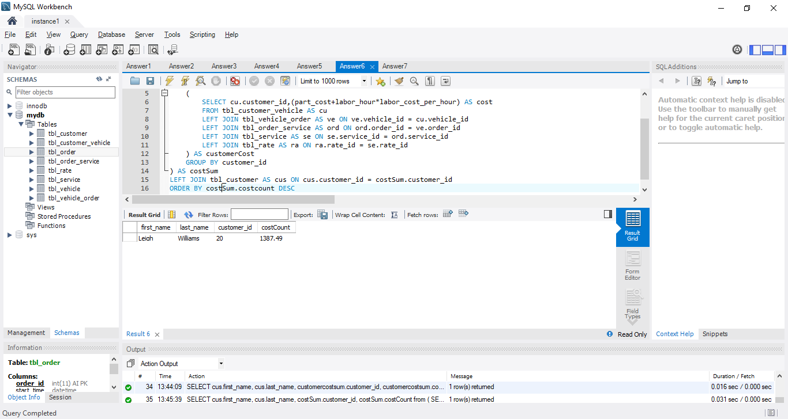

7. Query:

SELECT ve.vehicle_id,ve.year,ve.make,ve.model,ve.mileage,vehicleTotalCost.orderNumber,vehicleTotalCost.vehicleSum

FROM tbl_vehicle AS ve

LEFT JOIN

(SELECT vehicleTotal.vehicle_id, COUNT(vehicleTotal.order_id) AS orderNumber,SUM(vehicleTotal.cost) AS vehicleSum

FROM(

SELECT veor.vehicle_id,veor.order_id,(part_cost+labor_hour*labor_cost_per_hour) AS cost

FROM tbl_vehicle_order AS veor

LEFT JOIN tbl_order_service AS orse ON orse.order_id=veor.order_id

LEFT JOIN tbl_service AS se ON se.service_id=orse.service_id

LEFT JOIN tbl_rate AS ra ON ra.rate_id=se.rate_id

)AS vehicleTotal

GROUP BY vehicleTotal.vehicle_id

)AS vehicleTotalCost on vehicleTotalCost.vehicle_id=ve.vehicle_id

;

Screenshot:

