The Aura Operating Zeitgeist

The Last Operating System You Will Ever Need and Your Gateway to Infinity.
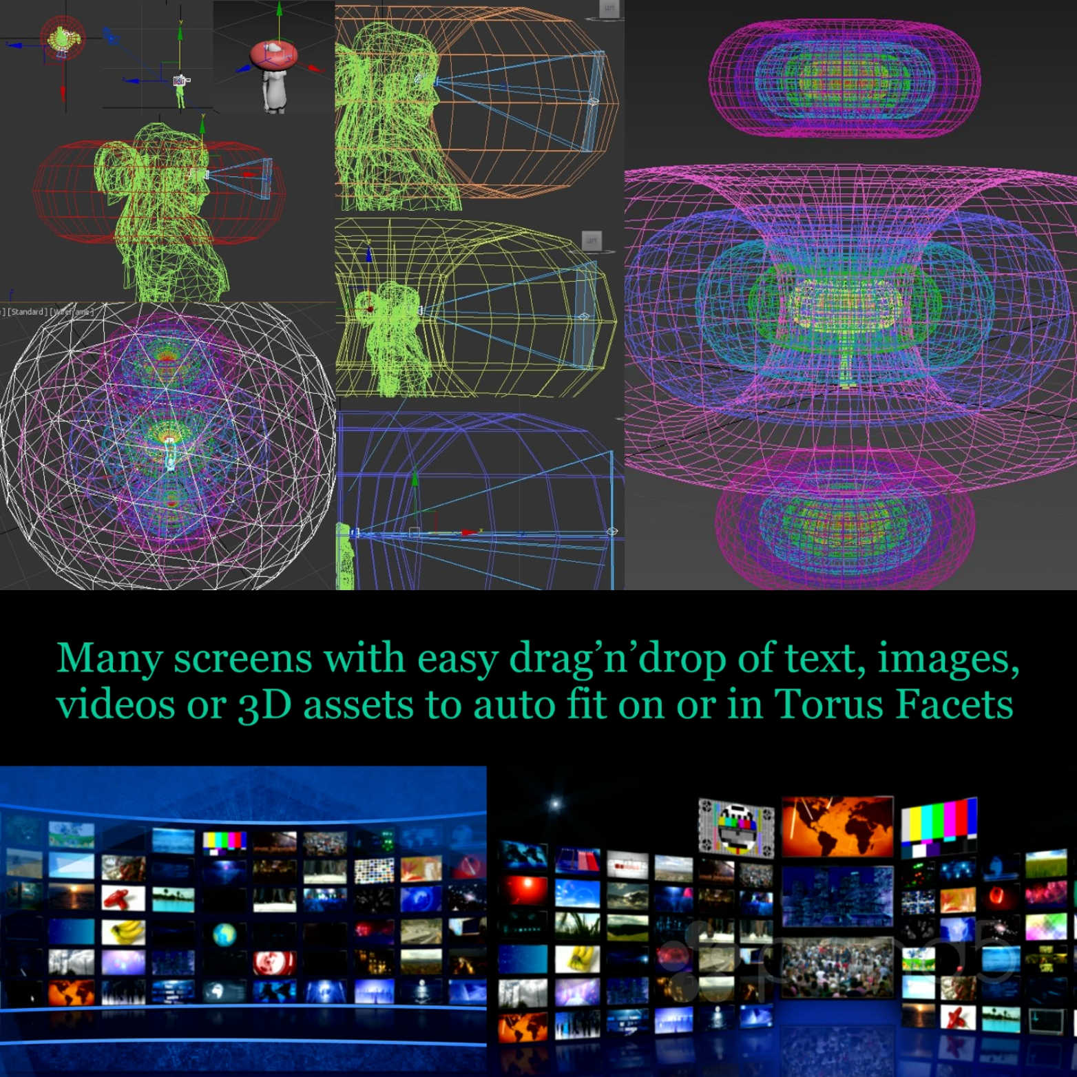
Date: Fri 6th April 2018 Version: 0.1 Status: Draft for advisor review, subject to change.

Abstract:

AuraOZ is a 3 dimensional digital aura that acts as your personal interface to the internet of everything in our hyper-connected world of infinite realities.

The vision of the Aura Operating Zeitgeist is to create the last operating system you will ever need and give people more power over computers than most of us could ever imagine was possible. The power to cast your will across the vast distances of space and time through the internet and have it made manifest in digital form for you to share, learn from and interact with like never before.

Add to AuraOZ a high definition virtual version of your real body so that you can migrate your health records into your avatar and visualize how to tune yourself into peak physical and mental condition. With fast access machine learning algorithms taking just seconds to activate, your custom lesson plans will help you to achieve many more goals in life.

The full scope of AuraOZ is limited only by your choices as you develop your personal system through the full code stack. Are you a team player, or do you fly solo? Are you a creature of habit, or are you someone who tries anything with a moment’s notice? Are you designing your aura for business and to serve customers, or are you designing it for your personal life and service to self?

In the infinite possibilities available through AuraOZ, One thing is for certain. The objective in creating this and sharing it with the world is to collaboratively define joyous, virtuous and compassionate responsible abundance in the base reality we begin from. Always remember where you came from, and be good.

Table of Contents
Abstract: 2
1. Background 4
2. The Internet 5
The Beginning 5
Centralized, Decentralized and Distributed 5
The Third Dimension and Beyond 5
3. Software and Intelligence 6
Problems with Unintuitive Controls and Interoperability 6
Problems with Social Media and Today’s Internet 6
Humanizing Big Data 7
Crowd Intelligence towards Artificial General Intelligence 8
4. Trust, Compassion and Reputations 9
Unspoken Actions to Build Trust and Compassion 9
Using Blockchain and Auras for Reputation Management 9
5. Creating and Learning from New Worlds 10
Personal Worlds 10
Social Worlds 10
Environmental Responsibility 10
6. Business Opportunities 11
Full Stack Training on Holiday 11
Travel Agency 11
Business Consultancy 11
Governance Consultancy 11
Life Coaching 11
Second Language Training 12
Disability Support Services 12
Emergency Response Services 12
Game Design Services 12
Space Development 12
7. Marketing 13
8. Risk 13
9. Roadmap 14
10. Team 15
11. Advisors 16

Background

An Aura in western society is typically frowned upon by science as paranormal fiction and esoteric nonsense. I take no position in regard to the authenticity of naturally occurring aura’s, however with the rapid increase in advanced capabilities being granted to humans via computers, I believe that we should design computational Aura’s using many of the idealistic philosophies from esoteric Aura’s.
“An aura or Human energy field is, according to New Age beliefs, a coloured emanation said to enclose a human body or any animal or object.^{[1]} In some esoteric positions, an aura is described as a subtle body.^{[2]} Psychics and holistic medicine practitioners often claim to have the ability to see the size, colour and type of vibration of an aura. ^{[3]}” https://en.wikipedia.org/wiki/Aura_(paranormal)
The philosophy of the Human Aura is an ancient philosophy that, as far as I can discern, was first recorded in the Vedic Sanskrit script somewhere between 1100 and 1700 BC. It is suspected that the Vedas had previously been transmitted verbally in song for many generations prior to being scribed.
“The Vedas (/ˈveɪdəz/;^{[1]} Sanskrit: वेद veda, "knowledge") are a large body of knowledge texts originating in the ancient Indian subcontinent. Composed in Vedic Sanskrit, the texts constitute the oldest layer of Sanskrit literature and the oldest scriptures of Hinduism.^{[2][3]} Hindus consider the Vedas to be apauruṣeya, which means "not of a man, superhuman"^{[4]} and "impersonal, authorless".^{[5][6][7]"}” https://en.wikipedia.org/wiki/Vedas
With the vast amounts of big data being produced by the human species and our TechnoSphere, we are forced to imagine new ways of visualizing this data to understand it and gain valuable insight. I believe that we can combine the best of the esoteric philosophies with the internet to create a new superhuman general intelligence that is simultaneously centralized, decentralized and distributed.

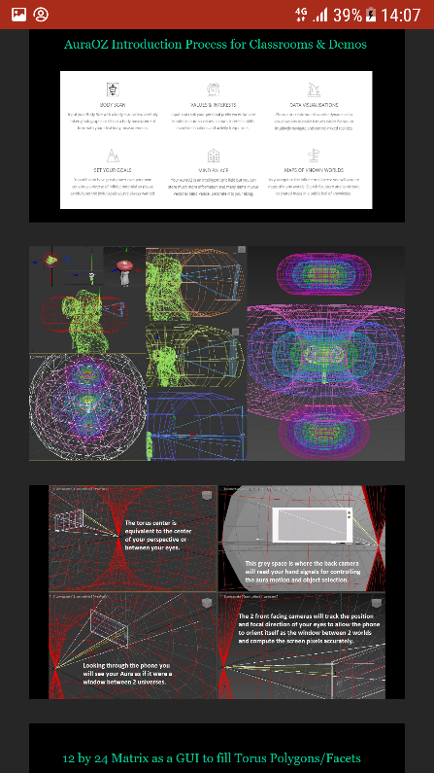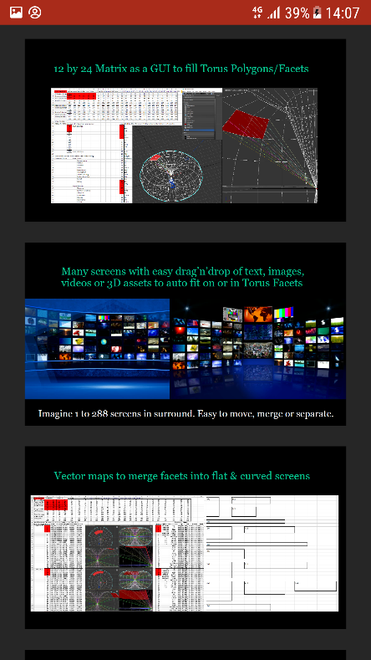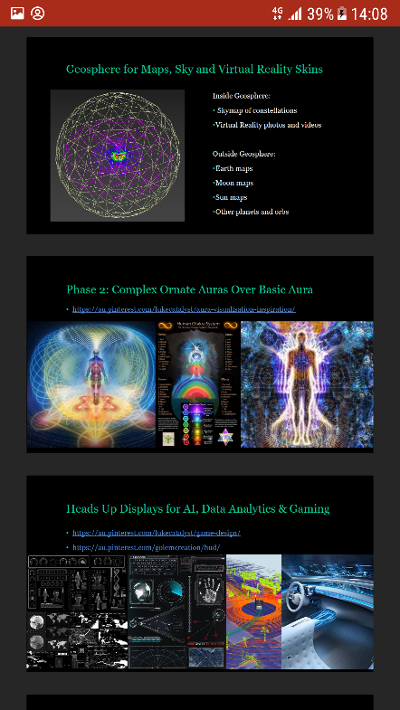

The Internet

The Beginning
The organisational structure of AuraOZ will be such that all critical conversations and negotiations shall be conducted in a recorded video chat then transcribed into actionable and verifiable code to minimise misunderstandings and errors of judgement. This format will also empower better global synchronization of actions to minimise repetition and maximise efficient allocation of resources.

Centralized, Decentralized and Distributed
Non-personal generalized big data will be gathered where appropriate and via informed consent to establish a framework for a centralized general intelligence. Facial Recognition will be decentralized and customized for each individual Aura so that they can maintain their specific levels of privacy and Data Security. Finally the Social Responsibility components will be managed on a distributed system.

The Third Dimension and Beyond
As we can see with the increasing successes of Augmented Reality Apps for advertising like Time Magazine covers, games like Pokémon Go and hardware like Oculus, HoloLens or Magic Leap, the internet is increasingly moving into the 3rd dimension. Science fiction movies and television series are paving the way for popular culture to mass adopt this new way of thinking about the internet and the best geometry for the interface of this 3D internet is almost certainly going to be an Aura.
In the AuraOZ protocol we are using 7 matrices of 12 objects by 24 objects. That gives us 7 by 288, a total of 2,016 objects to assign actions, meaning and context to. In addition, each of the 7 matrices has a specific colour; Red Orange Yellow Green Blue Indigo Violet and a range of colour within which each torus is enabled to transition through to massively increase the number of assignable variables. Each matrix is then folded upon itself into 3 Dimensional space and manipulated into a horn torus.
Each of the 7 toroids has a specific size, location and orientation in 3D space which is relative to the size and manoeuvrability of the human who is to operate the Aura, but the absolute centre of all 7 toroids remains at an x,y,z point of zero,zero,zero. By moving these toroids and their 288 objects into very precise configurations of orientation, colour, string, loops, triggers etc., vast numbers of computations and increasing complexity towards artificial general intelligence are possible.
At the absolute centre the human perspective is inserted via a virtual camera. Then a graphical user interface enables the user to assign content to each of the objects in each of the toroids. The magic of intelligence begins here as the human builds patterns of information, association and context in each layer of the Aura. Machine learning algorithms will be implemented to the specific geometry of each Aura for an ever increasing number of use cases such as pattern recognition, speech to text, text to speech, sentiment analysis, language translation, generative environments and many more.
Once the Aura of a new creator is implemented, tested and debugged the user will generate their virtual clone. A digital copy of their body that can either be designed from the ground up in 3D or generated from high resolution photographs, videos or laser scanners. This clone will then become the interactive model for the user to store, maintain and understand their health records as well as interactively tune their physical capabilities to an optimal level like never before possible.

Software and Intelligence

Problems with Unintuitive Controls and Interoperability

Problems with Social Media and Today’s Internet

Humanizing Big Data

Crowd Intelligence towards Artificial General Intelligence

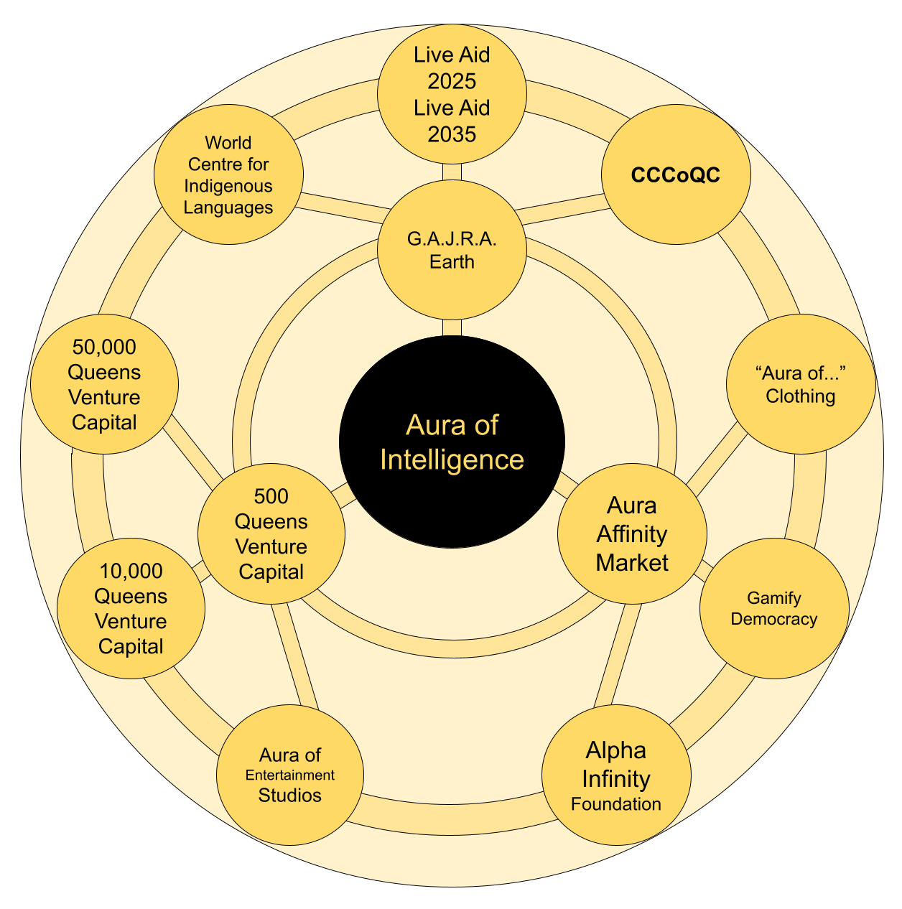

Trust, Compassion and Reputations

Unspoken Actions to Build Trust and Compassion
Interactions between auras can hint at deeper meaning by noticing bio signals that are beyond normal ranges of perception.

Using Blockchain and Auras for Reputation Management
Token Economics and gifts to reward good behaviour
As conversation occurs, NLP action prompts can auto build icons and quotes into a visual space as a pre-curser to generating smart contracts. When it is time to summarize and confirm actions the people involved in the conversation can shift those prompts or icons as required, into a confirm box while definitions and expectations are clarified and agreed upon.
Gamification of meetings and activities can be used to earn reputation points and measured against a matrix of urgency, importance, frequency, success rate, body language, and lasting impressions.

Creating and Learning from New Worlds

Personal Worlds

Social Worlds

Environmental Responsibility

Business Opportunities

Full Stack Training on Holiday
The core business during the start-up phase of AuraOZ will be a training organisation coupled to a travel agency. Through this we will sell 7 to 14 day holidays and train people how to develop the full code stack for AuraOZ while contributing to the co-creation of a general intelligence. Subsequently the fully trained AuraOZ professionals will then establish the various consulting businesses across the world, increasing our reach and impact on sustainable development. We will carefully select the first 100,000 people to attend these training holidays so we create many strategic opportunities.

Travel Agency
The travel agency is likely to be a joint venture with a select number of senior advisors from the international hotel and resort management industry. This will enable us to access premium advice, industry leading systems access, top notch referrals and group booking discounts immediately. We will target the premium holiday and corporate training markets from upper midscale to luxury.

Business Consultancy
As we continue to implement and improve our machine learning protocols then share them into the general intelligence of the AuraOZ organisation, we will aim to quickly become the gold standard of business intelligence and change management. A large emphasis will be put into balancing structural problems such as gender inequality, wealth disparity, waste and inefficiencies via more automation without causing social strain in the workforce or their surrounding communities.
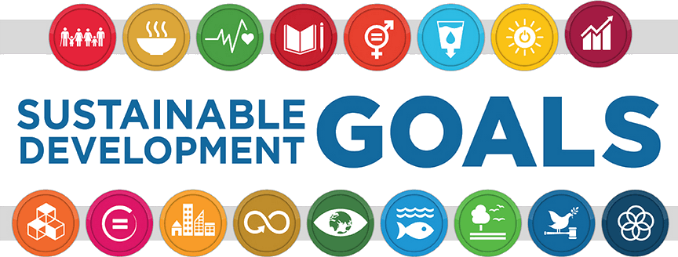

Governance Consultancy
As governments across the planet are increasingly focusing their attention on developing Smart City protocols, digital currencies, citizen engagement, life long learning and sustainable development we will position our teams to maximize our positive influence. For instance the Indian government has shortlisted 100 smart city corporations to access increasing pools of funds to deliver infrastructure that will give their citizens a much better quality of life and eradicate poverty. It is our responsibility as global citizens to build and provide access to the best civil standards and protocols in the world.

Life Coaching
In this consultancy we will teach people to simulate their existing life in a generative environment, then reflect on what their ideal lifestyle would contain so that we can simulate the differences and timelines required to make the shift. Furthermore we will inspire people to build a 3rd simulation that is based on their ideal reality if the object of money was replaced by the values of responsible abundance plus several of their own core values such as joy, compassion, travel, sharing etc. If the customer authorises us to use their non-personal data from this 3rd simulation, it will enable us to simulate larger scale transition strategies for facilitating responsible abundance globally. The core objective for AuraOZ to facilitate global joyous virtuous compassionate responsible abundance via a stable, data driven transition in partnership with citizens, corporations, governments and cultures.

Second Language Training
Using our 3D AuraOZ we will construct an application that activates the front and rear cameras on a smart phone to record the local environment. An object detection algorithm will then identify as many objects as possible, surrounding them with a bounding box that allows the user of the phone to name the object and/or confirm the auto suggestion. Once each object is confirmed in the first language, any other language can be prompted into the environment via text and voice. Over time the user can then string together visual and audible cues for associations, sentences, definitions and origins to learn many languages and build their own lesson plans.

Disability Support Services
Imagine almost any physical and mental disability and then imagine how an artificially intelligent superhuman digital avatar could engage with the dependent person via a virtual Aura to improve their life and independence. Many combinations of cameras, mics and automata can increase the ability of dependents to communicate, move, prepare food, travel, clean, learn, teach and play given the right amount of training support and a connected environment like a smart city. This system is intended as a short term fix while the medical industry advances to a level where disabilities are reversible and money is no longer a barrier to returning people to the full capacity of their self.

Emergency Response Services
As our professional AuraOZ operators travel the world interacting with new cultures, environments and governments we will amass significantly important data sets to manage coordinated responses to natural disasters. Machine vision algorithms will give Aura operators the instant ability to control drones for fast reconnaissance when entering a danger zone to identify and prioritise people in need during the most critical life and death situations. With each new algorithm our capabilities enhance and so does our ability to mitigate the worst consequences of future occurrences. By also investing in semi-automating the creation and distribution of local and regional disaster preparedness plans we can save more lives as high speed internet connectivity around the world continues to advance.

Game Design Services
Through our evolution in the generative environment algorithms we will be granted the opportunity to become a world leading game design collective and this should not be taken lightly. The future of inclusive societies can best be realized through the gamification of learning, just in time training and self-directed personal development. In addition to this, as our understanding of consciousness grows we will be increasingly held accountable for the content we produce and its effects on society. True to our core values of joyous virtuous compassionate responsible abundance, we will not create any games that train people to accept or inflict violence.

Space Development
To ensure that humanity of Earth becomes a multi-planetary and multi-stellar species we will engage with international space agencies and start-ups to provide advice on, co-create and evolve only civil non-military ambitions in space development. This has already begun via an advisory board role with The Space Development Nexus in India http://spacedevelopmentnexus.com which is an inspirational network that now spans many countries and tens of thousands of people. SDNx contributes much to the advancement of space research, development, education, policy development and competitions.
“Equipped with his five senses, man explores the universe around him and calls the adventure Science.” — Edwin Hubble, The Nature of Science, 1954.

Marketing

Risk

Roadmap
Something visual like this example roadmap from an ICO:
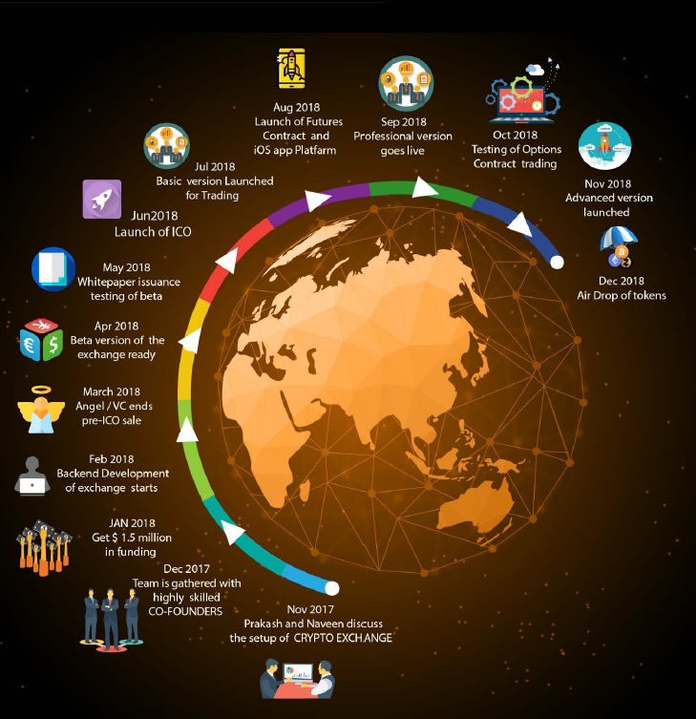
- Free AuraOZ App Development
- Advisory Group and Talent Acquisition
- AuraOZ Full Stack Development
- AuraOZ App Pre-Launch Preparations
- Travel Agency and Resort Partnerships
- Holiday Resort Training System Development
- Full Scale Indian AuraOZ App Launch
- First Full Stack Training Course
- First Consultancy outposts in India, Australia, China, UAE and others
- Push for AuraOZ App to exceed 100,000+ downloads or next milestone
- Global AuraOZ App Launch in multiple languages
- Aura Alliance of Businesses globally with “Aura” in their trading name
- First Millionaire AuraOZ’s for influencers
- Monetisation Phase Begins
- Second Language Training

Team

Name:
Networking & BlockChain
Linked In Profile
Bio:

Name:
ML, Ai & Data Science
Linked In Profile
Bio:

Name:
Founder & Joint Ventures
Linked In Profile
Bio:

Name:
Unity XR & 3D Modelling
Linked In Profile
Bio:

Name:
Community Builder
Linked In Profile
Bio:

Name:
IT Hardware
Linked In Profile
Bio:

Name:
Leadership Trainer
Linked In Profile
Bio:

Name:
Motivation Specialist
Linked In Profile
Bio:

Name:
Talent Acquisition
Linked In Profile
Bio:

Advisors

Name:
International Law
Linked In Profile
Bio:

Name:
Event Management
Linked In Profile
Bio:

Name:
Travel Agency
Linked In Profile
Bio:

Name:
Finance and Accounting
Linked In Profile
Bio:

Name:
Linguistics Expert
Linked In Profile
Bio:

Name:
Video Production
Linked In Profile
Bio:

Name:
Disability Support
Linked In Profile
Bio:

Name:
Emergency Services
Linked In Profile
Bio:

Name:
Media and PR
Linked In Profile
Bio:

Name:
EU
Linked In Profile
Bio:

Name:
APAC
Linked In Profile
Bio:

Name:
Space Development
Linked In Profile
Bio:

Name:
North America
Linked In Profile
Bio:

Name:
Africa
Linked In Profile
Bio:

Name:
South America
Linked In Profile
Bio:

Name:
United Nations
Linked In Profile
Bio:

Name:
Indo-China
Linked In Profile
Bio:

Name:
Middle East
Linked In Profile
Bio:

